Influenza and Zoonoses Education among Youth in Agriculture
FINAL Progress Report

Please return completed Progress Report to CSTE at mschroeder@cste.org.

- Identify your top achievements for the project.

- Hold 4-State Workshop
  - Invited colleagues from Canada, MT, SD, and WY.
  - See Appendix One for workshop summary notes
- Hired a summer intern
  - Completed State Fair observations
    - State Fair in 2017:
      - 2017 – of those entering the barn
        - 20.8 % were observed eating in the barn
        - 32.0 % were observed drinking
        - 8.8 % were observed putting non-food objects in their mouth and
        - 24.3 % were observed bringing a stroller into the barn
    - State Fair in 2018:
      - 2018 – of those entering the barn
        - 15.4 % were observed eating in the barn
        - 6.2 % were observed drinking
        - 2.0 % were observed putting non-food objects in their mouth and
        - 11.6 % were observed bringing a stroller into the barn
  - Design unique posters for fair barns containing animals
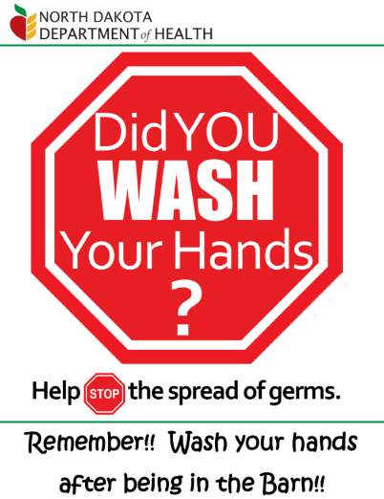
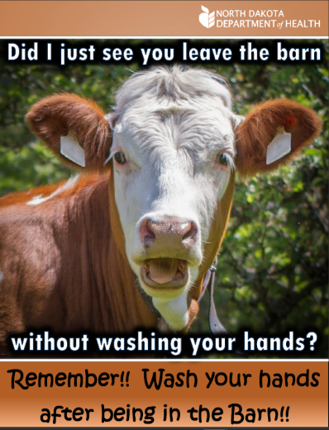
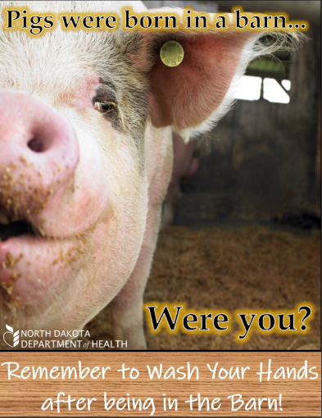

- Three different posters were developed so that fairs could have a variety of posters around the fair grounds. The goal is to continually catch the eye of fairgoers.
- These posters have been printed and will be mailed to all fairs for the 2019 fair season.
  - Demonstrate GloGerm and mucus swap activities (“train-the-trainer”)
      - The video tutorials have been completed. We are currently going through the editing process.
      - We plan to post the videos by February 2019.
- Creation and distribution of a fair newsletter
  - This newsletter was created to highlight resources, provide up-to-date information, disease information, tips for healthy fairs, etc. for fair staff, veterinarians, 4-H leaders, local public health units and fairgoers.
- LESSON LEARNED: The goal was to distribute a monthly newsletter in June, July and August. However, only two newsletters were distributed, as this is an extremely busy time of year for 4-H leaders, fair directors and the state veterinarian’s office, and putting together articles and resources for a newsletter became a hardship. Our goal is to do a quarterly newsletter in 2019 and develop a resource-based webpage for public use.
- Creation of Germ Buster presentation
- A Deputy Germ Buster presentation was created for a target audience of younger 4-H members. This presentation works nicely with our hands-on demonstration kits (i.e., GloGerm, mucus swap activity, glitter pig activity).
- Purchase of demonstration kits
  - GloGerm
    - We purchased GloGerm kits for the health department and several kits for the 4-H Youth in Ag director. The goal is for the health department to use these kits when talking with groups about the spread of germs, especially influenza. Additionally they can be used when presenting to youth and (in 2019) the goal is to have a kid’s day at the state fair and do these demonstrations at the fair. The 4-H kits are meant to be “rented out” from the 4-H office by 4-H club leaders in order to offer demonstrations by their clubs without having to purchase the kits.
  - Glitter Pig
    - Funds were used to purchase the supplies for the glitter pig demonstration for both the health department and the 4-H Youth in Ag director for the same reason as the GloGerm kits. We wanted to offer multiple options so the same demonstrations are not always used.
  - Mucus Swap
    - Same as other demonstration kits, they are available for employees and others to borrow in order to help spread the message. Both the phenolphthalein/baking soda and the food coloring options are available in the kits. This allows demonstrators to determine which age-appropriate demo to use depending on the audience.
- These kits were purchased in August and as of this report the GloGerm kits have been used five times:
  - 2 different school demonstrations
    - College (ages: 20+); approximately 250 in attendance.
    - Grade School (ages: 8-10); approximately 20 in attendance
  - Nursing staff (ages: adult); approximately 20 in attendance
  - Division of Disease Control, ND Dept of Health (ages: adults); approximately 20 in attendance
  - ND and SD Fair Directors (ages: adults); approximately 35 in attendance
- GloGerm kits were also purchased for the 3 states attending the workshop, as all expressed interest in having the option of doing demonstrations. They will also be sent an example of each poster along with the original Publisher document so that they can replace the logo for printing in their state.
- Presenting at Fair Directors Annual Meeting
  - While not part of our timeline for the project, we had the opportunity to present to the ND Fair Directors at their annual meeting, the Dakota Fairs and Celebrations Convention. This was really a great opportunity for us because we have never been asked before which meant that our project information is being spread through the right channels.
  - The presentation included not only health and health safety tips, but also information about the project, goals of the project, and what we are hoping to accomplish in 2019. There were approximately 35 directors present. Additionally, our presenters conducted the GloGerm demonstration for them, and it was very well received.

- Please list the collaborators on this project’s achievements and briefly describe their role in the project (i.e. 4-H, State PH, State Animal Health).

North Dakota:
- ND Dept of Health
- ND Dept of Agriculture, Animal Division^
- ND State Fair Director
- ND 4-H Youth in Agriculture Director^
*South Dakota:
- SD Dept of Health
- SD Public Health Veterinarian
- SD Animal Industry Board
*Montana:
- MT Dept of Health & Human Services
- MT 4-H Youth Director
- USDA APHIS VS
- MT Public Health Veterinarian
*Wyoming:
- WY Dept of Health
- USDA
- WY Public Health Veterinarian

*All organizations contributed to the meeting through presentations and group discussions. The state workshop group also suggested an annual phone call with all parties in order to maintain momentum for the group. The group was very interested in the demonstrations (GloGerm, glitter pig, etc.) so funding was used to purchase GloGerm kits for each state so that they would be able to provide these demonstrations in their states.
^Additionally, the State Veterinarians office and 4-H Youth in Ag director contributed to the projects, newsletter, and providing demonstrations.

- Please describe areas of concern or challenges in meeting the objectives or providing deliverables.
- Remaining in contact with rural fairs regarding collaboration and feedback, since many board members are volunteers and are busy with their primary occupations.
- Student intern retention with school starting up in early/mid-August
- When we contacted the State Fair to coordinate events or workshops, the fair schedule was full and they weren’t able to fit us in. In the future, we will need to contact the State Fair in advance (previous fall) to reserve times.
- The one goal we did not reach was to do health presentations to the 4-H clubs that have more agriculture-based members. With the late start of the student intern, this was just not accomplished. Our goal for 2019 is to do at least one 4-H presentation in each region.

- Please include an updated project timeline.
- There is no updated timeline as this is the final project report.
- Since funding is not guaranteed, some of the sustainable project goals and objectives for 2019 are as follows:

Objective One – Collaborative Development
 | Activity |  | Completion Date
 | Continue to meet with 4-H Youth Livestock Specialist |  | throughout summer
 | Continue to meet with State Veterinarians |  | throughout summer
 | Meet with FFA Leaders |  | May 2019
 | Hold workshop call |  | May 2019
Objective Two – Training Activities
 | Activity |  | Completion Date
 | Post demonstration videos |  | Feb 2019
 | Present to 4-H groups in each region |  | Jan-Aug 2019
Objective Three – Education
 | Activity |  | Completion Date
 | Mail out demonstration kits |  | Jan 2019
 | Post examples of posters to Basecamp |  | Jan 2019
 | Work with state fair to hold demonstrations |  | July 2019
 | Develop newsletter/resource website |  | April 2019

- If you have materials you are already distributing, please upload a PDF or a link to the Basecamp site (https://3.basecamp.com/3164497/buckets/2026830/vaults/306679424) For Basecamp access, please email mschroeder@cste.org.

- Handwashing posters intended to be hung up at county fairs to remind fairgoers to wash their hands will be posted to Basecamp by the end of January 2019.

- Please list suggestions for CSTE and CDC for how we can best facilitate your progress.

- Provide connection or information from other states regarding their experiences connecting with rural fairs. This would be helpful for us as we find it difficult to contact and remain in contact with rural fair boards.

