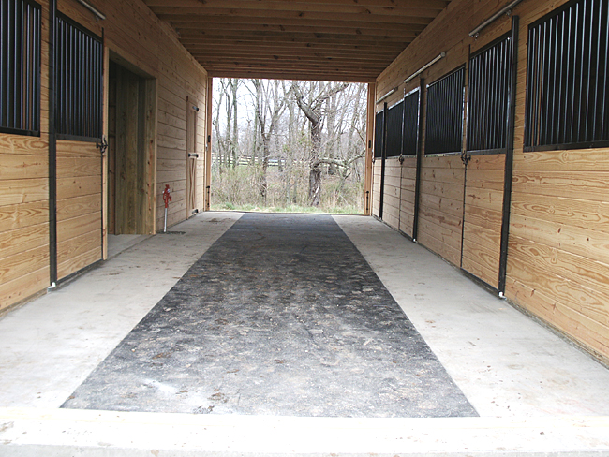


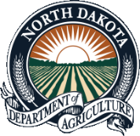
Montana, North Dakota, South Dakota, Wyoming: Working together for Healthier Fairs
Workshop Summary Report


FEEDBACK
We appreciate all feedback! We want to continue to improve future meetings, speakers and content. We had 12 people (48%) respond to the follow up survey/email collecting feedback about the training (10 in person; 2 via webinar). All 12 people felt that the training had value and they all indicated that they would attend another.

We are still interested in feedback on this workshop, whether you only attended a small portion online, or both days in-person. If you have not filled out the evaluation please click on the following link:
Working_Together_For_Healthy_Fairs_Evaluation

Thank you for attending the 2018 Working Together for Healthier Fairs Workshop. Everyone’s effort, is greatly appreciated and contributed to the success of the meeting.
The following pages contain an overview of each day’s presentations and panel discussions.
Workshop by the Numbers
11
Presentations, Panel Sessions and Group Discussions
4
Jurisdictions Represented
29
Total Attended


What Went Well!





Thanks for coordinating this
So good to understand both sides of a story
Useful to hear about healthy fair experiences in other states
The guest speakers were
very valuable
Thanks for a quality exchange of information
This training was of value to me

Was often hard to hear on the phone. Conduct planned technology checks to make sure everything is still working
The training could have used a bit more structure to use the time more wisely
Have constructive post-mortems on issues that arose in any of the States
Have a follow up meeting next year about what worked and what didn’t
Provide handouts of the information prior to the meeting so participants could come more prepared
Continue to invite resource personnel with specific expertise from outside the region

Improvements Suggested

Day One Summary: Key Takeaways
- Swab pigs at fairs. Go to 100 fairs every year in multiple states. On average, 30% positive for influenza. Visit fairs likely to have risk factors for influenza transmission.
- Have seen some decreases in influenza at fairs through efforts implemented. Developed a white paper to minimize influenza in swine exhibitors. vet.osu.edu/sites/vet.osu.edu/files/legacy/userimages/u29/Measures%20to%20Minimize%20Influenza%20Transmission%20at%20Swine%20Exhibitions%203-11-13.pdf
- Sort boards are dirty! So is the environment. Greater than one surface tested positive at 50% of fairs that were sampled.
- People need to wash their hands! Results from one observational study showed less than 50% used the hand hygiene stations and most of those that used the stations were adult women and children. Hand washing stations were used more frequently than sanitizer.
- We now know what a Glitter Pig is!
- Learned about becoming a Swientist – swientist.vet.ohio-state.edu/
- Mucus Swap demonstration


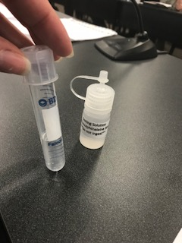

- WY has a “Healthy Exhibition Animals” handbook - www.uintacounty.com/DocumentCenter/View/1893/Healthy-Exhibition-Animals---Guideline-for-Exhibitors-2013
- MT has been targeting veterinarians through veterinary accreditation in public health and zoonotic diseases.
- SD has an exhibition rule requiring a health certificate issued within 30 days of exhibition for all animals. Their state fair has veterinary oversight.
- ND works with their state fair board on the role of the state veterinarians at the state fair. There is no quarantine area on-site at the state fair, owners are told to leave the fairgrounds with sick animals.
Panel Discussion: Public Health and State Veterinarians
WY, MT, SD, and ND
Presentation:
Animal Influenza Ecology & Epidemiology Research Program
Jacqueline Nolting, MS, PhD
Ohio State University

Panel Discussion: 4-H Youth Directors and Leaders
MT, WY, and ND
- Many programs have implemented the whole or parts of the Excellence in Exhibition program - www.cfsph.iastate.edu/YouthInAg/
- Have found that first- and second-year students are hungrier for information (4-H and FFA)
- 72-hour mandate for swine showings is helpful to limit transmission
- Scenario-based trainings have been implemented to incorporate zoonotic disease and biosecurity into trainings
- Have used Glo Germ kits, biosecurity video clips, state livestock quiz bowl contest, etc., to help educate participants
- State-wide course camp is being implemented
- One focus area has been on animal science and are working on a mechanism for kids to get college credit for some of the courses
- Video technology such as Zoom has been used to deliver curriculum content


Panel Discussion: Fair Directors and Managers
SD, WY, and ND
- Many use the compendium for placement of handwashing signs and stations - nasphv.org/Documents/AnimalContactCompendium2017.pdf
- Barn superintendents are critical to keeping an eye on the animal barns
- Need to incorporate fun/clever signs to grab people’s attention. Some organizations have used grant dollars to purchase more handwashing stations and signs
- Fairs want to educate about how animals are part of the food chain and about animals and agriculture in general
- Ways health departments can collaborate with fairs:
  - Approach fair managers with issues or other happenings, let them know of issues before public or other notifications
  - Help with signage, consistent messages, catchy signs, instructions on where to place signs, what they are intended to be used for, etc.
  - Speak at fair conventions or meetings

Day Two Summary: Key Takeaways
- Talked about the importance of youth involvement in agriculture
- Web-based education has been found to be the best way to reach children
- Blue Not Flu lessons – Showed a demonstration of the program to the workshop group
  - Used Articulate e-learning software to build the program
- At the end of the Blue Not Flu lessons about 25% of participants want to have a career in animal health or other related field
- Plan to develop a new course targeted for kids 7-12 years. Will be web-based with more games, less text, and shorter lessons
- Glo Germ – sprinkle powder in doorway and use a black light later to see how germs can spread as people walk through the door
- Similar to the mucus swap, food coloring is used (yellow and blue) to simulate infection spread (blue is infected and yellow is not-infected)

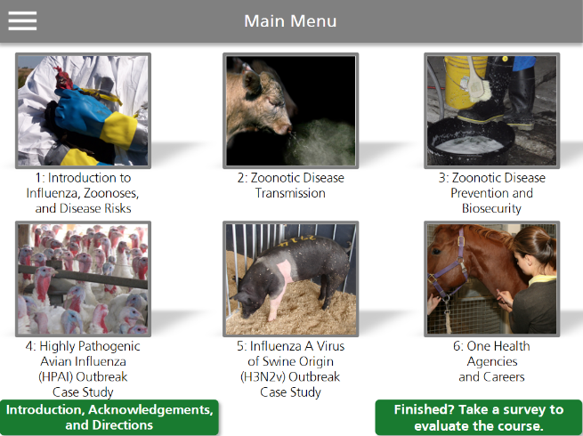
- WY indicated that most zoonotic disease cases are Campy cases associated with branding. Did an E. coli risk study in rural vs. urban settings and found rural had high levels of antibodies to E. coli
- MT gave an overview of zoonotic diseases in MT and provided some examples of posters that they have used
- ND talked about a variant influenza investigation, swine influenza at a ND fair, an STEC outbreak associated with attending a fair, and the “when/how/why” of communication with the public
- SD has a One Health website (www.onehealthsd.org/) with state materials and resources. Talked about a Cryptosporidium outbreak associated with a petting zoo at school and how they developed a checklist for petting zoos as a result of this outbreak
Presentation: Center for Food Security & Public Health at ISU’s College of Veterinary Medicine
Abbey Canon, DVM, MPH
Iowa State University
Panel Discussions:
Epidemiologists

MT, WY, SD, and ND


- Liked the idea of offering programs for kids, train-the-trainer, older 4-H participants doing presentations and education for younger 4-H members in the group.
- Do things at the fair to keep FFA/4-H involved throughout the fair like hygiene scavenger hunts or a “Healthy Stall Contest” – get the media involved to increase participation.
- Using demonstrations to make presentations more interesting (e.g., Glo Germ, mucus swap, glitter pig, etc.)
- ND offered to check with CSTE about the purchase of demonstration kits for surrounding states to “share the wealth”
- Using 4-H members to do video shorts for Facebook or pics of practicing good hygiene measures for Instagram. Putting these on state websites and others to encourage participation.
- Everyone indicated that it would be good for public health to take the lead to develop handwashing posters for all fairs in their state so that messages would be the same and consistent.
Education





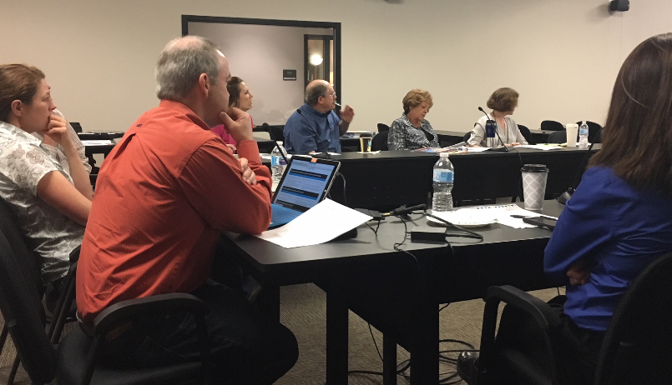
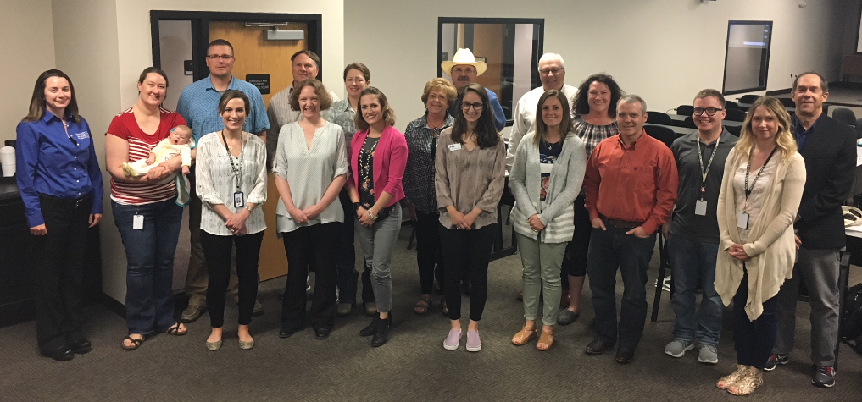
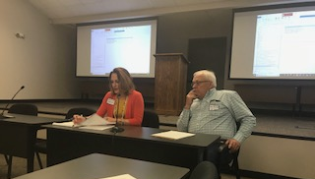
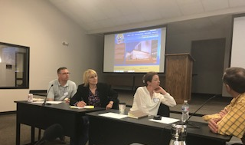
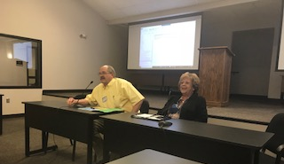


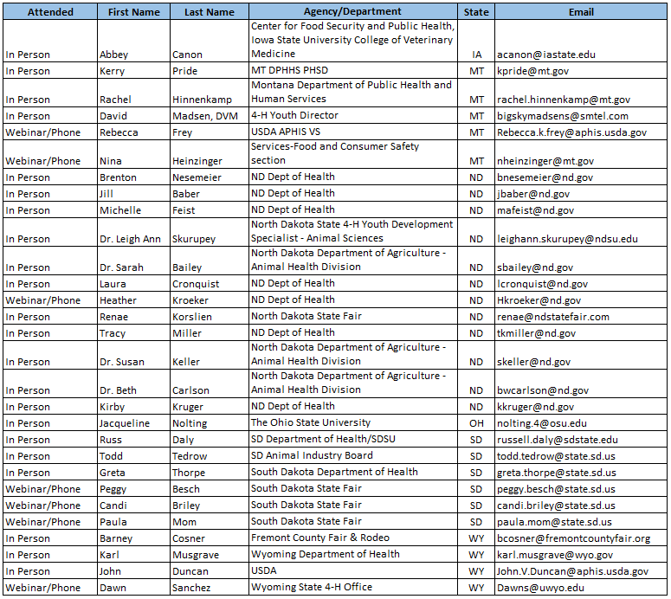
Thank
you to all who made this 4-state workshop a success!!

