Please return completed Progress Report to CSTE at mhuynh@cste.org by May 17, 2019.
Note: Please submit one response per jurisdiction.

- List project deliverables and describe progress made towards completion of these deliverables:

- Deliverable 1: Broad dissemination of skill-a-thon materials within Ohio and Indiana
Accomplishments/Progress to-date:
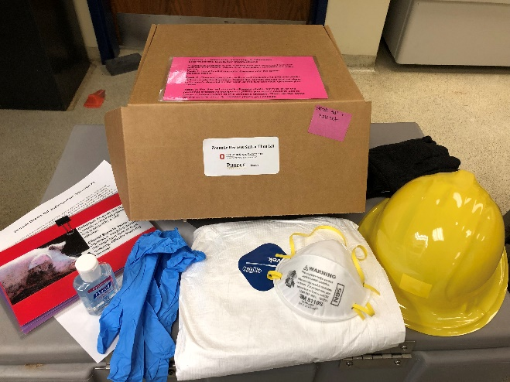
Disseminated zoonotic disease risk and prevention skill-a-thon kits to each county in Ohio and Indiana. In all, 180 kits that contained instructions, disease information, and PPE items were sent to extension educators in both states
Fig. 1. Skill-a-thon kit materials

Did this deliverable include an educational intervention: Yes

- Deliverable 2: Host “Becoming a Swientist” programming with OH-pigs Ohio Summer Swine Circuit participants
  - Host interactive kick-off training session in the beginning of the show season
  - Collect and disseminate healthy habit selfies throughout the show season
  - Wrap up awards ceremony at the annual banquet

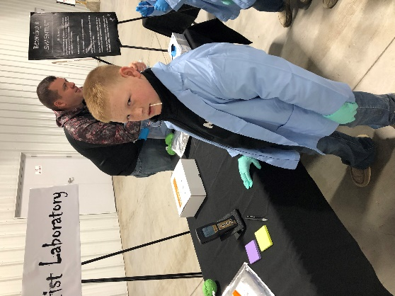
Accomplishments/Progress to-date:
Conducted hands on training with youth attending 4-H/FFA conferences during the winter and spring of 2019. Activities included; Ohio 4-H Conference, Ohio 4-H Junior Swine Day, OH-Pigs Jackpot Circuit kick-off weekend, and various 4-H club and FFA chapter visits. Participants at the Ohio 4-H Conference also included adult volunteers who will disseminate information with youth in their regions across Ohio. Activities include “Administer Vaccines” along with immunology basics; “Clean or Dirty” using ATP technology, “Mucus Swap”, “Diagnose the Pig”, and various other demonstrations of biosecurity concepts.

Did this deliverable include an educational intervention: Yes

Fig. 2. Swine exhibitor completing “Clean or Dirty” event at the OH-Pigs kick-off weekend.

- Deliverable 3: Interactive presence with the National Junior Swine Association to engage national level swine jackpot show participants
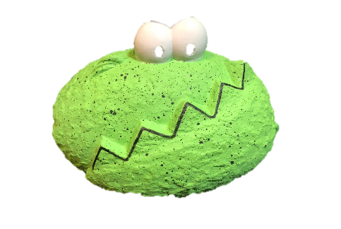
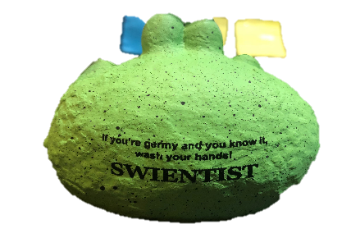
Accomplishments/Progress to-date: Educational promotion items (germ stress balls) were distributed to all 450 youth who registered to compete in the NSR Winter Type Conference in Perry, Georgia.
Fig 3. Germy stress ball

Did this deliverable include an educational intervention: No

- Deliverable 4: The following research questions are addressed in the 2018 economics and anthropology study. 1) What is the total value of the exhibition swine industry in the United States?
2) What are the associated costs of influenza A virus outbreaks at swine exhibitions at the local, state, and national levels?
3) What barriers are responsible for the lack of adoption of disease mitigation strategies among swine exhibitors?
4) How do swine exhibitors measure risk over reward when choosing which recommended healthy habits to employee in their routine?

Accomplishments/Progress to-date: Data collection and analysis for the anthropology and economics piece of our study has been ongoing. We have determined that the show swine industry has an economic of $1.2 billon per year. We have also documented the behaviors of individuals at swine shows and their thoughts that influences those behaviors. Generally, participants feel they are implementing recommended procedures to protect animal health; however, they feel zoonotic influenza A virus transmission is not a risk worth altering behaviors to avoid.

Did this deliverable include an educational intervention: No

- List the collaborators involved to-date and briefly describe their role in the project (i.e. 4H, State PH, State Animal Health).
    - Ohio 4-H: Collaborators were instrumental in the design and dissemination of the skill-a-thon kits. They piloted materials during the 2017 and 2018 Ohio State Fair skill-a-thons and provided edited written materials to be included in the kits. In addition, they provided a short overview and training with extension educators to ensure the kits were being used properly across the state. Skill-a-thon kits are being considered for inclusion in the 4-H mall, along with learning lab kits; which is being led by 4-H collaborators.
    - Indiana 4-H: Skill-a-thon kits were used for biosecurity training at a “Teens as Teachers” event, prior to each county extension educator receiving a kit to be used with their youth.
    - Ohio State University, Department of Agricultural, Environmental, and Development Economics: Collaborators used data compiled by AIEERP and extension educators to develop economic models to determine the value of the show swine industry. The value of $1.2 billion per year has been validated and manuscript preparation is underway.
    - Animal Influenza Ecology and Research Program: OSU collaborators conducted hands on training with youth attending Ohio 4-H Conference, Ohio 4-H Junior Swine Day, OH-Pigs Jackpot Circuit kick-off weekend, and various 4-H club and FFA chapter visits. Activities include “Administer Vaccines” along with immunology basics; “Clean or Dirty” using ATP technology, “Mucus Swap”, “Diagnose the Pig”, and various other demonstrations of biosecurity concepts. OSU collaborators have also coordinated data collection for the economics and anthropology studies and are assisting with manuscript preparation. In addition, the AIEERP assembled and shipped all skill-a-thon kits.

- Describe areas of concern or challenges in meeting the objectives or providing deliverables.

    - One of our objectives included being a part of the LEAD camp hosted by the National Junior Swine Association (NJSA), however the camp was cancelled due to a change in leadership within the NJSA organization. Instead we will be hosting Swientist sessions for swine exhibitions and youth involved in swine production at an Indiana Biosecurity event; during the Illinois State fair; and at the NPIC Annual meeting.
    - The World Pork Expo is cancelled for 2019, due to the risk of the introduction of African Swine Fever, however the pig show (and Swientist training) will continue as proposed.

- Include an updated project timeline, if relevant.
    - Swientist programing is underway and the contest will run until the end of June.
    - Training activities will be complete at The Exposition (formerly known as World Pork Expo), the Illinois State Fair, Indiana Biosecurity workshop, and NPIC annual meeting.
    - Manuscripts for the economics study and anthropology study are being drafted.

- Would you like to request an extension on your contract? If so, please provide an estimated project end date in which all activities and deliverables will be completed. Please note, this does not guarantee approval of extension. Additional information may be requested, as relevant, including revised workplan, timeline, and budget. CSTE will be in touch following review of your report to discuss next steps for contract amendment.

Yes, we would like to request an extension thru August 31, 2019 to complete the Becoming a Swientist program for the 2019 show season.

6) If you have a story or anecdotal example of how an individual, group, or community was positively impacted OR an outbreak response that was better facilitated as a result of your YIA project’s interventions, either describe it here or just write ‘YES’ and we will follow up with you at a later date. These ‘success’ stories combined with quantitative impact numbers will be used to share project successes with leadership.

We received the comments below from the Junior Swine Day organizer:

Junior Swine Day Speakers:

I have a story I wanted to share with you all. I had a lady come up to me at lunch time on Saturday and said her son was not a good student in school, yet took 6 pages of notes from the morning presentations. Being a high school teacher and amazed that her son took that much interest in pigs she told him that if he worked really hard he could pursue a career in animal agriculture at Ohio State. She said he didn’t know that was possible, but exited the opportunity existed and told her that he wanted to pursue that goal. His mother thanked me for the opportunity to attend and that it made a huge impact on her son.

Makes it all worth it and to think that we might have that kind of impact on someone’s life is amazing. Thanks for all you do to make Junior Swine day a success!! It was with your help, thanks!!

Dale

Impact Chart
If the activity/deliverable described is/included an Educational Intervention, please complete this portion of the report
Impact |  |  |  |  |  |  | Evaluation
Intervention Activity | Baseline # prior to 2018-19 grant period | How did you measure the baseline? Did you include direct participants, families, etc? | 2018-19 Audience (youth, community leaders, etc?) | # of attendees/participants | # of materials distributed | Did you collaborate with another state? If so, which one(s)? | Pre-test administered? (How many? To whom?) | Post-test administered? (How many? To whom?)
EXAMPLE: Four Scenario based training exercises | X# of training sessions held in 2016 to X total youth aged 11-15 | Only counted the number of actual youth who attended the session | Youth aged between 12 and 16 | X # attendees per training; total of X attendees
Junior Swine Day | Sessions held each year from 2016-2018; with 100-200 students reached each year | Counted the number of youth attending each year | Youth swine exhibitors aged 9-19 | 380 | Youth learned basic immunology and how to properly give a pig a vaccination | No | No | Evaluation completed at end of session: mean score of 4.7/5.0
Ohio 4-H Conference | A variety of workshop types held 2016-2018 with 15-20 attending each time. In 2018 we had a booth that could be visited by the 1500 attendees. | Counted number of youth who attended the sessions each year | Adult and teen 4-H volunteers | 120 | 120 lesson plan packets | No | Post pre-test: Knowledge Before  Mean: 2.6/5 | Knowledge after Mean:  4.5/5  Quality of Presentation Mean: 4.6/5
OH-Pigs Kick-off | Hosted sessions in 2017 and 2018 with approx. 100 youth at each | Counted number of youth participating each year | Youth swine exhibitors age 3-21 | 100 | Youth completed a clean/dirty activity  Hand-out flyers for Becoming a Swientist program and ~ 50 stress germs | No | No | No
Zoonotic Disease risk and prevention skill-a-thon kits | 0 | This is a new collaboration for the 2019 program year | Indiana and Ohio youth ages 9-18 enrolled in 4-H | 11,679 youth enrolled in swine 4-H projects in Ohio | 180 kits to each county in OH and IN | Indiana | Skill-a-thon station was piloted at the 2017 and 2018 Ohio State Fairs | Forthcoming
Educational materials in NJSA show registration bags | 0 | This is a new collaboration for the 2019 program year | Youth swine exhibitors ages 3-21 registered at National Swine Registry show in Perry, GA | 450 | 450 Stress germs | Yes, youth from multiple states attended show sponsored by NSR | NO | No

