2019 Influenza Among Youth in Agriculture Project Summary
Background
This is the third year that Maine received funding for the Influenza Among Youth in Agriculture Project. In year one of this funding, Maine Center for Disease Control and Prevention (Maine CDC) and Maine Department of Agriculture, Conservation, and Forestry (Maine DACF) created materials and piloted youth activities. During year two, Maine piloted a train-the-trainer and held a successful training event. The train-the-trainer provided direct instruction to youth agricultural leaders about zoonotic diseases, signs and symptoms of these diseases, prevention strategies to reduce the risk of transmission, and biosecurity techniques. Train-the-trainer participants then shared the information and materials with their local youth agriculture groups.
During the first two years of the project, Maine also created several posters, an influenza reminder postcard, a zoonotic matching game, and a card game called Germ-O. The matching game consists of a set of cards with zoonosis and One Health related terms and definitions. These cards can be used to play different games in which a term is matched to the definition to reinforce vocabulary. Germ-O is a card game that teaches youth about zoonotic diseases, their animal hosts, and biosecurity measures. This card game is based around the rules of the well-known card game UNO.
In the third year of this project, Maine’s grant objectives included another train-the-trainer event, interstate collaboration with Massachusetts and New Hampshire, creating additional posters, and distributing materials. Maine’s 2019 Grant Objectives:
- Modify two posters (chicks and salmonella & general farm safety) and create one poster (cryptosporidiosis and cows) to be New England specific
- Distribute educational materials
- Interstate collaboration with New Hampshire
- Hold Train-the-Trainer Event with New Hampshire
- Interstate collaboration with Massachusetts
The long-term goal of this project is to improve education and awareness of One Health in youth involved in agriculture and reduce the incidence of zoonotic diseases. Short-term objectives of the youth in agriculture project include:
- Improve interstate collaboration with New Hampshire and Massachusetts to enhance regional partnerships regarding influenza and zoonotic diseases
- Improve train-the-trainer participant awareness and knowledge of zoonotic diseases, including zoonotic disease transmission and prevention
- Facilitate a better understanding of the roles that public and animal health play in disease prevention among train-the-trainer participants
- Motivate train-the-trainer participants to adopt behaviors that can prevent zoonotic disease transmission
- Encourage participants to spread the information and materials gained during the training to other groups and/or youth
- Provide the Eastern States Exposition with materials and information to strengthen biosecurity measures
Methods
Modify Two Posters and Create One New Poster
Maine CDC reached out to Minnesota Department of Health to get permission to modify the baby chicks and salmonella poster and the general farm safety poster. After Maine CDC received permission, Maine CDC’s Infectious Disease Health Educator worked with our graphic designer to modify these two posters and create a new cryptosporidiosis and cows poster.
Distribute Educational Materials
In January 2019, Maine DACF presented a program on good practices for agricultural fairs at the Maine Association of Agricultural Fairs annual meeting and distributed public health signage created through this award to fair superintendents and youth agricultural leaders for use at agritourism venues and fairgrounds. In April, Maine DACF mailed a packet of information that goes to the fair presidents with regulatory and human and animal public health guidance information for the livestock superintendents in it to reinforce these messages. Additional public health materials are brought by DACF personnel during in-person visits to each of the fairs, including influenza postcards for pig scramble participants and supplemental hygiene and health signage. Maine CDC and Maine DACF also distributed posters created under this project to all train-the-trainer participants. Posters developed from this project area also available to order through Maine CDC’s Disease Surveillance Epidemiology Program’s Orderable Materials Website: https://www.maine.gov/dhhs/mecdc/infectious-disease/order-form-wn.shtml.
Interstate Collaboration with New Hampshire
Maine DACF contacted New Hampshire Department of Agriculture, Markets, and Food (DAMF) to initiate interstate collaboration. All partners attended a meeting to discuss the train-the-trainer event that Maine held in 2018 and discussed the idea of a joint train-the-trainer in 2019. New Hampshire agreed that this training opportunity would be beneficial to 4H leaders in New Hampshire. Maine CDC, Maine DACF, and New Hampshire DAMF identified and recruited youth agricultural leaders for participation in a Zoonotic Disease Train-the-Trainer event held on May 5th, 2019. The invitees included 4-H leaders, University of Maine (UMaine) 4-H extension leaders, University of New Hampshire professors, New England Agriculture teachers, and individuals who worked with youth in agriculture in other settings. Maine and New Hampshire recruited through established relationships at Maine DACF and New Hampshire DAMF as well as personal invitations with partners at UMaine Cooperative Extension and University of New Hampshire’s Dairy Program.
Prior to the training, Maine CDC and Maine DACF staff worked to update training materials from the previous years’ train-the-trainer event. This included updating the Healthy Animals, Healthy People presentation and creating a new biosecurity presentation. Maine CDC and Maine DACF included the posters in the training materials for the train-the-trainer event.
Hold a Train-the-Trainer Event
Components of the zoonotic diseases train-the-trainer event included:
- Pre- and post-testing to gauge attendee content knowledge
- Two PowerPoint presentations about zoonotic disease transmission, prevention, biosecurity, and agritourism
- Four hands-on activities designed to reinforce concepts
- Take home educational materials including disease fact sheets, biosecurity posters, and activity materials
- Follow-up instruction guiding participants on how to present the material and how to notify Maine CDC about any outreach done to track the reach of the train-the-trainer event.
Maine CDC’s Influenza Epidemiologist delivered a presentation on the basics of influenza, zoonotic diseases, and prevention of transmission. Maine DACF’s Assistant State Veterinarian gave a presentation and led a discussion on agritourism and the importance of biosecurity. Maine CDC’s Infectious Disease Health Educator led a germ swap activity with a pig scramble scenario and a walk through of an online zoonotic disease course with the group. Maine CDC and Maine DACF then divided participants into three groups that rotated through activity stations. Maine CDC’s Influenza Epidemiologist, Maine DACF’s Assistant State Veterinarian, and an agricultural development agent each led a hands-on activity. The three groups rotated through the activities in 15-minute increments. Activities included a zoonosis matching game, Germ-O card game, and a GLO GERM™ handwashing activity. All attendees received a binder with materials from the event as well as an activity kit which included Germ-O, the matching game, and materials to run the GLO GERM™ and germ swap activities.
Interstate Collaboration with Massachusetts
Maine is working across state lines with Massachusetts on a partnership with the Eastern States Exposition, also known as The Big E. The Big E is the largest agricultural event on the eastern seaboard and takes place in September. Maine DACF met with the Director of Agriculture for The Big E to explain the CSTE grant and resources that Maine may be able to offer to their venue to help improve biosecurity and educate the public. The Director for Agriculture is working with the Executive Team to get approval to move forward with this collaboration. Maine expects that collaboration with Massachusetts will continue after this grant cycle is over. Maine DACF will work with The Big E to identify key areas for signage for handwashing stations and livestock display areas, which will likely include an on-site evaluation of the event venue prior to introduction of animals to the fairgrounds this year.

Results
Modify Two Posters and Create One New Poster
Maine CDC’s graphic designer created these three posters:
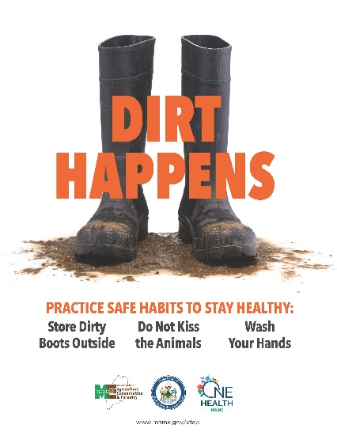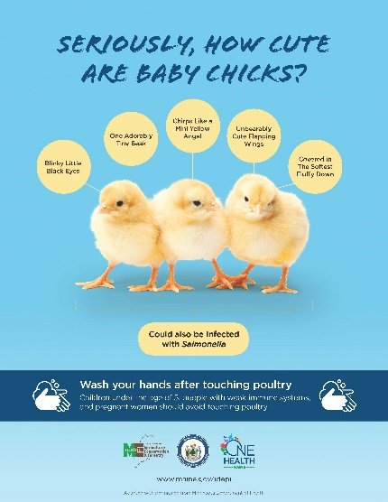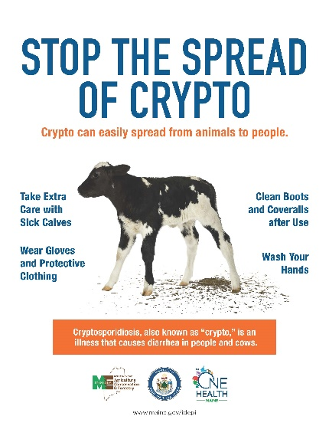

Distribute Educational Materials
In the last year, Maine CDC distributed the following materials created under this project:
- Agriculture Influenza Pig Poster: 77
- Agriculture Influenza Pig Postcard: 1,030
- Dirt Happens Poster: 363
- Visit Another Time – Tractor Poster: 454
- Handwashing Handprint Poster: 625
- Share Your Love – Cows: 162
- Share Your Love- Hands: 1,112
In the last year, other states and organizations requested materials created under this project:
- Oregon Health Authority – Portland, OR (Germ-O)
- Thunder Bay Junior High – Portland, OR (Germ-O)
- South Dakota State University – Brookings, SD (Germ – O, vocab matching game, various posters)
- International Community Health Services – Seattle, WA (Posters)
- Maryland Department of Health (Posters)
- Cypress Woods Elementary School – New Port Richey, FL (Posters)
- East Windsor High School – W Suffield, CT (Posters)
- National Pork Board – Clive, IA (Germ-O)
Maine CDC and Maine DACF also provided the following with a portable handwashing station under this project:
- Northern Maine Fair (ME)
- Windsor Fair (ME)
- Union Fair (ME)
- Ossipee Valley Fair (ME)
- Farmington Fair (ME)
- Cumberland Fair (ME)
- Litchfield Fair (ME)
- Pittston Fair (ME)
- Phoenix Stables Horseback Riding Center (NH)
Interstate Collaboration with New Hampshire & Train-the-Trainer Event
Eighteen attendees and four staff attended the train-the-trainer event on Sunday, May 5th in Eliot, Maine. Six of the eighteen attendees resided in Maine and the remaining twelve were from New Hampshire. Attendees included representatives of the Cheshire Fair, Hillsborough County Agricultural Fair, Deerfield Fair, Lancaster Fair, Fryeburg Fair, Acton Fair, and Farmington Fair.
As of July 8, 2019, twelve attendees completed a follow-up feedback form. Eight of these individuals completed an educational event using the materials and information provided to them during the train-the-trainer event. Four of these individuals have upcoming events planned where they plan to use the materials. The remaining six participants did not return follow-up forms after multiple attempts to contact these individuals. The average number of participants in each event that already took place is 22, with a range of eight to more than 50 per event. 4H groups represented the majority of the youth trained along with an Animal Science class and agriculture education classroom. Some participants chose to use the Healthy Animals, Healthy People presentation along with two or three games, while others utilized all materials and games. Please see the 2019 Train-the-Trainer Summary for pre- and post-test results from this training.
By the end of the fall 2019, the twelve responding attendees plan to train more than a total of 226 individuals with an age range of 8-18 years old as well as training K-12 teachers involved in the New Hampshire Agriculture in the Classroom participants. One attendee also plans to run a session at the 4H leader’s conference for New Hampshire.
Interstate Collaboration with Massachusetts
Maine DACF spoke with the Director of Agriculture at The Big E, who is getting approval for moving forward with the CEO of The Big E.

Discussion
This was the second consecutive year that Maine held an influenza and zoonotic diseases train-the-trainer event for youth leaders. In 2018, 39 people from Maine attended the training event, while less than half the number of attendees were present at the 2019 event, which included a total of 18 participants from Maine and New Hampshire. This reduced number of attendees was unexpected, as there was more time for recruitment in the current funding cycle as compared to the previous year. It is possible that the smaller attendance meant many of the interested participants in Maine, particularly those in southern Maine, where both years’ events took place, attended the event in 2018. Additionally, it was difficult to find a weekend that no other agricultural events were taking place in Maine or New Hampshire. Conflicting agricultural events, including ones that Maine CDC and DACF may have been unaware of, could have contributed to the decreased number of participants.
Maine CDC and Maine DACF provided attendees of the training with all the materials needed for running the activities on their own. This made it easier for the 2019 attendees to complete the activities portion of the training on their own, compared to 2018 when Maine CDC mailed kits to participants after the event. Some attendees contacted Maine CDC for additional copies of Germ-O and the matching game.
Interstate collaboration with New Hampshire was ultimately helpful but proved difficult at times. A representative from New Hampshire Division of Public Health Services initially agreed to the project but never became involved due to a personal matter. New Hampshire’s State Veterinarian helped Maine coordinate many aspects of the training and reached out to contacts in order to push out the training information. This effort positively impacted the overall attendance at the training. Unfortunately, there was no representation from New Hampshire animal or public health at the day of the train-the-trainer due to a conflicting Northeast Poultry Show.
Conclusion
Though not as many people attended the train-the-trainer event in 2019 as the previous year, the event was successful in that it reached the goal of educating leaders of youth in agriculture on zoonotic diseases and One Health and helped to strengthen Maine’s relationship with its neighboring state, New Hampshire. Of the attendees who have followed up with Maine CDC thus far, all have either held or are planning to hold a training of their own. It is expected that over 226 youth in Maine and New Hampshire will be trained on zoonotic diseases and One Health by the end of the fall. Due to low attendance numbers, it’s possible that interested train-the-trainer participants have already taken part in this, or the previous years’ training, indicating that another training in the near future may be in low attendance, or may do better in another location. It is possible that even with a hotel room provided, interested participants may be unwilling or unable to travel a far distance to attend a future training. Since Maine held the train-the-trainer event in Portland in 2018 and Eliot in 2019 there may be interest in holding a training in central or northern Maine or even in New Hampshire.
While interstate collaboration was not always easy due to a lack of communication and scheduling conflicts, the collaboration with New Hampshire for this project proved beneficial in the present and will continue to do so in the future. New Hampshire is now aware of projects Maine has been working on and Maine’s interest in working across state lines. With the contacts established, Maine and New Hampshire may continue to work together in both agriculture and infectious disease matters. Due to very positive Initial interactions with Massachusetts collaborators, we anticipate that The Big E management will be interested in using our public health signage and biosecurity strategies at the fairgrounds as early as this year.

