Appendix X. Data Dictionary
Data Source: American Community Survey
Topic: Demographics
Maintained: US Census Bureau
Accessibility: Public
Example URL: https://www.census.gov/programs-surveys/acs
Years available: Five year estimates at county level, annualized, 2000-2017
Definition: Demographic indicators, such as per capita income, unemployment, etc.

Summary: the American Community Survey (ACS) has county level data on a number of subject areas, including education, employment, income, race and ethnicity. Depending on county size, this information may only be available as five-year estimates. Because ACS data is available to the public, collected on a regular basis, and available at the county level, it can form a basic core set of indicators that every state and jurisdiction health department can use to assess county level vulnerability. ACS data is available at the Census Tract level for larger counties that want to target sub-county areas.
In some states, such as New Mexico, demographic data may be supplied by academic partners, in New Mexico’s case, the Bureau of Business and Economic Research at the University of New Mexico. States and jurisdictions should make their own determination if more specific data is more useful for the vulnerability assessment, while maintaining reporting consistent with departmental standards.

Potential indicators:
Core:
S2301 – Employment Status - 2017 ACS Five Year Estimates
S1701 – Poverty Status in the Past 12 Months – 2017 ACS Five Year Estimates
Core: S1901 – Income in the Past 12 Months – 2017 ACS Five Year Estimates
Core: B02001 – Race Universe: Total population – 2013-2017 ACS Five Year Estimates
S2701 – Selected Characteristics of Health Insurance Coverage by Age – 2013-2018

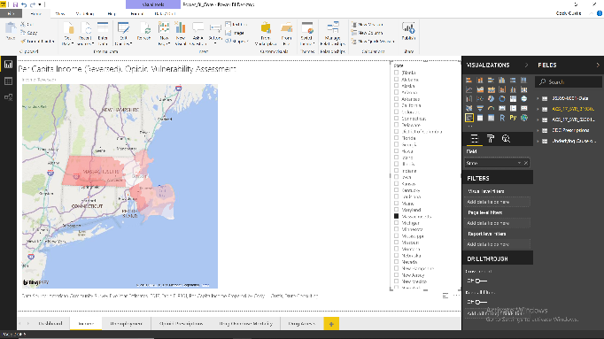

Data Sources: CDC Wonder – Detailed Mortality
Topic: Mortality
Maintained: CDC
Accessibility: Public
Example URL: https://wonder.cdc.gov/controller/datarequest/D76
Years available: Wonder :1999-2017; Standard Certificate of Death 2003 implementation varies by state
Definition: Number (or rate) of deaths with underlying cause of death from vital statistics data

Summary: CDC Wonder provides county level morality data based on ICD-10-CM cause of death. Cause of death can be categorized as either underlying cause (UCOD; one cause per death) or multiple / contributing cause (MCOD; potentially many). Use of underlying vs multiple cause varies by topic area, Van Handel et. al. used underlying cause in the national assessment. For counties with fewer than 10 deaths, CDC Wonder excludes data from those counties.
Morality data is also collected at the state and jurisdictional level, each state maintains its own vital statistics system. These systems generally use a version of the 2003 US Standard Certificate of Death, although year of implementation varies, and systems may add variables based on state to state differences. The legal status and availability of state specific death data varies from jurisdiction to jurisdiction, in some places the death certificate is mostly public, in other places, access is highly restricted. Indicators calculated from state data vs Wonder data may be slightly different due to lags in reporting and state custom, it is not expected this difference will have practical impact.
At the state level, there is interest in examining literal, rather than coded, cause of death. Such analysis is beyond the scope of this data dictionary.
For counties with missing or unavailable data Van Handel et. al. imputed values based on geographic proximity. Other potential imputation options include using a statewide average, or adjusting for counties with similar size or demographic characteristics.

Potential Indicators:
Core: Drug Overdose Mortality – Per 100,000 Population, Underlying Cause (also available as part of Recommended CSTE Surveillance Indicators for Substance Abuse and Mental Health)

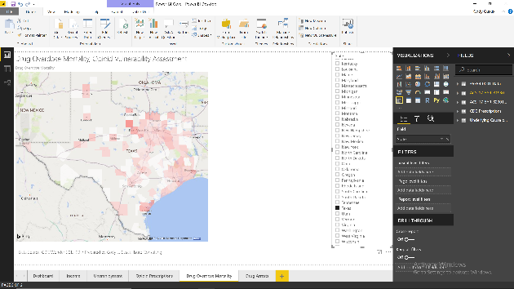
Data Sources: IQVIA Xponent 2006-2017
Topic: Drug Prescriptions
Maintained: CDC
Accessibility: Public
Example URL: https://www.cdc.gov/drugoverdose/maps/rxrate-maps.html
Years available: CDC 2006-2017
Definition: Per capita prescriptions (per 100 residents) for opioids, IQVIA sample of 50,000 retail pharmacies.

Summary:
CDC IQVIA Xponent data is based on a survey of retail pharmacies and gives the number of opioid prescriptions per 100 residents. This is different from other data sources, such as DEA Arcos, which gives the amount of opioids (in milligram morphine equivalent; MME) or state Prescription Drug Monitoring Programs (PDMPs), which generally give the proportion of residents with opioid prescriptions.
The Van Handel et. al. analysis used DEA Arcos data, which is MME.
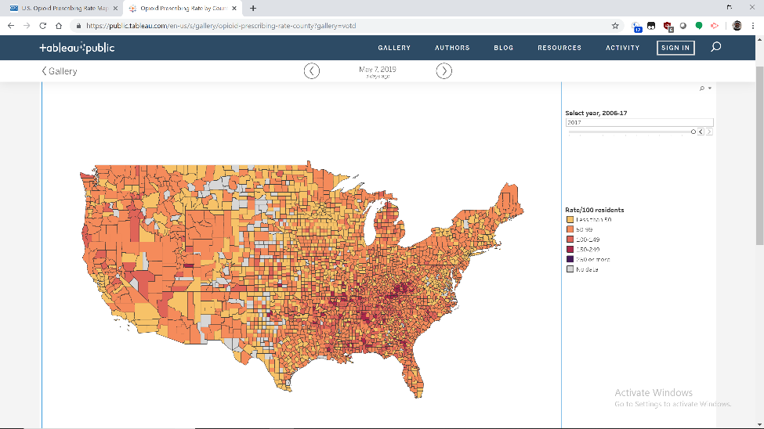
https://public.tableau.com/en-us/s/gallery/opioid-prescribing-rate-county?gallery=votd

Data Sources: Emergency Department Data, Inpatient Admission Data
Topic: Morbidity (Hospitalization)
Maintained: State health departments / state hospital associations
Accessibility: Varies. Some states have public use data files with high levels of detail, other states have no public hospitalization data
Example URL: https://www.hcup-us.ahrq.gov/db/availability_public.jsp
Years available: Varies by state; ICD-10-CM transition first full year in 2016
Definition: Number of admissions or encounters meeting selected indicator criteria

Inpatient admission and emergency department data are collected in nearly every state and jurisdiction. Collection is, roughly, half by state health departments and half by state hospital associations. Data elements vary by jurisdiction, but generally include ICD-10-CM diagnosis codes, selected demographic data, and selected information about insurance. Data quality varies from jurisdiction to jurisdiction.
With the ICD-10-CM transition, certain indicators are still in development. The CSTE ICD-10-CM Drug Poisoning transitioning workgroup is developing a new case definition of drug overdose, which is expected to be released in June 2019. Neonatal abstinence syndrome is also available from hospital discharge data, among other sources.
For diseases like hepatitis C and HIV, hospitalizations reflect not only incidence, but also patterns of care and availability of outpatient treatment. Many individuals who live with HIV and / or hepatitis C will never be hospitalized for such. Syndromic surveillance may be more sensitive to outbreaks of disease.

Potential Indicators:
Hospitalizations attributable to drugs with potential for abuse and dependence, all drugs (also available as part of Recommended CSTE Surveillance Indicators for Substance Abuse and Mental Health)
Neonatal abstinence syndrome (https://www.cdc.gov/mmwr/volumes/65/wr/mm6531a2.htm?s_cid=mm6531a2_e )
HIV Hospital Stays (https://www.hcup-us.ahrq.gov/reports/statbriefs/sb206-HIV-Hospital-Stays-Trends.pdf )
Hepatitis C Hospital Stays (https://www.hcup-us.ahrq.gov/reports/statbriefs/sb232-Hepatitis-C-Hospital-Stays-Trends.jsp?utm_source=ahrq&utm_medium=twitter&utm_term=&utm_content=1&utm_campaign=ahrq_hcup232 )
CDC Opioid Overdose Indicator Support Toolkit, Version 3.0

Data Sources: Syndromic Surveillance (Biosense)
Topic: Morbidity (Syndromic)
Maintained: State and local health departments, in partnership with CDC
Accessibility: Varies.
Example URL: https://www.cdc.gov/nssp/index.html
Years available: Varies by state; ICD-10-CM transition first full year in 2016; generally near real time.
Definition: TBD

Syndromic surveillance is collected from emergency departments (ED) and other sources, but has a different focus than hospitalization data. Hospitalization data is based on billing systems with primary and principal diagnosis codes assigned by trained Health Information Management (HIM) professionals with access to full medical records and conditions diagnosed by physicians. Hospitalization data is usually collected quarterly or annually. Syndromic data, on the other hand, is based on chief complaint as described by patients, and collected on a near real time basis.
Syndromic data was originally developed to detect bioterrorism events. It’s role has expanded to be used for examining other outbreaks of public significance, such as influenza-like-illness (ILI). Case definitions are still in development. A study of three regions found general agreement between chief complaint (CC) and discharge diagnosis (DD).

Data Sources: NCHS Population Estimates; American Community Survey
Topic: Population
Maintained: US Census Bureau
Accessibility: Public
Example URL: https://www.cdc.gov/nchs/nvss/bridged_race.htm;
Years available: NCHS: 1990-2017 (back to 1969 with SEER series); ACS: https://www.census.gov/acs/www/data/data-tables-and-tools/ 2000-2017
Definition: Persons, meeting specific demographic characteristics

Both the National Center for Health Statistics (NCHS) and American Community Survey (ACS) maintain population estimates that are useful for state and local health departments.
NCHS estimates are single year of age, Hispanic ancestry, bridged race, single year, sex, county level estimates from 1990-2017, updated annually. NCHS estimates are highly detailed, however, bridged race categories may not be useful for examining specific populations. NCHS estimates also require software to pivot and manipulate in order to make them useful for public health purposes.
ACS estimates, on the other hand, may have far more detail in certain cases (for example, detailed breakdowns of specific American Indian / Alaska Native tribal membership, alone or in combination) and are generally organized in a manner that makes them easier to use. The downside is that demographic combinations are limited to pre-selected categories. For example, Table B02014 has very detailed information on specific tribal grouping at the county level, but no information on age or sex within such groupings.
For totals, estimates from NCHS and ACS should be identical.
Some states may maintain other sets of population estimates, state and local health departments may use such depending on customary policy.

Potential Indicators:
ACS S0101 – Age and Sex
Core: Percent White, Non-Hispanic Population
Data Sources: SAMHSA Practitioner and Program Data
Topic: Practitioners
Maintained: SAMHSA
Accessibility: Public
Example URL: https://www.samhsa.gov/medication-assisted-treatment/practitioner-program-data/treatment-practitioner-locator
Years available: Current snapshot
Definition: Number of practitioners with buprenorphine prescribing privileges.

Substance Abuse and Mental Health Services Administration (SAMHSA) maintains a list of physicians with buprenorphine prescribing waivers at the zip code level. This data can be aggregated to county level estimates.
Before analysis, data wrangling is necessary to complete the data. For example, one provider has an address of Scottsdale, Arizona, yet is missing county information. Scottsdale is located in Maricopa County. The exact nature of appropriate data wrangling depends on the capabilities of software used and the skills of the analyst.

Potential Indicators:
Core: Buprenorphine Prescribing Potential by Waiver per 10K Persons

Data Sources: Uniform Crime Reporting Program Data: County-Level Detailed Arrest and Offense Data
Topic: Arrests
Maintained: University of Michigan; United States Department of Justice; Federal Bureau of Investigation
Accessibility: Public
Example URL: https://www.icpsr.umich.edu/icpsrweb/content/NACJD/index.html
Years available: Pre-1990- 2014 (Mapped as of May 11, 2019), 2016
Definition: Arrests according to type of crime, total drug arrests

County-level arrest data is available from the Uniform Crime Reporting Program Data, maintained at the University of Michigan. Van Handel et. al. used total drug arrets in the national assessment. Jurisdictions may prefer to use state sources to be consistent with state reporting requirement or for more timely reporting.
Population totals are provided in the dataset. These totals are used for calculating rates.

Potential Indicators:
County-level total drug arrests.

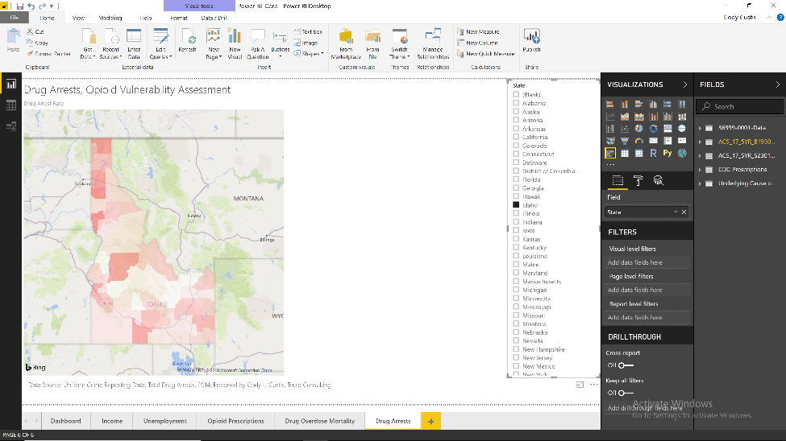

https://www.ncbi.nlm.nih.gov/pmc/articles/PMC6087962/

