TITLE PAGE

JVA TOOLKIT DRAFT (FULL DOCUMENT)

Table of Contents
TITLE PAGE 1
Executive Summary – for CDC website posting 2
1. Homepage 2
2. Introduction 2
3. Indicator Identification 2
4. Data collection and exploration 2
Assessment Approaches 2
5. Identifying prevention gaps 3
6. Using assessment findings to address prevention gaps 3
7. Intervention considerations 3
8. Collaboration examples 3
9. Communication resources/tools 3

Executive Summary – for CDC website posting

- Background including public health issue and grant program
- Core indicators used for the assessment
- Outline some of the data sources
- Overview of the four primary methods (descriptive geospatial analysis, SVI, statistical modeling, spatial epidemiology)
- Identifying gaps in services
- Developing plans to address gaps
- Collaboration, communication, and dissemination strategies
- Statement of what is in toolkit, its dissemination and use
- Citation for toolkit

Background
Due to the rise in opioid use, dependence, and overdoses in the United States, many state, local, and tribal public health agencies have expanded their prevention strategies to include more comprehensive data collection activities and implementation of local level intervention services.

In 2018, the Centers for Disease Control and Prevention (CDC) released emergency funding [REF 1] in response to the current opioid overdose crisis. The National Center for HIV/AIDS, Viral
Hepatitis, STD, and TB Prevention (NCHHSTP) launched activities within the Jurisdictional
Recovery domain, directly funding 40 states and the District of Columbia to support state and local health departments to develop and disseminate jurisdiction-level vulnerability assessments. These assessments identified sub-regional areas at high risk for opioid overdoses and bloodborne infections associated with injection drug use. To support public health jurisdictions in conducting their assessments, CDC also funded the Council for State and Territorial Epidemiologists (CSTE) to provide technical assistance including developing a toolkit of resources for jurisdictions planning to conduct or update their own assessments.

Below we present the 6 main steps for conducting a jurisdiction-level vulnerability assessment to identify sub-regional areas at high risk for opioid overdose or bloodborne infections from injection drug use in order to develop and initiate implementation of plans to address prevention and intervention needs.

Core Indicators
The first step was to identify and prioritize indicators associated with the outcomes of interest. Indicators should be available at the sub-regional level (e.g., county, ZIP code) and timely. Some core indicators used by states include: economic indicators; employment status, poverty status, income, and health insurance; mortality; drug overdose mortality per 100,000 population, underlying cause; opioid prescriptions; CDC IQVIA Xponent per capita prescriptions, buprenorphine prescribing potential by waiver per 10k persons; crime; Uniform Crime Reporting Program Data, total drug arrests.

Data sources
The second step was to compile data and calculate indicators, if needed. Data used in assessments varied from state to state, but a number of sources were fairly common and included: National – American Community Survey (ACS), Behavioral Risk Factor Survey (BRFSS), USDA Food Security Survey, the Prescription and Drug Monitoring Program (PDMP), National Electronic Disease Surveillance System (NEDSS) and census information; State/Local – vital records, hospital discharge data, and police crime laboratory data.

Overview of the Four Primary Analytic Methods
The third step was to develop the assessment. There were 4 primary analytic methods applied
Descriptive Geospatial Analysis. Data exploration examines software used to perform opioid related vulnerability, along with selected indicators (per capita drug arrests and per capita opioid prescriptions) as examples. It discusses the advantages and disadvantages of working with Microsoft Power BI and R, and has example maps.
Composite Index Score. The Composite Index Score (CIS) approach is based on the Social Vulnerability Index by the Geospatial Research, Analysis, and Services Program, (GRASP). However, for jurisdiction level opioid related vulnerability assessment, indictors appropriate to opioid related vulnerability are used. For the specific example, public data on socioeconomics, crime, prescriptions, and mortality is used to calculate the CIS for counties in Texas. This example serves as a template for counties to perform CIS analysis. An Excel spreadsheet is available elsewhere on the toolkit website.
Statistical Modeling. The statistical modeling section goes through appropriate types of models, predictor variable selection, transformations, correlation matrices, factor analysis and presentation of coefficients. It serves as a guideline for the methods and advantages of statistical modeling over CIS approaches.
Spatial epidemiology. [add from Tufts work]

Identifying Gaps in Services
After conducting assessments, states examined higher vulnerability areas further to identify what services and resources are available in those areas to mitigate these risks. These gap identification efforts typically involved reaching back to stakeholders, such as county programs and providers to analyze findings and provide feedback. Other approaches involved creating lists of community-based programs and providers of treatment services and comparing the locations of those to the identified highly vulnerable populations to see where pockets of need still exist.

Developing Plan to Address Gaps
Developing plans to address the identified gaps in services also centered around stakeholder engagement. Often, models of services that worked well in one area of the state were leveraged to help plan for an area experiencing a gap in service. For example, it was found that some counties were providing rapid testing services or syringe exchange programs outside of their catchment areas due to existing gaps in the other counties. New developments in treatment and harm reduction can also become the basis for plans being developed to address gaps. Increasing awareness and providing education around prescriptions for buspirone is an example of a plan to address a gap in harm reduction. Implementing medication treatment for addiction is another example of a relatively new approach that could be implemented to address gaps in services.

Collaboration, Communication and Dissemination Strategies
Throughout the process, public health jurisdictions used a variety of strategies to engage and communicate with stakeholders about the assessments and to disseminate the findings of the assessment. Frequently, existing stakeholder groups and public health partners were engaged early in the assessment process (see the process flowchart) to discuss the goals of the project, potential indicators, and data sources. Health departments found that leveraging existing relationships and coordinating with partners already implementing prevention strategies and disease control measures to address opioid use and the spread of bloodborne pathogens was most effective in securing buy-in and participation in the assessment. Results were communicated using the health department website, newsletters, community meetings, webinars, and legislative briefings. In the final stages of the assessments, stakeholders reviewed the draft plan to address intervention gaps and provided feedback prior to finalization and implementation.

What is contained in this Toolkit?
This toolkit provides standardized guidance, tools, and vignettes featuring real examples of state-based assessments to epidemiologists and other public health professionals seeking to assess their jurisdictions’ vulnerability for opioid overdoses and bloodborne infections associated with non-sterile drug injection. The guidance presented in this toolkit reflects the technical assistance delivered to grantees in response to challenges and questions that arose during the conduct of their projects.

Citation The toolkit can be found at: http:

- Homepage – list of sections/links and TBD graphic (CSTE, Thought Bridge, and Tsuro)
  - Background including public health issue and grant program
  - One sentence description
  - Goal of toolkit
  - Intended audience
  - Glossary?
  - Statement of what is in toolkit, and its dissemination and use
  - Citation for toolkit
  - Acknowledgement statement

- Introduction (Thought Bridge and Tsuro)
  - Description of paper and update, and general approaches taken by the states

Due to the rise in opioid use, dependence, and overdoses in the United States, many state, local, and tribal public health agencies have expanded their prevention strategies to include more comprehensive data collection activities and implementation of local level intervention services.

In 2018, the Centers for Disease Control and Prevention (CDC) released emergency funding [REF 1] in response to the current opioid overdose crisis. The National Center for HIV/AIDS, Viral
Hepatitis, STD, and TB Prevention (NCHHSTP) launched activities within the Jurisdictional
Recovery domain, funding 40 states and the District of Columbia to support state and local
health departments to develop and disseminate jurisdiction-level vulnerability assessments. These projects built on the methods established in the National Vulnerability Assessment conducted in 2016 by Van Handel et al. [REF 2] [hyperlink to paper]

These assessments identified sub-regional areas at high risk for opioid overdoses and areas at high risk for bloodborne infections associated with non-sterile drug injection. The assessment findings are being used to develop plans that strategically allocate prevention and intervention services to maximally reduce the life-threatening complications of the national opioid crisis. Key stakeholders and other health district officials are using the vulnerability assessments to address gaps in prevention, intervention, and distribution of resources including
HIV/HCV linkage to treatment, naloxone distribution, and substance use disorder treatment. To support public health jurisdictions in conducting their assessments, CDC also funded the Council for State and Territorial Epidemiologists (CSTE) to provide technical assistance including developing a toolkit of resources for jurisdictions planning to conduct or update their own assessments.

CSTE was well positioned to provide technical assistance for two reasons: 1) CSTE serves as the professional home for almost 2,000 epidemiologists representing all 50 states, many territories and many local and tribal jurisdictions; 2) CSTE routinely provides professional development to the epidemiologic workforce through communities of practice and workgroups, toolkits, webinars and an annual conference. This toolkit reflects the CSTE mission to:

- Promote effective use of epidemiologic data to guide public health practice and improve health,
- Support effective public health surveillance and epidemiologic practice through training, capacity development, and peer consultation, and
- Develop standards for practice.

The purpose of this specific toolkit is to provide standardized guidance, tools, and vignettes featuring real examples of state-based assessments to epidemiologists and other public health professionals seeking to assess their jurisdictions’ vulnerability for opioid overdoses and bloodborne infections associated with non-sterile drug injection. The guidance presented in this toolkit reflects the technical assistance delivered to grantees in response to challenges and questions that arose during the conduct of their projects.

Do we need a terminology or glossary section here?
Glossary:

American Community Survey (ACS): An annual survey performed by the US Census Bureau of the characteristics of American households. Available at the county and census tract levels.
Composite Index Score (CIS): Methods that assign ranks to jurisdictions based on vulnerability.
CDC WONDER: An online database with detailed mortality data at the county level.
Hepatitis C (HCV): An infectious disease associated with intravenous drug use, particularly acute cases in individuals under age forty.
Human Immunodeficiency Virus (HIV): An infectious disease often associated with intravenous drug use.
Poisson Regression: A statistical modeling technique for count data and rates.
Negative Binomial Regression: A statistical modeling technique for count data and rates, with an additional term to model large variance.

This toolkit provides guidance on:

- Indicator identification
- Data collection and exploration
- Assessment approaches including the descriptive geospatial analysis, social vulnerability index, statistical modeling, and spatial epidemiologic analyses
- Identifying prevention gaps
- Using assessment findings to address prevention gaps and intervention considerations
- Collaboration, Communication, and Dissemination examples
- Communication resources/tools

CSTE Jurisdictional Vulnerability Assessment Toolkit 03/xx/2020. Toolkit Background and Introduction. Retrieved from [web link].

Acknowledgement Statement: “This product was developed by CSTE, Thought Bridge, LLC and Tsuro Consulting with subject matter support and review from CDC/NCHHSTP. The vulnerability assessment project and the associated toolkit was funded through CDC’s National Center for Injury Prevention and Control, Cooperative Agreement Number 1NU1ROT000018-01-00. The findings are those of the consultants and do not necessarily represent the views of the Centers for Disease Control and Prevention.”

REFERENCES
- Cooperative Agreement for Emergency Response: Opioid Public Health Crisis Response National Call (June 18, 2018). https://www.cdc.gov/cpr/readiness/funding-opioid.htm

- Van Handel, M.M., Rose, C.E., Hallisey, E.J., Kolling, J.L., Zibbell, J.E.,...Brooks, J.T. (2016). County-Level Vulnerability Assessment for Rapid Dissemination of HIV or HCV Infections
Among Persons Who Inject Drugs, United States. J Acquir Immune Defic Syndr. 73(3), 323-331.

- Indicator Identification (Tsuro)
  - General description
  - Rhode Island vignette
Many jurisdictions used county level indictors from the Van Handel at al analysis (Cite: https://www.ncbi.nlm.nih.gov/pmc/articles/PMC5479631/.), particularly the smaller set of drug overdose deaths, prescription opioid sales, per capita income, unemployment, and buprenorphine prescribing potential by waiver. In many cases, states already had these indicators available, such as drug overdose deaths from state vital statistics programs.
Appendix X provides an example data dictionary for data sources usable for the opioid related vulnerability assessment. The goal is to offer jurisdictions information about general availability of data sources, indicators creatable from those data sources, strengths and weaknesses. Since many data sources are collected and maintained at the state and local level, specific availability may vary. Health departments are encouraged to weight the usefulness of indicators in predicting opioid related outbreak vulnerability, ease of collection, and the needs of program partners when choosing indicators to collect.
When selecting indicators, jurisdictions are reminded that one or two indicators should be selected per topic area, unless needs of program partners or specific areas suggest otherwise. For example, the ACS indicator of unemployment (age 16+) or per capita income is likely sufficient to address economics factors, unless one needs to examine unemployment among specific populations. Likewise, DEA Arcos data, IQVIA Xponent and prescription drug monitor programs all measure opioid prescriptions. If your department already has a standard variable to measure opioid prescriptions, use that variable. Include multiple variables on the same topic area with caution, or reweight by topic area rather than individual variable.
States that used vulnerability indices generally used indicators found in Table X, or similar indicators. States that used more complicated analysis methods found other indicators useful, such as measures of Years Potential Life Lost (YPLL), urban / rural classification, and access to vehicles.
Selected indicators are available as a comma separated value file on the toolkit website; more recent data may be available from the primary sources.

Table 1. Selected Indicators for Opioid Related Vulnerability
Topic | Source | Description
Demographics | American Community Survey | S2301 – Employment Status, detailed information on unemployment
Demographics | American Community Survey | S1901 – Income in the Past 12 Months, detailed information on per capita income
Demographics | American Community Survey | S2701 – Selected Characteristics of Health Insurance Coverage by Age, detailed information on health insurance coverage
Mortality | CDC Wonder | Drug Overdose Mortality – Per 100,000 Population, Underlying Cause
Prescriptions | IQVIA Xponent | Per capita prescriptions (per 100 residents) for opioids
Population | American Community Survey | ACS S0101 – Age and Sex
Buprenorphine Waivers | SAMHSA | Buprenorphine Prescribing Potential by Waiver per 10K Persons
Crime | Uniform Crime Reporting Data | County-Level Detailed Arrest and Offense Data

- Data collection and exploration (Tsuro)
  - General description
  - Rhode Island vignette

Data exploration was done in two main phases, initial mapping and exploration followed by final mapping. While there are many software options that can support this type of mapping and data exploration, we used Microsoft Power BI for phase 1 and R for phase 2. Power BI offers ease of use for data exploration and interactive dashboards; R is strong for complex programming tasks and publication graphics. Power BI Desktop is free for analysts to use; however, one needs a license to use Power BI Pro for collaboration. Dashboards and reports may be uploaded to the public web using the free version of Power BI, but sharing interactive dashboards privately requires licensing. R has the advantage of being open source, and free to use for any purpose. Due to R’s statistical underpinnings, it is capable of doing advanced analysis, such as Poisson and Negative Binomial regression or complex spatial correlation. This section goes through both the computing aspects of analysis, along with specific examples.
For data exploration, we used Power BI. We mapped drug overdose death rates in Figure X. Power BI is heavily reliant on slicers, which allow users to subset data. Similar exploration can be performed for any of the 50 states and District of Columbia, using the slicer on the right.
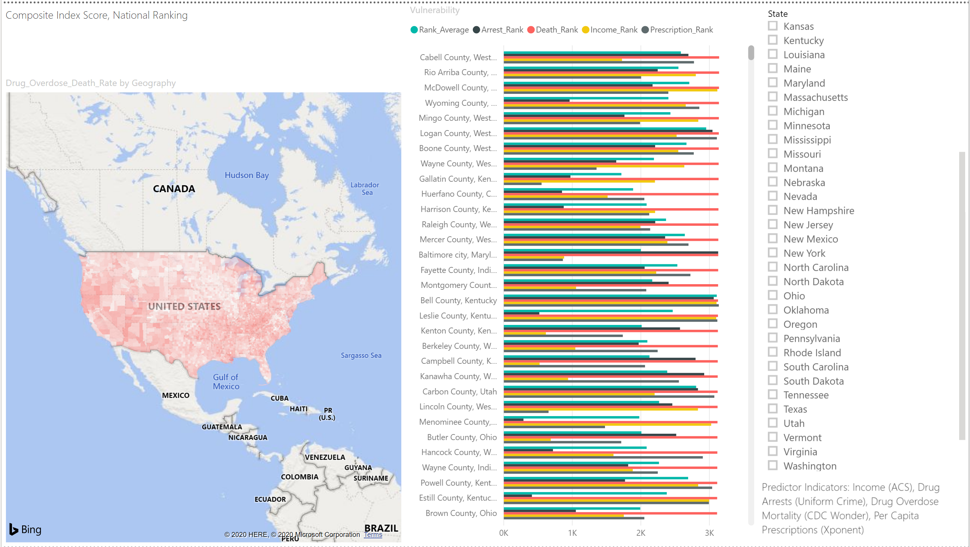
Figure 1. Drug Overdose Deaths

A county level dashboard can be created for any state. Here we created an illustrative dashboard to examine all 3412 counties and county equivalents in the United States, using indicators from the indicator identification section (Table X Previous Section). This enabled us to look at specific indicator values, and identify counties of interest. The county level dashboard has both values and ranks. In this case, counties are sorted by drug overdose death rates. Cabell County, West Virginia has the highest value of drug overdose death rate (89.8 per 100,000; Figure X). In addition to the high drug overdose rate, Cabell County has a high prescription drug rate (106.8 per 100 population; ranked 2775) and a high drug related arrest rate (68.87; ranked 2694). All indicators are ranked in a “higher is worse” manner, in order to simplify comparison.

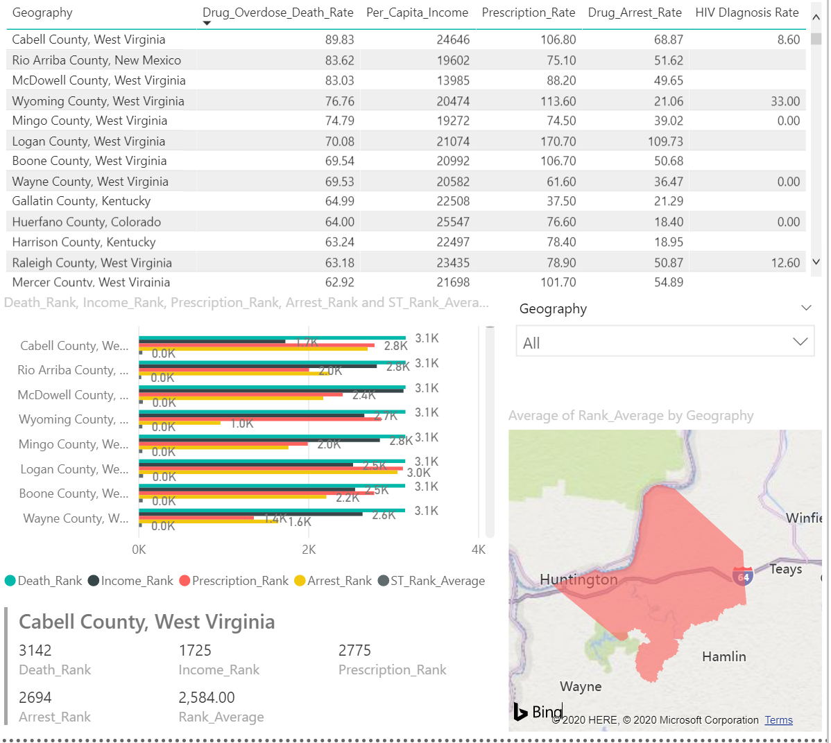
Figure 2. County Level Indicators

We used R for both data wrangling and for final maps of the following core indicators at the county level: drug arrests, per capita income, overdose deaths, opioid prescriptions, unemployment, and buprenorphine prescription capacity, (Figure X). These maps are available as high resolution PDF files from the CDC. When producing sharable maps, we recommend that each map include similar labels and data sources, an appropriate legend, and a north arrow. For some states, the legend may need to be manually placed due to layout requirements.
For example, in the map of opioid prescription rates produced with R (Figure 3), a descriptive title, clear data source and legend, and North arrow are included. From this map you can see a dark red cluster in southeast Indiana, showing high rates of prescriptions, and a yellow cluster in northeast Indiana, showing low rates of prescriptions. IQVIA Xponent data is defined as number of prescriptions per 100 population, counties with rates higher than 100 have more prescriptions than individuals.
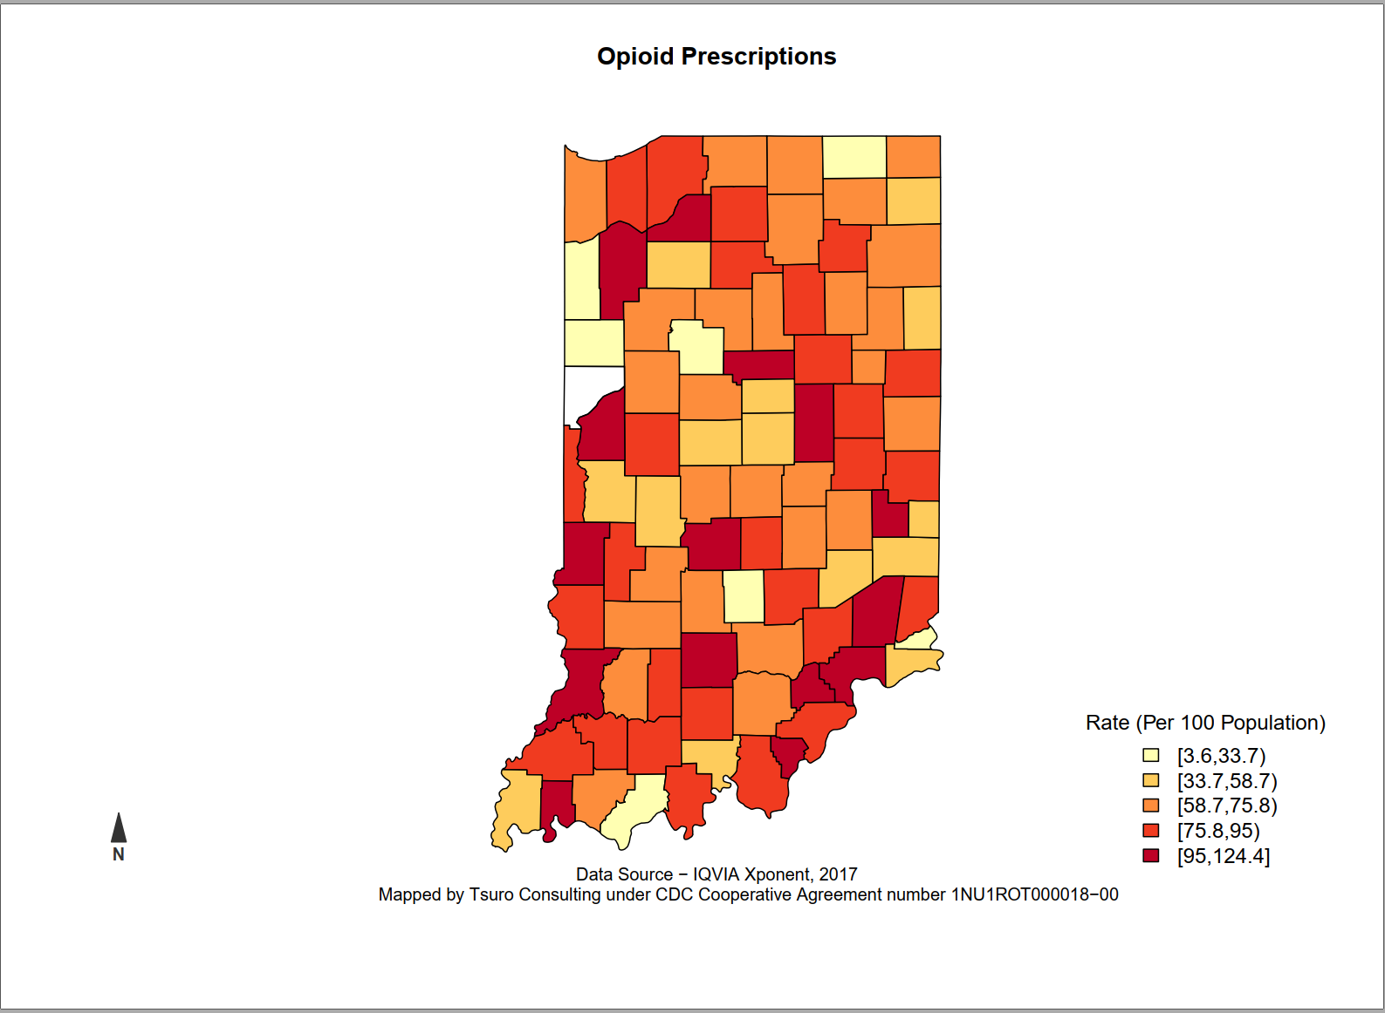
Figure 3. Example County Level Map
For most indicators, we used the Jenks natural breaks algorithm with five classes for mapping. Although quantile mapping may be more familiar to some audiences, quantile mapping assumes that the underlying distribution of the variable is symmetric. As such, Jenks was more appropriate for mapping all county equivalent.

Four programs in R Studio (cite: R Core Team (2019). R: A language and environment for statistical computing. R Foundation for Statistical Computing, Vienna, Austria. URL
https://www.R-project.org/.) are available as appendices. Both State_Heatmaps.R and National_Heatmaps.R have code to create a series of choropleth maps for the indicators in Table X. Users are encouraged to use these programs as a starting point for mapping and analyzing new indicators, with the advantage that R can do any necessary analysis. The Data Wrangling code is a sequence of read and merge routines that bring in many datasets and create a single file with the indicators from Table X. Buprenorphine is a program to read in, clean, and sum the provider level buprenorphine waivers from the SAMHSA website into a county level summary.

Rhode Island Vignette

Information provided by Katherine Howe and Thomas Bertrand of Rhode Island Department of Health (RIDOH)

Rhode Island 2019 Opioid JVA work employed a more sophisticated statistical model approach featuring computer learning techniques. The model was proposed by Brown University partners as the best approach and ultimately included over 300 variables which explored geographic units as far down as census tracts and zip codes. Rhode Island administrative geography is limited to 5 U.S. counties, so to look closer at population characteristics it was important and helpful to look at census tracts and even zip codes in some cases. The granularity of census tract data helped local health departments understand their community level approach with greater detail and accuracy.

Input and output data from the model aligned well with Hepatitis surveillance programs in the State which provided overdose deaths as a proxy for injection use, Hepatitis C, and HIV incidence rates. Other critical variables included single member households, complete kitchen in housing units, and census data including: divorce, housing unit type, race, under $10 thousand in annual income, and binary variables for non-employed households, and households with no vehicles.

High risk area maps were developed for and presented to community leaders in Providence and in more rural areas of the state. RFP announcement were also made seeking action-proposals for vulnerable areas (e.g. syringe services, naloxone). Additionally, Rhode Island’s team offered extended 3-hour trainings for technical support in developing planning efforts and investment scenarios, and collaboration building.

ESRI helped visualize geospatially the model results across census tracts. Tracts were ultimately ranked and assigned a score indicating level of risk, via outcomes from the machine learning model. Choropleth shades of blue and red spectrums were used and worked well with audiences. Some risk factor data provided high enough definition to identify individual neighborhoods with heightened risk. In addition to ESRI ArcGIS, Adobe Illustrator was used to inset the maps and publish content online as well as layer content onto google maps for street level review.

For Rhode Island the JVA work has been a turning point in terms of advancing the State’s HIV program, overdose preventions, Health and Human Services programs, and for the Governor’s Office task force. Overall, the work has generated much interest by other agencies and the general public. Tremendous stakeholder activity has come as a result. Needle exchanges have expanded, and more funds have come to the table aside of Federal funding sources.

At Stakeholder meetings fifty to seventy individuals or representatives would typically be in attendance, and the team would provide a 35-page report for general orientation to the method and results. A lot of time was spent working on language prepared in the map layout in this report. Findings will also eventually be shared at community meetings, and with the Governor’s office task force meeting March 20, 2020 with more than 100 people.

Rhode Island found that success has come through refinement of language. Language development has been key for the making the most of their opportunity. Another experience that has been unique to Rhode Island is the detail that has encouraged action at the neighborhood level. Partnering with Brown University and other subcontractors has helped Rhode Island make use of detailed variables and geography. And working closely with CDC has expanded their analytical capacity. RFP integration for syringe service, internal OD health department, city of Providence, has boosted budget levels and action-oriented success.

Rhode Island would like to share their village project prevention plan and a 1-page summary with interested States and Jurisdictions.

Assessment Approaches
  - CIS (Tsuro)
    - General description
    - Missouri vignette
    - Code
Jurisdiction Vulnerability Assessment: Composite Index Score Approach:
The Composite Index Score (CIS) approach for the Jurisdiction Vulnerability Assessment (JVA) uses methods similar to those developed for the Social Vulnerability Index (SVI) by the Geospatial Research, Analysis, and Services Program, (GRASP), which looks at the vulnerability of communities to disasters, such as earthquakes, hurricanes, and floods. The mechanics behind jurisdiction vulnerability are similar, however, CIS uses indicators selected by subject matters experts, in this case, indicators relating to intravenous drug use (IDU), which makes communities vulnerable for outbreaks of both Hepatitis C (Hep C), HIV infection and opioid overdose. CIS offers an indirect method of assessing risk for counties. Van Handel et al. (2016) found the following indicators for IDU vulnerability: drug overdose deaths, prescription opioid sales, per capita income, percent population white, unemployment and buprenorphine prescription capacity. Below we describe an example for one state using data for opioid prescriptions, drug arrests, and drug overdose deaths, along with the ACS per capita income variable to calculate the CIS.
CIS uses the rankings of indicators within each jurisdiction to assess which counties (or other subdivisions) are most vulnerable to outbreaks associated with IDU. The ranking method is less statistical but very adaptable and works well in applied situations. In contrast, regression approaches (both Poisson and Negative Binomial) have more robust modeling and predictive power, at the cost of complexity, both for the modeler and for users of the model, such as local health departments and constituents at town hall meetings.

CIS Example:
For this example, we used the following category / indicator pairs, based on publicly available data:
  - Socioeconomics: Per Capita Income (2013-2017 American Community Survey)
  - Crime: Drug Arrest Rate (Uniform Crime Reporting Program Data, 2016)
  - Prescriptions: IQVIA Xponent (Per 100 Capita Prescriptions, 2017)
  - Mortality: Drug Overdose Rate (CDC Wonder, 2013-2017)
To handle missing data and zeros, we made the following assumptions. We assumed that zero values were a legitimate reflection of zero events and assigned the nationwide median for missing (N/A) values, as a simple form of imputation. We ranked each indicator among the 3412 counties and county equivalents, with a “higher is worse” categorization (see Table X). We then took the average of the four ranks to calculate the CIS for each county. Analysis was performed using widely available spreadsheet software (Microsoft Excel).
Table 1. Select Indicators
Geography | Drug Arrests (Rate, Rank) | Opioid Prescriptions (Rate, Rank) | Drug Overdose Deaths (Rate, Rank) | Per Capita Income (Value, Rank) | Average Rank
Bell County, Kentucky | 113 (3063) | 228 (3137) | 60 (3126) | 14754 (3104) | 3107.5
Clay County, Tennessee | 87 (2920) | 191 (3125) | 49 (3108) | 17667 (3002) | 3038.75
Grundy County, Tennessee | 83 (2891) | 141 (3046) | 35 (3009) | 15824 (3080) | 3006.5
Scott County, Tennessee | 100 (3006) | 154 (3075) | 29 (2841) | 18748 (2902) | 2956
Logan County, West Virginia | 109 (3045) | 170 (3109) | 70 (3137) | 21074 (2522) | 2953.25

Mapping the CIS for each county using Microsoft Power BI, we observed higher vulnerability in the South and Mountain West, although high vulnerability counties were found throughout the United States (Figure X). Specific counties can then be further explored to understand the underlying factors contributing to their CIS; see Cabell County, West Virginia in the previous section.

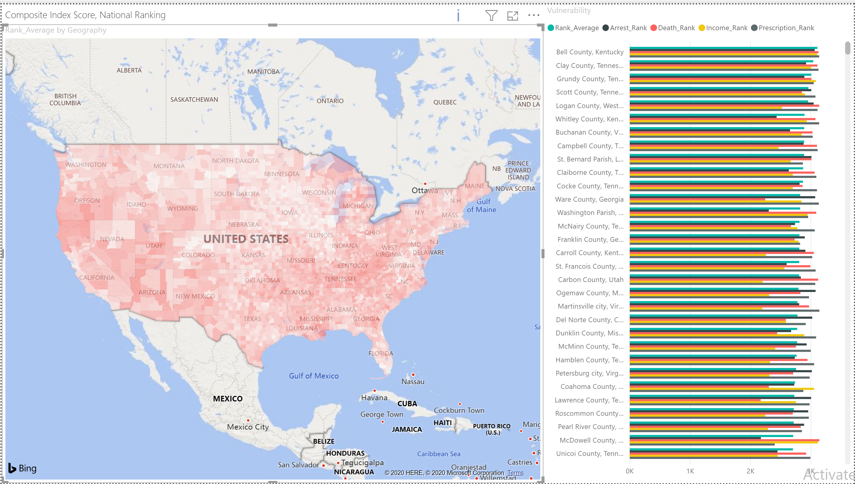
Figure 4. CIS Vulnerability

When interpreting the CIS, an appropriate outcome metric for context should be used. For this CIS example, jurisdictions used metrics such as diagnoses of Hepatitis C or HIV from state registries, in some cases combining the two. Other jurisdictions used hospitalization data for Hepatitis C or HIV, also, in some cases combining the two.
When presenting the CIS to stakeholders, we offer the following recommendations:
- Focus on areas with high outcome metric / high CIS: Areas with high outcome metrics and high vulnerability represent areas where resources should be dedicated. Health departments should look at available resources within these areas and see what steps are being taken, and could be taken, to address IDU in those communities.
- Focus on areas with low outcome metric / high vulnerability: Areas with a low outcome metric but high vulnerability may be due to protective factors such as needle exchange programs, Naloxone availability, or programs by local public health officials. Conversely, such areas may reflect a lack of testing for the outcome metric, such as lack of capacity to test for HIV / HCV.
- Focus on areas with high outcome metric / low vulnerability: Areas with a high outcome metric and low vulnerability may reflect exogenous factors, such as changes in drug traffic patterns. When working with one state, a county with high HCV incidence was a county that contained a major Interstate highway and located near a large urban area in a neighboring state.
We created a county focus template using Bexar County, Texas (Appendix X) as an example. This template is a generic example of how states can focus on specific regions. Because of the large numbers of missing values in the selected outcome variable (HIV diagnoses, CDC/NCHHSTP AtlasPlus Public Data), outcome ranking for Bexar is currently blank. Indicators are ranked in a “higher is worse” format where higher values represent more vulnerability or negative outcome. Jurisdictions may modify this template as needed when working with local health partners.

Missouri Vignette
Information provided by Becca Mickels, Chief, Bureau of Reportable Disease Informatics
Missouri Department of Health and Senior Services

Missouri’s Opioid 2019 JVA work focused on the development and communication of a social vulnerability index (SVI), an approach that aggregates multiple factors related to opioid related disease risk, and relates this risk across a geography including 114 counties (115 when including St. Louis). The primary intent of Missouri’s selected approach was to manage time and to offer simplicity in communication with the public. Overall, the results were a success and the methodology they employed seemed to be more transparent and easier to share.

Their rank sum methodology ranked counties between 1st and 115th position. Stakeholders involved in the process were helpful in suggesting that some of the social and economic variables were possibly influencing the model with greater weight than needed. These suggestions moved the JVA team to experiment with adjustments to increase the profile of individual outcomes as compared to the more general social and economic factors. Ten variables were ultimately included in the JVA model, five of these variables captured outcomes such as hepatitis C infection, overdose, blood born infections; and five were community factors. Concerns with community factors like poverty rate, uninsured, arose from the appearance of correlation and common rank results.

Data for their SVI approach were sourced from several different agencies. Overdose data came from the Bureau of Vital Stats, ER data came from the Bureau of Health, mental health departments shared drug related arrests, and the American Community Survey (ACS) was sourced for community factors.

The method and results were eventually discussed and shared across six stakeholder meetings. In these meetings variable weighting and variable changes were discussed and determined. These meetings corresponding with HIV care regions, where approximately 50 invitations were sent out, per meeting. A wide variety of attendees contributed to the process including mental health staff, police, coroners, non-profit staff, and even school representatives.

Visually speaking, maps were developed and shared at stakeholder meetings to help communicate the draft results of the method and ranking outcomes. Maps were provided with final outcomes as well as individual variables such as some of the community factors. ESRI software including ArcGIS published maps for key variables. Certain variables were chosen over others to address and avoid small number issues in presenting data.

For outreach, Missouri’s team placed community-level calls with vulnerable counties and used data to apply for action grants for HIV blood born work. Five local agencies were reviewed and selected for funding. The jurisdictional vulnerability assessment (JVA) work was also used for individual project evaluation in the state, and if appropriate staffing is made, available results will be used again next year for evaluation of certain project success.
Missouri finished with limited time for dissemination given the lengthy approval process at the State-level. The full report will eventually post on a website with related resources. This website will be made available ahead of a presentation to the public health department. The presentation will cover the important subjects over a 90-minute period. Additionally, presentations will be made on live webinars, posters will be made, and outreach calls placed. Some additional focus will be provided to rural counties which often fail to get as much attention, but where health outcomes can be critical. For example, Missouri had a significant Hepatitis A outbreak in a rural county area.

Missouri’s team found that overall, the work has taken longer to get done than originally anticipated, and the team had to set limits to the project scope with only one year of funding available. It was also challenging for their team not to have the funding available to hire more staff. On a more positive note, stakeholder meetings in the middle of the process timeline turned out to be very affective and useful for drafting content for the final report. For these meetings, facilitators were hired to collect written content and to capture stakeholder ideas from parties less willing to speak publicly. Missouri gathered written comments and obtained helpful input from stakeholders in this way.

Overall, success for Missouri included working closely with stakeholders, and ultimately having work that was well received and appreciated by other agencies and the public. The work increased team credibility, with both internal agency groups and multiple work groups outside the agency. It was also a success for Missouri’s team to get final draft approval, and additional funding for the model.

Missouri would like to share with other States and Jurisdictions the published final report, county-level profiles, the plan, and the website when it is up and running, including data tables formatted and available in Microsoft Excel.

  - Statistical modeling (Thought Bridge & Tsuro)
    - General description
    - Illinois Vignette
    - Regression models for count data tool
    - Model convergence tips tool
    - Frequently Asked Questions (FAQ) tool
    - Code

Overview of the three main methods – Modeling
Count (or rate) outcome data were principally modeled using Poisson or Negative Binomial regression. The decision between the regression methods was based on if overdispersion was present in the outcome, as indicated by a Chi-square goodness of fit (GOF) test. Negative Binomial regression was utilized when overdispersion was present; Poisson regression was employed otherwise. To determine which candidate predictors to include in a multivariable model, two steps were generally taken. First, each predictor variable was bivariably fit, and outcome associations with p-values less than 0.1 (i.e., marginal significance) were retained for multivariable model consideration. Second, the remaining predictor variables were correlated together, as a check for multicollinearity. Predictor variable pairs that strongly correlated together were flagged (generally >0.7), and the predictor from the pair with the stronger outcome association was retained, with the other being dropped. Thus, predictors that had at least a marginal bivariable association with the outcome and low collinearity with other characteristics were considered for multivariable modeling. Additional characteristics that may epidemiologically confound or bias outcome associations were further included, when appropriate. Multivariable regression modeling used either forward, backward, or stepwise selection, and the final models were selected after evaluation of fit statistics, adjustment for confounding, and error residuals. Predicted outcome rates were generated at the unit of analysis level (e.g., county/zip code) and ranked from highest rates to lowest rates for reporting A task flow diagram for best regression modeling practices can be found here. [Link: JVA Regression Model Task flow Tool].

Statistical Modeling for Count Data
Regression Modeling versus CIS
An alternative to the Composite Index Score (CIS) is statistical regression modeling. Regression modeling utilizes outcomes (dependent variables) and predictors (independent variables), similar to those in the CIS; however, regression has the advantage of employing quantitative methods, such as maximum likelihood, to determine the strengths and directions of associations between predictor variables and outcomes. Moreover, validated statistical models can predict outcomes, whereas, CIS is limited to county rankings, based on vulnerability inputs. The choice of technique ultimately depends on both the familiarity of the analyst with the methods and the statistical literacy of the audience; an analyst must not only be familiar with the technique used, but also be able to explain the technique and results to others.
Regression Model Options for Count Data
When assessing count or rate data as an outcome, Poisson or Negative Binomial are preferred regression methods. Both Poisson and Negative Binomial regression methods appropriately weigh both the count of events and exposure, either in time or population. For example, in 2017, the crude death rates in Ada County and Clark County, Idaho were 7.1 and 8.0 per 1,000 population, respectively. Ada County had 3,229 deaths with a population of 456,849; Clark County had 7 deaths with a population of 873. Poisson and Negative Binomial regression both assign a weight to Ada County hundreds of times larger than that of Clark County (proportional to the population size difference); whereas an ordinary least squares regression would inappropriately weigh the counties equally, despite the massive population difference.
In a Poisson model, the analyst assumes the outcome variable to follow a Poisson distribution, and that the natural-log of the expected value (i.e., the mean) of the outcome can be estimated by a linear combination of the predictor variables. A critical assumption of the Poisson distribution, however, is the raw mean and variance of the outcome are approximately equal. In practice, this is rarely true, with variances either far exceeding the mean (overdispersion, most common) or being below the mean (underdisperson, less common). Use of Poisson regression in the presence of overdispersion (or underdisperson) can lead to biased standard errors and incorrect conclusions regarding statistical significance.
Negative Binomial regression is a generalization of Poisson regression that uses a mixture of Poisson and Gamma distributions to model the outcome, loosening the assumption of an equal raw mean and variance. In practice, Negative Binomial regression is often appropriate over Poisson regression, but the analyst should not simply default to Negative Binomial regression for all analysis cases. When the outcome data truly follow a Poisson distribution, Poisson regression will provide the least biased standard errors and p-values, over Negative Binomial regression. A chi-square goodness of fit (GOF) test for overdispersion exists and should be considered when equality of mean and variance is in question. Both this question and others regarding statistical modeling are addressed in the FAQ document [Link: Frequently Asked Questions Document]. For SAS users, code and a discussion on GOF testing and regression modeling are shown in the following webinar presentation. [Link: JVA Tech Assistance Webinar_Thought Bridge 20190911_v2]
Outcome
The outcome variable for count-based regression models should always be a raw count, with population included as an offset characteristic. It is not advised to transform the count outcome or to include the population as a numeric predictor variable. Likewise, as seen in the Idaho example, using rates as outcomes gives improper weight. In count-based regression, offset variables determine exposure, and are modeled with the outcome variable, not the predictor variables.
Predictor Variables
When determining independent variables for a study, states should consider a variety of data sources a priori. See the Data Collection and Exploration sections for common sources. Common predictor variables used in the JVA assessments were: drug overdose deaths, prescription opioid sales, mental health services, insurance coverage, urgent care access, vehicle access, access to interstate, buprenorphine prescribing potential, education, income, poverty, race / ethnicity, unemployment, population density, urban / rural status, and drug arrest data. Additional characteristics germane to specific states and/or geographic regions should be further considered and included.
Transformations
For count-based regression analysis, it is not recommended to transform the outcome data. The continuous predictor data, however, can be transformed to meet model assumptions and assist with interpretability. Log₁₀ and natural-log transformation were most prominently used in the JVA assessments. Log₁₀ transformations are useful if an independent variable is on a scale where order of magnitude differences are important, for example, per capita income. Natural-log transformation are useful for data that are right-skewed, for example, miles to nearest healthcare facility. Other common transformations include: arcsine (for values between 0 and 1), square root (for count data), and inverse hyperbolic sine (for right skewed data that include 0 and/or negative values).
Variable Selection
Given a moderate to large set of potential predictor variables, an analyst must choose a limited number for regression modeling, contingent on sample size and multicollinearity (i.e., high correlation among 2+ predictor variables). The process most frequently used for JVA assessments involved Steps: (1) bivariable regression modeling, (2) correlation of predictor variables, and (3) selection procedures for the final multivariable model. For Step 1, each predictor variable is independently associated with the count outcome using either Poisson or Negative Binomial regression, as appropriate. Variables that are statistically significant at p<0.1 and/or have epidemiological significance are retained. Remaining predictor variables are then correlated with each other using Pearson or Spearman correlations (Step 2). Predictor pairs that correlate >0.7 are flagged for multicollinearity, and the predictor from the pair with stronger outcome association is maintained. Finally, for Step 3, the remaining predictor variables are considered for multivariable inclusion and modeled using either stepwise, forward, or backward selection. For advanced models (e.g., those modeling longitudinal data), stepwise procedures are often not available, and the analyst must choose between either forward or backward selection. As previously inferred, the analysis should not be guided by statistical significance alone, but also informed by industry standards and subject matter expertise, while building the final multivariable models. For an analysts modeling correlated (or longitudinal) data, issues with model convergence sometimes arise. In these circumstances, please see the referenced file that provides tips for such situations. [Link: JVA Convergence Questions]
In addition to correlating predictors for checks on multicollinearity, a more sophisticated approach employs methods from principal components and factor analysis. Principal components are a type of dimension (data) reduction that clusters correlated predictors into groups (i.e., components). The first step is generating a covariance matrix between predictors, then calculating the components and eigenvalues (entities that represent the variance explained by each component). Sums of these eigenvalues are visualized using a Scree plot. The user is tasked with picking the number of components that explain the most variance, without overfitting, a technique called the “Elbow Method”. In the example below, a 24-item (variable) psychological measure has most of the variance explained by the first three or four components (at the “elbow” of the curve). As such, a researcher would consider three or four principal components as candidates to include in a follow-up factor analysis.
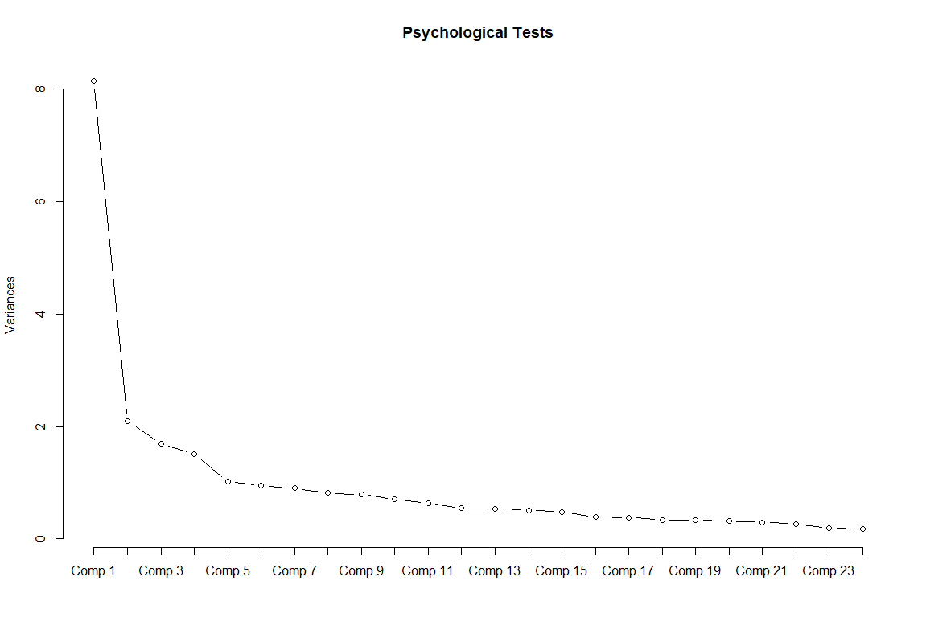
Figure 1. Example Scree Plot
A factor analysis rotates principal components in geometric space to create orthogonal (i.e., uncorrelated) constructs on which predictor variables load. The advantage of factor analysis is that it separates variables into independent groupings, with higher absolute loadings representing greater associations with the factor constructs. Consider the results below from a state involved in the JVA (Table X). Based on this Table, one of YPLL (Years Potential Life Lost), MME90 (90 Milligrams Morphine Equivalent per day), or opioid prescribing could be selected to represent Factor 1 (top three absolute loadings); one of rural, poor health, or HIV could be selected to represent Factor 2; and one of percent without high school diploma, percent unemployed, or percent vacant housing could be selected to represent Factor 3. A user may choose more than one variable to represent each Factor (e.g., both YPPL and MME90 for Factor 1), but would need to again check for correlation between these characteristics.
Table X. Rotated Factor Pattern Results, Selected State
 | Factor 1 | Factor 2 | Factor 3
Teen Birth Rate | 2 | 1 | 57
Rural | 25 | -67 | 6
Percent Unemployed | 4 | 53 | 56
Gini Index | 12 | 53 | 8
Percent Without High School Diploma | 11 | 38 | 60
Percent Vacant Housing | 40 | -4 | 57
YPLL | 85 | 35 | 2
HIV Rate | 2 | 57 | 14
Syphilis Rate | -26 | 4 | 48
MME90 | 79 | 9 | 0
Opioid Prescribing | 82 | -23 | 4
Poor Health | 48 | 66 | 5

Once candidate variables have been identified, appropriate statistical software (e.g., SAS, R, STATA) can be used to create the final multivariable model using previously described procedures. Coefficients for Poisson and Negative Binomial regression are measured on a logarithmic odds scale, and as such, are interpreted as the difference in logs of expected counts per unit change in the predictor variable, given the other predictor variables in the model are held constant.
Table X is an example of how to present results from a regression analysis. In addition to regression coefficients, standard errors, and p-values, it has median and mean (i.e., summary) values of the predictor variables.
Table X. Measures of central tendency, regression coefficients, standard error, and significance level for variables used in vulnerability assessment
Variable | Median | Mean | Regression Coefficient | Standard  Error | P- value
Log of MME for all prescribed drugs | 17.81 | 17.66 | 0.54 | 0.06 | <0.001
Drug overdoses for all drugs, 2017 to 2018, per 100,000 population | 414.13 | 414.61 | 0.0015 | 0.0005 | 0.004
Rate of sexually transmitted infections, per 100,000 population | 555.07 | 717.23 | 0.0006 | 0.0002 | <0.001
Percent of population that is non-Hispanic white | 70.19 | 65.40 | 0.017 | 0.005 | 0.001

For ease of interpretation, and in addition to the multivariable regression coefficients, many states chose to display ranked vulnerability scores. Vulnerability scores are simply the predicted rates for study outcomes, calculated from multivariable Poisson / Negative Binomial regression models. To get these rates, a user calculates predicted values directly from their multivariable regression equation. These raw, predicted values are in the form of log-counts per person. These values can be exponentiated to get predicted counts per person (i.e., person-rates). This rate is not population-specific, and can be comparable across other sampling units (e.g., counties). Many times, it was reasonable to multiply this person-rate by a constant to get an epidemiological rate (e.g., rate per 100,000). These epidemiological rates were used as the final vulnerability scores and ranked for reporting.

  - Spatial epidemiology and example (Tsuro)
    - General description
    - Oregon vignette
    - Illinois vignette
    - Code

The most common form of spatial epidemiology used as part of opioid related vulnerability was the choropleth map, which maps a variable using color intensity. We recommend using color schemes from Colorbrewer (Cite: http://colorbrewer2.org/# Cynthia A. Brewer, Geography, Pennsylvania State University), which has a number of schemes, including sequential (for increasing rates), diverging (for comparing above and below a baseline), and qualitative (no meaningful sort order for outcomes). The figure below is per capita income from the American Community Survey and uses a sequential yellow-orange-red color scheme, mapped using R and Leaflet and uploaded to RPubs, a public website for visualizations created in R.
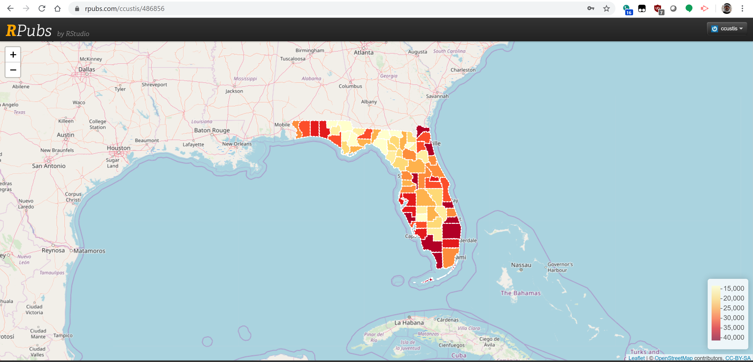
Figure 1. Per Capita Income, 2013-2017 American Community Survey
Rather than use formal statistical modeling, most states referred to preexisting knowledge about their states. These include such things as local health districts composed of a number of counties, or regions based on geography such as mountains or rivers. Cross border effects were also important, especially for states with large metropolitan areas located in neighboring states.

Oregon’s County-Level Vulnarability Assessment (Pickle, 2019. Viral Hepatitis Program Acute and Communicable Diseases) provided a thorough example of spatial epidemiology using a variety of choropleth map approaches, as introduced above. Oregon methodological approaches were mixed and involved a high number of key indicator variables that were eventually reduced in a backwards stepwise fashion until high, independent correlation with their independent variable was found. Their final model included top four variables there were used to generate a vulnerability score for each County. Those variables included: high intensity drug trafficking area, premature deaths, risky opioid prescribing, and lack of transportation or vehicle availability. For these surveillance data, a vulnerability score was generated using a linear prediction statement.
On the spatial side, using ESRI software, Oregon proceeded to generate an overall vulnerability score map using natural breaks in the vulnerability score, and assigning labels ranging from: lowest, low, mid-range, high, up to highest; as shown in Figure 2.

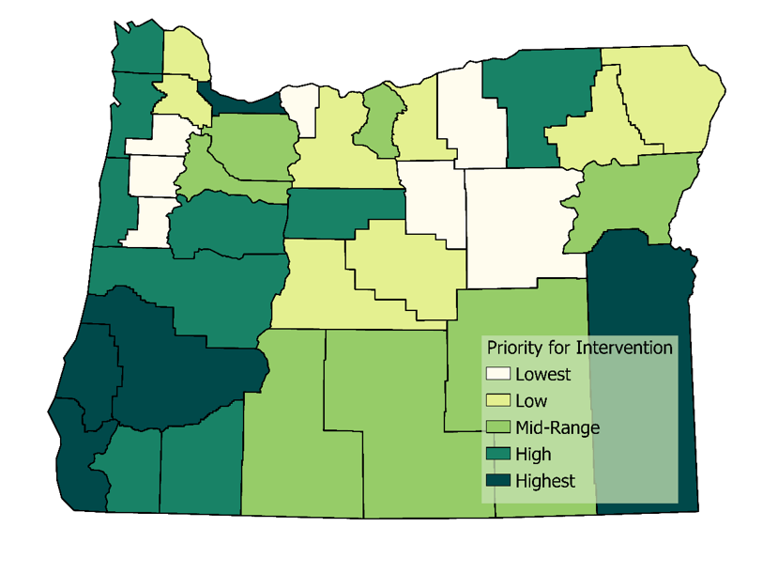
Figure 2. Vulnerability Assessment Groups by Oregon County

Oregon, sequentially produced a similar stylized County-level map for each sub-variable in the model. Breaks in additional maps were chosen based on the statistical properties of each variable mapped, and additional geospatial layers were added for relevance. For example, Oregon layered interstate and highway data on top of the county map showcasing high intensity drug trafficking areas. Layering here helped demonstrate the reliance on interstate travel for drug movement.
Oregon faced limitations with respect to choropleth mapping including a limited number of counties and the geographically large size of their rural counties compared to urban. Especially in southern parts of the state, large county size made it difficult to discern risk arising in specific communities. Cara Bergo and Mai Pho, Illinois Department of Public Health

Illinois leveraged national (e.g., US census; NEDSS) and local data sources (e.g., vital records) to derive 30 predictor variables to associate with the study outcome, counts of Hepatitis C infections in individuals under age 40. Sampling units were at the zip code level, and Illinois employed Negative Binomial regression methods after observing overdispersion in the outcome. Specifically, analysts ran bivariable regression models for each predictor (i.e., 30 models) to inform a multivariable analysis; counts of Hepatitis C was the outcome, and a population offset by zip code was included. These bivariable regression models eliminated 9 predictors due to statistically insignificant associations with the outcome at the 0.05 level. The remaining 21 predictors were placed into a multivariable model and backward selection was used to derive the final model containing 11 significant predictors. Model assumptions and fits were checked and predicted person-rates were calculated for each zip code. These person-rates were used as the final vulnerability scores and ranked for reporting and mapping. For this analysis, Illinois used PROC GENMOD in SAS v.9.4 (Cary, NC) for regression modeling. Prior to regression modeling, Illinois combined data over two years (2017-2018), and all sampling units were treated as independent.
Illinois mapped by zip code. When working with local partners, Illinois found that zip code level data gave far more detail than county level maps, allowing local officials to focus on specific neighborhoods of high risk and high outcome. Illinois mapped both rates and counts of combined HCV incidence and drug overdose (2017-2018) and a vulnerability model. Partners found both outcome rates (for relative standing) and raw counts (for prioritizing resources) useful, along with high risk in a separate map.
Illinois used a number of software packages for mapping. Initial mapping was done in both R and GeoDa. Illinois had an academic contact who was able to map using Carto, an online package that produces interactive maps.
Despite the large number of zip codes in Cook County (2019 population of over five million people), there was only a single zip code that was in the top 10%. Therefore, Illinois did not highlight Cook County in the statewide maps; it plans to produce zip code level maps specifically for Cook County and Chicago partners during regional meetings.
- Identifying prevention gaps (Thought Bridge)
  - General description
  - New York vignette

- Using assessment findings to address prevention gaps and intervention considerations (Thought Bridge)
  - General description
  - Nebraska vignette

Information provided by Felicia Quintana-Zinn

Nebraska’s Department of Health and Human Services (DHHS) sought to conduct a vulnerability assessment to both identify the high burden jurisdictions in the state, and to take a wholistic approach to the entire state population. Nebraska has both rural and frontier areas, which despite having higher burdens of risk for opioid overdose and bloodborne disease transmission, lack the resources to address these risks. Public health jurisdictions had been expressing interest and need for an assessment for several years, and collaborations and conversations that laid the groundwork for the assessment had begun two years ago.

Initial efforts looked at resources and gaps, especially for the five high burden jurisdictions. One striking gap noted was the correlation between drug overdoses and income levels. Another was the lack of treatment providers in less populated areas, with certain areas having only one provider that would require a 2 to 3-hour drive for those seeking treatment. A third gap noted was that while individuals who overdose might get emergency treatment, many do not go on to treat the underlying addiction that led to the overdose. The grant funding allowed the state to continue and expand upon what they were already doing to address the public health risks.

Nebraska leveraged existing stakeholder coalitions to determine how to best use the assessment findings to address the identified prevention gaps for the state. To address the service provider gap, the locations of testing sites for hepatitis C and HIV along with treatment providers and recovery resources will be listed by county and local health department locations on the DHHS website, as well as the website for the local health department association. To address the income and risk gap, existing resources such as behavioral health programs were identified to assist with payment for treatment for very low-income populations. And by working closely with law enforcement, emergency medical services, the state patrol, and other public safety organizations, treatment information and resources can better reach the populations experiencing overdoses.

While Nebraska is still working through the best ways to address newly identified populations at risk for opioid overdose and bloodborne disease transmission, they are continuing their ongoing interventions to match existing resources with identified gaps.

- Collaboration, Communication, and Dissemination (Thought Bridge)
  - General description
  - Michigan or South Dakota vignette
  - Communication and dissemination process model

- List of additional project resources
  - Data Dictionary – Data dictionary for selected indicators with comments about state level data
  - Focus Template: Bexar County – Example template to display county level data using Composite Index Score (CIS) methods.
  - Composite Index Score – National.xlsx – Excel file to compute CIS using four indicators (drug arrests, prescriptions, overdose mortality, income) as described in data dictionary
  - Buphrenorphine.R, State_Heatmaps.R, R_Data_Wrangling.R, National_Heatmaps.R – Selected R code to wrangle Buphenorphine data, create state level heatmaps, do additional data wrangling, and create national heatmaps.
  - National Indicators.csv – County level data for selected indicators, as described in the data dictionary. Note that the data was current at the time of project, however, many datasets are updated on an annual basis and users should strive for the most up to date data.
  - County_Level_Maps.zip – County Level maps for selected indicators (as described in the data dictionary) for 50 states and the District of Columbia.

