Diagnosis and Inspection of Head Lice
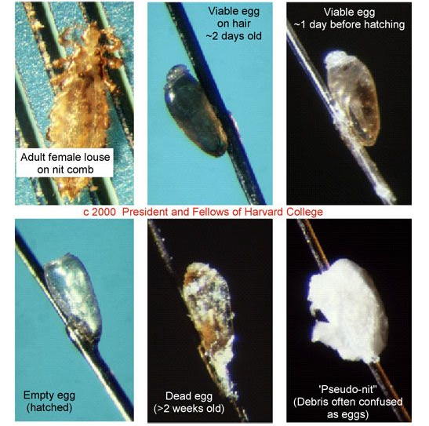
Eggs are often mistaken for dandruff, eczema, other scalp conditions, or hair product buildup. The easiest way to differentiate between the aforementioned and a head louse egg is to use a fine-tooth comb to attempt to gently dislodge the target area. A louse egg is held to an individual hair with a cement-like glue, so if it would take a lot more effort to remove than dandruff or hair product buildup. Viable head lice eggs are often found on the base of the hair shaft within a ¼ inch of the scalp and are especially common behind and above the ears and at the back of the neck.2

Figure F: Lice eggs (nits) in comparison to dandruff and other skin conditions.
Head lice are spread in two ways: direct contact and indirect contact. The most common method of spread for head lice is through prolonged, direct contact between one individual’s head with a lice infection and another individual without a head lice infestation. Prolonged direct head contact is often unintentional, often occurring at sleepovers between children, wrestling between children, standing concerts between adults, crowded sports events/arenas between adults, and more. There is a small chance that head lice can be also indirectly shared through hats, scarves, coats, coat racks, lockers, hairbrushes, headphones, pillows, towels, upholstered furniture and stuffed toy animals.
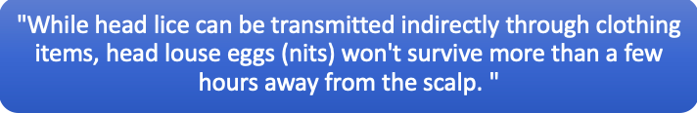
The best way to inspect a possible lice infestation is to manually detect any living lice by using a strong light source, disposable gloves, and a disposable hair parting tool (such as a lice comb or fine-toothed comb). Mass screenings are no longer recommended because they lead to social stigma and decrease accuracy of diagnosis. In group settings, such as schools and other childcare facilities, individuals that are suspected of having head lice should be examined by a trained professional in a private area. However, if more than one individual is being inspected for a head lice infestation, then a new disposable hair parting tool and new disposable gloves are needed.
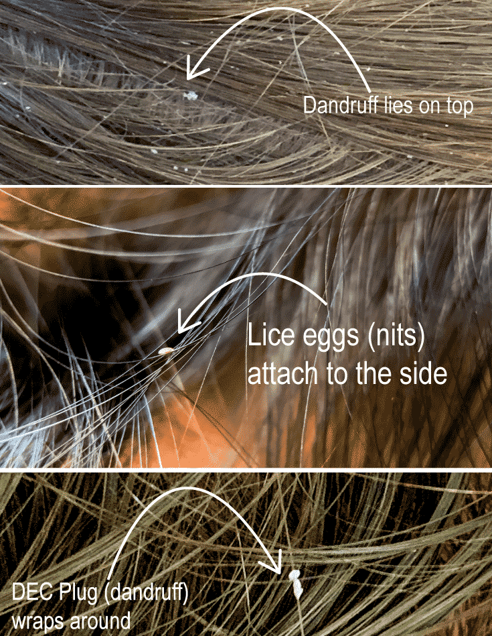
Using the strong light source, it is best to part the hair with the disposable hair parting tool and closely examine the scalp for any possible living lice or nymphs. Start at the nape of the neck and behind the ears, the most common places to find head lice. Continue the inspection throughout the head. The standard to be diagnosed with a head lice infestation is to find a living head louse on the head, as the casing on nits (head lice eggs) can last for several weeks after the end of the infestation.

Figure G: Above is a diagram of the visual differences between head lice and dandruff.

Common Symptoms/Signs and Risk Factors (Exposure)
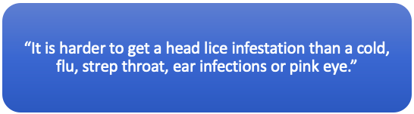

Common Signs/Symptoms of a Head Lice Infestation and Reasons
Scalp Itchiness/Sores on the scalp | Allergic reaction to lice bites
Drowsiness and/or irritability | High activity of the lice disrupts sleep
Tickling sensation on the scalp | Movement of the lice
Many individuals with a head lice infestation show no symptoms or signs, making a diagnosis of head lice necessary.
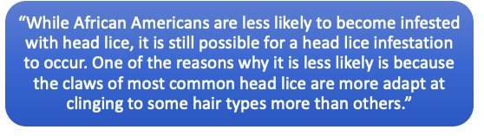
Common Risk Factors and Practices to Avoid a Head Lice Infestation
  Risk Factors |   Safe Practices
Shared beds | Separate pillows (separate beds if possible)
Wrestling between children | Maintaining physical distance
Braiding or Combing each other’s hair | Only braid or comb your own hair
Activities that require prolonged contact between people’s heads (reading circles, etc.) | Avoid prolonged contact between people’s heads

Lice Treatments

According to the American Academy of Pediatrics, you should never initiate treatment unless there is a clear diagnosis of head lice.

Topical pediculicides, such as permethrin 1% lotion, are first-line treatments for head lice. Multiple novel treatments have shown limited evidence of effectiveness superior to permethrin. Extensive environmental decontamination is not necessary after head lice are diagnosed.9 Focus on ridding the head lice infestation from the affected individual and regularly checking close contacts.
Below is a chart of recommended lice treatments. Patient age, treatment cost, side effects, ease of use, and local resistance patterns (if known) are all considerations when choosing a treatment. Permethrin and pyrethrins are the preferred first choice in areas without known resistance to these products; they are inexpensive and have a long history of use for head lice. All topical pediculicides should be rinsed over a sink rather than in a shower/bath to limit skin exposure. Warm water is preferred over hot water to minimize vasodilation.

Head lice (pediculicides) medications9
​Permethrin lotion (1%)​ (Nix) | - Over the counter medicine  - Usually less than $25  - Apply to shampooed (using a nonconditioning shampoo) and towel-dried hair; then rinse off after 10 minutes.  - Repeat on day 9 if live lice are seen.  - Kills lice; does not kill lice eggs  - Approved for use in children 2 months and older
​Pyrethrin-based product (shampoo or hair mousse) (e.g., Rid) | - ​Over the counter medicine  - Usually less than $25  - Apply to dry hair and rinse off after 10 minutes.Rinse over a sink rather than in a shower/bath to limit skin exposure. Warm water is preferred over hot water to minimize vasodilation.  - Repeat on day 9 if live lice are seen.  - Kills lice; does not kill lice eggs.  - Approved for use in children 2 years and older.
​Malathion lotion (0.5%) (Ovide) | - ​Prescription needed.  - Usually costs $200-299 (without insurance)  - Apply to dry hair and rinse off after 8–12 hours. Repeat in 7-9 days if live lice are seen.  - Kills lice and lice eggs.  - Approved for use in children 6 years or older.  - Flammable due to high alcohol content. Patients and caregivers should be instructed to allow hair to dry naturally (avoid hair dryer, flat iron, etc.) and not to smoke near the child.
​Benzyl alcohol lotion (5%) (Ulesfia) | - ​Prescription needed.  - Usually costs anywhere between $26-299 (without insurance) (dependent on amount of bottles and brand)  - Apply to dry hair and rinse off after 10 minutes. Repeat after 7 days if live lice are seen.  - Kills lice; does not kill lice eggs.  - Contains no neurotoxic pesticide.  - Approved for use in infants and children 6 months and older.
​Spinosad topical suspension (0.9%) (Natroba) | - ​Prescription needed.  - Usually costs $200-299 (without insurance)  - Apply to dry hair and rinse off after 10 minutes. Repeat after 7 days if live lice are seen.  - Kills lice and lice eggs.  - Approved for use in infants and children 6 months and older.
​Ivermectin lotion (0.5%)(Sklice) | - ​Over the counter medicine  - Apply to dry hair and rinse off after 10 minutes.  - Kills lice; does not kill lice eggs. However, may prevent newly hatched lice from living.  - Usually costs $200-299 (without insurance)  - Approved for use in infants and children 6 months and older.

Retreatment is not needed, one application only: Treatment with Ivermectin lotion (0.5%)(Sklice).

Retreatment is recommended between days 7 and 9 if live lice are seen: Treatment with Malathion lotion (0.5%) (Ovide) or Spinosad topical suspension (0.9%) (Natrobia).

Retreatment is recommended between days 9 and 10 if live lice are seen: Treatment with Permethrin lotion (1%); Pyrethrin-based product (shampoo or hair mousse) or Benzyl alcohol lotion (5%) (Ulesfia).

Manual Removal of Head Lice

Wet combing is an effective nonpharmacological treatment option9, as lice that are wet stay still. The wet combing method is an effective method for removing head lice without or along with using a pediculicide for treatment:

Nurse / head lice. (2016). Retrieved April 14, 2021, from https://www.etsdnj.us/Page/7071
Lice vs dandruff - 7 key differences between lice eggs and dandruff. (2021, March 14). Retrieved April 14, 2021, from https://myliceadvice.com/lice-vs-dandruff-lice-eggs-photos/
Devore, C. D., & Schutze, G. E. (2015). Head lice. PEDIATRICS, 135(5). doi:10.1542/peds.2015-0746
Gunning, K., Kiraly, B., & Pippitt, K. (2019). Lice and Scabies: Treatment Update. American Family Physician, 10, 635-642.
Goddard, J. (2003). Physician's Guide to Arthropods of Medical Importance (4th ed.). Boca Raton, FL: CRC Press.

