Table of Contents
Introduction 2
Acknowledgements 2
Overview 2
Why Focus on Head Lice? 3
Epidemiology of Head Lice 4
Diagnosis and Inspection of Head Lice 5
Common Symptoms/Signs and Risk Factors (Exposure) 7
Lice Treatments 9
Head lice (pediculicides) medications 9
Manual Removal of Head Lice 11
Practices to Note When Treating Head Lice 12
What to Look for After Head Lice Treatment 12
Resistance to Head Lice Treatments (Pediculicides), Next Steps 13
Other Biting Arthropods Mistaken for Head Lice 14
Appendix A: Quick Guide on How to Treat Head Lice 17
Appendix B: Benefits of Wet Combing 18
Appendix C: Head Lice Policy Recommendations 19
Appendix D: 10 Truths About Head Lice 21

Introduction

The purpose of this manual is to provide current information on head lice in the state of Tennessee. It is intended for use by local health departments, healthcare providers, local childcare and school facilities, and other group settings. It is also intended to act as a comprehensive guide to identify, treat, manage and prevent head lice. This manual serves both as a technical review and a quick reference on the nature of head lice infestations and will be the first of its kind in Tennessee.

Acknowledgements

Overview
The infamous head louse (Pediculosis humanus capitis) has plagued human societies for centuries. The first egg remains were dated back to the first B.C.. Children aged 3-12 years have become the most common carriers of head lice, with women coming in second and men being the least likely. The prevalence of head lice infestations has little to do with age or gender, but is solely dependent upon close contact, such as children playing closely together with their heads frequently touching, or adults living in overcrowded facilities1. Head lice infestations are not considered a health hazard as they do not spread disease. Most people will have a head lice infestation of 10-20 eggs. In severe infestations, the hair may become matted with a mixture of nits, nymphs, and adults1. The main symptom of a lice infestation is itching, especially at night, due to the increased activity of the lice during this time; however, most individuals experience no symptoms.
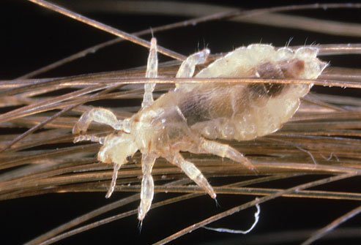
Figure A: Pictured above is a head louse attached to an individual hair shaft.

Why Focus on Head Lice?
Although a head lice infestation cannot transmit a disease agent to the carrier, the social stigma resulting from a head lice infestation is often severe, causing relentless embarrassment, assumptions about the individual’s personal hygiene, and shame for the individual. Additionally, the current head lice policies in place at a significant number of childcare and educational facilities, known as “no-nit” policies, often cause a child with a head lice infestation to miss an unnecessary amount of school days, but fail to reduce prevalence in the community. The economic burden of head lice is also substantial, approaching $1 billion annually for the combined direct (medicines, products and treatments to remove head lice and its eggs) and indirect costs (missed work and school days, misuse of products and treatments, misdiagnosis) concerning a head lice infestation. In many areas of the world, head lice are a serious public health problem, and in many countries, prevalence has been increasing1. This is still an important issue of individual health, and measures need to be taken to educate and prevent further head lice infestations.
Epidemiology of Head Lice

The head louse has three stages of lice: egg, nymph, and adult. Eggs are glued to the base of individual hair shafts of the person experiencing the infestation and last for a week unhatched (7-10 days). The nymphal stage lasts 8-9 days and is characterized by egg hatching and an increase in lice activity, especially at night. At this stage common symptoms start appearing, such as drowsiness and itching more than normal, as the lice infestation often disturbs the individual’s rest due to intense head scratching. Finally, the last stage is the adult, which live on average for a little over 8-9 days4, but reproduce new eggs (both viable and non-viable) at an average rate of 80-212 eggs per female in perfect conditions.4 Most individuals will have a maximum infestation of 10-20 lice eggs or nits1.
Figure B: Pictured above is a head louse nymph emerging from the egg stage onto an individual hair shaft.
Figure C: Pictured above from right to left, are the visible stages of the head louse, from the three substages of the nymph stage (seen in N1, N2, and N3)

Diagnosis and Inspection of Head Lice

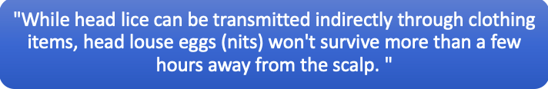
Eggs are often mistaken for dandruff, eczema, other scalp conditions, or hair product buildup. The easiest way to differentiate between the aforementioned and a head louse egg is to use a fine-tooth comb to attempt to gently dislodge the target area. A louse egg is held to an individual hair with a cement-like glue, so if it would take a lot more effort to remove than dandruff or hair product buildup. Viable head lice eggs are often found on the base of the hair shaft within a ¼ inch of the scalp and are especially common behind and above the ears and at the back of the neck1.
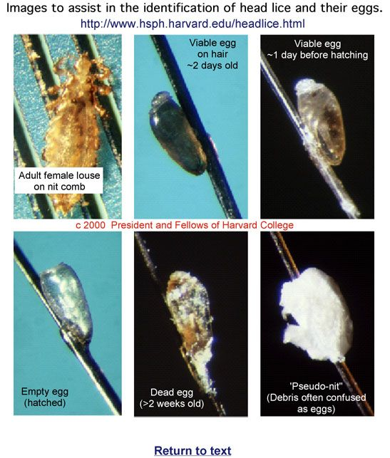
Figure D: Lice eggs (nits) in comparison to dandruff and other skin conditions.
Head lice are spread in two ways: direct contact and indirect contact. The most common method of spread for head lice is through prolonged, direct contact between one individual’s head with a lice infection and another individual without a head lice infestation. Prolonged direct head contact is often unintentional, often occurring at sleepovers between children, wrestling between children, standing concerts between adults, crowded sports events/arenas between adults, and more. There is a small chance that head lice can be also indirectly shared through hats, scarves, coats, coat racks, lockers, hairbrushes, headphones, pillows, towels, upholstered furniture and stuffed toy animals.
The best way to inspect a possible lice infestation is to manually detect any living lice by using a strong light source, disposable gloves, and a disposable hair parting tool (such as a lice comb or fine-toothed comb). Mass screenings are no longer recommended because they lead to social stigma and decrease accuracy of diagnosis. In group settings, such as schools and other childcare facilities, individuals that are suspected of having head lice should be examined by a trained professional in a private setting. However, if more than one individual is being inspected for a head lice infestation, then a new disposable hair parting tool and new disposable gloves are needed.
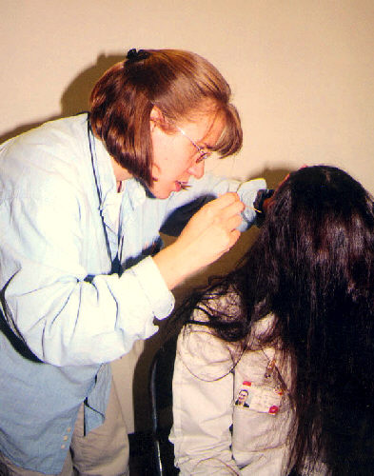
Using the strong light source, it is best to part the hair with the disposable hair parting tool and closely examine the scalp for any possible living lice or nymphs. Start at the nape of the neck and behind the ears, the most common places to find head lice. Continue the inspection throughout the head. The standard to be diagnosed with a lead lice infestation is to find a living head louse on the head, as the casing on nits (head lice eggs) can last for several weeks after the end of the infestation.

Figure E: A woman accurately checks for a head lice infestation using a light source, magnifying glass and sectioning the hair for increased visibility. She also only inspects one individual as opposed to conducting a mass screening.

Common Symptoms/Signs and Risk Factors (Exposure)

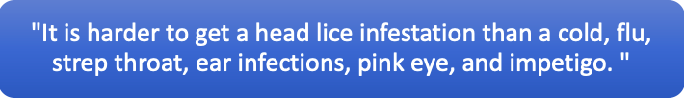
Common Signs/Symptoms of a Head Lice Infestation and Reasons
Scalp Itchiness/Sores on the scalp | Allergic reaction to lice bites
Drowsiness and/or irritability | High activity of the lice disrupts sleep
Tickling sensation on the scalp | Movement of the lice

Many individuals with a head lice infestation show no symptoms or signs, making a diagnosis of head lice necessary.

Common Risk Factors and Practices to Avoid a Head Lice Infestation
Risk Factors | Safe Practices
Shared beds | Separate pillows (separate beds if possible)
Wrestling between children | Maintaining physical distance
Braiding or Combing each other’s hair | Only braid or comb your own hair
Activities that require prolonged contact between people’s heads (reading circles, etc.) | Avoid prolonged contact between people’s heads

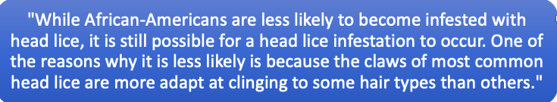

Lice Treatments

According to the American Academy of Pediatrics, you should never initiate treatment unless there is a clear diagnosis of head lice.

First-line pharmacologic treatment of head lice is permethrin 1% lotion or shampoo. Multiple novel treatments have shown limited evidence of effectiveness superior to permethrin.Extensive environmental decontamination is not necessary after head lice is diagnosed6. Focus on riding the head lice infestation from the affected individual.

Below is a chart of recommended lice treatments, from safest and most effective to least tested or least effective:

Head lice (pediculicides) medications
​Permethrin lotion (1%)​ (Nix) | - Over the counter medicine  - Usually less than $25  - Apply to shampooed and towel-dried hair; then rinse off after 10 minutes  - Kills lice; does not kill lice eggs  - Approved for use in children 2 months and older
​Pyrethrin-based product (shampoo or hair mousse) (Rid) | - ​Over the counter medicine  - Usually less than $25  - Apply to dry hair and rinse off after 10 minutes.  - Kills lice; does not kill lice eggs.  - Approved for use in children 2 years and older.
​Malathion lotion (0.5%) (Ovide) | - ​Prescription needed.  - Usually costs $200-299 (without insurance)  - Apply to dry hair and rinse off after 8–12 hours.  - Kills lice and lice eggs.  - Approved for use in children 6 years or older.
​Benzyl alcohol lotion (5%) (Ulesfia) | - ​Prescription needed.  - Usually costs anywhere between $26-299 (without insurance)(dependent on amount of bottles and brand)  - Apply to dry hair and rinse off after 10 minutes.  - Kills lice; does not kill lice eggs.  - Contains no neurotoxic pesticide.  - Approved for use in infants and children 6 months and older.
​Spinosad topical suspension (0.9%) (Natrobia) | - ​Prescription needed.  - Usually costs $200-299 (without insurance)  - Apply to dry hair and rinse off after 10 minutes.  - Kills lice and lice eggs.  - Approved for use in infants and children 6 months and older.
​Ivermectin lotion (0.5%)(Sklice) | - ​Over the counter medicine  - Apply to dry hair and rinse off after 10 minutes.  - Kills lice; does not kill lice eggs. However, may prevent newly hatched lice from living.  - Usually costs $200-299 (without insurance)  - Approved for use in infants and children 6 months and older.

Retreatment is not needed, one application only: Treatment with Ivermectin lotion (0.5%)(Sklice).

Retreatment is recommended between days 7 and 9 if live lice are seen: Treatment with Malathion lotion (0.5%) (Ovide) or Spinosad topical suspension (0.9%) (Natrobia).

Retreatment is recommended between days 9 and 10 if live lice are seen: Treatment with Permethrin lotion (1%); Pyrethrin-based product (shampoo or hair mousse) or Benzyl alcohol lotion (5%) (Ulesfia)

Manual Removal of Head Lice

Wet combing is an effective nonpharmacologic treatment option6, as lice that are wet stay still can’t move quickly away from disturbances. The wet combing method is an effective method for removing head lice without or along with using a pediculicide for treatment:

Characteristics of Lice Combs
An effective lice comb should:
  - Be disposable
  - Have small comb teeth to effectively remove nits and adults
  - Have no gaps or only tiny gaps between the comb teeth
Figure F: Pictured above, to the left, is an effective lice comb. A flea comb, pictured to the right, can also be used effectively.

Practices to Note When Treating Head Lice

- Please keep pediculicides (head lice treatment medications) AWAY FROM THE EYES AND MOUTH.

- Most pediculicides ARE FLAMMABLE, so keep the affected individual away from fire and set a timer for treatment to avoid chemical burns.

- ALWAYS check the recommended age for each treatment.

- As aforementioned, extensive environmental decontamination is NOT necessary after head lice is diagnosed6. Avoid lice sprays.

What to Look for After Head Lice Treatment

After a head lice treatment is successfully applied, there should be no living head lice adults or nymphs in the affected individual’s hair (see “Diagnosis of Head Lice” section for a reminder on how to effectively check for head lice). HOWEVER, head lice eggs (also called nits) may still be seen days, and sometimes weeks, after a successful treatment. These non-viable eggs usually appear yellow and are farther from the scalp (over ½ an inch) than livings eggs and should NOT be a cause for concern. Clean the external environment by vacuuming the surrounding area (where the treatment was applied and where the affected individual sleeps) and soaking bedding, combs, etc. in hot water for at least 10 mins.6 If there are still living head lice adults or nymphs after initial treatment and retreatment (if applicable), see the next section on resistance to head lice treatment and next steps.

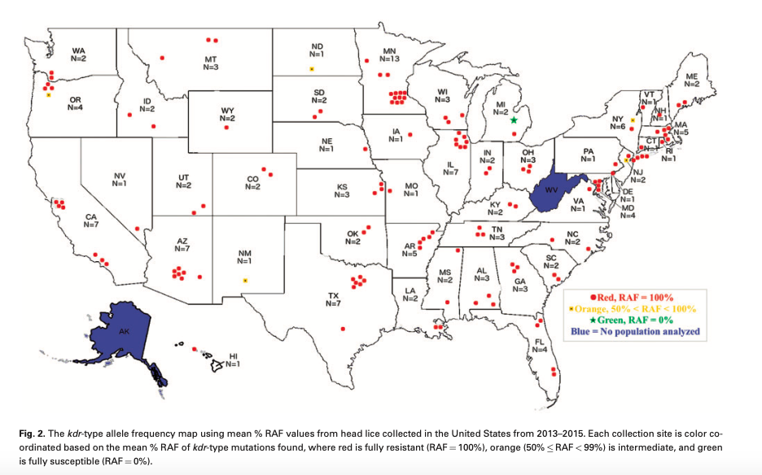
Resistance to Head Lice Treatments (Pediculicides), Next Steps

Recently, there have been noted cases of head lice that are resistance to current treatments and medications, as can be seen in the 2016 map above, with the state of Tennessee having at least 3 cases where head lice showed full resistance (RAF = 100%) to current treatments and medications. This is not unusual, as many insects will develop resistance to threatening products over time. If this is the case, please see a medical health professional or go to your local health department for assistance in treatment options for fully resistance lice.

Other Biting Arthropods Mistaken for Head Lice

There are a few other biting arthropods that are often or can be often mistaken for head lice, specifically bed bugs, scabies, body lice and pubic lice. Please seek assistance from your local health department or a medical professional if the target individual is believed to have one or more of these conditions, as they can only be treated by a medical professional.
Bed Bugs
Bed bugs are small, crawling parasitic insects that rely on the blood of people or animals while they sleep or stay in place for long periods of time. They are wingless (can’t fly) and can live several months without a blood meal. They are found globally and can infest new homes and areas quickly, but do not spread disease. The most common signs and symptoms of a bed bug infestation are the red colored blood spots on a piece of furniture and the characteristic bite marks on body parts that make contact with the bed while sleeping.
Scabies
Human scabies is caused by a skin infestation of the small human itch mite, which burrows into the upper layers of the skin to live and lay eggs. Similar to head lice, scabies spread by prolonged direct skin-to-skin contact with an individual who has a scabies infestation and they do not transmit disease. Scabies can be found globally and are most common in crowded conditions, such as nursing homes, child-care facilities, and prisons. The most common signs and symptoms of a scabies infestation are a characteristic pimple-like skin rash and small burrow tunnels under the skin, along with intense itching.
Body Lice
Body lice are parasitic insects that live on clothing or bedding used by persons with a body lice infestation. They spread both through direct-skin-to-skin contact with a person with an infestation and through indirect contact with that individual’s personal bedding and other items. Body lice do transmit diseases, such as epidemic typhus, trench fever and louse-borne relapsing fever. Body lice infestations are mainly found in homeless populations and refugee camps and are rare for individuals who bathe regularly or have access to fresh laundry or bedding. The most common signs and symptoms of a body lice infestation are intense itching, vagabond’s disease (swelling of heavily bitten areas of skin that have become thick and discolored), and symptoms related to any transmitted diseases.
Pubic Lice
Pubic lice are parasitic insects found mainly in the genital area, although they can be found in other areas of coarse hair, such as eyebrows or eyelashes, armpits, beards or mustaches. According to the Center for Disease Control and Prevention, “Public lice on the eyebrows or eyelashes of children may be a sign of sexual exposure or abuse”. Pubic lice are most common in sexually active adults and are often difficult to find, requiring official diagnosis from a medical professional. Pubic lice are found globally and do not transmit disease, although their presence is often correlated with the presence of sexually transmitted diseases11. The most common signs and symptoms of pubic lice are itching in the genital area and visible crawling lice.

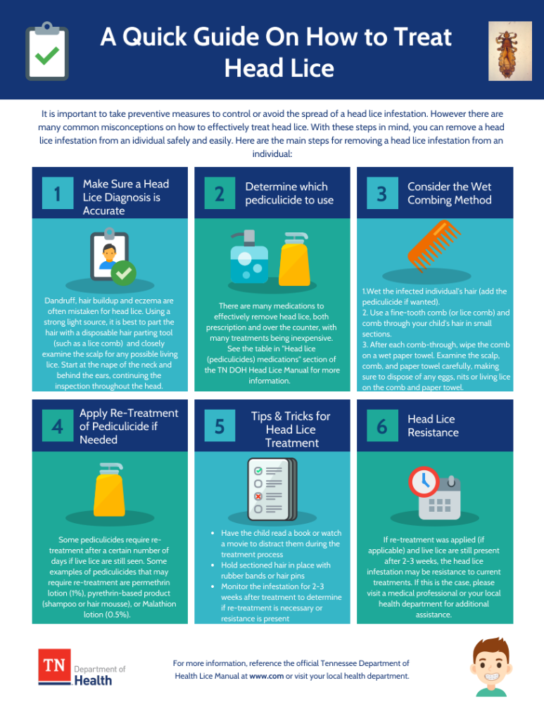
Appendix A: Quick Guide on How to Treat Head Lice

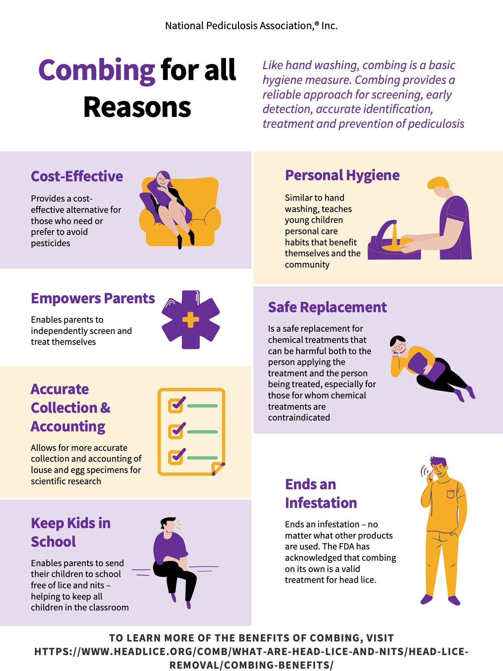
Appendix B: Benefits of Wet Combing

Appendix C: Head Lice Policy Recommendations
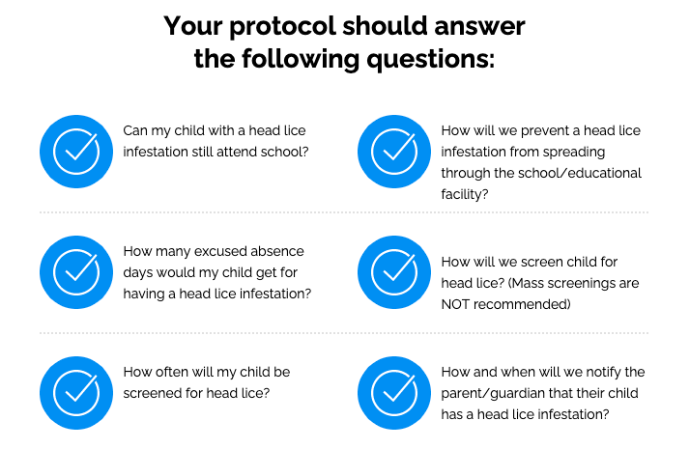

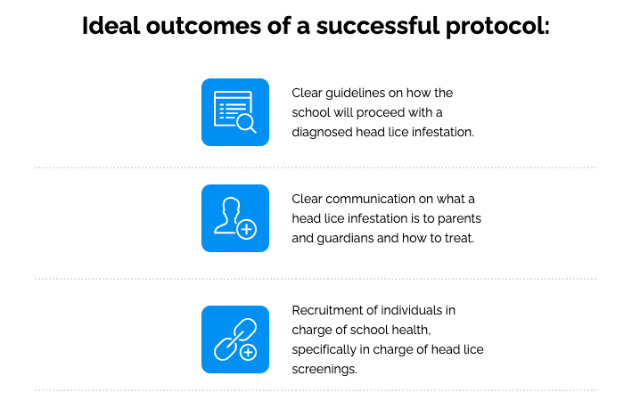

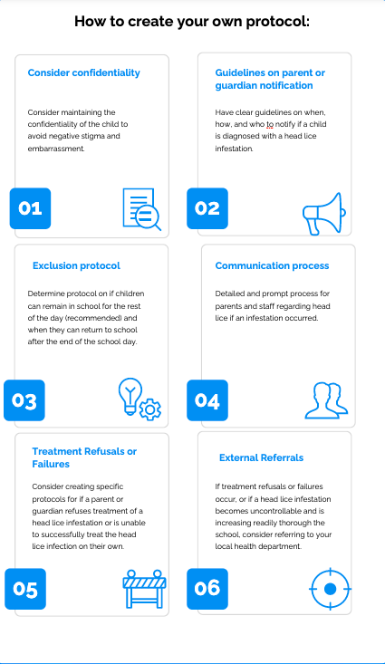

Appendix D: 10 Truths About Head Lice

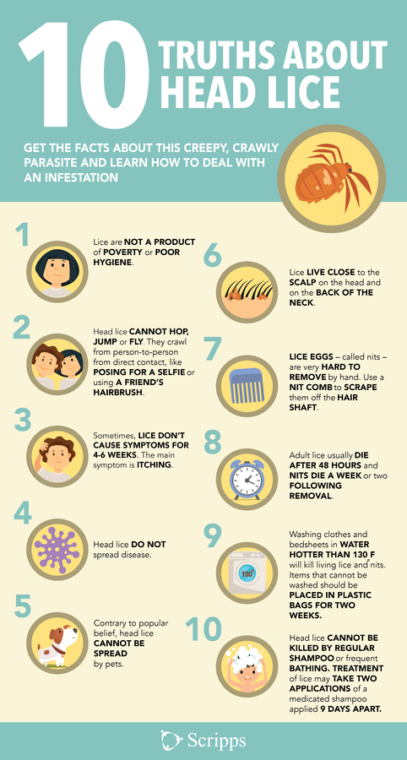

Goddard, J. (2003). Physician's Guide to Arthropods of Medical Importance (4th ed.). Boca Raton, FL: CRC Press.
Service, M. W. (2018). Medical entomology for students. Cambridge: Cambridge University Press.
Hansen RC, O-Haver J, (2004). “Economic Considerations Associated with Pediculus humanus capitis Infestation,” Clinical Pediatrics, 43 (6): 523-527.
Kettle, D. (1995). Medical and Veterinary Entomology 2nd Edition. Wallington, UK: CAB International.
Devore, C. D., & Schutze, G. E. (2015). Head lice. PEDIATRICS, 135(5). doi:10.1542/peds.2015-0746
Gunning, K., Kiraly, B., & Pippitt, K. (2019). Lice and Scabies: Treatment Update. American Family Physician, 10, 635-642.
Gellatly, K. J., Krim, S., Palenchar, D. J., Shepherd, K., Yoon, K. S., Rhodes, C. J., Lee, S. H., & Marshall Clark, J. (2016). Expansion of the Knockdown Resistance Frequency Map for Human Head Lice (Phthiraptera: Pediculidae) in the United States Using Quantitative Sequencing. Journal of medical entomology, 53(3), 653–659. https://doi.org/10.1093/jme/tjw023
CDC - bed bugs - frequently asked Questions (FAQs). (2020, September 16). Retrieved March 31, 2021, from https://www.cdc.gov/parasites/bedbugs/faqs.html
CDC - SCABIES - general information - frequently asked Questions (FAQs). (2020, September 01). Retrieved March 31, 2021, from https://www.cdc.gov/parasites/scabies/gen_info/faqs.html
CDC - lice - body lice - general information. (2013, September 24). Retrieved March 31, 2021, from https://www.cdc.gov/parasites/lice/body/gen_info/index.html
CDC - lice - Pubic "crab" - general information - frequently asked Questions (FAQs). (2020, September 17). Retrieved March 31, 2021, from https://www.cdc.gov/parasites/lice/pubic/gen_info/faqs.html
https://www.headlice.org/comb/what-are-head-lice-and-nits/head-lice-removal/combing-benefits/
https://www.scripps.org/news_items/4316-ridding-your-kid-of-head-lice

