Table of Contents
Introduction 2
Acknowledgements 2
Overview 3
Why Focus on Head Lice? 4
Epidemiology of Head Lice 6
Diagnosis and Inspection of Head Lice 7
Common Symptoms/Signs and Risk Factors (Exposure) 9
Lice Treatments 10
Head lice (pediculicides) medications 11
Manual Removal of Head Lice 13
Practices to Note When Treating Head Lice 14
Important Do’s: 14
Important Do Not’s 14
What to Look for After Head Lice Treatment 15
Reasons for Head Lice Management Failures 17
Resistance to Head Lice Treatments (Pediculicides) 17
Other Biting Arthropods Mistaken for Head Lice 18
Appendix A: Quick Guide on How to Treat Head Lice 21
Appendix B: Benefits of Wet Combing 22
Appendix C: Head Lice Policy Recommendations 23
Appendix D: 10 Truths About Head Lice 25

Introduction

The purpose of this manual is to provide current information on head lice in the state of Tennessee. It is intended for use by local health departments, healthcare providers, local childcare and school facilities, and other group settings. It is also intended to act as a comprehensive guide to identify, treat, manage and prevent head lice. This manual serves both as a technical review and a quick reference on the nature of head lice infestations and will be the first of its kind in Tennessee.

Acknowledgements
Tennessee Department of Health
Abelardo Moncayo, Ph.D.
Joseph George, MS, PG
Calla Reed, B.A.

Tennessee Department of Children’s Services
Patricia Slade, MSN, MBA, RN
Amanda Johnson, MPH, RN, CHES

University of Tennessee
Karen Vail, Ph.D.

Overview
The infamous head louse (Pediculosis humanus capitis) has plagued human societies for millennia. The first egg remains were dated back to 10,000 years ago. Children aged 3-12 years have become the most common carriers of head lice, with women coming in second and men being the least likely. The prevalence of head lice infestations has little to do with age or gender, but is solely dependent upon close contact, such as children playing closely together with their heads frequently touching, or adults living in overcrowded facilities.2 Head lice infestations are not considered a health hazard. as they do not spread disease. Most people will have a head lice infestation of 10-20 eggs. In severe infestations, the hair may become matted with a mixture of nits, nymphs, and adults.2 The main symptom of a lice infestation is intense itching of the scalp, especially at night, due to the increased activity of the lice during this time; however, most individuals experience no symptoms.
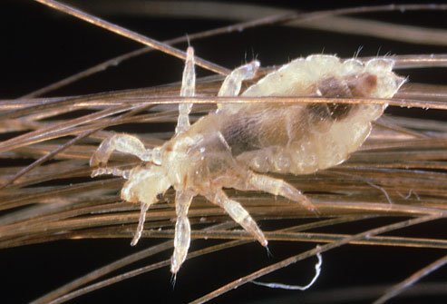
Figure A: Pictured above is a head louse attached to an individual hair shaft.

Why Focus on Head Lice?
Although a head lice infestation cannot transmit a disease agent to the carrier, the social stigma resulting from a head lice infestation is often severe, causing relentless embarrassment, assumptions about the individual’s personal hygiene, and shame for the individual. Additionally, the current head lice policies in place at a significant number of childcare and educational facilities, known as “no-nit” policies, often cause a child with a head lice infestation to miss an unnecessary amount of school days, but fail to reduce prevalence in the community. The economic burden of head lice is also substantial, approaching $1 billion annually for the combined direct (medicines, products and treatments to remove head lice and its eggs) and indirect costs (missed work and school days, misuse of products and treatments, misdiagnosis) concerning a head lice infestation. In many areas of the world, head lice are a serious public health problem, and in many countries, prevalence has been increasing.2 This is still an important issue of individual health, and measures need to be taken to educate and prevent further head lice infestations.
Pesticides have been misapplied in an attempt to control head lice in school settings. Although it is unnecessary to apply pesticides to the classroom to manage head lice because they only survive about 48 hours off the host, classrooms are sprayed for head lice in about one-fifth of Tennessee's school systems (Figure B). Head lice premise spray cans have been found repeatedly in Tennessee kindergarten or pre-K classrooms, and sometimes they are accessible to children in unlocked floor cabinets (Figure C). This violates the label, which indicates "keep out of the reach of children" because pesticides are potentially hazardous in children's hands. Also, teachers and other school staff break the law if they apply pesticides in a school without a licensed pesticide applicator's supervision (TCA 62-21-124). This manual will also help users reduce pesticide misapplications and potential mishaps.
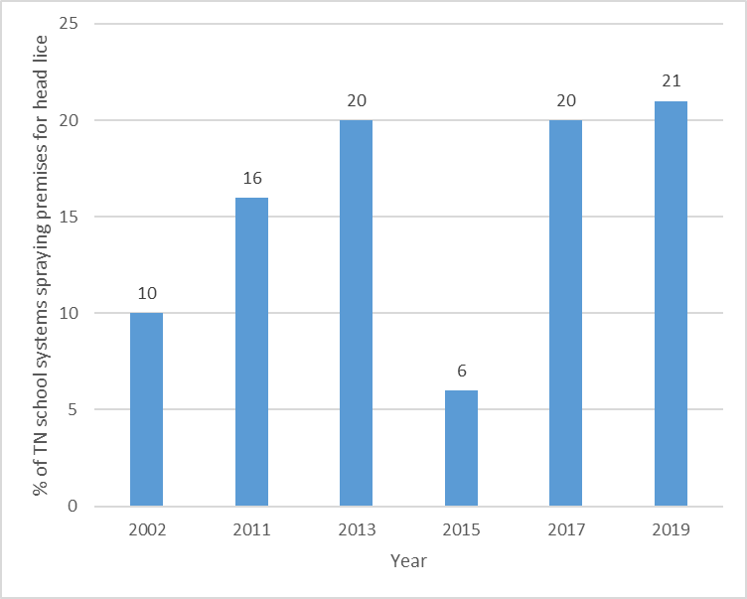

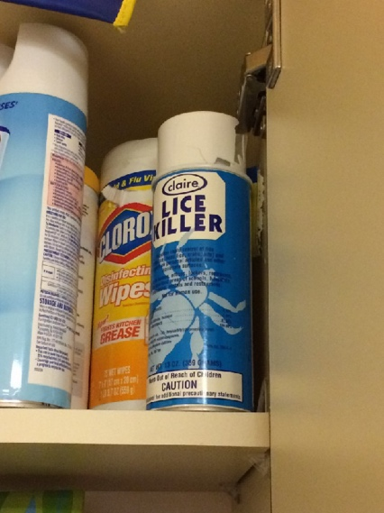
Figure B. Results of school pest management surveys conducted by the University of Tennessee Urban IPM Team. Response rates were 32% in 2002 and ranged from 66 to 72% from 2011 to 2019. The most recent survey results indicate about 1/5 of Tennessee’s school system are unnecessarily applying premise sprays for head lice management.5

Figure C. Flying and Crawling Insect Killer Premise Spray can in an unlocked, floor cabinet of a Pre-K classroom.

Epidemiology of Head Lice
The head louse has three stages of lice: egg, nymph, and adult. Eggs are glued to the base of individual hair shafts of the person experiencing the infestation and last for 7-10 days unhatched. The nymphal stage lasts 8-9 days and is characterized by egg hatching and an increase in lice activity, especially at night. At this stage common symptoms start appearing, such as drowsiness and itching more than normal, as the lice infestation often disturbs the individual’s rest due to intense head scratching. Finally, the last stage is the adult, which live on average for a little over 8-9 days6, but reproduce new eggs (both viable and non-viable) at an average rate of 80-212 eggs per female in perfect conditions.6 Most individuals will have a maximum infestation of 10-20 lice eggs or nits.2

Figure D: Pictured above is a head louse nymph emerging from the egg stage onto an individual hair shaft.3

Figure E: Pictured above from right to left, are the visible stages of the head louse, from the three substages of the nymph stage (seen in N1, N2, and N3).3

Diagnosis and Inspection of Head Lice
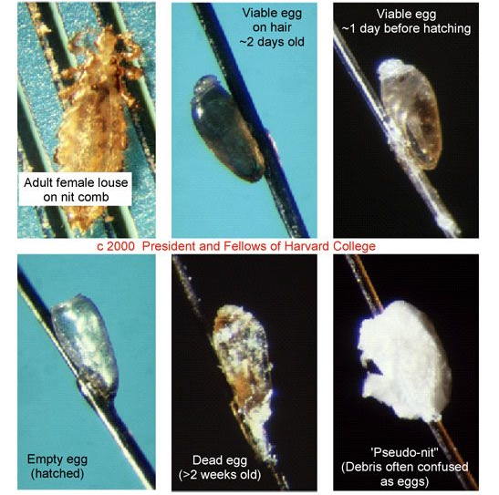
Eggs are often mistaken for dandruff, eczema, other scalp conditions, or hair product buildup. The easiest way to differentiate between the aforementioned and a head louse egg is to use a fine-tooth comb to attempt to gently dislodge the target area. A louse egg is held to an individual hair with a cement-like glue, so if it would take a lot more effort to remove than dandruff or hair product buildup. Viable head lice eggs are often found on the base of the hair shaft within a ¼ inch of the scalp and are especially common behind and above the ears and at the back of the neck.2

Figure F: Lice eggs (nits) in comparison to dandruff and other skin conditions.
Head lice are spread in two ways: direct contact and indirect contact. The most common method of spread for head lice is through prolonged, direct contact between one individual’s head with a lice infection and another individual without a head lice infestation. Prolonged direct head contact is often unintentional, often occurring at sleepovers between children, wrestling between children, standing concerts between adults, crowded sports events/arenas between adults, and more. There is a small chance that head lice can be also indirectly shared through hats, scarves, coats, coat racks, lockers, hairbrushes, headphones, pillows, towels, upholstered furniture and stuffed toy animals.
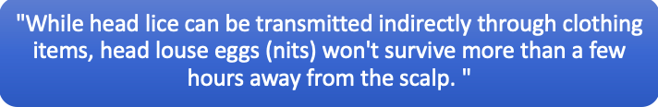
The best way to inspect a possible lice infestation is to manually detect any living lice by using a strong light source, disposable gloves, and a disposable hair parting tool (such as a lice comb or fine-toothed comb). Mass screenings are no longer recommended because they lead to social stigma and decrease accuracy of diagnosis. In group settings, such as schools and other childcare facilities, individuals that are suspected of having head lice should be examined by a trained professional in a private area. However, if more than one individual is being inspected for a head lice infestation, then a new disposable hair parting tool and new disposable gloves are needed.
Using the strong light source, it is best to part the hair with the disposable hair parting tool and closely examine the scalp for any possible living lice or nymphs. Start at the nape of the neck and behind the ears, the most common places to find head lice. Continue the inspection throughout the head. The standard to be diagnosed with a head lice infestation is to find a living head louse on the head, as the casing on nits (head lice eggs) can last for several weeks after the end of the infestation.

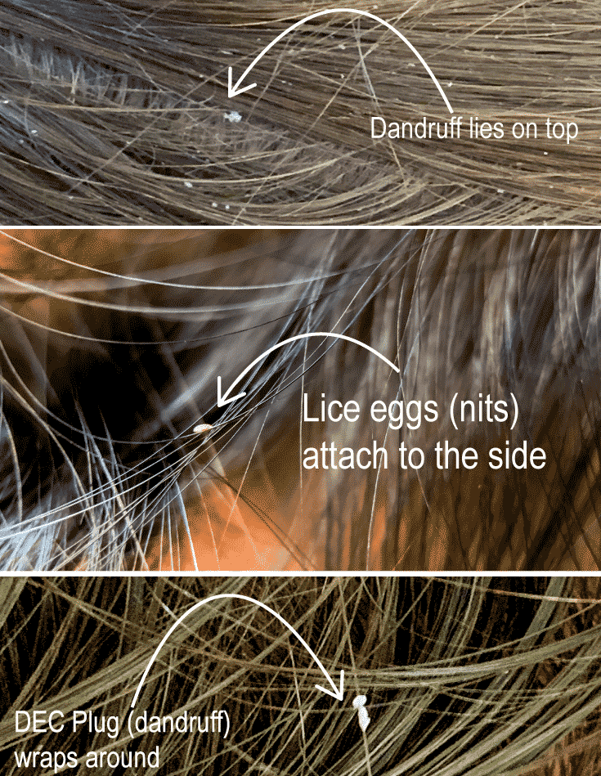

Figure G: Above is a diagram of the visual differences between head lice and dandruff.

Common Symptoms/Signs and Risk Factors (Exposure)
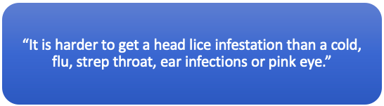

Common Signs/Symptoms of a Head Lice Infestation and Reasons
Scalp Itchiness/Sores on the scalp | Allergic reaction to lice bites
Drowsiness and/or irritability | High activity of the lice disrupts sleep
Tickling sensation on the scalp | Movement of the lice
Many individuals with a head lice infestation show no symptoms or signs, making a diagnosis of head lice necessary.
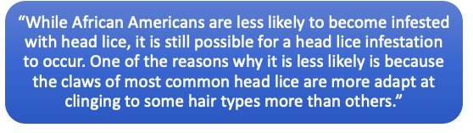
Common Risk Factors and Practices to Avoid a Head Lice Infestation
  Risk Factors |   Safe Practices
Shared beds | Separate pillows (separate beds if possible)
Wrestling between children | Maintaining physical distance
Braiding or Combing each other’s hair | Only braid or comb your own hair
Activities that require prolonged contact between people’s heads (reading circles, etc.) | Avoid prolonged contact between people’s heads

Lice Treatments

According to the American Academy of Pediatrics, you should never initiate treatment unless there is a clear diagnosis of head lice.

First-line pharmacologic treatment of head lice is permethrin 1% lotion or shampoo. Multiple novel treatments have shown limited evidence of effectiveness superior to permethrin. Extensive environmental decontamination is not necessary after head lice are diagnosed.9 Focus on ridding the head lice infestation from the affected individual and regularly checking close contacts.
Below is a chart of recommended lice treatments, from safest and most effective to least tested or least effective:

Head lice (pediculicides) medications9
​Permethrin lotion (1%)​ (Nix) | - Over the counter medicine  - Usually less than $25  - Apply to shampooed and towel-dried hair; then rinse off after 10 minutes  - Kills lice; does not kill lice eggs  - Approved for use in children 2 months and older
​Pyrethrin-based product (shampoo or hair mousse) (Rid) | - ​Over the counter medicine  - Usually less than $25  - Apply to dry hair and rinse off after 10 minutes.  - Kills lice; does not kill lice eggs.  - Approved for use in children 2 years and older.
​Malathion lotion (0.5%) (Ovide) | - ​Prescription needed.  - Usually costs $200-299 (without insurance)  - Apply to dry hair and rinse off after 8–12 hours.  - Kills lice and lice eggs.  - Approved for use in children 6 years or older.
​Benzyl alcohol lotion (5%) (Ulesfia) | - ​Prescription needed.  - Usually costs anywhere between $26-299 (without insurance) (dependent on amount of bottles and brand)  - Apply to dry hair and rinse off after 10 minutes.  - Kills lice; does not kill lice eggs.  - Contains no neurotoxic pesticide.  - Approved for use in infants and children 6 months and older.
​Spinosad topical suspension (0.9%) (Natrobia) | - ​Prescription needed.  - Usually costs $200-299 (without insurance)  - Apply to dry hair and rinse off after 10 minutes.  - Kills lice and lice eggs.  - Approved for use in infants and children 6 months and older.
​Ivermectin lotion (0.5%)(Sklice) | - ​Over the counter medicine  - Apply to dry hair and rinse off after 10 minutes.  - Kills lice; does not kill lice eggs. However, may prevent newly hatched lice from living.  - Usually costs $200-299 (without insurance)  - Approved for use in infants and children 6 months and older.

Retreatment is not needed, one application only: Treatment with Ivermectin lotion (0.5%)(Sklice).

Retreatment is recommended between days 7 and 9 if live lice are seen: Treatment with Malathion lotion (0.5%) (Ovide) or Spinosad topical suspension (0.9%) (Natrobia).

Retreatment is recommended between days 9 and 10 if live lice are seen: Treatment with Permethrin lotion (1%); Pyrethrin-based product (shampoo or hair mousse) or Benzyl alcohol lotion (5%) (Ulesfia).

Manual Removal of Head Lice

Wet combing is an effective nonpharmacologic treatment option9, as lice that are wet stay still. The wet combing method is an effective method for removing head lice without or along with using a pediculicide for treatment:

Characteristics of Lice Combs
An effective lice comb should:

  - Be disposable
  - Have small comb teeth to effectively remove nits and adults
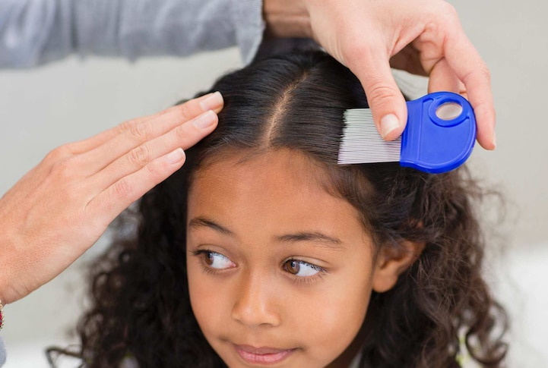
  - Have no gaps or only tiny gaps between the comb teeth
Figure H: Pictured to the left is an effective lice comb. A demonstration of how to use a lice comb is pictured to the right.

Practices to Note When Treating Head Lice

Important Do’s:
- Do take an integrated pest management approach (monitor, vacuum home furniture, launder bedding, towels and clothes, treat the head, nit-comb, and evaluate results).
- Do follow pediculicide product directions exactly as written.
- Do keep pediculicide medications out of the eyes. If they get onto the eyes they should be immediately flushed away.
- Do rinse all topical pediculicides from the hair over a sink, rather than in the shower or bath to limit skin exposure, and to use warm water rather than hot water to minimize absorption.
- Do follow label instruction carefully for second pediculicide treatments. (not all treatments require a 2nd application)
- Do use gloves when applying treatments if the label directions indicate their use.
- Do invest time in manual nit removal and infestations will be resolved faster.
- Do try to relax and relax your child, head lice can be dispatched completely.

Important Do Not’s
- Do not treat with a pediculicide if there is no evidence of live nymphs or adult head lice.
- Do not use a pediculicide shampoo as a routine shampoo, the products do not prevent a person from getting head lice.
- Do not assume a one-step treatment will be 100% effective at killing lice and eggs.
- Do not leave products on the head for longer than directed.
- Do not retreat sooner than directed.
- Do not use extra amounts of any lice medication unless instruction to do so by your health care provider and/or pharmacist.
- Do not use different head lice drugs at the same time unless instructed to do so by your health care provider and/or pharmacist.
- Do not treat an infested person more than 2-3 times with the same medication if it does not seem to be working. This may be caused by using the medicine incorrectly or by resistance to the medicine. Always seek the advice of your health care provider. They may recommend an alternative medication.
- Do not apply pesticides to the premises for head lice. Head lice persist for less than 48 hours when removed from their host.
- Do not resort to dangerous practices such as aerosol insecticide sprays or total release foggers (bug bombs), or highly flammable materials such as kerosene or gasoline!
Modified from: https://acis.cals.arizona.edu/community-ipm/public-health-ipm/head-lice
and https://www.cdc.gov/parasites/lice/head/treatment.html

What to Look for After Head Lice Treatment

After a head lice treatment is successfully applied, there should be no living head lice adults or nymphs in the affected individual’s hair (see “Diagnosis of Head Lice” section for a reminder on how to effectively check for head lice). However, head lice eggs (also called nits) may still be seen days, and sometimes weeks, after a successful treatment. These non-viable eggs usually appear yellow and are farther from the scalp (over ½ an inch) than livings eggs and should NOT be a cause for concern.
You do not need to spend a lot of time or money on housecleaning activities. However, doing certain environmental cleaning activities will help reduce the chances of becoming reinfested with head lice14:
- Soak combs and brushes in hot water (at least 130°F) for 5-10 minutes
- Wash clothes, hats, bed linens, and towels in hot water (at least 130 °F) and dry on high heat for 30-40 minutes. Items that cannot be washed may be dry cleaned or sealed in a plastic bag for 2 weeks. Note: you do not need to wash pillows or mattresses; lice do not burrow like bed bugs.
- Wash or vacuum any stuffed toys that may have been in contact with head lice. Place them in the dryer on high heat for 30 minutes.
- Other cloth surfaces that may have been in direct head contact with someone with lice in the past 3 days should be vacuumed, lint rolled or covered with a sheet for a few days.
  - These include cloth furniture, carpets, rugs, large pillows, etc. Car seats and headrests should be vacuumed, lint rolled or covered with a pillowcase for 3 days.
- Do not spray pesticides in the home or other areas/places children spend time; they can be toxic if inhaled or absorbed through the skin

Reasons for Head Lice Management Failures14

1. Misdiagnosis of a head lice infestation. A person has head lice if they have crawling bugs on their head or many lice eggs (also called nits) within a quarter inch (approximately the width of your pinky finger) of the scalp. Nits found on the hair shaft further than 1/4 inch from the scalp have already hatched out. Treatment is not recommended for people who only have nits further than one-quarter inch away from the scalp.
2. Not following treatment instructions fully. See instructions below for how to treat a head lice infestation. Using medication alone is not likely to cure a head lice infestation.
3. Medication not working at all (resistance, see below). If head lice medication does not kill any crawling bugs, then resistance is likely. If the medication kills some of the bugs, then resistance to medication is probably not the reason for treatment failure (see item #2 and #4).
4. Medication kills crawling bugs but is not able to penetrate the nits. It is very difficult for head lice medication to penetrate the nit shell. Medication may effectively kill crawling bugs but may not affect the nits. This is why follow-up treatment is recommended.
5. New infection. You can get infested more than once with head lice. Teach family members how to prevent re-infestation.

Resistance to Head Lice Treatments (Pediculicides)

Super lice are head lice that have genetically mutated to become resistant to the active ingredients in some traditional lice treatment products. Super lice do not look any different from regular lice. They can only be identified by their resistance to traditional lice treatments containing pyrethrin and permethrin. Aside from being an annoyance, super lice are no more dangerous than regular lice. For prescribed medication, only use the recommended dosage. If the treatment does not seem to be working you may need a stronger prescription. Discuss your options with your doctor.

Other Biting Arthropods Mistaken for Head Lice

There are a few other biting arthropods that are often or can be often mistaken for head lice, specifically bed bugs, scabies, body lice and pubic lice. Please seek assistance if the target individual is believed to have one or more of these conditions, as scabies, pubic lice and body lice can only be treated by a medical professional or your local health department and bed bugs by a pest management professional.
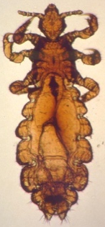
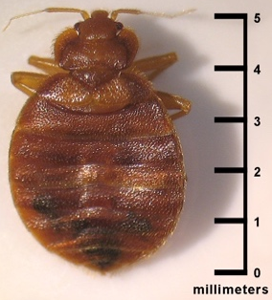
Bed Bugs

Figure I: Bed bug image (on the left) vs. head louse image (on the right)3

Bed bugs are small, crawling parasitic insects that rely on the blood of people or animals while they sleep or stay in place for long periods of time. They are wingless (can’t fly) and can live several months without a meal. They are found globally and can infest new homes and areas quickly, but do not spread disease. The most common signs and symptoms of a bed bug infestation are dark fecal spots on furniture or bedding and the characteristic bite responses on body parts that make contact with the bed when the person is sleeping.
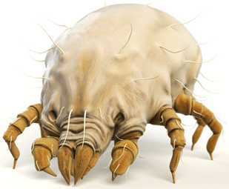
Scabies

Figure J: human itch mite image (on the left) vs. head louse image (on the right) 3
Human scabies is caused by a skin infestation of the small human itch mite, which burrows into the upper layers of the skin to live and lay eggs. Similar to head lice, scabies spread by prolonged direct contact with an individual who has a scabies infestation. The human itch mite does not transmit disease. Scabies can be found globally and are most common in crowded conditions, such as nursing homes, child-care facilities, and prisons. The most common signs and symptoms of a scabies infestation are a characteristic pimple-like skin rash and small burrow tunnels under the skin, along with intense itching.
Body Lice

Figure K: Body louse image (on the left) vs. head louse image (on the right)3

Body lice are parasitic insects that live on clothing or bedding used by persons with a body lice infestation. They spread both through direct-skin-to-skin contact with an infested person and through indirect contact with that individual’s personal bedding and other items. Body lice do transmit diseases, such as epidemic typhus, trench fever and louse-borne relapsing fever. Body lice infestations are mainly found in homeless populations and refugee camps and are rare for individuals who bathe regularly or have access to fresh laundry or bedding. The most common signs and symptoms of a body lice infestation are intense itching, vagabond’s disease (swelling of heavily bitten areas of skin that have become thick and discolored), and symptoms related to any transmitted diseases.
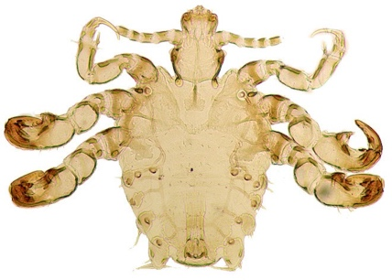
Pubic “Crab” Lice

Figure L: pubic louse image (on the left) vs. head louse image (on the right) 3
Pubic lice are parasitic insects found mainly in the genital area, although they can be found in other areas of coarse hair, such as eyebrows or eyelashes, armpits, beards or mustaches. According to the Center for Disease Control and Prevention (CDC), “Pubic lice on the eyebrows or eyelashes of children may be a sign of sexual exposure or abuse.” Pubic lice are most common in sexually active adults and are often difficult to find, requiring official diagnosis from a medical professional. Pubic lice are found globally and do not transmit disease, although their presence is often correlated with the presence of sexually transmitted diseases.16 The most common signs and symptoms of pubic lice are itching in the genital area and visible crawling lice.

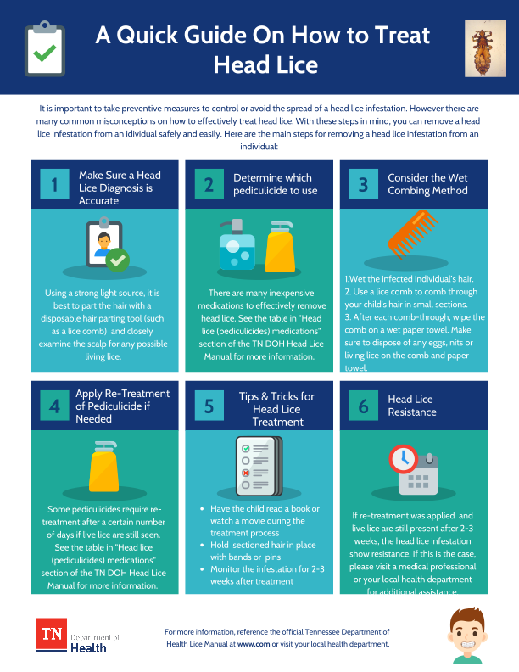
Appendix A: Quick Guide on How to Treat Head Lice

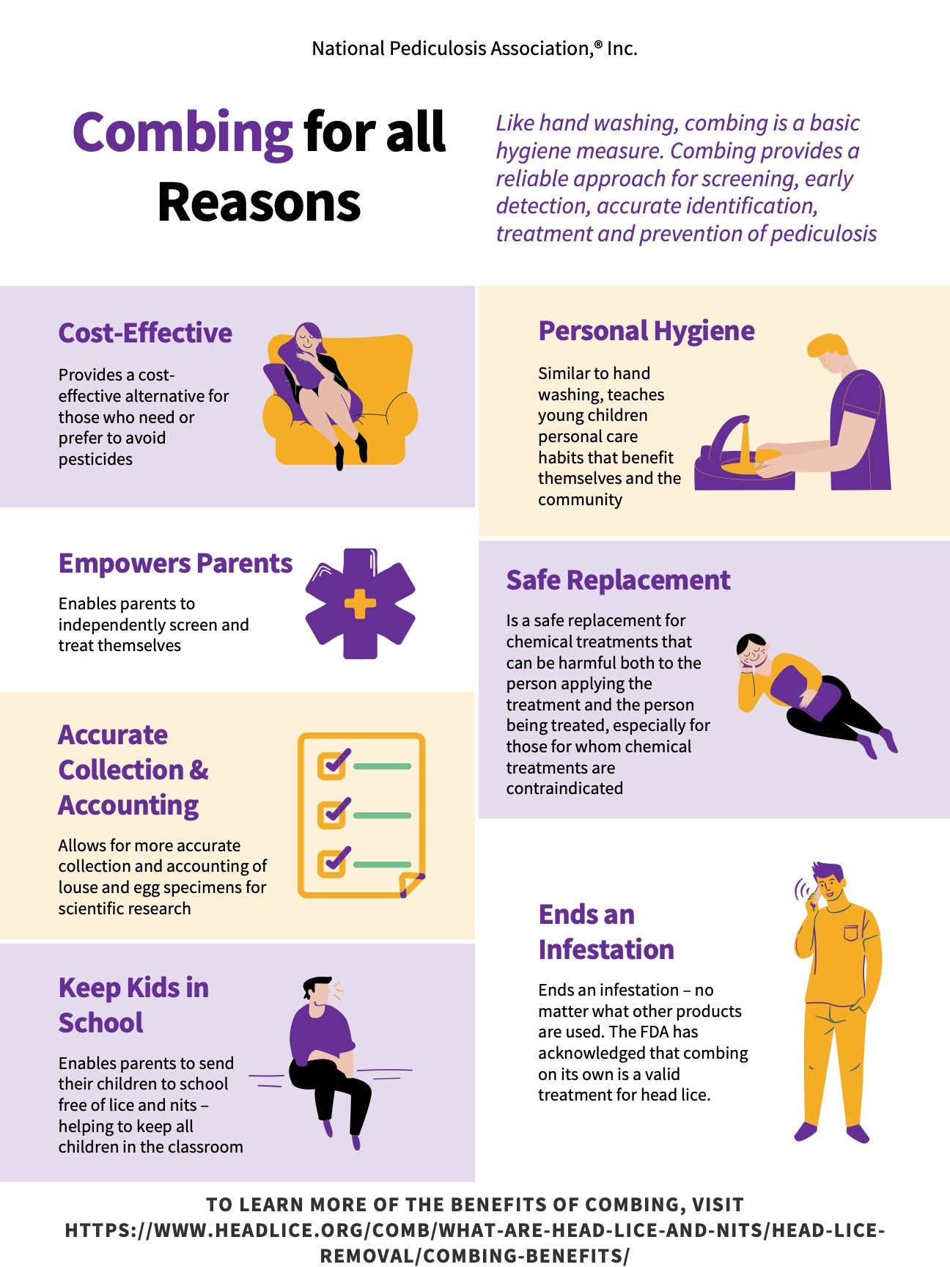
Appendix B: Benefits of Wet Combing

Appendix C: Head Lice Policy Recommendations
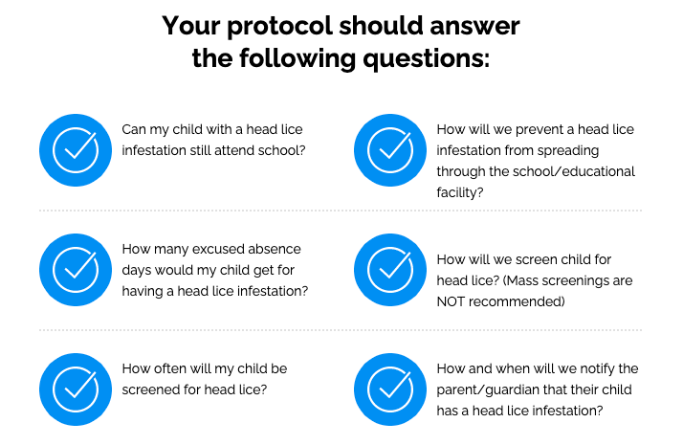

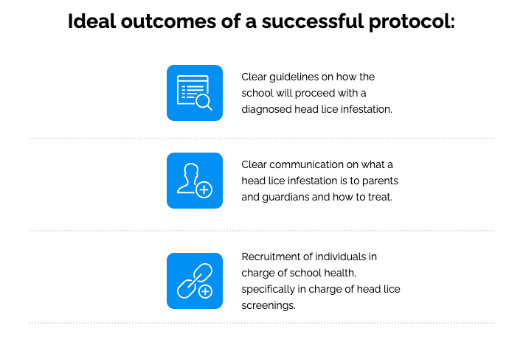

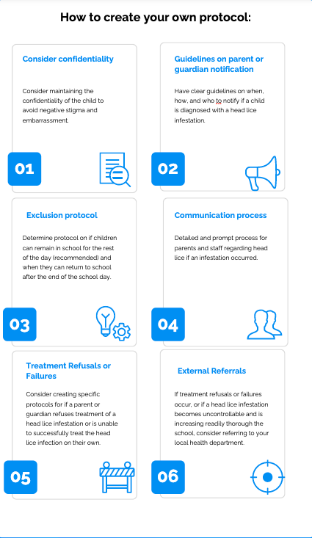

Appendix D: 10 Truths About Head Lice

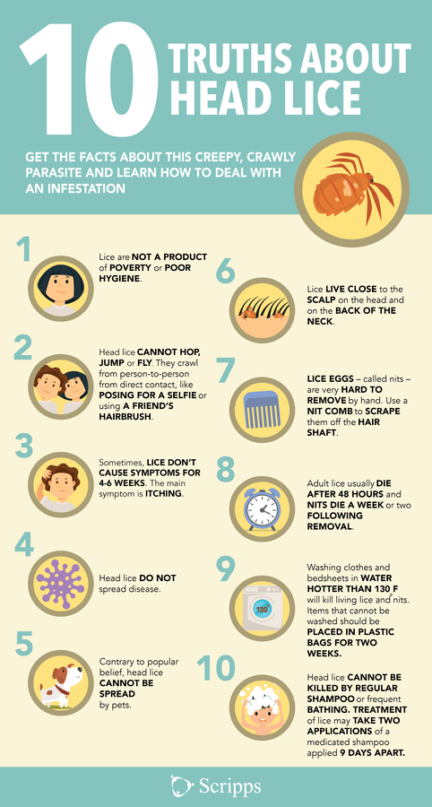

Araújo, A., L.F. Ferreira, N. Guidon, N. Maues da Serra Freire, K.J. Reinhard and K. Dittmar. 2000. Ten Thousand Years of Head Lice Infection. Parasitology Today, 16(7): 269.
Service, M. W. (2018). Medical entomology for students. Cambridge: Cambridge University Press.
Home - public Health IMAGE LIBRARY(PHIL). (n.d.). Open-source image. Retrieved April 14, 2021, from https://phil.cdc.gov/
Hansen RC, O-Haver J, (2004). “Economic Considerations Associated with Pediculus humanus capitis Infestation,” Clinical Pediatrics, 43 (6): 523-527.
Vail, K.M. 2018. Head Lice Spray Cans and Cleaners Found in Unlocked, Floor Cabinets in Classrooms for Young Children, Again! It’s Time to Remove Stored Insecticides from Classrooms! Pests and Pesticides in Child-serving Facilities: An IPM Newsletter 11(4): 1-2.
Kettle, D. (1995). Medical and Veterinary Entomology 2nd Edition. Wallington, UK: CAB International.
Nurse / head lice. (2016). Retrieved April 14, 2021, from https://www.etsdnj.us/Page/7071
Lice vs dandruff - 7 key differences between lice eggs and dandruff. (2021, March 14). Retrieved April 14, 2021, from https://myliceadvice.com/lice-vs-dandruff-lice-eggs-photos/
Devore, C. D., & Schutze, G. E. (2015). Head lice. PEDIATRICS, 135(5). doi:10.1542/peds.2015-0746
Gunning, K., Kiraly, B., & Pippitt, K. (2019). Lice and Scabies: Treatment Update. American Family Physician, 10, 635-642.
Goddard, J. (2003). Physician's Guide to Arthropods of Medical Importance (4th ed.). Boca Raton, FL: CRC Press.
[CVS Head Lice Removal Combs and Magnifying Glass, 2 CT]. (n.d.). Retrieved 2021, from https://www.cvs.com/shop/cvs-health-lice-removal-combs-and-magnifying-glass-2ct-prodid-1013430
Le Fur, L. (n.d.). [Young girl patiently sitting while having her head manually combed with a lice comb.]. Retrieved 2021, from https://www.abc.net.au/news/health/2020-09-24/how-to-get-rid-of-headlice/12523068
CDC. (2021, April 14). CDC- Parasites. Retrieved April 14, 2021, from https://www.cdc.gov/parasites/.
CDC - bed bugs - frequently asked Questions (FAQs). (2020, September 16). Retrieved March 31, 2021, from https://www.cdc.gov/parasites/bedbugs/faqs.html
Human itch mite. (2019, October 04). Retrieved April 14, 2021, from https://www.rottler.com/pests/profile/human-itch-mite
CDC - SCABIES - general information - frequently asked Questions (FAQs). (2020, September 01). Retrieved March 31, 2021, from https://www.cdc.gov/parasites/scabies/gen_info/faqs.html
CDC - lice - body lice - general information. (2013, September 24). Retrieved March 31, 2021, from https://www.cdc.gov/parasites/lice/body/gen_info/index.html
Pearson, G. (2017, June 03). Pubic lice: Still not going extinct. Retrieved April 14, 2021, from https://www.wired.com/2014/09/pubic-lice-still-not-going-extinct/
CDC - lice - Pubic "crab" - general information - frequently asked Questions (FAQs). (2020, September 17). Retrieved March 31, 2021, from https://www.cdc.gov/parasites/lice/pubic/gen_info/faqs.html
https://www.headlice.org/comb/what-are-head-lice-and-nits/head-lice-removal/combing-benefits/
https://www.scripps.org/news_items/4316-ridding-your-kid-of-head-lice

