Brief Description: A vaccinator is a licensed healthcare professional who has the appropriate training and certification to screen and vaccinate clients.

Jynneos vaccine is a vaccine indicated for prevention of smallpox and monkeypox disease in adults 18 years of age and older determined to be at high risk for smallpox or monkeypox infection. Since August 9, 2022, the standard regimen has been authorized for people aged <18 years under an Emergency Use Authorization. Jynneos vaccine is an attenuated, non-replicating live vaccine in suspension for injection. It elicits a humoral and cellular immune response to orthopoxviruses for the prevention of smallpox and monkeypox.

Jynneos vaccine- 18 years old and Older
  - Each vial contains preservative free sterile liquid.
  - Each vial contains 5 doses administered intradermally for adults.
  - Schedule- 2 dose (0.1ml) series, separated by 28 days. Administered intradermally
  - If Vaccine is frozen, vial needs to thaw prior to administration.
  - Once punctured/uncapped- viability is only 8 hours.
  - DO NOT REFREEZE ONCE THAWED.

Jynneos vaccine- LESS than 18 years old
  - Each vial contains preservative free sterile liquid.
  - Each vial contains 1 dose administered subcutaneously for adults.
  - Schedule- 2 dose (0.5ml) series, separated by 28 days. Administered subcutaneously
  - If Vaccine is frozen, vial needs to thaw prior to administration.
  - Once punctured/uncapped- viability is only 8 hours.
  - DO NOT REFREEZE ONCE THAWED

Dosing Intervals
- The second dose may be given at day 29-35. If the second dose is not administered during the recommended interval, it should be administered as soon as possible.
- Avoid scheduling 2nd dose prior to 28 days (minimum interval) as per the manufacturer’s instructions. However, based on ACIP’s general best practices, a dose may be administered up to 4 days before the minimum interval of 28 days (grace period, minimum of 24 days after the first dose). Nevertheless, if the second dose is inadvertently administered before the minimum interval, the dose may not need to be repeated.

Vaccine Effectiveness
  - In earlier studies in Africa, the smallpox vaccine was 85% effective.
  - Jynneos vaccine effectiveness was concluded from clinical studies on the immunogenicity and from efficacy data from animal studies.
  - When fully vaccinated, peak immunity is 2 weeks after 2nd vaccine (Jynneos is given as 2 vaccines, 28 days apart). Duration of immunity is unknown.
  - After contact to a Monkeypox case (high and intermediate risk): The vaccine must be given within 4 days of last day of exposure to prevent disease OR if given 4 to 14 days after exposure, the vaccine will lessen the severity of illness.

Contraindications and Precautions of Jynneos Vaccine
- Contraindications
  - Severe allergic reactions (anaphylaxis) to a previous dose(s) of Jynneos vaccine
- Precautions
  - Immediate allergic reaction (within 4 hours of exposure) to Eggs or Eggs products
  - Immediate allergic reaction to Benzonase, Tromethamine (Tris), Gentamycin and/or Ciprofloxacin
  - History of immediate allergic reaction to any other vaccine or injectable therapy; IM, intravenous, or subcutaneous vaccines or therapies not related to Jynneos vaccine or other smallpox/monkeypox vaccine.

- Definition: Immediate allergic reaction is defined as any hypersensitivity-related signs or symptoms such as urticaria (hives) angioedema (swelling), respiratory distress or anaphylaxis that occurs within four hours following exposure to a previous dose of Jynneos vaccine or other smallpox vaccine or other vaccines or medications.

Adverse Reactions- Majority had local or systemic reactions post-vaccination lasting 1 to 6 days (both naïve and experienced).
  - Adverse Reactions and Events of Jynneos Vaccine (Vaccine Naïve)

- Localized

  - Pain at the injection site
  - Redness
  - Swelling
  - Induration
  - Itching

- Systemic
- Muscle pain
- Headache
- Fatigue
- Nausea
- Chills
  - Fever (>100.4°F)

- Adverse Reactions and Events of Jynneos Vaccine (Vaccine Experienced, who had monkeypox or smallpox vaccine in the past).

- Localized

    - Redness at the injection site
    - Pain at the injection site
    - Induration
    - Swelling
    - Itching (injection site)

    - Systemic
  - Fatigue
• Headache
• Muscle pain
• Nausea
• Chills
• Fever (>100.4°F)

Clinical Considerations:
- History of Infection
  - This vaccine is not indicated for treatment of monkeypox or smallpox.
  - This vaccine is used as a pre-exposure or post-exposure prophylaxis treatment for prevention of Monkeypox/Smallpox.

Person with underlying medical conditions
- HIV or other immunocompromising conditions including immunosuppressive medications
    - Safe to administer in immunocompromising conditions.
    - Potential for reduced immune response after vaccination.
    - Need to continue to follow all current guidelines to protect against Monkeypox.
    - Vaccine naïve HIV infected adverse reactions were similar or lower than non-HIV infected vaccine naïve individuals.
    - Vaccine experienced HIV infected adverse reactions reported fever and chills at 1.5% and 8.4% and the remainder of side effects were similar to non-HIV infected vaccine experienced.

Pregnant or lactating people
- Human data is insufficient to inform vaccine-associated safety risk in pregnancy of the Jynneos vaccine. It has been shown to be safe to the developing fetus in animal studies; rats and rabbits.
- In lactating people, it is not known if Jynneos is excreted in breast milk. It is not known the effects of breast milk on the breast-fed infant or on milk production/excretion.
- A person offered JYNNEOS vaccine due to an exposure to monkeypox virus or disease should be vaccinated regardless of concurrent pregnancy or breastfeeding.

Persons with Heart Disease or Multiple Cardiac Risk Factors:
- No increase in risk of myocarditis or myopericarditis found in studies with Jynneos vaccine.
- Persons with underlying heart disease or >3 major cardiac risk factors for myocarditis or myopericarditis should be counseled about the risk of vaccine since uncertain about etiology of myocarditis or myopericarditis with replication competent smallpox vaccines like ACAM-2000.
  - Major cardiac risk factors: Hypertension, Diabetes, Hypercholesterolemia, Heart disease at age < 50 years in a 1st degree relative, and smoking

Concurrent Vaccinations
- Separate Jynneos vaccine from other mRNA COVID-19 vaccines by >30 days due to myocarditis risk. If an orthopoxvirus vaccine is offered for prophylaxis in the setting of a monkeypox outbreak, orthopoxvirus vaccination should not be delayed because of recent receipt of a -19 vaccine; no minimum interval between COVID-19 vaccination with these vaccines and orthopoxvirus vaccination is necessary.
- Because JYNNEOS is based on a live, attenuated non-replicating orthopoxvirus, JYNNEOS typically may be administered without regard to timing of other vaccines. This includes simultaneous administration of JYNNEOS and other vaccines on the same day, but at different anatomic sites if possible.

Observation Period Following Monkeypox Vaccination
- 15 minutes
- 30 minutes
  - if they have a history of anaphylaxis to Benzonase, Tromethamine (Tris), gentamicin, ciprofloxacin, chicken, or egg protein
  - History of immediate allergic reaction to any other vaccine or injectable therapy; IM, intravenous, or subcutaneous vaccines or therapies not related to Jynneos vaccine or other smallpox/monkeypox vaccine
Preparing the vaccine to be administered INTRADERMALLY:
- Allow the vaccine to thaw and reach room temperature before use (should take 5 minutes)
- Once thawed, inspect for particulate matter or discoloration, (milky light yellow to pale white colored)
- Place in coolers for up to 12 hours (if thawed and uncapped). (2 to 8°C per data logger)
- Clean hands with alcohol hand sanitizer
- When ready to use, gently swirl vial for at least 30 seconds
- Wipe the top of the vial with an alcohol wipe
- Withdraw 0.1 ml into a sterile syringe (½ inch, 27 gauge, 1ml) for administration and carefully replace the syringe cap

Prior to administering vaccine:
- Assure that you have 0.1ml of Jynneos vaccine in the syringe and you have a ½ inch, 27-gauge needle before injecting the patient.
- If the volume is less than the recommended or there is particulate matter or discoloration, please do not vaccinate the patient and return the dose to Denise Flores.

Administering Vaccine
- Route: Intradermal injection
- Site-Forearm area, (see Figure 1)
  - Steps
    - Change gloves and use hand sanitizer before and after each patient.
    - Instruct patient to extend her/his arm, support the elbow and forearm on a flat surface and clean the injection site, typically the inner side of the forearm
    - Choose the injection sire that is free of hair, moles, rashes, and scars.
    - Clean the injection site with an alcohol swab
    - Pull the skin taut with your nondominant hand and slowly insert the needle, bevel up, at a 5-to-15-degree angle, until the bevel is just under the epidermis (Figure 2)
    - Inject 0.1ml slowly. You will immediately see a wheal or bubble-like area on the skins surface. (Figure 3)
    - DO NOT rub the area after giving injection
    - A person who presents for their second JYNNEOS vaccine dose who is still experiencing erythema or induration at the site of intradermal administration of the first vaccine dose (e.g., the forearm) may have the second dose administered intradermally in the contralateral (opposite arm) forearm.

Figure 1. Location for intradermal injection

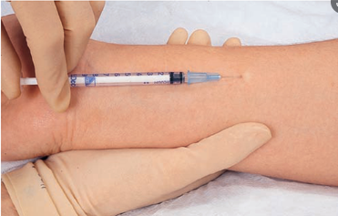

Figure 2. Layer of injection for Intradermal injection

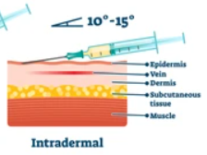

Figure 3. Results of Intradermal Injection

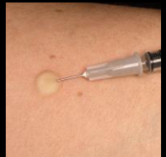

PLEASE USE SUBCUTANEOUS ROUTE FOR THOSE LESS THAN 18 YEARS OLD OR FOR THOSE WITH HISTORY OF KELOID SCARRING

Preparing the vaccine:
- Clean hands with alcohol hand sanitizer
- When ready to use, gently swirl vial for at least 30 seconds
- Wipe the top of the vial with an alcohol wipe
- Withdraw 0.5 ml into a sterile syringe for administration and carefully replace the syringe cap.

Prior to administering vaccine:
- Assure that you have 0.5ml of Jynneos vaccine in the syringe and you have a 5/8-inch, 23-25 gauge before injecting the patient.
- If the volume is less than the recommended or there is particulate matter or discoloration, please do not vaccinate the patient and return the dose to Denise Flores.

Route: Subcutaneous injection
- Site-Deltoid area, back of upper arm (see Figure 1)
- Identify the injection site using anatomical landmarks
- The injection site is on the dorsal aspect in the middle of the upper arm, adjacent to the tricep muscle
- Insert the needle at a 45-degree angle into the subcutaneous tissue (see figure 2) on the identified injection site
- Lift the fat and skin away from the muscle (Figure 3.) and inject all the vaccine

Figure 4. Location for subcutaneous injection
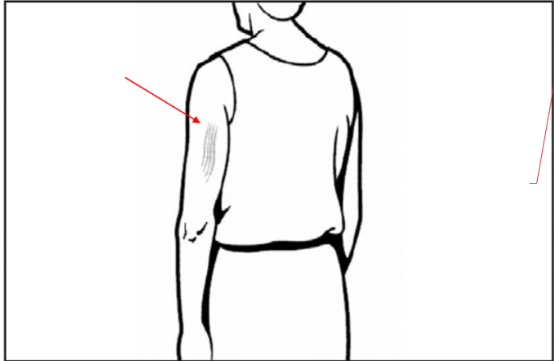

Figure 5. Layer of injection for subcutaneous injections
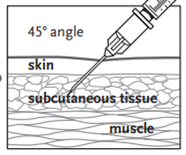

Figure 6. Technique for subcutaneous injections
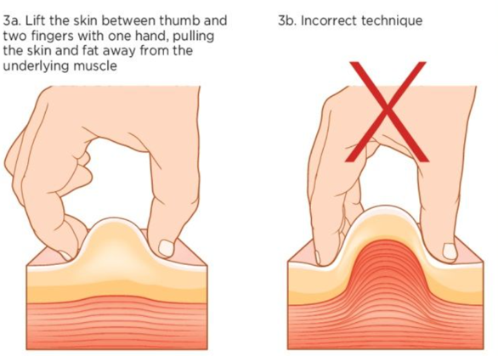

Interchangeability of dosing recommendations
- When necessary, a person aged 18 years or older who received one JYNNEOS vaccine dose with the standard subcutaneous regimen may receive a second dose with the alternative intradermal regimen at the recommended interval (i.e., 28 days) to complete the vaccination series. For example, a person who received only one dose of the subcutaneous regimen before the date of initial Emergency Use Authorization for the intradermal regimen (August 9, 2022), may receive one dose with the alternative regimen to complete the series. Also, a person whose 18th birthday occurs between their first and second dose may complete the series with the alternative regimen.

Personal Protective Equipment (PPE)
- Vaccinators will be required to use the following PPE during vaccination.
  - N95 mask
  - Gloves – change gloves and conduct hand hygiene before and after each employee/patient
  - Gowns
  - Eye protection (googles or face shield)

Infection Control
- Change gloves and use hand sanitizer before and after each patient.
- At the beginning, in-between each patient and at the end of each clinic, use disinfectant wipes to clean your areas (chair, table, and anything that was touched during appointment).
- Keep 6 feet distance from patient before/after administering vaccine

Protecting the Cold-Chain
- Vaccines are kept in specialized vaccine coolers during the Monkeypox Vaccine Clinic.
- Keep the vaccine coolers closed and zipped when not in use.
- Do not remove more than 1 vaccine from the cooler at a time.
- Please ensure temp data logger is working. Temperature should read 2-8°C (if refrigerated) at all times.

Standing Orders
- Prior to the start of the clinic, all vaccinators must thoroughly read and understand the Monkeypox vaccine standing orders issued by the Medical Epidemiologist and the Adverse Reaction Management Standing Orders.
- All vaccinators must comply with the Lake County Health Department standing orders.
- Medical questions or questions about the standing orders should directed at the Medical Epidemiologist if necessary (847-309-9671).

Steps from Checking in to documenting.
- Patient will walk in and check in with the STI Staff
- Patient will be given a consent form and screening questions to fill out and a copy of the VIS/EUA/Monkey Pox Facts to read prior to vaccination
- After all documentation is filled out, the patient will head to the screeners to make sure all documentation is completed and to answer any questions that screener or patient may have.
- Screener will walk the patient to the vaccinator with vaccine and paperwork
- Vaccinator will confirm name and dob of patient from screening form to assure that they have the correct patient.
- Vaccinator will vaccinate patient and have them walk to the waiting room to schedule their 2nd appointment.
- Vaccinator will fill out the Lot Number, Expiration Date, Site, Route, Dose, Date Vaccine was given, signature and put the document on the desk to be pick up by IZ staff
- Vaccinator will make sure to clean table, chair, and any area the patient touched prior to accepting another patient.
- IZ staff will collect documents from desk and document in the nurse visit encounter with confirmation of no symptoms, provision of VIS statement, counselling and asking of questions and administration of vaccine

Observation Post-Vaccination
- Be prepared to respond to medical emergencies per the Management of Adverse Reactions standing orders.
- Please review prior to the clinic and be familiar with these standing orders.
- A stocked emergency bag is available in the vaccination area. Make sure to know where it is located prior to the clinic.

Needle sticks
- If a vaccinator experiences a needle stick, notify Mark Horner at 847-377-8056 before the patient leaves the clinic.
- The vaccinator shall wash the area thoroughly with soap and water.
- The vaccinator or supervisor will ask the patient to supply a blood sample per our agency’s protocol.
- The vaccinator will proceed to an LCHD/CHC occupational health facility for a blood draw.
- The vaccinator must create an incident report within Health Safety Zone, the LCHD/CHC incident reporting platform (https://events.healthcaresafetyzone.com/EventsModuleWeb/default.aspx?cs=d13c51f1-6cac-4beb-abd2-d7b9e5b7387f)..

VAERS Reporting Requirements

- Healthcare professionals are required to report the following to the Vaccine Adverse Event Reporting System (VAERS):
- Vaccine administration errors (whether associated with an adverse event [AE] or not). This would include injecting in correct site, damage to needle while injecting, etc.
- If an administration error occurs, please complete the VAERS report form and notify Denise Flores at 847-989-0226.
- The vaccinator must create an incident report within Health Safety Zone, the LCHD/CHC incident reporting platform (https://events.healthcaresafetyzone.com/EventsModuleWeb/default.aspx?cs=d13c51f1-6cac-4beb-abd2-d7b9e5b7387f)..

