- Reviewed UC Past Discussions
  - Discussed how to ID UC types (Urgent Care, Primary Care, Specialty Care, and combinations of these)
    - WA adds “U -“ to the beginning of the MSH field 4.1 name to ID Urgent Care, add “H - “ to ID Emergency Departments, add “P - “ to ID Primary Care, add “S - ” to ID Specialty Care, “UPS – “ to ID Urgent Care, Primary Care, and Specialty Care (together), etc.
    - Another way of doing this is to use the Facility Visit Type field 5 values (noted in HL7 OBX field 3 value “SS003, )
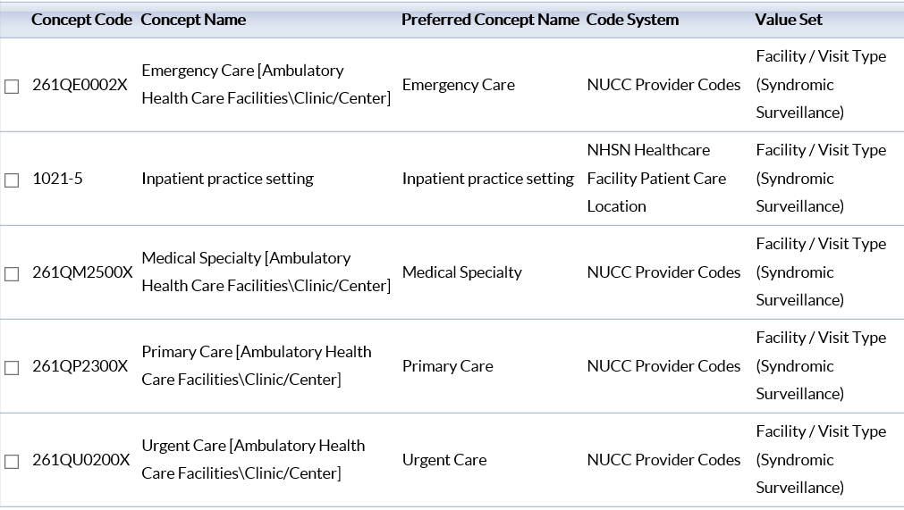
    - FL advised they also use PV1 field 2 “Patient Class” on the left below with “O” (Outpatient) and see if new value “U” could be included for Urgent Care or could use, or use PV1 field 4 “Admission Type” value “U” (on right below)
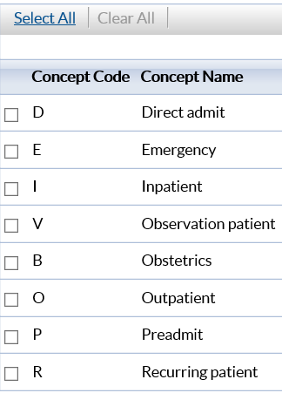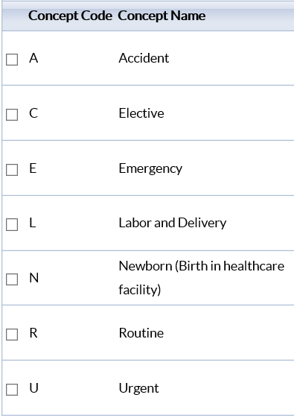
- Discussed referrals from a SCOPUS article. In the Scopus article survey a third of patients (over 65 were referred to ED by GPs and Specialists) and these patients were concerned with the comprehensive, quality care in the ED. UC sub-committee meeting attendees noted that ED referrals show up in Chief Complaint text and in Triage Notes.
- Older adults will likely continue to use EDs for non-urgent medical care until "one-stop" settings better address the needs of this population.
- Discussed Other UC Topics
  - UC collection is low compared to hospital collection (based on NSSP CoP Survey feedback):
- WA advised they have 1/3 of their identified UC facilities onboarded (113/330)
- FL advised they have 8% (80/1000) of hospital UC facilities onboarded
- A number of jurisdictions aren’t collecting at this time
  - Data quality challenges/issues
    - FL advised low volume for UC chief complaint, triage notes, discharge diagnosis codes (compared to ED), issue of greater onboarding timeliness with UC within 24 hour period, and concern on how to filter UC from ED patients
    - UC used for events such as school and sport physicals, queried NH UCs and advised primarily used for injuries/STDs (Sexually Transmitted Diseases)/Acute Respiratory Ill ess (includes ILI)
    - Discussed surveying NSSP CoP regarding issues, and developing a standardized way of identifying UC – but tabled for now
  - Future ESSENCE UC reporting
    - Dave added UC reporting as a possible future ESSENCE reporting request via the Technical Committee
  - Questions regarding UC in rural settings:
    - What is the value of UC in rural settings?
    - What are typical utilization patterns in jurisdictions onboarding UC?
    - Are UCC’s expanding treatments?
- Discussed new SCOPUS UC-related articles:
  - The Urgent Care Surge, by Joseph Burns, Managed-Care (Langhore, PA), 38(5), pp. 38-43, April 30, 2019. Three main points – UC growth has increased yearly since 2013, has overtaken ED low-acuity conditions in 2012, and in 2017 patients are primarily covered by commercial insurance followed by Medicare and Medicaid
    - https://www.managedcaremag.com/archives/2019/5/urgent-care-surge
    - 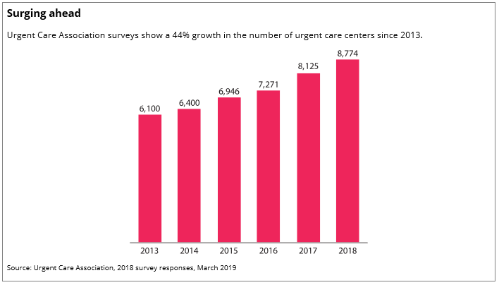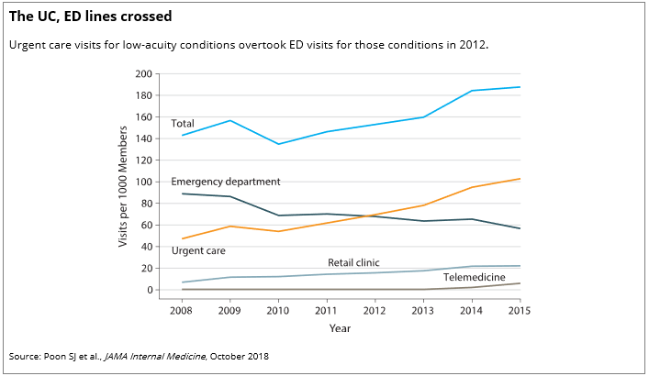
    - 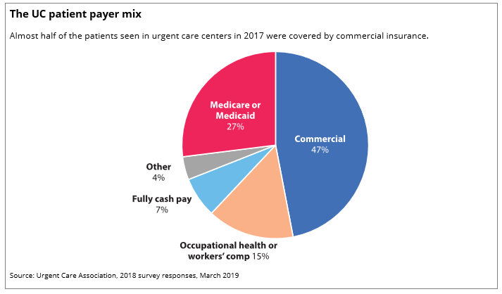
  - Impact of Urgent Care Openings on Emergency Department Visits to Two Academic Medical Centers Within an Integrated Health Care System by L. Carlson, etc., Annals of Emergency Medicine, 2019
    - https://www.sciencedirect.com/science/article/abs/pii/S0196064419305347
    - In this paper, we aimed to assess the change in low-acuity ED utilization at 2 academic medical centers in relation to patient proximity to an affiliated urgent care. Conclusion…in similar settings urgent care center development may be an effective strategy for health systems hoping to decrease ED utilization for low-acuity conditions at academic medical centers. We identified a statistically significant reduction in the likelihood of ED visits for low-acuity conditions by patients living within 1 mile of an urgent care center at 1 of the 2 academic medical centers.
  - Urgent Care Center and Emergency Department Utilization for Non-Emergent Health Conditions: Analysis of Managed Care Beneficiaries by A.C. Adigun, etc., Population Health Management, 22(5), pp. 433-439, 2019
    - https://www.researchgate.net/publication/329405160_Urgent_Care_Center_and_Emergency_Department_Utilization_for_Non-Emergent_Health_Conditions_Analysis_of_Managed_Care_Beneficiaries
    - The objective was to identify predictors of utilization for urgent care centers (UCCs), emergency departments (EDs), or for both services for non-emergent health conditions among beneficiaries from a managed care organization (MCO) who resided within a 10-mile radius of UCCs. About 22.7% were UCC users, 66.8% were ED users, and 10.5% used both. African Americans (incident rate ratio [IRR] = 0.95; 95% confidence interval [CI]: 0.91-0.98] were less likely to use UCCs and more likely to use the ED (IRR = 1.10; 95% CI: 1.07-1.13). Beneficiaries with multiple chronic conditions were more likely to use the ED than UCCs. Distance was not a predictor of UCC or ED usage. Utilization of UCC was low for non-emergent health conditions. African Americans and individuals with multiple chronic conditions preferred the ED to UCC for non-emergent health conditions. This study implies that MCO beneficiaries, especially the African American population, need to be informed about UCC locations and services provided.
  - Urgent Care Finds Its Place In the Age of ACOs by Richard Kirkner, Managed Care, 11/16/2014
    - https://www.managedcaremag.com/archives/2014/11/urgent-care-finds-its-place-age-acos
    - ‘We do not want to be in competition; we want primary care to refer to us and we want to refer to primary care,’ says Jack Cornwell, MD, regional medical director at CareWell Urgent Care.
    - Urgent care is finding its place in the shared-risk model… a doc-in-a-box concept. It provides a higher level of care than a retail clinic or a primary care physician’s office, but not the higher level of service that an emergency room provides.
    - The broadest definition of urgent care, as defined by the Urgent Care Association of America, is treating walk-ins for acute illness or injury that does not threaten life or limb and is beyond the scope of the typical primary care practice or retail clinic.
- Discussed new Topic - What is new regarding UCC in Rural Settings?
  - Using Urgent Care Centers to Support Rural Patient Care Access by Sarah Heath, AHA guidebook
    - November 07, 2017 -Urgent care centers are effective for overcoming patient care access issues in medically underserved areas, according to the American Hospital Association (AHA).
    - Urgent care centers attend to emergency medical situations that are not life-threatening, such as a laceration, broken bone, or sprain; and can meet rural medical needs of the community while reducing costs (as they are less costly than ED’s)
    - AHA Developed guidebook and Strategies (toolkit) to Enhance Rural Healthcare Access (https://www.ama-assn.org/about/research/health-workforce-mapper)
    - Medical Resident Shortage Hinders Rural Patient Care Access. AHA recommended a Congress-sponsored UCC demonstration program that would test different payment models for the offices (advised break-even point is 25 patients/day).
  - Jurisdictional UC feedback regarding rural setting:
    - I questioned who to share the AHA guidebook and toolkit in our call and Amanda Morse (WA) and NH (me) advised we’d share this in our jurisdictions (I shared the AHA information with NH’s Rural Health Program manager and plan to share with NH’s Hospital Association too).

    - Krystal Collier and Sara Chronister shared a mobile urgent care clinic advertisement (https://www.dispatchhealth.com/how-it-works/), another possibility for rural health access to health care. Check it out.
- Next UC Sub-committee meeting will be in January 2020

