This document contains the narrative that describes OD2A Linkage to Care DFD
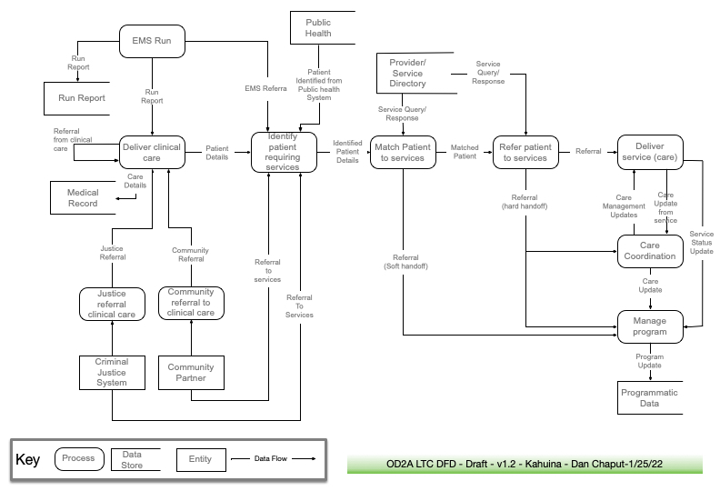

Supporting text for the OD2A LTC Data Flow Diagram v 1.1
Process: Justice Referral to Clinical Care – Data that describes the patient and a recommendation/order for care type of care the justice system sees as a need. Likely to include all the data from a community referral with additional information as required by the justice system.
Entity Description
Criminal Justice System - The criminal justice system entities at any jurisdictional level (e.g. local, county, state, tribal, territorial, federal, etc). Many of these programs have systems that conform to the NEIM information model. Concepts from that model should be considered for inclusion as indicators.

Process: Community referral to Clinical Care - Data that describes the patient and a recommendation/order for care type of care the community partner sees as a need.

Entity Description - Community Partner - Community based partners include any entity outside of clinical care and the criminal justice system.

Process: EMS Run - An EMS (ambulance) run occurs. Information is typically captured in an electronic patient care reporting (ePCR) system. When transport occurs, the patient is delivered to clinical care in an emergency department. If clinical care is not indicated there may be a referral from EMS to support services or the run may simply end with the filing of a run report that remains with the EMS provider.
Data flows
Run report - data that are stored or transmitted at the end of an ambulance run. This data is expected to conform to the NEMSIS standard. as delivered to clinical care it may be in paper or electronic format. It is an input into Deliver Clinical Care and is persisted by EMS, often in an electronic format.
EMS Referral - data that are shared with another system with the intent of beginning some service related to SUD. Intended to be from an EMS run that ended without transport to clinical care. A direct referral from EMS. May not include all the data from a run report, but likely a subset of a run report
Process: Deliver Clinical Care
- Clinical care is a grouping of any kind of care including emergency department, inpatient, outpatient, provider office, etc. Any setting where a clinical encounter could start the process.
Data Flows
Patient Details - Patient details include information from the electronic health record or other records collected by the clinical care during the clinical encounter. Likely including patient demographics, such as name, address, date of birth, gender, contact information, some clinical details, etc. It may be in the format of a discharge summary or some sort of transition of care.
Care Details - The creation or updates of a patient’s chart/medical record.
Referral from Clinical Care – As “clinical care” here is performed in a number of situations there may be referrals with the many systems involved. This data flow recognizes that fact.

Process: Community referral to clinical care – A referral from any community setting that may refer an individual to a clinical setting for care for SUD.
Dataflow
Community referral to clinical care
Any data sent with a patient who is referred to clinical care from a community setting. Assumed to be highly variable in content.
Referral to services
Any data sent with a patient who is referred to a service (other than clinical care) from the justice system. Assumed to be variable in content and formality.
Process: Justice referral to clinical care - Referrals from the criminal just system may occur from many entities and based on many criteria. As noted above, this may be any part of the justice system at any jurisdictional level (e.g. local, county, state, tribal, territorial, federal, etc).
Dataflow
Justice referral to clinical care
Any data used when a patient is referred from a setting in the justice system to a clinical setting. Data may conform to the NEIM information model. See: https://www.niem.gov/. A recent article in health affairs references minimal treatment occurring in such referrals: https://www.healthaffairs.org/doi/10.1377/hlthaff.2017.0890

Process: Identify patient requiring services
Some actor reviews a patient’s medical history. See note below. Screening tools may be utilized. There may be a local protocol. The actor decides whether to refer to other services for treatment or social services. Additionally, some programs collect information from sources within the public health system to identify individuals in need or services.
Note: The actor involved by be discharge staff, a care coordinator, patient navigator, etc. In a particular instance of this process, this may occur inside of another process including clinical care, the criminal justice system, community partner, or it may be a patient self-referring into some system.
Data flow
Identified patient details - these data include any patient details from the referring system with (possibly) the addition of information about any screening results and the types of services recommended for this individual patient.
Patient Identified from Public Health – Data collected data from a variety of public health sources & systems used to identify individuals in need of SUD services.
Date store
Public Health – The collection of data in the public health system used to identify individual patients. Includes hospital discharge, vital statistics, drug overdose reporting, PDMP, etc.
Process: Match Patient to Services
The actor matches a patient to a specific service (or services) based on the recommendation of the process”identify patient requiring services”, combined with patient demographics and SDOH characteristics, and referencing a provider/service directory for the optimal match to patient. As with “identify patient requiring services” this process may be included in another process such as “deliver clinical care”, as part of a discharge process from clinical care. Many different individuals may perform this process such as case managers, patient navigators, or peer navigators, etc.
Data flows
Service Query/Response - The data used to match a particular patient to a particular service. The query would include information on the type of service desired, location of the patient, preferred language, cultural and accessibility considerations, etc.
Matched patient - These data include all the information from upstream systems plus any data required to perform the actual referral. Additional queries and responses of a provider/service directory may be required to complete the referral. Like the preceding 2 processes it may be included as a process in another system.
Referral (soft handoff) - A soft hand off occurs when the patient is simply given information about a service or treatment and no further follow-up occurs. These data indicate to the OD2A program that a handoff occurred. Likely deidentified information is a summary format.
Data store
Provider/Service Directory – This may be an electronic source of data that could be queried, an info line “311” type of service, or at its simplest a list of available services. In a small community it may simple be common knowledge “in people’s heads”. It is assumed that additional information about this service such as contact information, location(s), services provided, languages spoken, accessibility considerations, etc. are available to provide a “best match”.
Process: Refer Patient to Service
The actual referral process where the patient is referred to a specific service as part of a hard handoff. Referral responses may be obtained from the service provider,
Dataflows
Referral - A referral occurs when the patient is introduced in some way to the service and the service confirms the handoff. These data are used to initiate the delivery of service.
Referral (hard handoff) - A hard hand off occurs when the patient is introduced in some way to the service and the service confirms the handoff. These data indicate to Care Coordination Staff (if there is any) and the OD2A program that a hard hand off occurred. For Care Coordination it would be identified information, for the program it may be deidentified information in a summary format.

Process: Deliver Service (care) - A particular service delivering services or care to a particular patient who has been referred to them.
Dataflows
Care update from service - Data on an identified patient or patients on the status of services being delivered. These might include that a patient has received a specified number of services, dates, and other information related to that specific service. It may also indicate missed appointments, and the inability to locate the patient, indicating lost to follow up.
Service Status Update - For programs or services where no case management exists these may be identified or deidentified data on the services being provided to individuals or summary data at the programmatic level. May range across a wide spectrum of formats and timing.
Process: Care Coordination
The process for those systems that have active Care Coordination, Case Management, Peer Navigation, or any similar process where there is follow-up at the individual level.
Data flow
Care Update - Information from the delivery service process combined with data from the care coordination process sent to program management in either a case level format or aggregate format as defined by the program.
Care Update from Service – Any details the care coordination process needs to share back to a service. Likely modifies what was requested in the referral. Examples include a request for extending services, some modification based on redundant services, etc.

Process: Manage Program
The process of managing the OD2A/LTC program has implemented in a jurisdiction. The part of the program that involvers tracking LTC and indicators to LTC. Note we end the process here. This diagram does not show the final management process of “reaching back around” to EHR’s, HIE’s, PDMPs, and other external system to reconstruct programmatic indicators.
Data store
Programmatic data – These data are used to develop programmatic reporting that would inform policy and program development and for reporting back to CDC.

