Meeting Minutes: CSTE Linkage to Care Community of Practice
Monday, January 24th
2:00 pm-3:15 pm EST

Recording link:

In attendance:
- Jessica Besecker, Delaware DHSS, OD2A
- Sarah Fulton, Case Western Reserve University, Cuyahoga County BH OD2A Evaluation
- Scott Johnston, Kansas Department of Health and Environment, OD2A Epi
- Yohei Iwashita, Commonwealth of the Northern Mariana Islands (CNMI) OD2A
- Shelby Nierman, Indiana Dept of Health
- Claire Nguyen - Oklahoma State Department of Health
- Caroline Judd, Delaware Division of Public Health
- Chelsea Clay, Arkansas Department of Health
- Arch Robertson, Arkansas Department of Health
- Sarah Vannice, Iowa Department of Public Health
- David Swenson, SyS Project Manager, NH DHHS DPHS
- Megha Parikh, MA DPH
- Kristy Arthur, Calif Dept of Public Health (CDPH SAPB)
- Danita Coulter, Kentucky Injury Prevention and Research Center/FindHelpNowKY.org
- Danielle Boyd_CSTE
- Christina Mrukowicz, Maricopa County (Arizona)
- Fei Wu, Missouri Department of Health and Senior Services
- Mary-Helen Wanat, Maricopa County (Arizona)
- Jade Skinner, Maine CDC
- Christina Galardi, CDC Foundation, Overdose Response Strategy - South Carolina
- Brenda Hernandez, MA Department of Public Health
- Rita Seith - Michigan
- Janet Nelson, Iowa Department of Public Health
- David Crow (he/his) - Cali DPH
- Daniel Rocha - FDOH Broward County
- Cody Hafford - Baltimore County DPH
- Kara Manchester, Ohio Department of Health
- Aaron Gardner, Riverside County, CA
- Marvin Smith , Oklahoma State Department of Health

2:00-2:10 Introduction
Cailyn Lingwall and Katie Loveland

Participant Poll Results
- Does your jurisdiction currently work with or manage PDMP data?

- Have you attempted to utilize PDMP to monitor opioid use disorder treatment and associated outcomes?
2:10-2:25 Linkage to Care Surveillance (LTC) Workgroup: CDC Prescription Drug Monitoring Program Overview

Wes Sargent, Division of Overdose Prevention, CDC

See attached slides

Dr. Robert Bree Collaborative Opioid Prescribing Metrics report shared by Wes
https://www.qualityhealth.org/bree/wp-content/uploads/sites/8/2018/06/Bree-Opioid-Prescribing-Metrics-Final-2017.pdf

2:25-2:45 Lela Kretzer: “Vermont’s Social Autopsy: An Analysis of Interactions with State Services Among Drug-Related Fatalities”

See attached slides

PDMP Group Discussion:

If you are working or managing PDMP data, in what ways are you using the data?
- Our PDMP data is managed by an external agency so we can only receive aggregate data. We plan on displaying prescribing patterns on our dashboard
- Oregon can and does data linkage.
- On Dashboard. We create indicators for safe prescribing (e.g., # of people on > 90 MMEs) and break down by geography
- Using for PRESCRIBER EDUATION planning
- Delaware is utilizing PDMP data on My Healthy Community (a data portal) and linked 2017 overdose death records to PDMP line level data.
Describe any ways that you are using PDMP data to monitor opioid use disorder treatment and associated outcomes.
- We link PDMP data to death data and nonfatal overdose data
- PDMP linked to fatal ODs
- Oregon PDMP has integrated with EHR’s and we both report prescribing but views etc informing use, risks, outcomes
What perceived barriers interfere with optimally working with PDMP data?
- We don't own the data and there are a lot of restrictions with data sharing
- PDMP data do not include MAT data
- Legal - strict interpretation of authorizing statutes
- Pharmacies not entering correct DEA number for providers
- Technical challenges with vendor (data going in but not coming out)
- Haven't been able to get prescriber-identified PDMP data to monitor AD; custodian (Justice) hasn't responded to data request submitted 1.5 years ago.
- Data housed at Narcotics Enforcement Division
- does not include VA and FQHC data
- Barrier: the agency that manages the PDMP data has a lot of restrictions for use. (E.g, can't "flag" individuals who have had an overdose
- PDMP for use and linkage has specific statute and rules that can limit who does and what information is shared with linkages

2:45-3:15 Overview and discussion of the Linkage to Care Indicators Project
Sarah Scott and Marcus Rennik, Kahuina Consulting

See attached slides
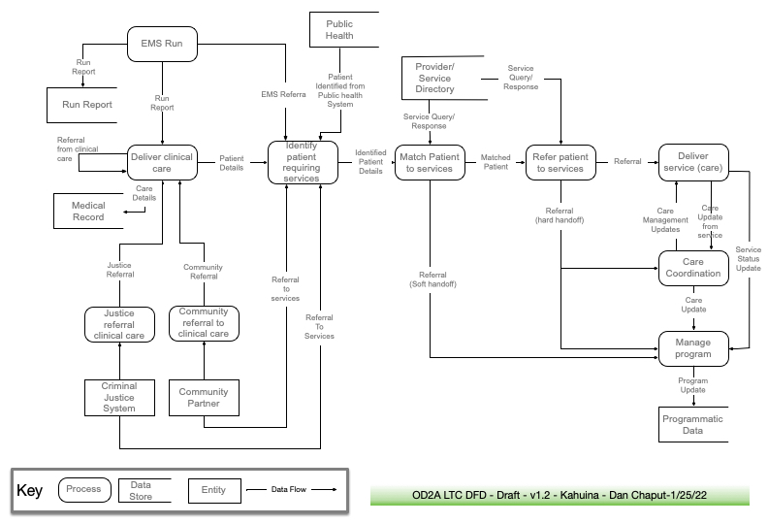
Please provide feedback to Kahuina Consulting at this Basecamp link: https://3.basecamp.com/3164497/join/qBR6JgvqmfBE

