CSTE Linkage to Care Community of Practice
Meeting Minutes- April 18th
2:00 pm-3:00 pm EST

In attendance:
- Ben Hallowell - RIDOH
- Cathy Lillehoj-IA DPH
- Rita Seith – MI
- Arch Robertson- Arkansas Department of Health
- Mary-Helen Wanat, Maricopa County Dept. of Public Health - Arizona
- Ron Prince - Wisconsin DPH/OD2A
- Danita Coulter, Kentucky Injury Prevention and Research Center - KY
- Cody Hafford - Baltimore County Department of Health
- Aaron Gardner, Riverside County, CA
- Asween Marco- Arkansas Department of Health
- Sarah Vannice - Iowa Dept. Public Health
- Caroline Judd, Delaware Division of Public Health
- Jennifer Liebreich, Association of Public Health Laboratories
- Scott Johnston, Kansas Department of Health and Environment
- Christina Mrukowicz, Maricopa County Department of Public Health
- Sarah Rosenberg, County of San Diego, CA
- Tammie Smith Hawaii State Department of Health Behavorial Health Administration, Adult Mental Health Division, Overdose Data to Action Grant Coordinator
- Diana Prieto, Florida Department of Health in Duval County
- Nick Black, Franklin County Public Health (OH)
- Dagan Wright - Injury and Violence Prevention Program - Public Health Division Oregon
- Treena Becker, Hawaii OD2A
- Yohei Iwashita, CNMI OD2A
- Kylie Yocum- CO Dept of Public Health and Environment
- Jan Markowitz, Baltimore County HD MD

2:00-2:10 Introduction
Katie Loveland, CSTE Contracted Facilitator
- Invitation to all participants to join Basecamp: https://3.basecamp.com/3164497/join/qBR6JgvqmfBE​​
- Register for CSTE Annual Conference (June 19-23) by May 5th at https://www.csteconference.org/index.php/2022-registration/

2:10-2:35 Novel approaches to linkage to care surveillance in Rhode Island
Ben Hallowell-Rhode Island Department of Health

Findings from Ben’s research: https://ajph.aphapublications.org/doi/abs/10.2105/AJPH.2021.306395
Full presentation slides will be added to Basecamp. For further questions contact Ben at Benjamin.hallowell@health.ri.gov

2:35-2:50 Discussion of continuum of care diagram and project updates

Sarah Scott—Kahuina Consulting

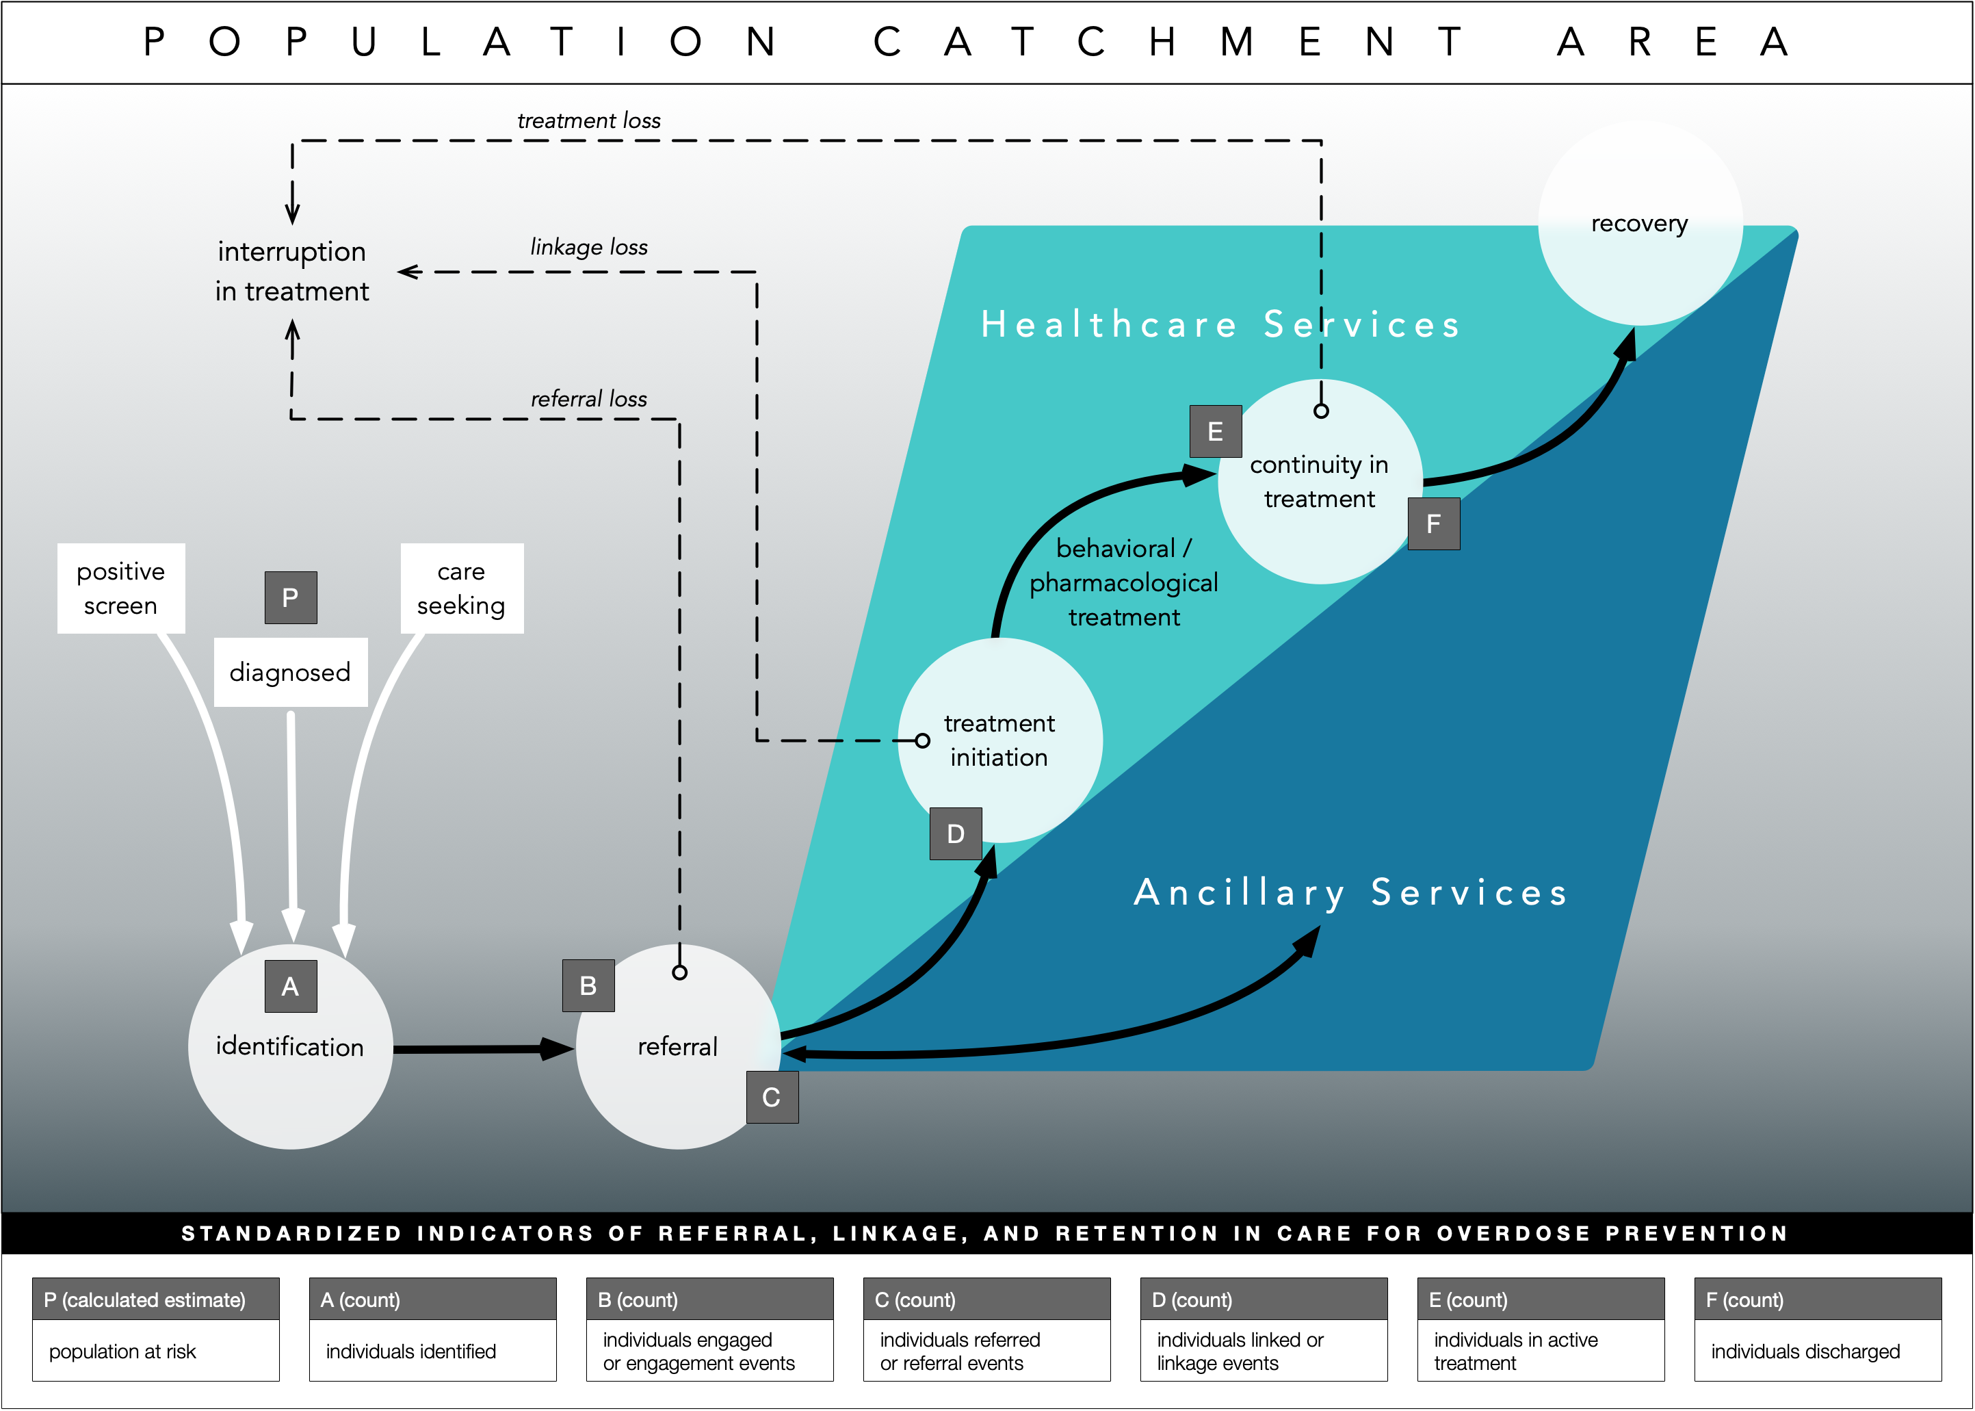

Please provide feedback on this Care Diagram at: https://3.basecamp.com/3164497/buckets/24532112/messages/4849275081

Questions for feedback:
Publicly-funded SUD treatment providers report unique, individualized treatment admissions and discharges to state agencies, which then standardize and submit Treatment Episode Data sets to SAMHSA.
- In your state, which agency collects the treatment episode data from the treatment providers?
- What is your program's relationship with this agency?
What, if any, data is available to you?
- Please describe the frequency, recency, and granularity of the data.
- What opportunities exist to work with this agency to enhance linkage to care surveillance?

2:50-3:00 Community of practice evaluation survey

Please complete the online survey to provide feedback on these calls!
https://www.surveymonkey.com/r/CSTECOPEval

