CSTE Innovative Surveillance Community of Practice
Local Outbreak Detection
Meeting Minutes- Monday, March 20th 2023
2:00 pm-3:00 pm EST

Recording
https://zoom.us/rec/share/ABUhb71BD8V_SYZXDPSW_Szm5yPMqqUlDafRV8hoOi0T2IJGPICMmDuqVjBOOnw.7hlMPaUszQ7Qc3zo

In attendance
- Becca Mickels, MO Dept of Health and Senior Services
- Aaron Gardner, Riverside County CA
- Kelsey Granger, APHL
- Lashunda Harden, New Jersey Department of Health
- Kylie Yocum, Colorado DPHE
- Jaime Iten, Ohio Department of Health
- Nicole Gautreau, Massachusetts Department of Public Health\
- Siobhan Loughman, Division of Epidemiology, New York State Dept. of Health
- Heath Cook, Knox County Health Department
- Daniel Rocha, FDOH
- Cody Hafford - Baltimore County Department of Health
- Lauren Bottoms-McClain, Cuyahoga County Board of Health
- Scott Johnston, Kansas Department of Health and Environment
- Cesar Arevalo, County of San Diego
- Morgan Murphy, DrPH - Cuyahoga County Board of Health
- Arch Robertson-Arkansas Department of Health
- Joe Simeone - Delaware Dept of Public Health
- Andrew Farrey, Kentucky Injury Prevention and Research Center
- April Vince, Cuyahoga County Board of Health, Northeast Ohio

Announcements:
CSTE Overdose Anomaly Toolkit: https://odalerts.cste.org/
OD2A Application website: https://www.cdc.gov/drugoverdose/od2a/funding-announcements.html

2:00-2:15 Introduction
Katie Loveland, facilitator

2:15-2:45 Knox County overdose response plan and data visualization
Health Cook, Knox County Health Department
Email: Heath.Cook@knoxcounty.org
See slides uploaded to Basecamp

2:45-3:00 Discussion

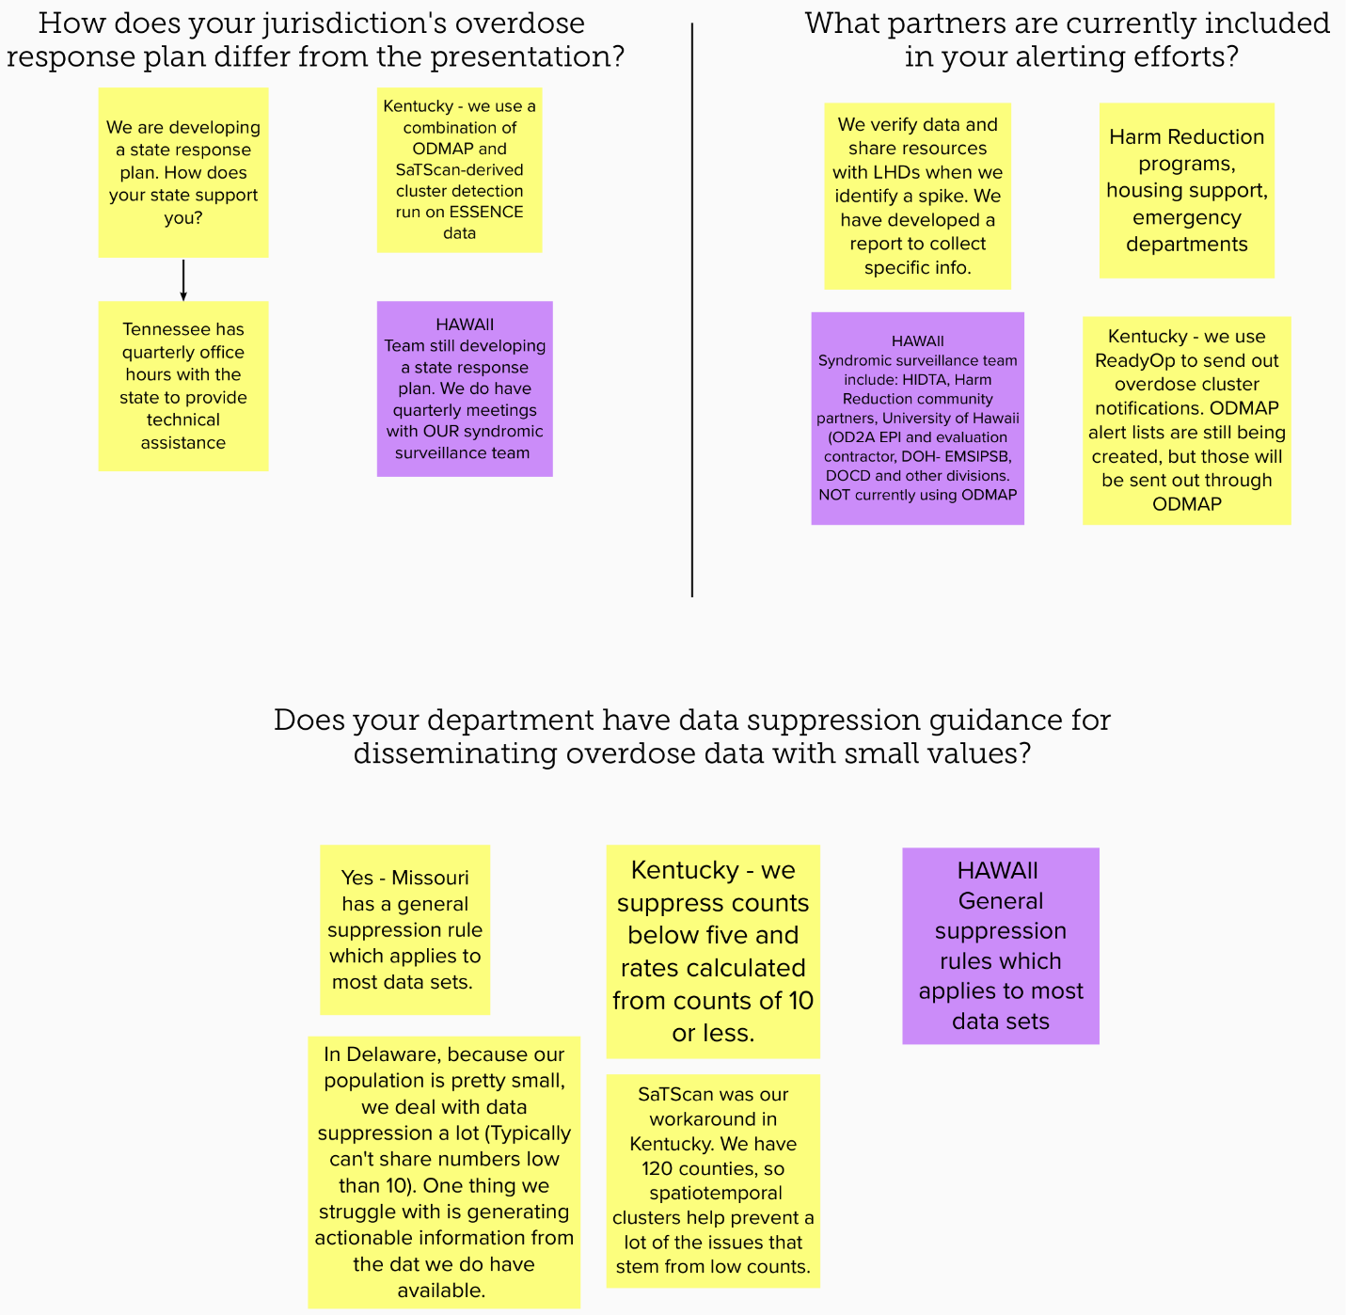

Idea for future meetings: Using SatScan for cluster analysis, especially for getting around the need to suppress small numbers. Example from Kentucky, “SaTScan was our workaround in Kentucky. We have 120 counties, so spatiotemporal clusters help prevent a lot of the issues that stem from low counts.”

