CSTE OH Spring Meeting – Speaker Ideas
Previous Conferences/Meetings to look to for speaker ideas:
- Adapting to Climate Change for Worker Safety, Health, and Wellbeing

Name: Brenda Jacklitsch
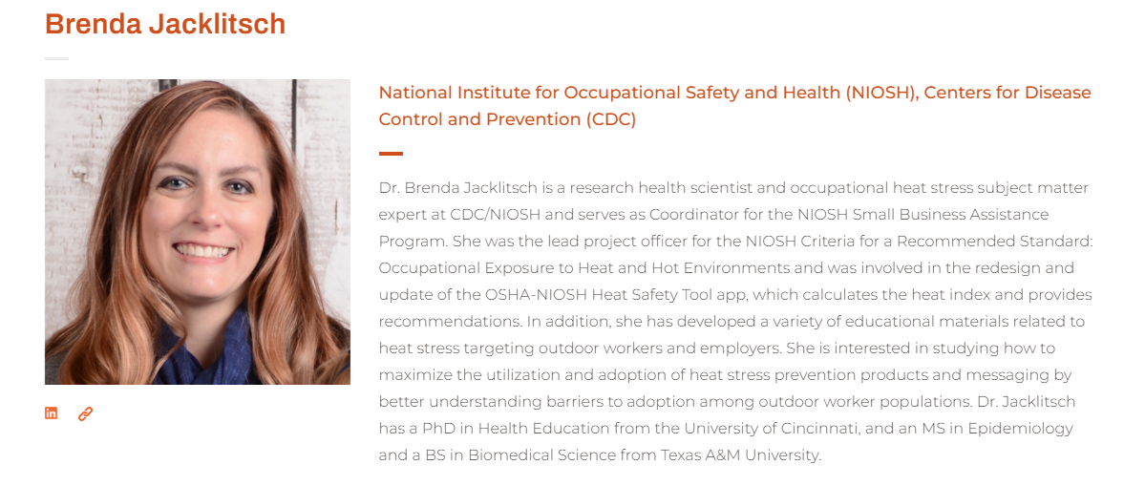Source: https://ghhin.org/people/brenda-jacklitsch/
Name: June T Spector, MD, MPH
Position: Associate Professor at UW, Environmental and Occupational Health Sciences
Research Focus: Heat Exposure and Working Populations
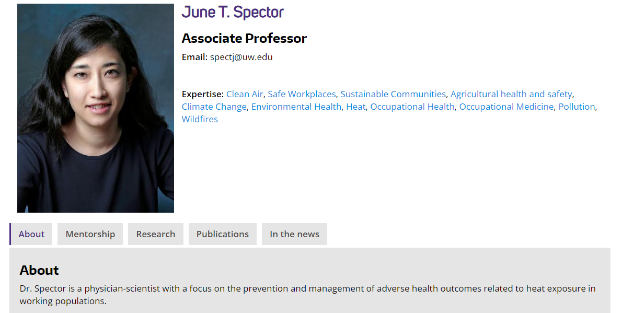
https://deohs.washington.edu/faculty/june-t-spector

Name: Paul Schulte, Ph.D., Director, Division of Science Integration, National Institute of Occupational Safety and Health (NIOSH), Centers for Disease Control and Prevention, Cincinnati, OH
Position: Director, Division of Science Integration, National Institute of Occupational Safety and Health (NIOSH), Centers for Disease Control and Prevention, Cincinnati, OH

Name: Michelle Tigchelaar, PhD
Research Focus is broader than climate and occupational health, but she has conducted a study on heat / ag workers, as well as prepared climate justice workshops for labor unions in Washington State (according to her website).
Source: https://michelletigchelaar.weebly.com/
Of note, their Focus: has studied heat and agricultural workers; not as broad on climate and working populations in general. See press release article detailing overview of the ag/heat study.

Organization: The National Council for Occupational Safety and Health (COSH) has a Heat and Climate Justice webpage. They had a webinar on Organizing for Heat Safety in the workplace. Could Consider reaching out to them to get more of an advocacy perspective. While not surveillance focused, could be nice to have a short presentation from someone who demonstrates how public health data/surveillance can inform advocacy efforts.
https://nationalcosh.org/heat-climate-justice

Name: Jeff Bethel, Ph.D
Research Focus: distribution and determinants of vector-borne and water-borne diseases are impacted by a changing climate.
Limitation: Doesn’t appear to have an occupational focus. He is an associate professor in the Oregon State University Department of Environmental and Occupational Health.

