Consolidated Speaker List

CSTE OH Spring Meeting – Speaker Ideas
Previous Conferences/Meetings to look to for speaker ideas:
- Adapting to Climate Change for Worker Safety, Health, and Wellbeing
- 2021_CSTE_Climate_Health_&_E.pdf (ymaws.com)

Name: Brenda Jacklitsch
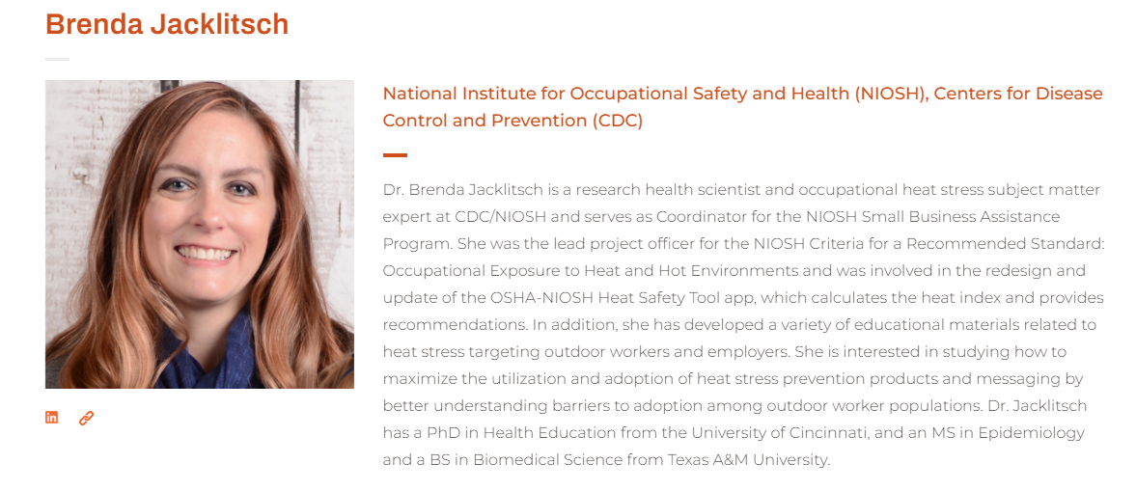Source: https://ghhin.org/people/brenda-jacklitsch/
Name: June T Spector, MD, MPH
Position: Associate Professor at UW, Environmental and Occupational Health Sciences
Research Focus: Heat Exposure and Working Populations
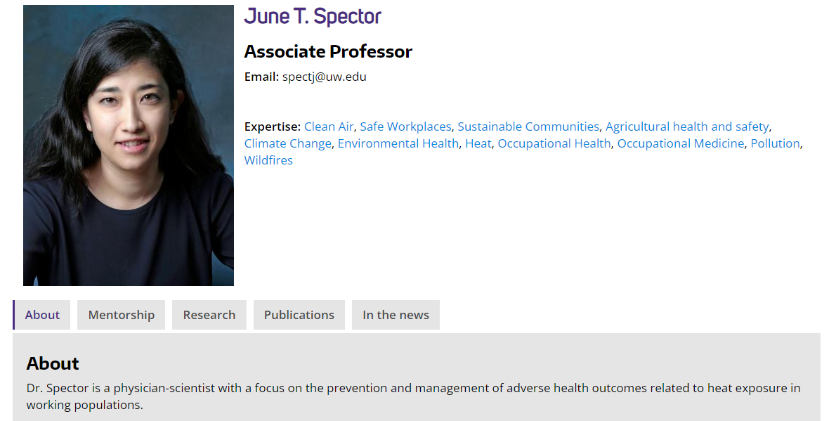
https://deohs.washington.edu/faculty/june-t-spector

Name: Paul Schulte, Ph.D., Director, Division of Science Integration, National Institute of Occupational Safety and Health (NIOSH), Centers for Disease Control and Prevention, Cincinnati, OH
Position: Director, Division of Science Integration, National Institute of Occupational Safety and Health (NIOSH), Centers for Disease Control and Prevention, Cincinnati, OH

Name: Michelle Tigchelaar, PhD
Research Focus is broader than climate and occupational health, but she has conducted a study on heat / ag workers, as well as prepared climate justice workshops for labor unions in Washington State (according to her website).
Source: https://michelletigchelaar.weebly.com/
Of note, their Focus: has studied heat and agricultural workers; not as broad on climate and working populations in general. See press release article detailing overview of the ag/heat study.

Organization: The National Council for Occupational Safety and Health (COSH) has a Heat and Climate Justice webpage. They had a webinar on Organizing for Heat Safety in the workplace. Could Consider reaching out to them to get more of an advocacy perspective. While not surveillance focused, could be nice to have a short presentation from someone who demonstrates how public health data/surveillance can inform advocacy efforts.
https://nationalcosh.org/heat-climate-justice

Name: Jeff Bethel, Ph.D
Research Focus: distribution and determinants of vector-borne and water-borne diseases are impacted by a changing climate.
Limitation: Doesn’t appear to have an occupational focus. He is an associate professor in the Oregon State University Department of Environmental and Occupational Health.

Jason Vargo – Community Development (frbsf.org)

Jason Vargo

Senior Researcher, Community Development
Jason Vargo is a senior researcher in community development focused on understanding the role of climate risks and equity in ensuring an inclusive and prosperous economy for all. Vargo brings a wealth of experience at the intersection of climate and health equity as well as healthy and resilient urban planning. Prior to joining the Fed, Jason was lead scientist in the California Department of Public Health’s (CDPH) Climate Change and Health Equity Section. During the pandemic he led the CDPH’s COVID-19 Modeling Team and was scientific lead for California’s Health Equity Metric, a first of its kind in the nation. Earlier, as an Associate Scientist at the University of Wisconsin-Madison, Jason helped establish a campus-wide initiative on cities and university-community partnership.
Jason attended the University of Michigan for his undergraduate studies in chemical engineering. As a graduate student, he pioneered a dual degree program of study in urban planning and public health between Georgia Tech and Emory University, respectively. Vargo’s doctoral work was completed at Georgia Tech and focused on the health impacts of the urban heat island. Dr. Vargo joined the Federal Reserve Bank of San Francisco’s Community Development team in September of 2021.
Contact Jason Vargo

Full Name
Andrea Wilkinson
Job Title
Health Scientist
Company
National Institute for Occupational Safety and Health (NIOSH)
Speaker Bio
Andrea Wilkinson is a Health Scientist for the National Institute for Occupational Safety and Health (NIOSH) specializing in the health of First Responders. Currently, Andrea is working on the National Firefighter Registry to better understand cancer and exposures in firefighters. Her other work has focused on investigating PPE efficacy as it relates to carcinogens and physiology, cardiovascular effects of fire training drills and live fire training, physiologic effects of heat stress, and the use of caffeine gum on the perception of pain and precision movements. Andrea also has extensive experience in sports medicine and cardiac rehabilitation. She has a special interest in preventative medicine for the tactical athlete and the physiological effects of fire training. Andrea is a member of CDC’s Global Rapid Response Team where she has responded to public health emergencies in a variety of settings and is a proud Honorary Lieutenant for the Hanover Park Fire Department.
Speaking At

