Hazard or Exposure Assessment for Occupational Health Surveillance from A Climate Change Lens
In classic occupational safety and health (OSH) surveillance, data are collected on work-related health outcomes and on the presence of health and safety hazards. We define health outcomes as injuries, diseases or fatalities and hazards as hazardous exposures or conditions. (NAS Document). The hazardous exposure or condition can be physical, chemical or biological factors, natural or human-made in a work environment. (EPHT variation) Exposures or conditions are typically assessed using exposure assessment.
The National Institute for Occupational Safety and Health defines exposure assessment as the science which “identifies and characterizes workplace exposures, develops estimates of exposure for exposure-response and risk assessment studies, and evaluates the significance of exposures and effectiveness of intervention strategies. Traditionally, exposure assessment comes after hazard assessment. “
There are standard approaches for OSH surveillance outlined in the National Academy of Science Surveillance for the 21st century document (excerpt Figure 3-1). However, new data resources are available to assess which are the natural or man-made conditions that when combined with work lead to some health outcome (injuries, diseases or fatalities). These aggregate data may be combined with health outcomes to generate hypotheses about the role of climate change impacts on workers.
The current workshop has assembled a group participating in state, tribal, local or territory based occupational surveillance to assess new data sources and provide a framework to integrate exposure data sources into OSH surveillance of health impacts related to climate change.
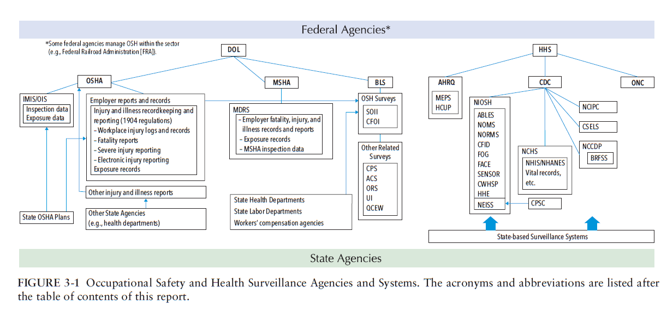
REFERENCES (TO BE ADDED)

