Go to https://factfinder.census.gov/faces/nav/jsf/pages/searchresults.xhtml?refresh=t
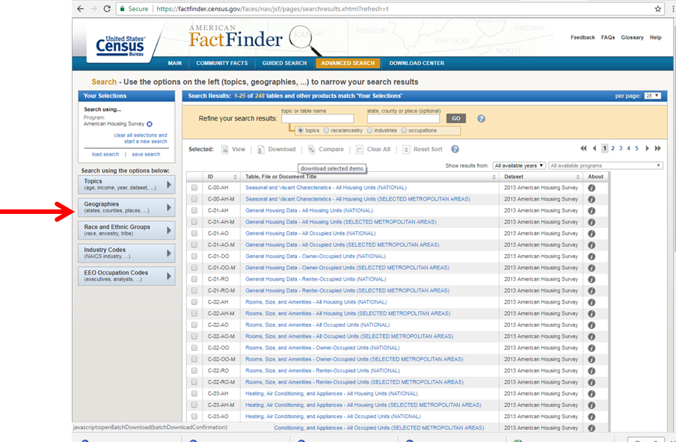
Click Here
Click on name shown below
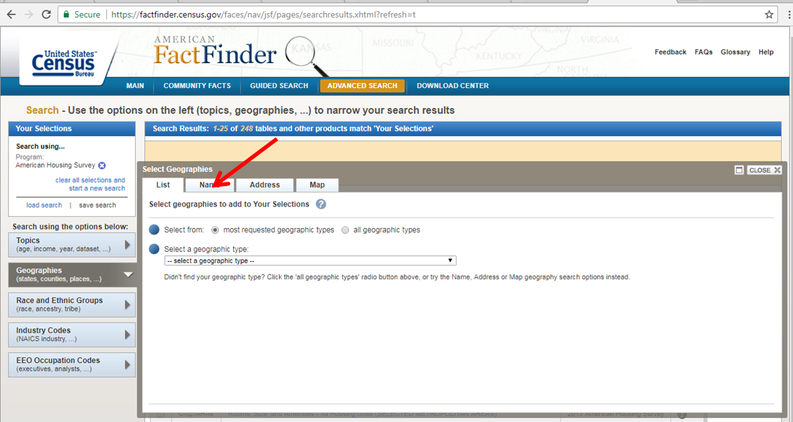

Enter the geography name for example: “Shelby County Tennessee” and click go
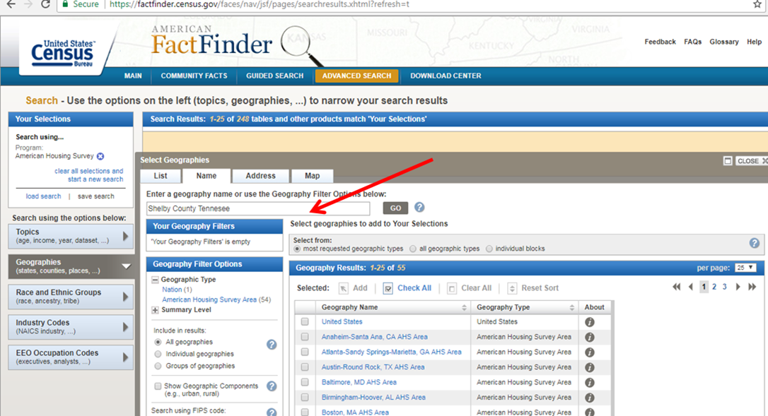
Under Geography Filter options select “Census Tract” for Census Tract data or “Zip Code /ZCTA” for Zip Code Level Data
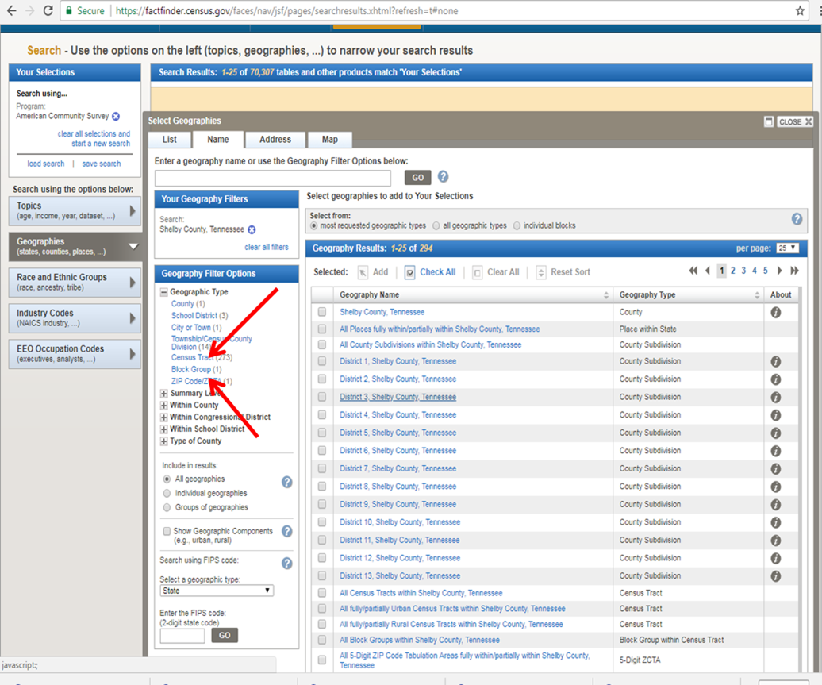

Select the geography (Census Tract or Zip Code)

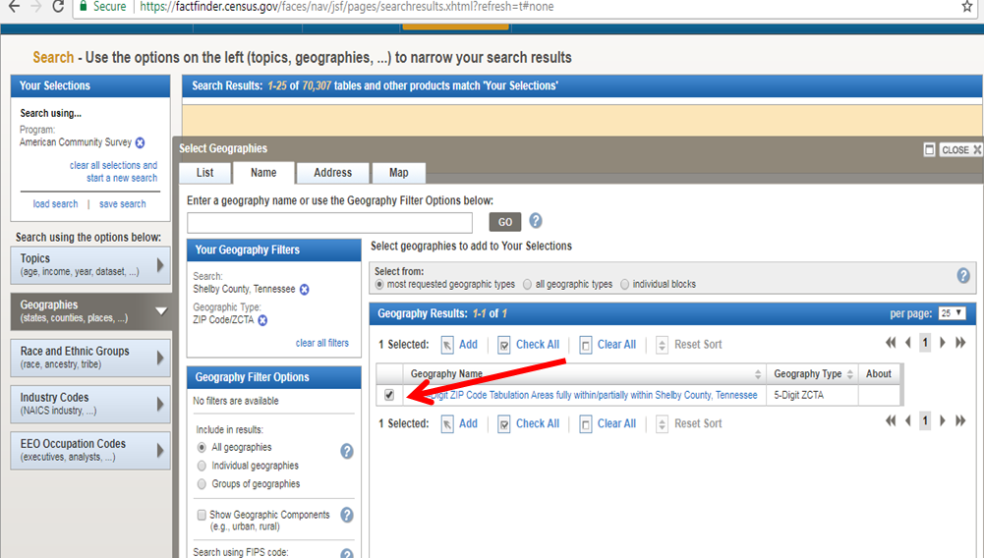
Add to your selection
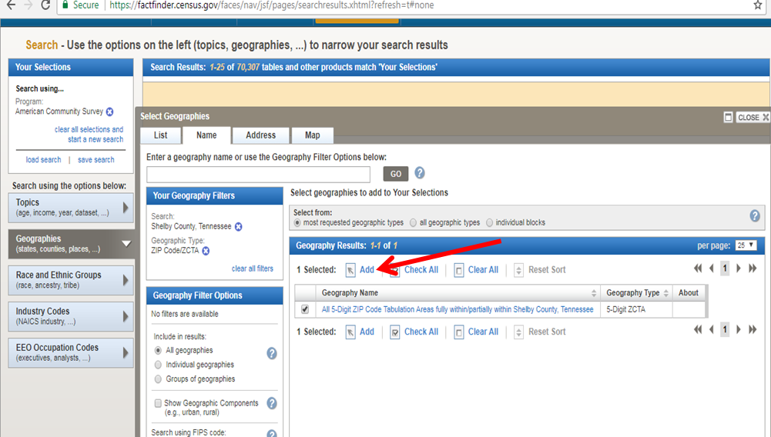
Close the window
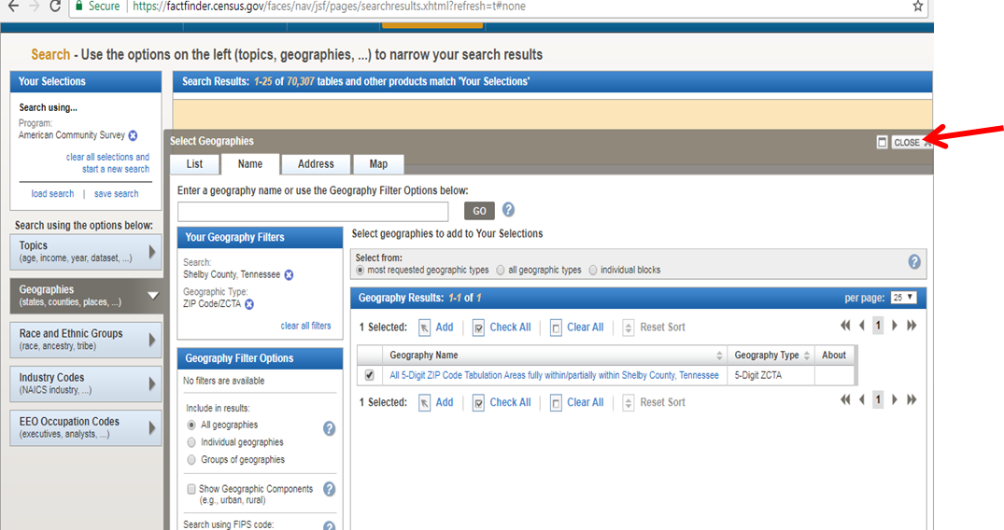
Enter the topics in the box below to search for the 6 EHI variables
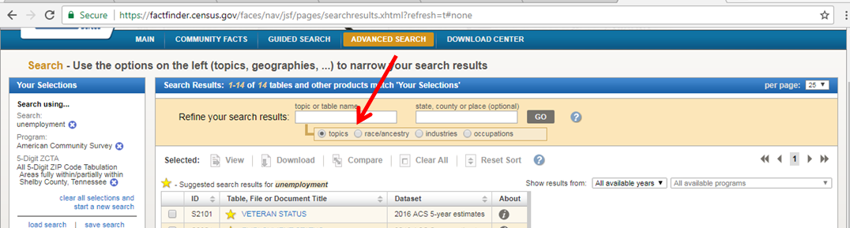

Topics to enter in the search box for each variable.
Topic to search for | EHI Variable | Description of variable
- Employment Status | Unemployment | the percent of the civilian population over the age of 16 who were unemployed
- Population under 18 years by age  - Population 60 years and over | Dependency | the percentage of the population that are under the age of 18 or over the age of 64
- Educational Attainment for the population 25 years and over. | Education | the percentage of the population over the age of 25 who have less than a high school education
- Per capita income in the past 12 months | Income Level | the per capita income
- Selected housing characteristics (Occupants per room) | Crowded Housing | Measured by the percent of occupied housing units with more than one person per room
- Poverty status in the past 12 months | Poverty | The percent of people living below the federal poverty level

Arrange the data in the data in an excel spread sheet and use the following formula to calculate EHI
For the calculation of all variables except for income:
X = ((Y-Ymin)/(Ymax—Ymin))*100
Where : X = standardized value of component variable (for example, unemployment rate) for each area to be computed.

Y = unstandardized value of component variable for each area
Ymin = the minimum value for Y across all area
Ymax = the maximum value for Y across all area

For example:
Zip Code A has unemployment rate of 35%
Minimum unemployment rate across all Zip Codes is 5%
Maximum unemployment rate across all Zip Codes is 70%

EHI for Unemployment (X) = ((35-5)/ (70-5))*100

For the calculation of Income:
X = ((Y-Ymax)/(Ymin—Ymax))*100
For example
Zip Code A has average income of $40, 000
Minimum income across all Zip Codes $15,000
Maximum income across all Zip Codes $100,000

EHI for income (X) = ((40,000-100,000)/ (15,000-100,000))*100

- Average of the standardized ratios of all six component variables
- Higher value indicating higher hardship.

