Adverse Childhood Experiences (ACEs)
Childhood experiences, both positive and negative, have a tremendous impact on future violence victimization and perpetration, and lifelong health and opportunity. ACEs are a collection of experiences that may be traumatic to children and youth, and include abuse, neglect, household challenges, and other adversities that occur during the first 18 years of life. ACEs are common, as two-thirds of surveyed U.S. adults experience at least one ACE and many adults experience more than one. ACEs can affect optimal health and development across the lifespan, particularly in the absence of protective factors. However, ACEs can be prevented.

In <State Name>, 62% of adults have experienced at least one ACE, and one in six have experienced three or more ACEs. Among <State> men, 25.5% experienced three or more ACEs compared to 22% of women.
Figure 1: Prevalence of ACEs among <State> adults, <Data Year>
Women
Men

Total

ACE Score
ACEs can have lasting effects on…

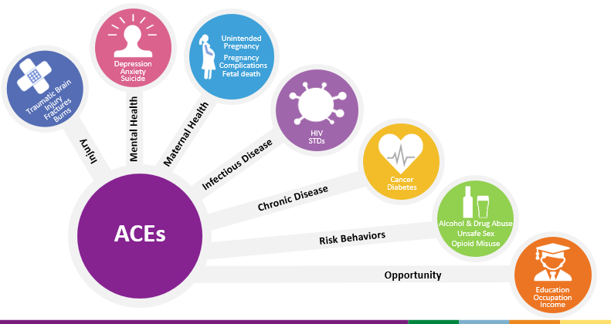

As the number of ACEs increases, so does the risk for these outcomes. However, it is important to remember that the presence of ACEs does not mean that a child will experience poor outcomes. Protective factors can prevent children from experiencing adversity and can protect against many of the negative health and life outcomes even after adversity has occurred.

State Health Department
LOGO

The ACE Pyramid
Exposure to ACEs may result in toxic stress responses that can impede a child’s development, such as changes in gene expression, changes in brain connectivity and immune function, and changes in the type of coping strategies adopted. While many coping strategies are healthy and help reduce acute stress, some (e.g., smoking cigarettes, drinking alcohol, using substances, engaging in risky sexual behavior) present additional risks to health and well-being. As such, exposure to early adversity can increase risk of later chronic and infectious health conditions through changes in physiological mechanisms, as well as increased engagement in health risk behaviors, and can ultimately result in premature death.
Types of ACEs
The Behavioral Risk Factor Surveillance System (BRFSS) is a statewide phone survey of non-institutionalized <State> adults 18 years and older. The ACE module was adapted from the CDC-Kaiser ACE study to collect information on child abuse and household challenges.

The most common ACE experienced by adults in <State> was emotional abuse with 34.4% of adults indicating that a parent or adult swore, insulted, or put them down before the age of 19. The next most prevalent ACEs are parental separation/divorce reported by 27.6% of adults, and household substance abuse reported by 27.6% of adults.
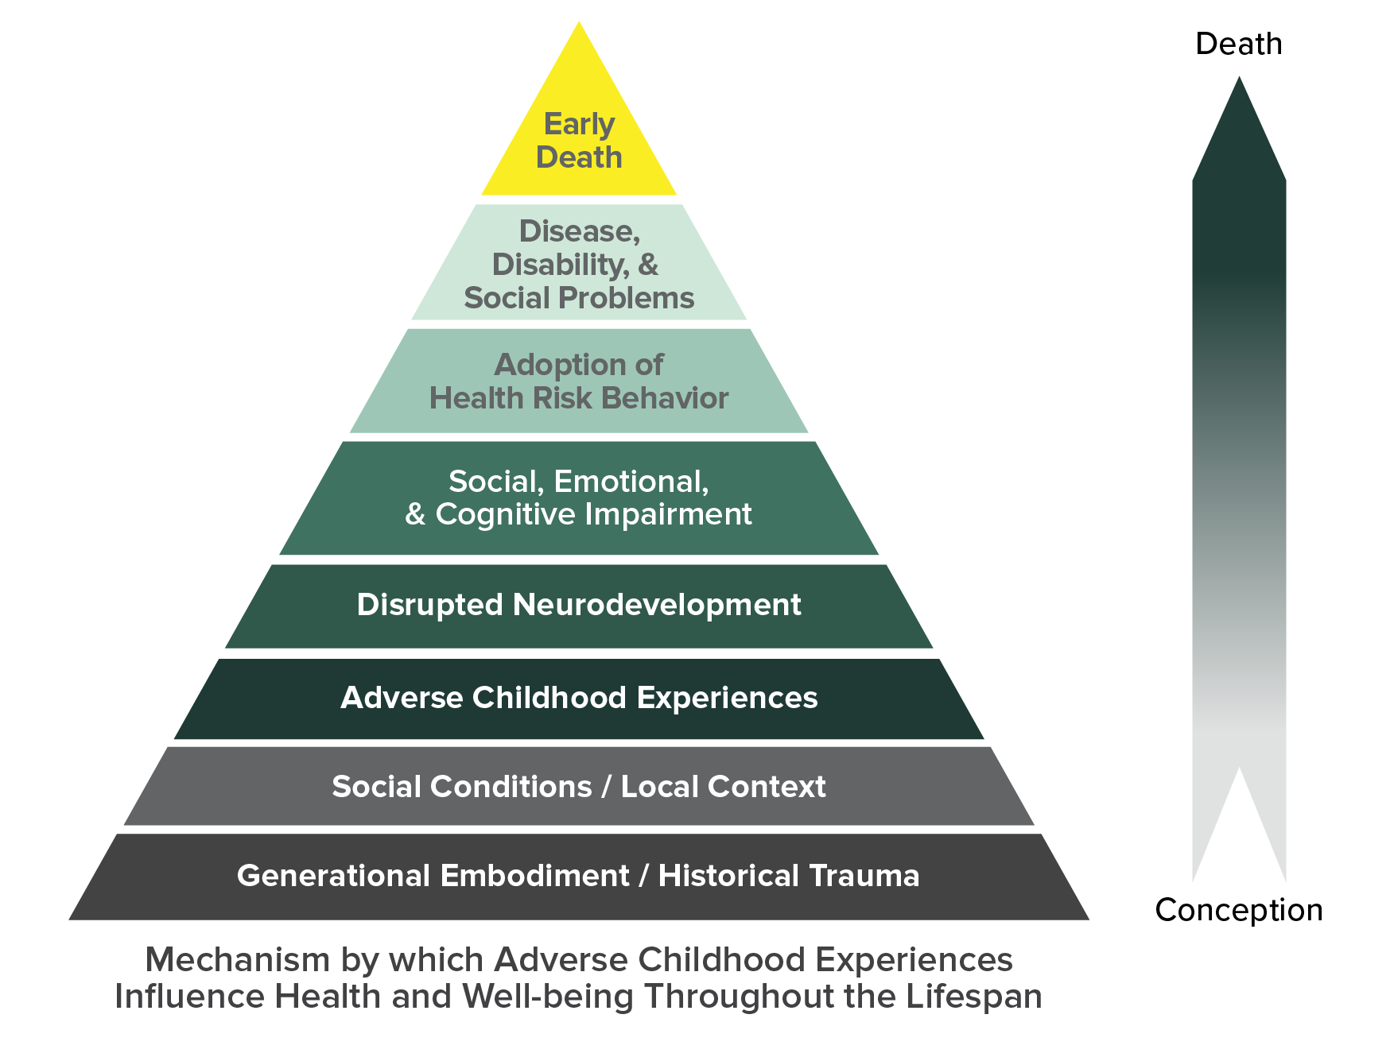

Figure 2: Percentage of ACEs among <State> adults, <Data Year>


7.9%
Incarcerated Household Member

11.6%
Sexual Abuse

16.5%
Household Mental Illness

17.5%
Intimate Partner Violence

34.4%
Emotional Abuse

17.9%
Physical Abuse

27.6%
Household Substance Abuse

27.6%
Parental Separation/Divorce

ACEs by Demographics
ACEs are common across all sociodemographic characteristics, yet some populations are more vulnerable to experiencing ACEs, such as children living in poverty and racial and ethnic minorities, because of the structural and social conditions in which some children and families live, learn, work, and play. Importantly, ACEs happen early in life and can shape children’s life opportunities, including school achievement and economic wellbeing.

Figure 4: Percentage Distribution of ACEs by Household Income Level in <State>

Figure 3: Percentage Distribution of ACEs within Racial/Ethnic Groups in <State>

Data sources: <Year> <State> Behavioral Risk Factor Surveillance System. Reference to any commercial entity or product or service on this page should not be construed as an endorsement by the Government of the company or its products or services.

STATE DEPARTMENT OF HEALTH
State DPH Injury Prevention Program Website
Released <Month, year>
Enhance parenting skills to promote healthy child development
- Early childhood home visitation
- Parenting skill and family relationship approaches
- In <State>, we <approaches>

Change social norms to support parents and positive parenting
- Public engagement and education campaigns
- Legislative approaches to reduce corporal punishment
- In <State>, we <approaches>

Intervene to lessen harms and prevent future risk
- Enhanced primary care
- Behavioral parent training programs
- Treatment to lessen harms of abuse and neglect exposure
- Treatment to prevent problem behavior and later involvement in violence
- In <State>, we <approaches>



Provide quality care and education early in life
- Preschool enrichment with family engagement
- Improved quality of child care through licensing and accreditation
- In <State>, we <approaches>


Strengthen economic supports for families
- Strengthen household financial security
- Family-friendly work policies
- In <State>, we <approaches>


Strategies & Approaches for Preventing ACEs

ACE Prevention Strategies
The wide-ranging health, social, and economic consequences of ACEs underscore the importance of preventing ACEs before they happen. CDC promotes lifelong health and well-being by assuring safe, stable, nurturing relationships and environments for all children.
- Essentials for Childhood proposes strategies communities can consider to promote relationships and environments that help children grow up to be healthy and productive citizens so that they, in turn, can build stronger and safer families and communities for their children. https://www.cdc.gov/violenceprevention/childmaltreatment/essentials.html
- CDC’s technical package for preventing child abuse and neglect identifies strategies to help states and communities prioritize prevention activities based on the best available evidence. These strategies focus on policies, programs, and norms change activities. https://www.cdc.gov/violenceprevention/childmaltreatment/prevention.html
- Violence Prevention in Practice is a new web-based resource to help states and communities take advantage of the best available evidence to prevent violence. https://vetoviolence.cdc.gov/apps/violence-prevention-practice

