Understanding Suicide

Suicide is death caused by injuring oneself with the intent to die. Several factors can increase the risk for suicide and protect against it. Suicide is connected to other forms of injury and violence and causes serious health and economic consequences. (copied from https://www.cdc.gov/violenceprevention/suicide/fastfact.html)

Impact and Magnitude of Suicide
Suicide is the [rank] leading cause of death in the United States and [rank] in [jurisdiction]. Over the past 10 years, the rate of suicide deaths has [increased/decreased], with the biggest change in [specific population or age group].

Figure 2: Top Mechanisms of Suicide by Age and Sex at Birth in <Jurisdiction>, <Data Year>

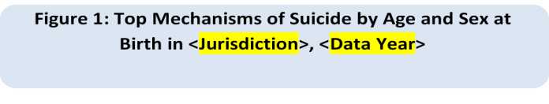
Figure 1: Trends in Suicide in [Jurisdiction],
[Data Years]

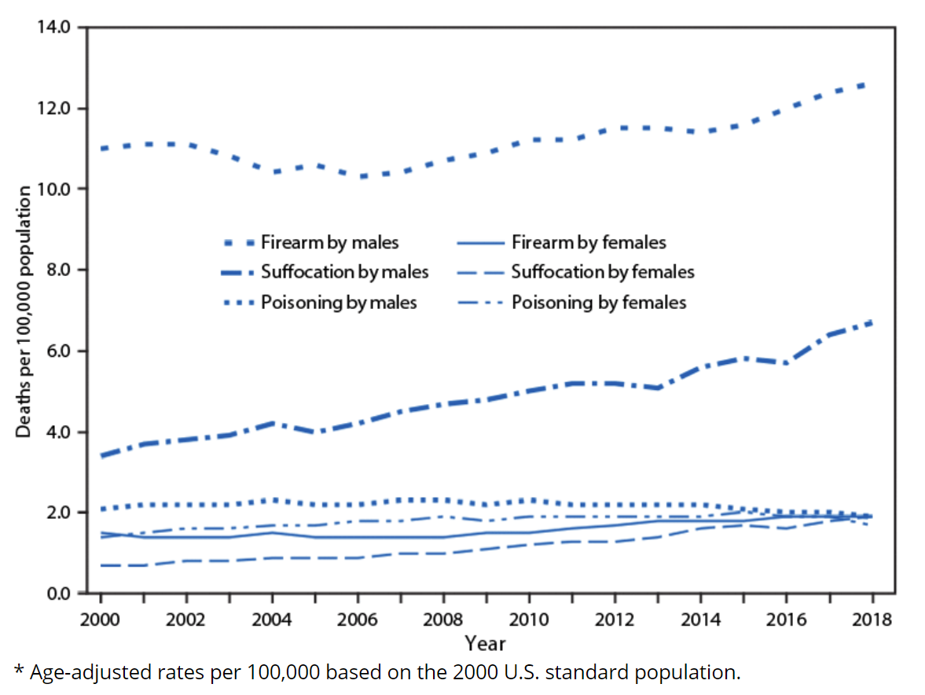
(Sample trend graph from https://www.cdc.gov/mmwr/volumes/69/wr/mm6909a7.htm)

Suicide by Race and Ethnicity
Suicide disproportionately affects [target group].

(SAMPLE HORIZONTAL BAR)
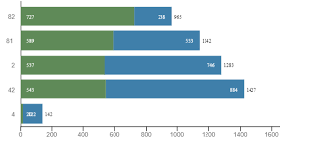

Identifying target populations (rural urban/frontier suicide rates, LGBTQ, youth populations, veterans, etc depending on availabilty)

Suicide by Geography
The majority of suicide deaths in [jurisdiction] occurred in [sub-area], and the highest rates per 100,000 residents were in [sub-area].

(Choose between map or table based on jurisdiction capability.)

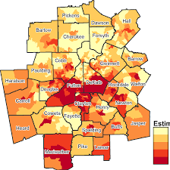

Sub-area | Rate
1.
2.
3.
4.
5.

State or Local Health Department LOGO
Suicide Prevention Strategies
[Insert text here]
This document was produced in conjunction with CDC's Core Violence and Injury Prevention Program under Cooperative Agreement 11-1101.

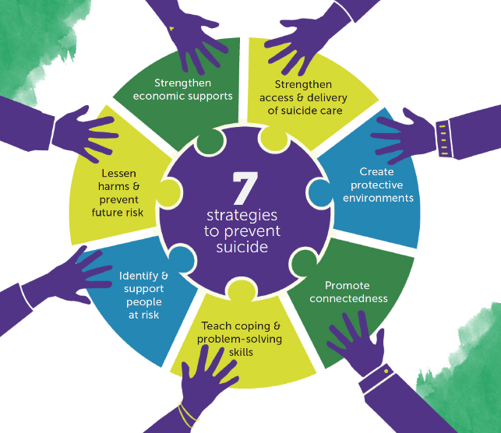
<STATE or Jurisdiction> Suicide Prevention Activities
Prevention
Surveillance
Partnerships

Accomplishments/Successes

For more information contact: <Contact information>
STATE DEPARTMENT OF HEALTH
State DPH Injury Prevention Program Website
Released <Month, year>

