Understanding TBI
Traumatic brain injury (TBI) is a serious public health problem and in the United States. A TBI is caused by a bump, blow, jolt, or penetration to the head that disrupts the normal function of the brain. Each year, traumatic brain injuries contribute to a substantial number of deaths and cases of permanent disability.

Figure 1: Percentage of Annual TBI-Related Deaths, Hospitalizations, and Emergency Department Visits, by Intent and Mechanism, in <State>, <Data Year>

Impact and Magnitude of TBI
During <Data Year>, a TBI was sustained by <total #> of people in <State>. Among those injured, <#> (<rate> per 100,000) died where TBI was reported as a cause of death on the death certificate alone or in combination with other injuries or conditions, another <#> (<rate> per 100,000), were hospitalized with a TBI alone or in combination with other injuries or conditions, and an additional <#> (<rate> per 100,000) were treated and released from emergency departments with a TBI alone or in combination with other injuries or conditions. An unknown number of individuals sustained injuries that were treated in other settings or went untreated.

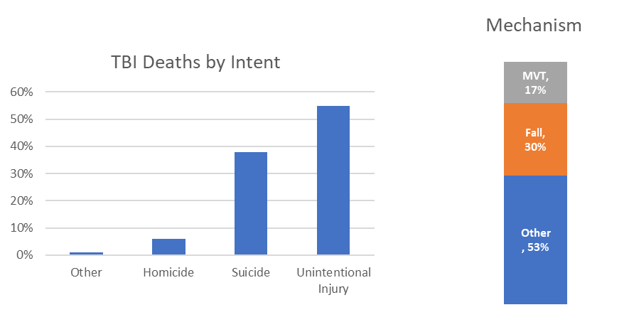

Causes of TBI
Cause of injury varies across the three levels of severity. <Cause> was the leading cause of injury among those who died where TBI was reported as a cause of death on the death certificate alone or in combination with other injuries or conditions. <Cause> was the leading cause of injury among those who were hospitalized with a TBI alone or in combination with other injuries or conditions. And, <cause> was the leading cause of injury among those who were treated and released from emergency departments with a TBI alone or in combination with other injuries or conditions.

Cause | Count | Rate per 100,000 people
1.
2.
3.
4.
5.
Figure 2: Top 5 Causes of TBI-related Deaths in <State>, <Data Year>

Figure 3: TBI by Age and Sex at Birth, in <State>, <Data Year>

TBI by Age and Sex at Birth
The highest number of TBI-related deaths* were among persons ages <insert age range>. Among those with TBI-related hospitalizations,** persons ages <insert age range> were most affected. Persons ages <insert age range made the most TBI-related emergency department visits.**
*TBI was reported as a cause of death on the death certificate alone or in combination with other injuries or conditions
** TBI alone or in combination with other injuries or conditions

State Health Department LOGO

This document was produced in conjunction with CDC's Core Violence and Injury Prevention Program under Cooperative Agreement 11-1101.

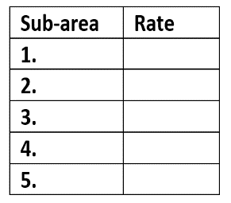
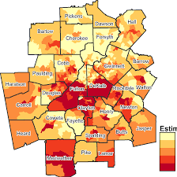
(Choose between map or table based on jurisdiction capability.)

TBI by Group
Certain populations have higher rates of TBI and may need special prevention measures. The majority of suicide deaths in [jurisdiction] occurred in [sub-area], and the highest rates per 100,000 residents were in [sub-area].

TBI Prevention Strategies
CDC’s National Center for Injury Prevention and Control (Injury Center) is committed to protecting people against preventable TBI by putting science into action.
- State Injury Prevention Programs - The Injury Center’s Core Violence and Injury Prevention Program (Core VIPP) funds state health departments to estimate the impact of TBIs and define the groups most affected. www.cdc.gov/injury
- Heads Up – Injury Center campaigns with free tools for health care providers, school administrators, nurses, teachers, coaches, and parents to help them recognize and respond to a TBI. www.cdc.gov/traumaticbraininjury
- Motor Vehicle Safety – Motor vehicle crashes are a leading cause of death, injury and TBI in the US. CDC’s primary prevention focuses on child passenger safety, seat belt use and reducing impaired driving. www.thecommunityguide.org/mvoi www.cdc.gov/motorvehiclesafety
<STATE> TBI Activities
Prevention
Surveillance
Partnerships

Accomplishments/Successes

Note: TBI-related cases were identified by first limiting the datasets to injury cases based on external cause of injury (deaths), primary diagnosis (hospitalizations), or both (emergency department visits). All fields were then searched for TBI diagnostic codes. Reference to any commercial entity or product or service on this page should not be construed as an endorsement by the Government of the company or its products or services.

STATE DEPARTMENT OF HEALTH
State DPH Injury Prevention Program Website
Released <Month, year>

