Understanding Unintentional Motor Vehicle Traffic Injuries
Every day, thousands of Americans are involved in motor vehicle crashes on public roadways that result in injury or death. Unintentional Motor Vehicle Traffic (MVT) Injuries include those to drivers, passengers, pedestrians, cyclists, and other occupants.

Burden and Overview
MVT injuries are the [rank] leading cause of hospitalizations in the United States and [rank] in [jurisdiction]. Over the past 5 years, the rate of MVT injuries has [increased/decreased], with the biggest change in [specific population or age group].

Type of Person Injured

Figure X: [insert title here], in <State>, <Data Year>

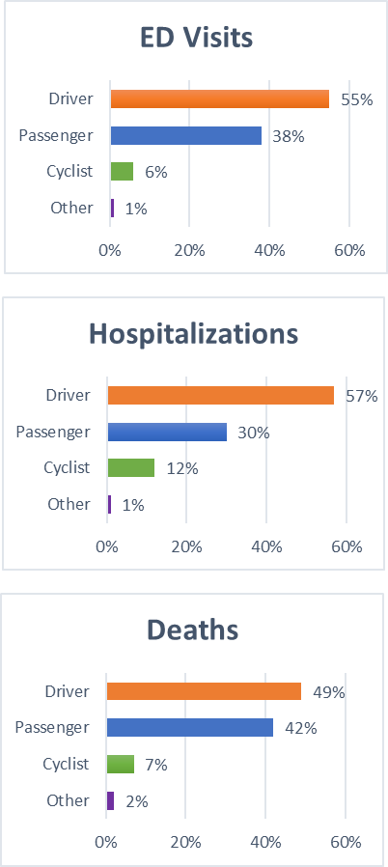
Figure X: Motor Vehicle Traffic Injury Pyramid in <State>, <Data Year>

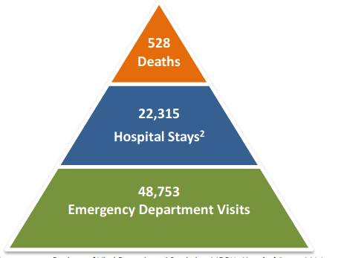

Figure X: Trends in Motor Vehicle Traffic Deaths in [Jurisdiction],
[Data Years]
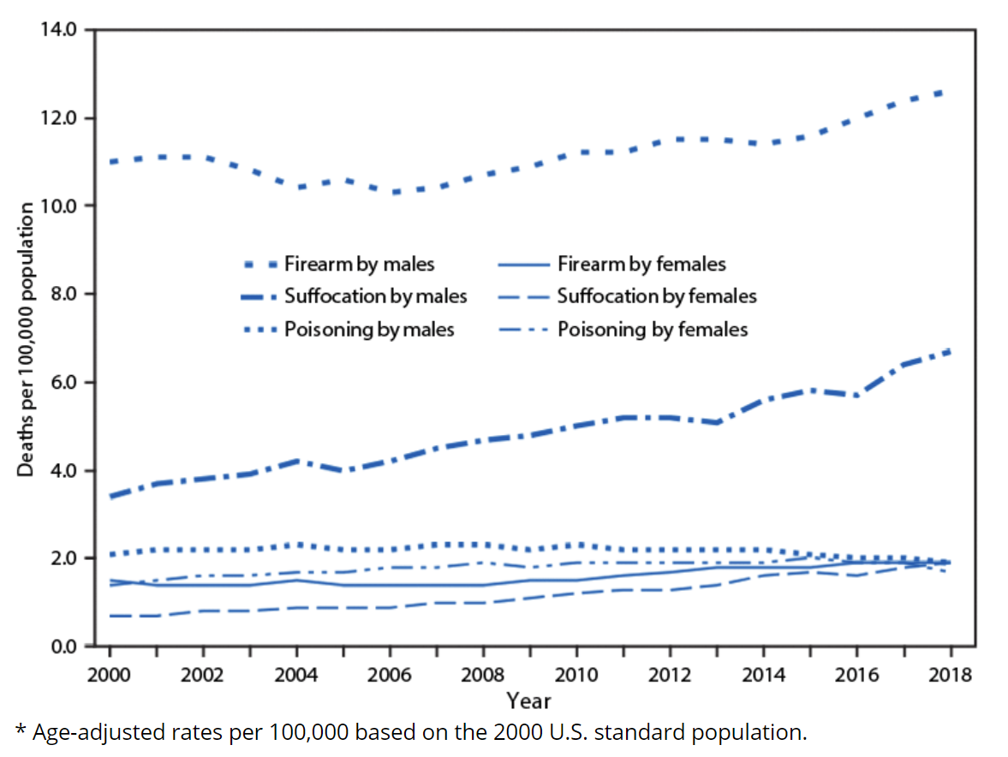
(Sample trend graph from https://www.cdc.gov/mmwr/volumes/69/wr/mm6909a7.htm)

Motor Vehicle Traffic Injuries Causing Traumatic Brain Injuries by Occupant
[Insert text here]

Motor Vehicle Traffic Injuries by Race and Ethnicity
[Insert text here]

Motor Vehicle Traffic Injuries Causing Traumatic Brain Injuries by Geography
The majority of motor vehicle traffic injuries in [jurisdiction] occurred in [sub-area], and the highest rates per 100,000 residents were in [sub-area].

(Choose between map or table based on jurisdiction capability.)

Unintentional Motor Vehicle Traffic Injuries by Age and Sex at Birth

Figure X: Motor Vehicle Traffic Injuries by Age and Sex at Birth, in <State>, <Data Year>

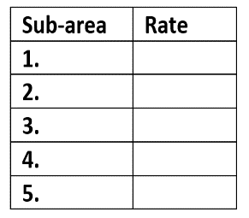
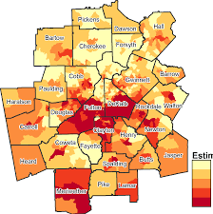
(Choose between map or table based on jurisdiction capability.)

Motor Vehicle Traffic Injuries Prevention Strategies
[Insert text here]
State Health Department LOGO
This document was produced in conjunction with CDC's Core Violence and Injury Prevention Program under Cooperative Agreement 11-1101.

<STATE> Motor Vehicle Traffic Injuries Activities
Prevention
Surveillance
Partnerships

Accomplishments/Successes

STATE DEPARTMENT OF HEALTH
State DPH Injury Prevention Program Website
Released <Month, year>

