Understanding Suicide

Suicide is death caused by injuring oneself with the intent to die. Several factors can increase the risk for suicide and protect against it. Suicide is connected to other forms of injury and violence and causes serious health and economic consequences. (copied from https://www.cdc.gov/violenceprevention/suicide/fastfact.html)

Impact and Magnitude of Suicide
Suicide is the [rank] leading cause of death in the United States and [rank] in [jurisdiction]. Over the past 10 years, the rate of suicide deaths has [increased/decreased], with the biggest change in [specific population or age group].

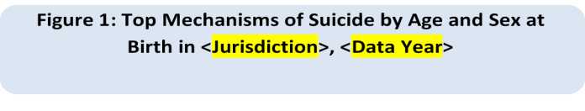
Suicide by Age and Sex at Birth

Figure 1: Trends in Suicide in [Jurisdiction],
[Data Years]

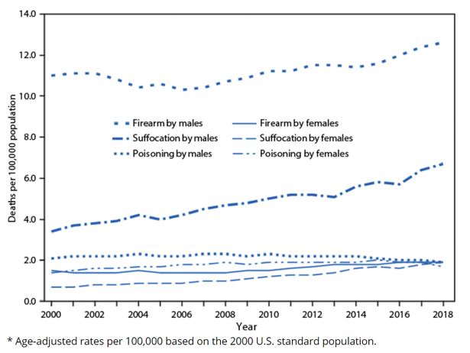
Figure 2: Top 3 Mechanisms of Suicide by Age and Sex at Birth in <Jurisdiction>, <Data Year>

Suicide by Race and Ethnicity
Suicide disproportionately affects [target group].

(SAMPLE HORIZONTAL BAR)
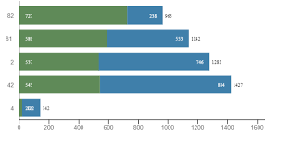

Identifying target populations (rural urban/frontier suicide rates, LGBTQ, youth populations, veterans, etc depending on availability)

(Sample trend graph from https://www.cdc.gov/mmwr/volumes/69/wr/mm6909a7.htm)
Suicide by Geography
The majority of suicide deaths in [jurisdiction] occurred in [sub-area], and the highest rates per 100,000 residents were in [sub-area].

(Choose between map or table based on jurisdiction capability.)

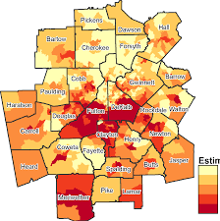

Sub-area | Rate
1.
2.
3.
4.
5.

Suicide Prevention Strategies
Suicide is preventable — Everyone can play a role Suicide prevention requires a comprehensive approach that occurs at all levels of society. The Centers for Disease Control and Prevention (CDC) has developed a set of strategies to help states, communities, and individuals reduce risk and increase resilience:

State or Local Jurisdiction Crisis Hotline
NATIONAL SUICIDE PREVENTION LIFELINE 1-800-273-TALK (8255)

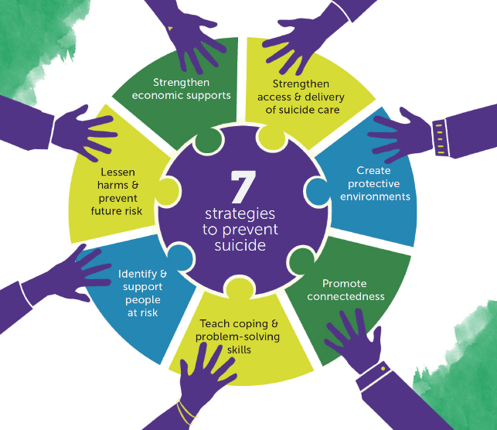

For planning and prevention resources visit CDC’s Suicide Prevention website.(add link text to website)

These need to be updated (KL 5/4):
Means: Reducing a suicidal person’s access to highly lethal means is an important part of suicide prevention. Learn more about means reduction at Harvard’s Means Matters.
Circumstances: Suicide is complex and many factors contribute to thoughts of suicide. Learn more from CDC’s Vital Signs.
BeThe1To: If you think someone you know is considering suicide, talk to them and connect them to the support they need. Learn 5 Steps you can take to be a supportive and empathetic listener for them.
Lived Experience: If you are thinking of suicide or made a suicide attempt, please know that help is available. Along with supportive family and friends, people who have experienced thoughts of suicide and suicide attempt survivors have created strong peer communities. Learn more at Now Matters Now.
Postvention: It’s important to support the individuals, families, and communities affected by suicide loss, to reduce the cycle of trauma and increased suicide risk. Learn more at the American Foundation for Suicide Prevention.
State or Local Health Department LOGO
<STATE or Jurisdiction> Suicide Prevention Activities
Prevention
Surveillance
Partnerships
Accomplishments/Successes

For more information contact: <Contact information>
STATE DEPARTMENT OF HEALTH
State DPH Injury Prevention Program Website
Released <Month, year>

