Pregnancy Risk Assessment Monitoring System (PRAMS)

- 46 of 50 states participate in core questions (Not included: OH, NC, ID, & CA).
To discuss ACEs and pregnancy fully, we need to understand it from two points of view.
- How ACEs have affected the mother’s life, how they may still be affecting her mentally and physically, and how they might interfere with her ability to nurture and care for her child.
- How a mother’s ACEs affect her developing baby and what effects the infant might experience in the womb and during its first few years of life.
Reference: ACEs and Pregnancy - Center for Child Counseling
Relevant PRAMS Questions to proxy for ACES – Core Questionnaire?
- Height & Weight for BMI (obesity)
- Age of motherhood (teenaged?)
- Pregnancy health
  - Non-gestational Diabetes
  - High BP
  - Depression
- Income and insurance status
- Unwanted pregnancy
Results: Path analysis revealed that the association between maternal ACEs and infant development outcomes at 12 months operated through 2 indirect pathways: biological health risk (pregnancy health risk and infant health risk at birth) and psychosocial risk (maternal psychosocial risk in pregnancy and maternal hostile behavior in infancy).
Conclusions: Psychosocial risks in pregnancy, but not in early infancy, contribute to the transmission of vulnerability from maternal ACEs to child development outcomes in infancy via maternal behavior. Maternal health risk in pregnancy indirectly confers risk from maternal ACEs to child development outcomes at 12 months of age through infant health risk. Maternal health and psychosocial well-being in pregnancy may be key targets for intervention.
Reference: Maternal Adverse Childhood Experiences and Infant Development | American Academy of Pediatrics (aappublications.org)
- Smoking practices
  - Smoked in the last 2 years
  - Number of cigarettes smoked per day in 3 months before pregnancy
  - Number of cigarettes smoked per day in last three months of pregnancy
  - Number of cigarettes smoked per day after birth
  - E-cigarette and hookah use
Conclusions: Mothers in this national sample who experienced adversity in childhood are more likely to smoke during pregnancy and their offspring are more likely to initiate smoking before age 18. Findings varied by type of adversity and race/ethnicity.
Implications: These findings support the importance of a life-course approach to understanding prenatal and intergenerational smoking, and suggest that maternal early-life history is a potentially important risk factor that could be targeted with screening and interventions to reduce smoking in pregnant women and their children.
Reference: The Role of Maternal Adverse Childhood Experiences and Race in Intergenerational High-Risk Smoking Behaviors (nih.gov)
- Drinking practices
  - Drinking in the last 2 years
  - Number of drinks per day in 3 months before pregnancy
For example, a recent study using data from the 2010 Nevada Behavioral Risk Factor Surveillance System showed that a history of childhood stressors, such as physical, sexual, and emotional abuse, influenced alcohol use among pregnant women. The research found a dose–response relationship between ACEs and alcohol use during pregnancy. This study contributes to a growing body of research that shows that the factors affecting alcohol use during pregnancy begin long before pregnancy...in fact, they likely begin in the pregnant mother’s own childhood.
Reference: ACEs and Pregnancy - Center for Child Counseling
- Physical violence
  - Physical violence 12 month prior to pregnancy
  - Physical violence 12 month during pregnancy
- Baby trauma
  - How long was baby in hospital?
- Breastfeeding (bonding)
  - Not at all
  - Less than 1 week
- Frequency of depression after birth
- Frequency of pleasure after birth

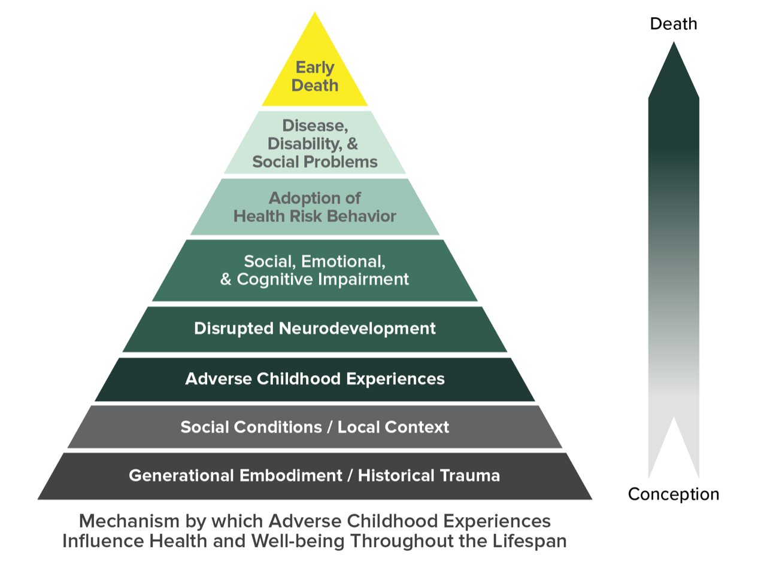Adverse Childhood Experiences Resources |Violence Prevention|Injury Center|CDC

