Template for Subcommittee Pages
 Oral Health Subcommittee

Name of Subcommittee Chair: TBD

CSTE Staff Contact: Nikka Sorrells

Image:
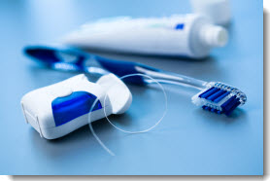

Mission/About paragraph:
The mission of the Oral Health Subcommittee is to support effective oral health and surveillance epidemiology. The strategic goal of the Oral Health Subcommittee is to utilize epidemiologic tools and resources to improve the public’s oral health. A major objective of the oral health subcommittee is to promote the use of epidemiologic data to reduce disparities by race, age, geography and income to improve oral health.
The Oral Health Subcommittee’s work encompasses a range of topics including epidemiology capacity building, advocating for oral health resources and evidence based policy, developing tools and resources that strengthen and guide epidemiology.

Recent Subcommittee activity/news/meetings/etc.:

Subcommittee resources/toolkits/etc.:
- The Oral Health Subcommittee worked on assessing oral health epidemiology capacity at the state-level through the 2013 National Epidemiology Capacity Assessment Oral Health Module (2013)
- The Subcommittee partnered with ASTDD to develop a conceptual framework and operation definition of State-Based Oral Health Surveillance Systems (2013)
- Position statements were created to support the development and adoption of indicators for national oral health surveillance (2012, 1999)
- 12-CD-01
- 12-CD-02
- 99-OH-01

RECENT FORUM ACTIVITY

Delete old forums

