Mississippi Methods and Results

Introduction
This document summarizes the plan to analyze Mississippi data for Jurisdictional Vulnerability Assessment (JVA). The methods are based on the Social Vulnerability Index, and the variable section is based on subject matter expertise from Mississippi (Van Handel, 2016).

Methods

Outcome Variables
The outcome variable for this analysis is Hepatitis C surveillance report data from Mississippi PRISM. The choropleth map below displays 2018 incidence rates (Figure 1). For modeling purposes, we used the arithmetic mean of the 2017 and 2018 rates as an outcome variable, in order to provide more statistical reliability. With small population changes, using the arithmetic mean of these year-over-year incidence rates provides similar results to recalculating a true two-year rate.
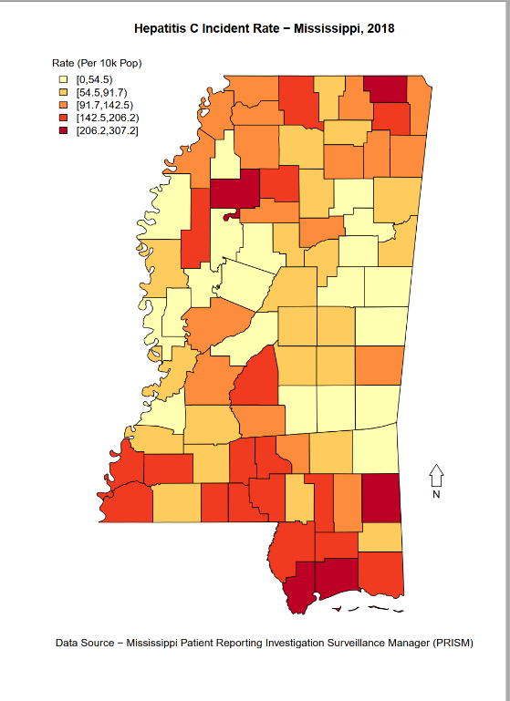

Figure 1. Hepatitis C Outcome Variable

Predictor Variables
The predictor variables for the Mississippi JVA model are: Per Capita Income (US Dollars; 2013-2017, American Community Survey; Reversed); County Level Overdose Death Rate (Deaths per 100,00; 2018, Mississippi Bureau of Narcotics), County Level Drug Arrest Rate (Arrests per 10,000; 2018, Mississippi Bureau of Narcotics), Opioid Prescriptions Per Capita (Rate of Residents with an Opioid Prescription (per 1,000); 2018, NSPARC). These predictors are similar to those recommended for county level jurisdictional vulnerability (Van Handel, 2016), although the specific sources are unique to Mississippi.

Imputation
For missing values, we impute based on the statewide median value. While this is less accurate than using a geographic weighted mean, this method is much easier to computationally implement.

Analysis
Our analysis uses the ranked values of each predictor variable, similar to the Social Vulnerability Index (CDC, 2018), and examines the Spearman rank correlation of the predictor variables with the outcome variable. In addition, we calculate the mean of the predictor variable ranks. The calculation is performed and available in an aggregated spreadsheet (Mississippi_Data_Model). Spearman rank correlations are calculated using R (Table X). As ranks are not well suited for transformations, variables were not logarithmically, or otherwise altered.
Table X. Spearman Correlation of Predictor Variables, Mississippi
 | HCV_Rate | Death_Rate | Arrest_Rate_10k | Prescription_Rate | Per Capita Income
HCV_Rate | 1 | 0.31 | 0.2 | 0.04 | 0.17
Death_Rate | 0.31 | 1 | 0.2 | 0.16 | 0.14
Arrest_Rate_10k | 0.2 | 0.2 | 1 | -0.15 | 0.45
Prescription_Rate | 0.04 | 0.16 | -0.15 | 1 | 0
Per Capita Income | 0.17 | 0.14 | 0.45 | 0 | 1

Although the Spearman rank correlation of per capita opioid prescriptions and Hepatitis C was weak ( r_{s} = .04), subject matter expertise and prior experience suggests that it should be included in the model. The positive (rather than negative) coefficient of correlation for per capita income and Hepatitis C is unexpected. However, as with per capita income, subject matter expertise and prior experience justify including it as part of a vulnerability index.
The interpretation of analysis output remains relatively intuitive as higher scores represent increased vulnerability, showing greater potential for negative outcomes. Conversely, lower scores represent decreased vulnerability. For example, Kemper County has the lowest reported HCV rate (25.3 per 100,000), therefore, it has a score of 1 for the outcome variable; Tallahatchie County has the highest reported HCV rate (329.2 per 100,000), it has a score of 82 for the outcome variable.
We used three tools to perform Mississippi’s JVA: Power BI (mapping, focus on univariate analysis), R (mapping, statistical analysis, data wrangling) and Microsoft Excel (ranking). Power BI enables users to interact with data; R has the strongest tools for spatial analysis; Microsoft Excel is a widely uses spreadsheet program that those without statistical programming backgrounds can manipulate.

Results

Univariate Results
Selected univariate results are in Table 1, shown below.

Table 1: Selected Univariate Results
Indicator | Min | 1st Quartile | Median | Mean | 3rd Quartile | Max
Drug Related Arrest Rate | 0.00 | 0.00 | 17.0 | 32.6 | 57.4 | 152.4
Suspected Overdose Death Rate | 0.00 | 0.00 | 10.0 | 9.94 | 14.2 | 32.0
Per Capita Income | 12,394 | 18,123 | 20,094 | 20,128 | 21,664 | 36,627
Per Capita Patients with Opioid Rx | 153 | 228 | 248.5 | 252.9 | 268 | 488
Hepatitis C Incidence | 0 | 63.3 | 100.0 | 106.7 | 151.7 | 329.2

Vulnerability Index Results
For ease, results are mapped using Power Bi Desktop. Power BI Desktop allows for local analysis and rapid visualization. For both the outcome variable: Hepatitis C and the predictor variables, there appears to be a cluster in the Gulf Coast section of Mississippi, near Hattiesburg.
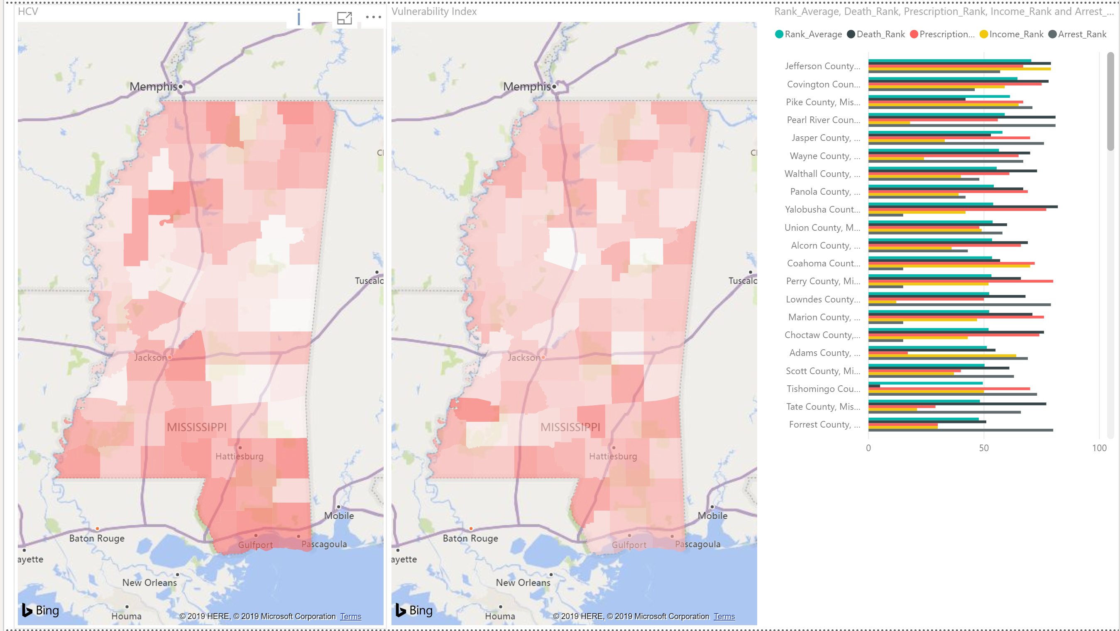
Figure 2 Jurisdiction Vulnerability Index Results
Based on this analysis, potential action items for Mississippi include making sure that individuals in the Gulf Coast have sufficient access to protective resources and treatment for HCV, HIV, and other opioid-related disease outbreaks.
While Tallahatchie County has the highest HCV rate, it has a low JVA score (average rank 29.5 of 82 counties, below the median value). This suggested vulnerability due to factors not captured in the model; further investigation is needed to determine if those factors are ongoing (a variable excluded from the model), unique (something about the county that makes it different), or one-time (perhaps HCV users moving the county).

Focus
The focus reviews the specific analysis results for Pearl River County, located in the Gulf Coast Region. Across the four indicators, Pearl River has an average rank of 59 (out of a maximum possible of 88 counties): 81 for deaths, 56 for prescriptions, 18 for income, 81 for drug arrests. It has the 74th highest rate of HCV incidence, 179 per 100,000 population.
By comparison to state averages (median rate of HCV incidence in Mississippi is 100 per 100,000 population) the HCV incidence is Pearl River County is 1.8 times higher. The two indicators where Pearl River County has the greatest ranked vulnerability are drug overdose deaths and drug arrests. By focusing on evidence-based programs that lower these indicators, Pearl River County’s HCV incidence would be expected to move closer to the statewide median, and thus reduce vulnerability.
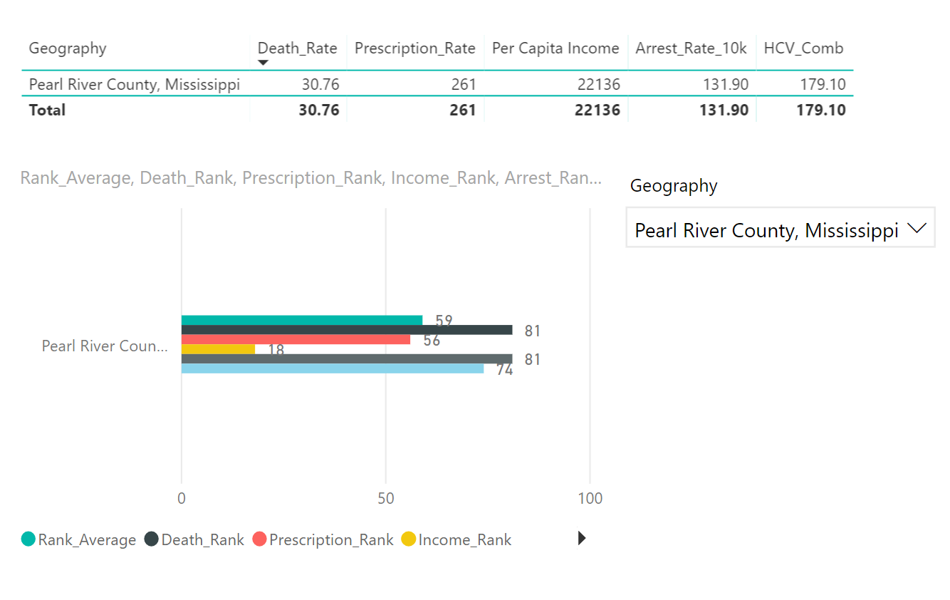
Figure 3. Information for Pearl River County

Conclusions
Unlike Poisson regression, this analysis method cannot predict outcome rates or offer deeper analysis into specific variables. However, as a general analysis, this model can be performed using basic spreadsheet calculations and therefore has a distinct advantage in ease of use, transparency, and relatively simple interpretations. Jurisdictions can easily substitute their own variables to perform this kind of analysis and determine county vulnerability in a customizable fashion. Depending on needs, the spreadsheet can be expanded to include Spearman rank correlation calculations or conditional formatting for percentiles.
The best way to share the interpretation of this model with members of the public, or stakeholders less familiar with this applied method, is to describe the resulting index, as a simple vulnerability ranked position. An explanation can therefore be reduced to the basic understanding that the average rank indicates broadly, the relative vulnerability position of a county, with respect to other counties that were included in the analysis. More so than with more advanced statistical methods, the average rank output can be communicated easily, and with certain familiarity to general audiences. This is because often, journalistic coverage of national statistics often converts results into ranks for states in the U.S. (e.g. average salary rank, alcohol consumed per capita rank, education spending rank, etc.). The results of this kind of analysis can be thought of and interpreted in a similar fashion.

Appendices:
Appendix X. Rank Values for Mississippi Counties
Geography | HCV_Rank | Income_Rank | Death_Rank | Arrest_Rank | Prescription_Rank | Rank_Average
Adams County, Mississippi | 63 | 64 | 55 | 69 | 17 | 51.25
Alcorn County, Mississippi | 79 | 36 | 69 | 43 | 66 | 53.5
Amite County, Mississippi | 38 | 46 | 13 | 68 | 35 | 40.5
Attala County, Mississippi | 18 | 34 | 6 | 11 | 61 | 28
Benton County, Mississippi | 17 | 60 | 52 | 10 | 33 | 38.75
Bolivar County, Mississippi | 16 | 68 | 19 | 12 | 47 | 36.5
Calhoun County, Mississippi | 29 | 63 | 11 | 4 | 12 | 22.5
Carroll County, Mississippi | 22 | 14 | 18 | 15 | 6 | 13.25
Chickasaw County, Mississippi | 35 | 48 | 19 | 53 | 42 | 40.5
Choctaw County, Mississippi | 19 | 43 | 76 | 15 | 74 | 52
Claiborne County, Mississippi | 7 | 80 | 19 | 15 | 9 | 30.75
Clarke County, Mississippi | 13 | 35 | 19 | 13 | 37 | 26
Clay County, Mississippi | 3 | 55 | 19 | 55 | 37 | 41.5
Coahoma County, Mississippi | 39 | 70 | 57 | 15 | 72 | 53.5
Copiah County, Mississippi | 42 | 58 | 19 | 50 | 54 | 45.25
Covington County, Mississippi | 55 | 59 | 78 | 46 | 75 | 64.5
DeSoto County, Mississippi | 54 | 4 | 59 | 82 | 16 | 40.25
Forrest County, Mississippi | 71 | 30 | 51 | 80 | 30 | 47.75
Franklin County, Mississippi | 59 | 6 | 54 | 6 | 17 | 20.75
George County, Mississippi | 27 | 27 | 65 | 15 | 81 | 47
Greene County, Mississippi | 81 | 62 | 19 | 54 | 4 | 34.75
Grenada County, Mississippi | 50 | 41 | 62 | 15 | 72 | 47.5
Hancock County, Mississippi | 73 | 8 | 19 | 61 | 30 | 29.5
Harrison County, Mississippi | 80 | 13 | 64 | 60 | 21 | 39.5
Hinds County, Mississippi | 58 | 17 | 56 | 74 | 5 | 38
Holmes County, Mississippi | 11 | 82 | 19 | 15 | 14 | 32.5
Humphreys County, Mississippi | 9 | 74 | 19 | 15 | 23 | 32.75
Issaquena County, Mississippi | 41 | 72 | 19 | 15 | 82 | 47
Itawamba County, Mississippi | 51 | 29 | 19 | 15 | 59 | 30.5
Jackson County, Mississippi | 76 | 7 | 74 | 52 | 50 | 45.75
Jasper County, Mississippi | 5 | 33 | 53 | 76 | 70 | 58
Jefferson County, Mississippi | 40 | 79 | 79 | 57 | 67 | 70.5
Jefferson Davis County, Mississippi | 65 | 67 | 17 | 15 | 46 | 36.25
Jones County, Mississippi | 33 | 28 | 16 | 64 | 55 | 40.75
Kemper County, Mississippi | 1 | 73 | 72 | 15 | 8 | 42
Lafayette County, Mississippi | 28 | 5 | 45 | 72 | 3 | 31.25
Lamar County, Mississippi | 48 | 3 | 58 | 65 | 26 | 38
Lauderdale County, Mississippi | 45 | 11 | 43 | 56 | 32 | 35.5
Lawrence County, Mississippi | 70 | 20 | 19 | 3 | 79 | 30.25
Leake County, Mississippi | 26 | 57 | 15 | 75 | 19 | 41.5
Lee County, Mississippi | 57 | 9 | 44 | 59 | 42 | 38.5
Leflore County, Mississippi | 15 | 75 | 2 | 14 | 45 | 34
Lincoln County, Mississippi | 36 | 32 | 1 | 45 | 26 | 26
Lowndes County, Mississippi | 30 | 12 | 68 | 79 | 50 | 52.25
Madison County, Mississippi | 20 | 1 | 9 | 78 | 11 | 24.75
Marion County, Mississippi | 78 | 47 | 71 | 15 | 76 | 52.25
Marshall County, Mississippi | 75 | 45 | 8 | 62 | 22 | 34.25
Monroe County, Mississippi | 24 | 22 | 7 | 8 | 64 | 25.25
Montgomery County, Mississippi | 49 | 15 | 19 | 15 | 52 | 25.25
Neshoba County, Mississippi | 12 | 54 | 10 | 15 | 56 | 33.75
Newton County, Mississippi | 34 | 26 | 4 | 15 | 36 | 20.25
Noxubee County, Mississippi | 4 | 71 | 19 | 15 | 58 | 40.75
Oktibbeha County, Mississippi | 2 | 25 | 19 | 9 | 1 | 13.5
Panola County, Mississippi | 43 | 39 | 67 | 42 | 69 | 54.25
Pearl River County, Mississippi | 74 | 18 | 81 | 81 | 56 | 59
Perry County, Mississippi | 61 | 52 | 66 | 15 | 80 | 53.25
Pike County, Mississippi | 66 | 65 | 42 | 71 | 67 | 61.25
Pontotoc County, Mississippi | 46 | 38 | 63 | 5 | 37 | 35.75
Prentiss County, Mississippi | 62 | 56 | 50 | 1 | 63 | 42.5
Quitman County, Mississippi | 8 | 76 | 19 | 15 | 44 | 38.5
Rankin County, Mississippi | 77 | 2 | 49 | 77 | 25 | 38.25
Scott County, Mississippi | 32 | 37 | 61 | 63 | 40 | 50.25
Sharkey County, Mississippi | 25 | 66 | 75 | 15 | 2 | 39.5
Simpson County, Mississippi | 56 | 51 | 19 | 44 | 23 | 34.25
Smith County, Mississippi | 10 | 19 | 19 | 51 | 40 | 32.25
Stone County, Mississippi | 64 | 23 | 46 | 70 | 52 | 47.75
Sunflower County, Mississippi | 67 | 77 | 12 | 15 | 12 | 29
Tallahatchie County, Mississippi | 82 | 78 | 19 | 15 | 6 | 29.5
Tate County, Mississippi | 53 | 21 | 77 | 66 | 29 | 48.25
Tippah County, Mississippi | 31 | 44 | 19 | 2 | 48 | 28.25
Tishomingo County, Mississippi | 60 | 50 | 5 | 73 | 70 | 49.5
Tunica County, Mississippi | 44 | 61 | 80 | 7 | 10 | 39.5
Union County, Mississippi | 37 | 49 | 60 | 58 | 48 | 53.75
Walthall County, Mississippi | 69 | 40 | 73 | 48 | 61 | 55.5
Warren County, Mississippi | 23 | 16 | 3 | 47 | 20 | 21.5
Washington County, Mississippi | 21 | 53 | 14 | 49 | 34 | 37.5
Wayne County, Mississippi | 6 | 24 | 70 | 67 | 65 | 56.5
Webster County, Mississippi | 46 | 31 | 19 | 15 | 78 | 35.75
Wilkinson County, Mississippi | 72 | 81 | 48 | 15 | 26 | 42.5
Winston County, Mississippi | 14 | 10 | 19 | 15 | 60 | 26
Yalobusha County, Mississippi | 68 | 42 | 82 | 15 | 77 | 54
Yazoo County, Mississippi | 52 | 69 | 47 | 15 | 15 | 36.5

