Introduction
These profiles serve as a starting point for analyzing vulnerability in the following regions of Mississippi: Gulf Coast, Pine Belt, Metro Jackson, Delta, Memphis Metro, and Appalachian. Counties are selected arbitrarily within each region. Indicators and outcomes are presented in a “higher is worse” ranking, where greater numbers represent more vulnerability or higher incidence.

Focus: Gulf Coast
Pearl River County is located in the Gulf Coast Region. Across the four indicators, Pearl River has an average rank of 59 (out of a maximum possible of 88 counties): 81 for deaths, 56 for prescriptions, 18 for income, 81 for drug arrests. It has the 74th highest rate of HCV incidence, 179 per 100,000 population.
By comparison to state averages (median rate of HCV incidence in Mississippi is 100 per 100,000 population) the HCV incidence is Pearl River County is 1.8 times higher. The two indicators where Pearl River County has the greatest ranked vulnerability are drug overdose deaths and drug arrests. By focusing on evidence-based programs that lower these indicators, Pearl River County’s HCV incidence would be expected to move closer to the statewide median, and thus reduce vulnerability.
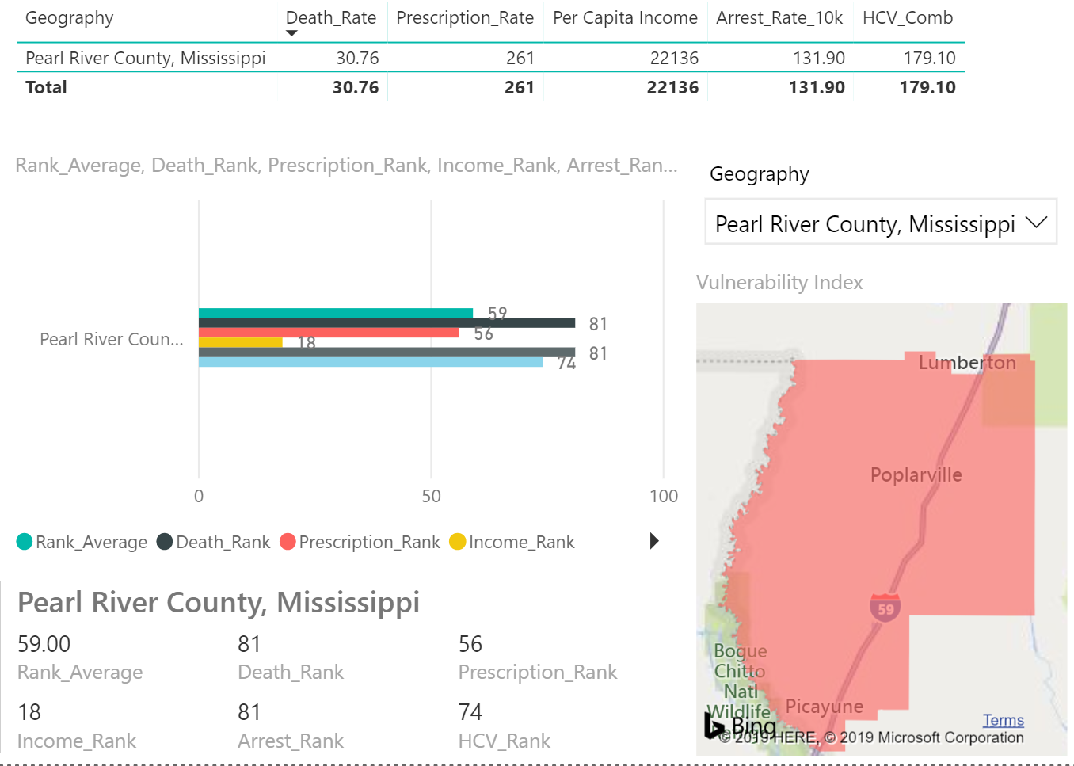

Focus: Pine Belt
Forrest County is located in the Pine Belt Region. Across the four indicators, Forrest County has an average rank of 47.75 (out of a maximum possible of 88 counties): 51 for deaths, 30 for prescriptions, 30 for income, 80 for drug arrests. It has the 71th highest rate of HCV incidence, 167 per 100,000 population.
By comparison to state averages (median rate of HCV incidence in Mississippi is 100 per 100,000 population) the HCV incidence is Forrest County is 1.7 times higher. The two indicators where Forrest County has the greatest ranked vulnerability are drug overdose deaths and drug arrests. By focusing on evidence-based programs that lower these indicators, Forrest County’s HCV incidence would be expected to move closer to the statewide median, and thus reduce vulnerability.
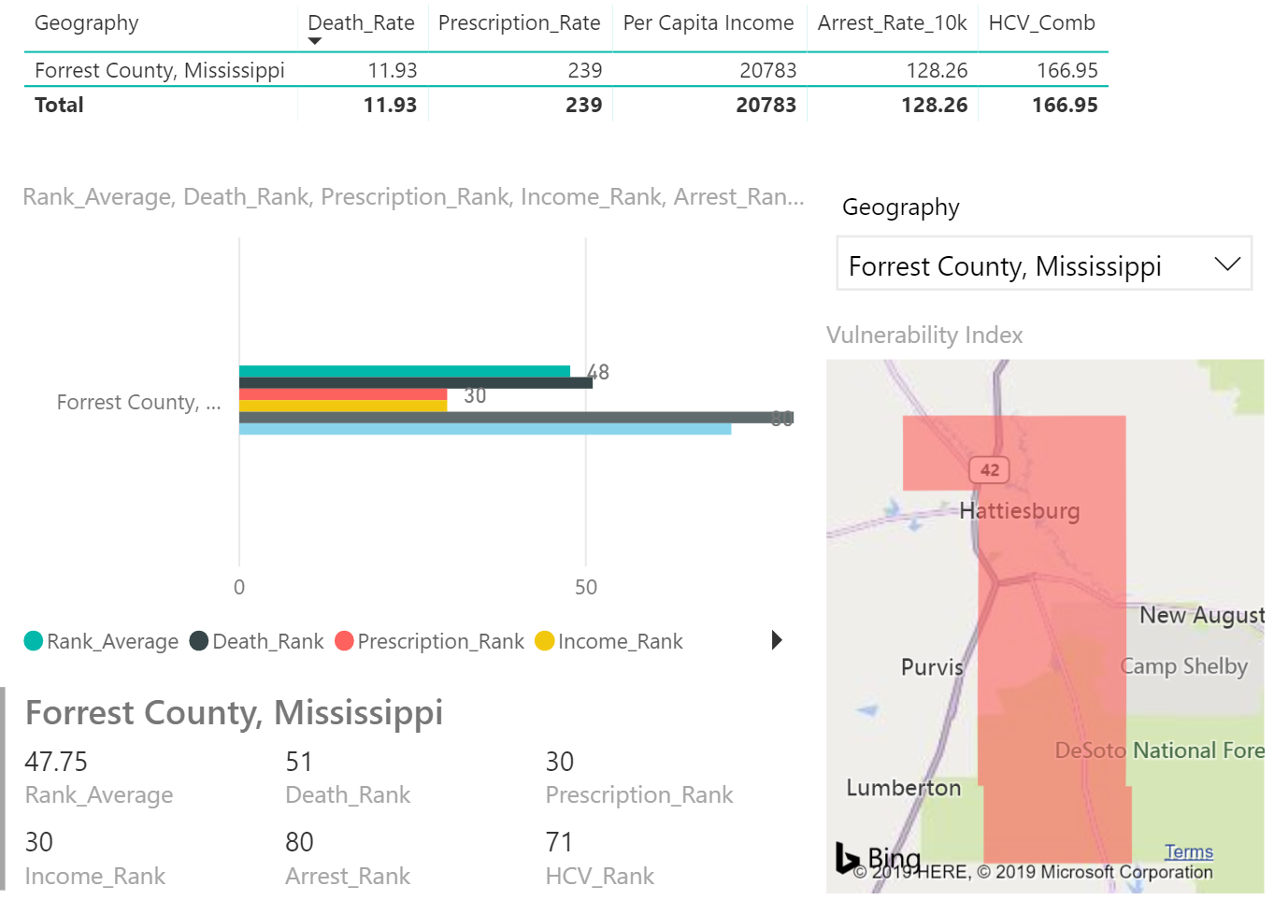

Focus: Jackson Metro
Hinds County is located in the Jackson Metro Region. Across the four indicators, Hinds County has an average rank of 38 (out of a maximum possible of 88 counties): 56 for deaths, 5 for prescriptions, 17 for income, 74 for drug arrests. It has the 58th highest rate of HCV incidence, 133 per 100,000 population.
By comparison to state averages (median rate of HCV incidence in Mississippi is 100 per 100,000 population) the HCV incidence is Hinds County is 1.3 times higher. The two indicators where Hinds County has the greatest ranked vulnerability are drug overdose deaths and drug arrests. By focusing on evidence-based programs that lower these indicators, Hinds County’s HCV incidence would be expected to move closer to the statewide median, and thus reduce vulnerability.
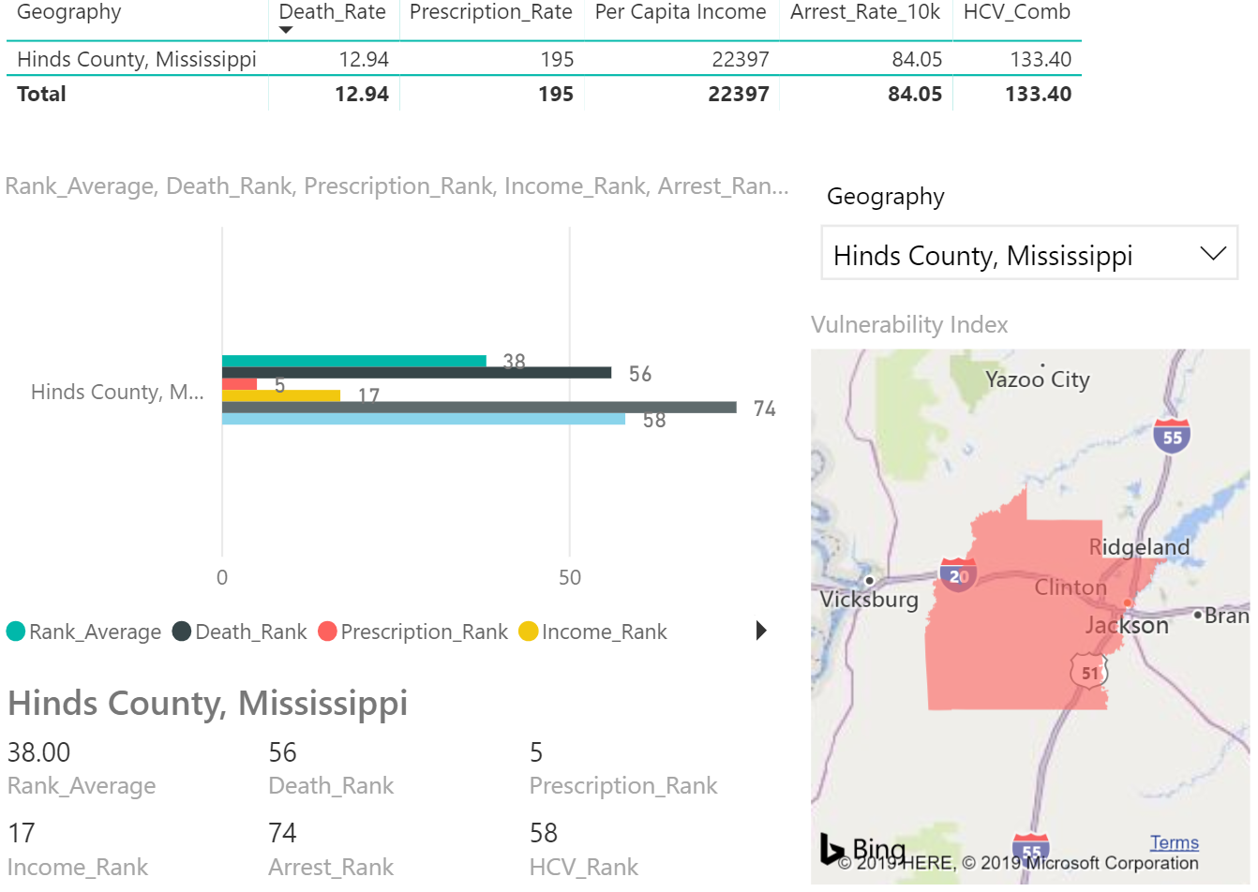

Focus: Mississippi Delta
Washington County is located in the Mississippi Delta Region. Across the four indicators, Washington County has an average rank of 38 (out of a maximum possible of 88 counties): 14 for deaths, 34 for prescriptions, 53 for income, 49 for drug arrests. It has the 21th highest rate of HCV incidence, 64 per 100,000 population.
By comparison to state averages (median rate of HCV incidence in Mississippi is 100 per 100,000 population) the HCV incidence is Washington County is 60% as high. The two indicators where Washington County has the greatest ranked vulnerability are income and drug arrests. By focusing on evidence-based programs that improve these indicators, Washington County’s HCV incidence would be expected to continue to decrease, and thus reduce vulnerability.
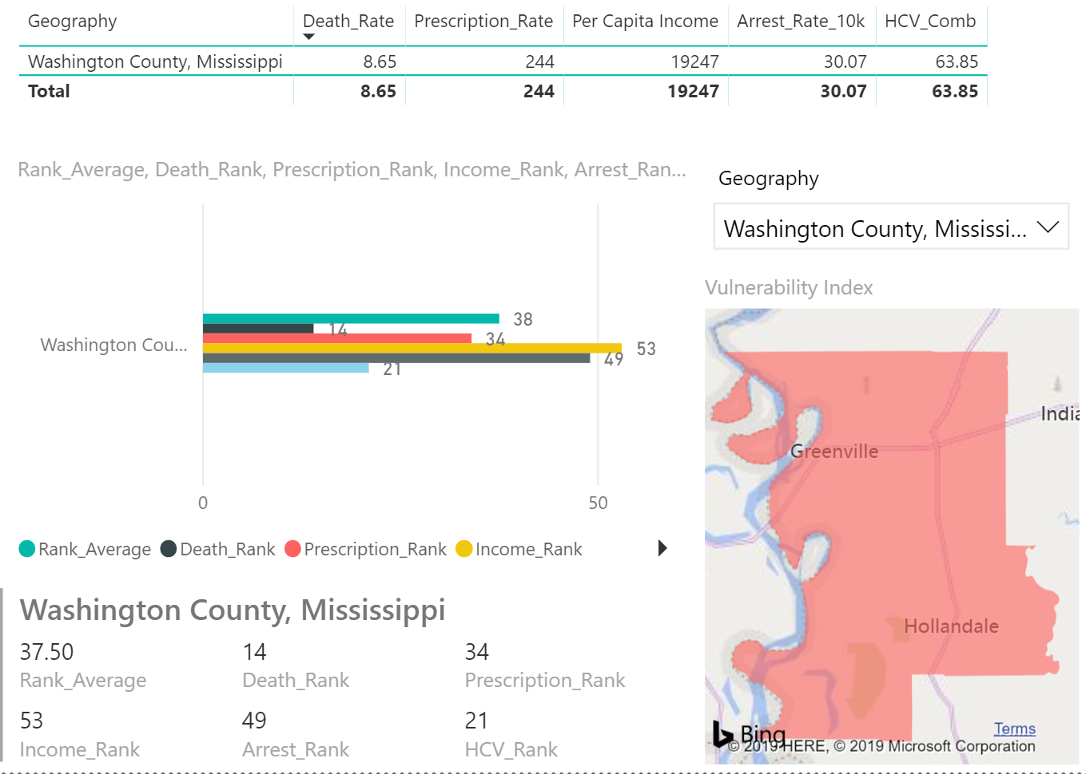

Focus: Memphis Metropolitan
Marshall County is located in the Memphis Metropolitan Region. Across the four indicators, Marshall County has an average rank of 34.25 (out of a maximum possible of 88 counties): 8 for deaths, 22 for prescriptions, 45 for income, 62 for drug arrests. It has the 75th highest rate of HCV incidence, 182 per 100,000 population.
By comparison to state averages (median rate of HCV incidence in Mississippi is 100 per 100,000 population) the HCV incidence is Marshall County is 1.8 times as high. The two indicators where Marshall County has the greatest ranked vulnerability are income and drug arrests. By focusing on evidence-based programs that improve these indicators, Marshall County’s HCV incidence would be expected to decrease toward the statewide median.
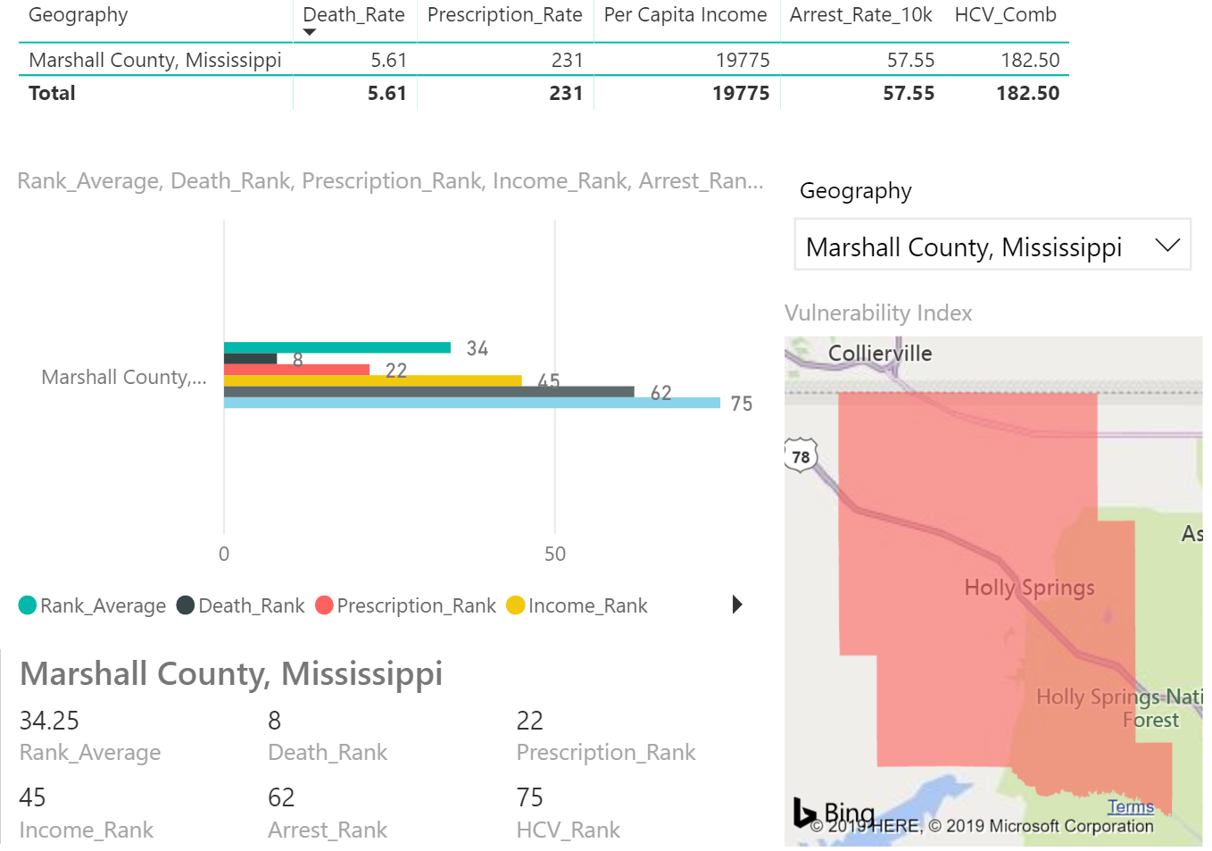

Focus: Applachia
Union County is located in the Applachain Region. Across the four indicators, Union County has an average rank of 53.75 (out of a maximum possible of 88 counties): 60 for deaths, 48 for prescriptions, 49 for income, 58 for drug arrests. It has the 37th highest rate of HCV incidence, 91 per 100,000 population.
By comparison to state averages (median rate of HCV incidence in Mississippi is 100 per 100,000 population) the HCV incidence is Union County is 91% as high. The two indicators where Union County has the greatest ranked vulnerability are income and drug deaths. By focusing on evidence-based programs that improve these indicators, Union County’s HCV incidence would be expected to decrease toward the statewide median.
