Jurisdiction Vulnerability Assessment: Composite Index Score Approach:
The Composite Index Score (CIS) approach for the Jurisdiction Vulnerability Assessment (JVA) uses methods similar to those developed for the Social Vulnerability Index (JVI) by the Geospatial Research, Analysis, and Services Program, (GRASP), which looks at the vulnerability of communities to disasters, such as earthquakes, hurricanes, and floods. The mechanics behind jurisdiction vulnerability are similar, however, CIS uses indicators selected by subject matters experts, in this case, indicators relating to intravenous drug use (IDU), which makes communities vulnerable for outbreaks of both Hepatitis C (Hep C), HIV infection and opioid overdose. CIS offers an indirect method of assessing risk for counties. Van Handel et al. (2016) found the following indicators for IDU vulnerability: drug overdose deaths, prescription opioid sales, per capita income, percent population white, unemployment and buprenorphine prescription capacity. Below we describe an example for one state using data for opioid prescriptions, drug arrests, drug overdose deaths, along with the ACS per capita income variable to calculate the CIS.
CIS uses the rankings of indicators within each jurisdiction to assess which counties (or other subdivisions) are most vulnerable to outbreaks associated with IDU. The ranking method is less statistical but very adaptable and works well in applied situations. In contrast, regression approaches (both Poisson and Negative Binomial) have more robust modeling and predictive power, at the cost of complexity, both for the modeler and for users of the model, such as local health departments and constituents at town hall meetings.
CIS Example – Texas:
We will use Texas as an example of how to perform a CIS. For this example, we used the following category / indicator pairs, based on publicly available data:
  - Socioeconomics: Per Capita Income (2013-2017 American Community Survey)
  - Crime: Drug Arrest Rate (Uniform Crime Reporting Program Data, 2016)
  - Prescriptions: IQVIA Xponent (Per 100 Capita Prescriptions, 2017)
  - Mortality: Drug Overdose Rate (CDC Wonder, 2013-2017)
To handle missing data and zeros, we made the following assumptions. We assumed that zero values were a legitimate reflection of zero events and assigned the statewide median for missing (N/A) values, as a simple form of imputation. We ranked each indicator among the 254 counties of Texas, with a “higher is worse” categorization (see Table X). We then took the average of the four ranks to calculate the CIS for each county in Texas. Analysis was performed using widely available spreadsheet software (Microsoft Excel).
Table 1. Select Indicators, Texas
Geography | Drug Arrests (Rate, Rank) | Opioid Prescriptions (Rate, Rank) | Drug Overdose Deaths (Rate, Rank) | Per Capita Income (Value, Rank) | Average Rank
Anderson County, Texas | 45.1 (110) | 62.2 (168) | 14.9 (227) | 17466 (239) | 186
Andrews County, Texas | 53.8 (140) | 52.5 (96) | 10.9 (62) | 29903 (40) | 84.5
Angelina County, Texas | 41.9 (91) | 88.7 (233) | 10.5 (53) | 21974 (182) | 139.75
Aransas County, Texas | 141.6 (248) | 83.0 (222) | 20.6 (250) | 29999 (36) | 189
Archer County, Texas | 53.1 (139) | 56.9 (109) | 25.1 (253) | 31103 (29) | 132.5

Mapping the CIS for each county using Microsoft Power BI, we observed higher vulnerability in counties along the Oklahoma border and counties located on the Gulf of Mexico (Figure X). Specific counties can then be further explored to understand the underlying factors contributing to their CIS. Using Power BI, we were able to look at Childress County, which had the highest CIS, and noted higher levels of drug arrests, per capita income, and opioid prescriptions, and median vulnerability in drug overdose deaths, due to missing data. Kleberg County, south of San Antonio on the Gulf Coast, had higher levels of drug arrests and per capita income, and median vulnerability in opioid prescriptions.
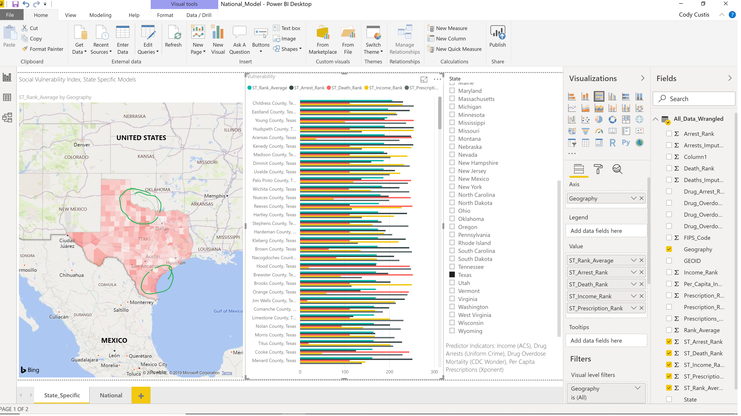
Figure 2. JVA, Texas
When interpreting the CIS, an appropriate outcome metric for context should be used. For this CIS example, jurisdictions used metrics such as diagnoses of Hepatitis C or HIV from state registries, in some cases combining the two. Other jurisdictions used hospitalization data for Hepatitis C or HIV, also, in some cases combining the two. For the Texas example, HIV diagnoses was used as the outcome metric. Assessing the CIS and the outcome metric together can add important context for understanding the CIS. For example, Reeves County, a rural county with a population of 13,783 in West Texas, had the highest rate of HIV diagnoses, 54.9 per 100,000. It also ranked 242th in terms of vulnerability.
When presenting the CIS to stakeholders, we offer the following recommendations:
- Focus on areas with high outcome metric / high CIS, such as Reeves County: Areas with high outcome metrics and high vulnerability represent areas where resources should be dedicated. Health departments should look at available resources within these areas and see what steps are being taken, and could be taken, to address IDU in those communities.
- Focus on areas with low outcome metric / high vulnerability, such as Taylor County (HIV diagnoses of 6.3 per 100,000; CIS of 151): Areas with a low outcome metric but high vulnerability may be due to protective factors such as needle exchange programs, Naloxone availability, or programs by local public health officials. On the other hand, such areas may reflect a lack of testing for the outcome metric, such as lack of capacity to test for HIV / HCV.
- Focus on areas with high outcome metric / low vulnerability, such as Chambers County (HIV diagnoses of 45.1 per 100,000, second highest in Texas; CIS of 95.25): Areas with a high outcome metric and low vulnerability may reflect exogenous factors, such as changes in drug traffic patterns. When working with one state, a county with high HCV incidence was a county that contained a major Interstate highway and located near a large urban area in a neighboring state.
We created a county focus template using Bexar County, Texas (Appendix X). This template is a generic example of how states can focus on specific regions. Because of the large numbers of missing values in the selected outcome variable (HIV diagnoses, CDC/NCHHSTP AtlasPlus Public Data), outcome ranking for Bexar is currently blank. As with the Texas example, indicators are ranked in a “higher is worse” format where higher values represent more vulnerability or negative outcome. Jurisdictions may modify this template as needed when working with local health partners.

Appendix X. Focus Template

Focus: Bexar County, Texas
Bexar County contains San Antonio. Across the four indicators, Bexar has an average rank of 112 (out of a maximum possible of 254 counties): 62 for deaths, 90 for prescriptions, 90 for income, 205 for drug arrests. It’s rate of HIV incidence is similar to the statewide rate of 19.0 per 100,000.
By comparison to state averages (statewide rate of HIV incidence in Texas is 19.0 per 100,000 population) the HIV incidence in Bexar County is 16% higher. The indicator where Bexar County has the greatest ranked vulnerability is drug arrests. By focusing on evidence-based programs that lower these indicators, Bexar County’s HIV incidence would be expected to move closer to the statewide value, and thus reduce vulnerability.
