Data Dictionary – Mississippi
Prepared by Cody L. Custis, Tsuro Consulting, for the Jurisdiction Vulnerability Assessment
Introduction:
This data dictionary is specific to Mississippi for the jurisdiction vulnerability assessment. It contains data sources, comments on data wrangling, and preliminary maps for certain indicators.
Disclaimer: the views and opinions expressed in this document are those of the authors, Cody Custis and Jordan Larson, both of Tsuro Consulting, and do not necessarily reflect the official policy or position of the Centers for Disease Control and Prevention, the Council of State and Territorial Epidemiologists, or any state, local, or tribal health agency.
Current Indicators:
County level overdose deaths (Mississippi Bureau of Narcotics)
Hepatitis C (Mississippi STD / HIV Program)
Opioid prescription rate by county (NSPARC report)
Drug related arrests by county (Mississippi Bureau of Narcotics)
Per capita income (American Community Survey)
Per capita Income

Topic: Demographics
Data Source: American Community Survey
Maintained: US Census Bureau
Accessibility: Public
Example URL: https://www.census.gov/programs-surveys/acs
Years available: Five year estimates at county level, annualized, 2000-2017

Summary: the American Community Survey (ACS) has county level data on a number of subject areas, including education, employment, income, race and ethnicity. Depending on county size, this information may only be available as five-year estimates. Because ACS data is available to the public, collected on a regular basis, and available at the county level, it can form a basic core set of indicators that every state and jurisdiction health department can use to assess county level vulnerability. ACS data is available at the Census Tract level for larger counties that want to target sub-county areas.

Core: S1901 – Income in the Past 12 Months – 2017 ACS Five Year Estimates – Available from Tsuro (April 2019)

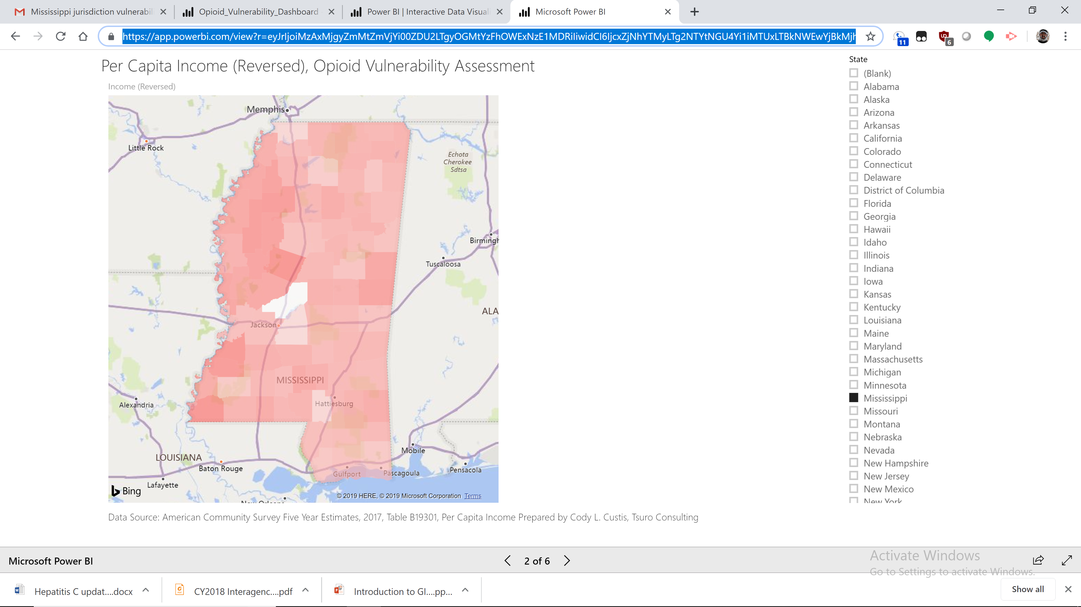
https://app.powerbi.com/view?r=eyJrIjoiMzAxMjgyZmMtZmVjYi00ZDU2LTgyOGMtYzFhOWExNzE1MDRiIiwidCI6IjcxZjNhYTMyLTg2NTYtNGU4Yi1iMTUxLTBkNWEwYjBkMjhiMCJ9

County Level Overdose Deaths
Topic: Mortality / Crime
Data Source: Mississippi – Bureau of Narcotics – Table 5 (Mortality and Arrests)
Maintained: Mississippi Opioid and Heroin Data Collaborative
Accessibility: TBD
Example URL: TBD
Years available: 2018
Comment from Meg: “This is provisional data from the Mississippi Bureau of Narcotics. We have no way to validate these data. We do know that for CY2017, MBN reported 255 suspected overdose deaths while Vital Records reported 346 drug overdose deaths.”
Data Wrangling Notes: PDF table was cut and paste using spreadsheet operations.
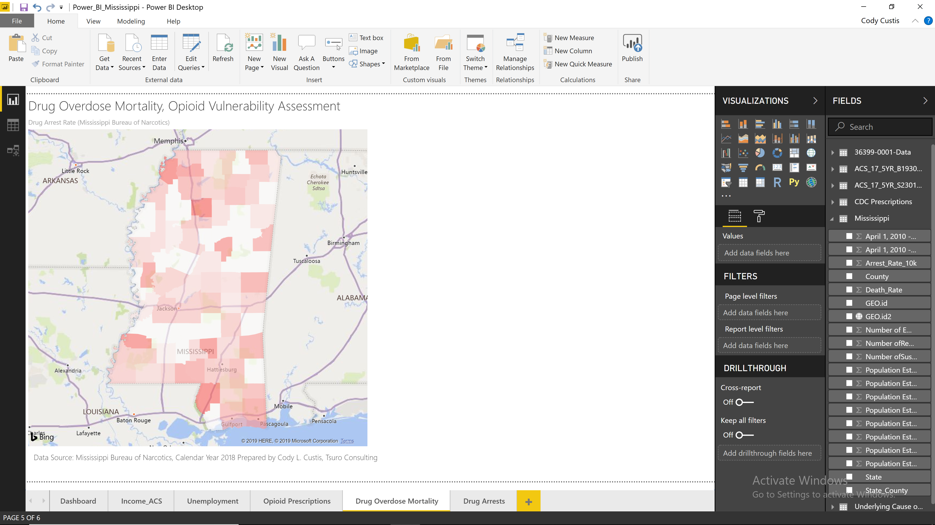

County Level Drug Arrests
Topic: Crime
Data Source: Mississippi – Bureau of Narcotics – Table 5 (Mortality and Arrests)
Maintained: Mississippi Opioid and Heroin Data Collaborative
Accessibility: TBD
Example URL: TBD
Years available: 2018
Comment from Meg: “This is provisional data from the Mississippi Bureau of Narcotics. We have no way to validate these data. We do know that for CY2017, MBN reported 255 suspected overdose deaths while Vital Records reported 346 drug overdose deaths.”
Data Wrangling Notes: PDF table was cut and paste using spreadsheet operations.

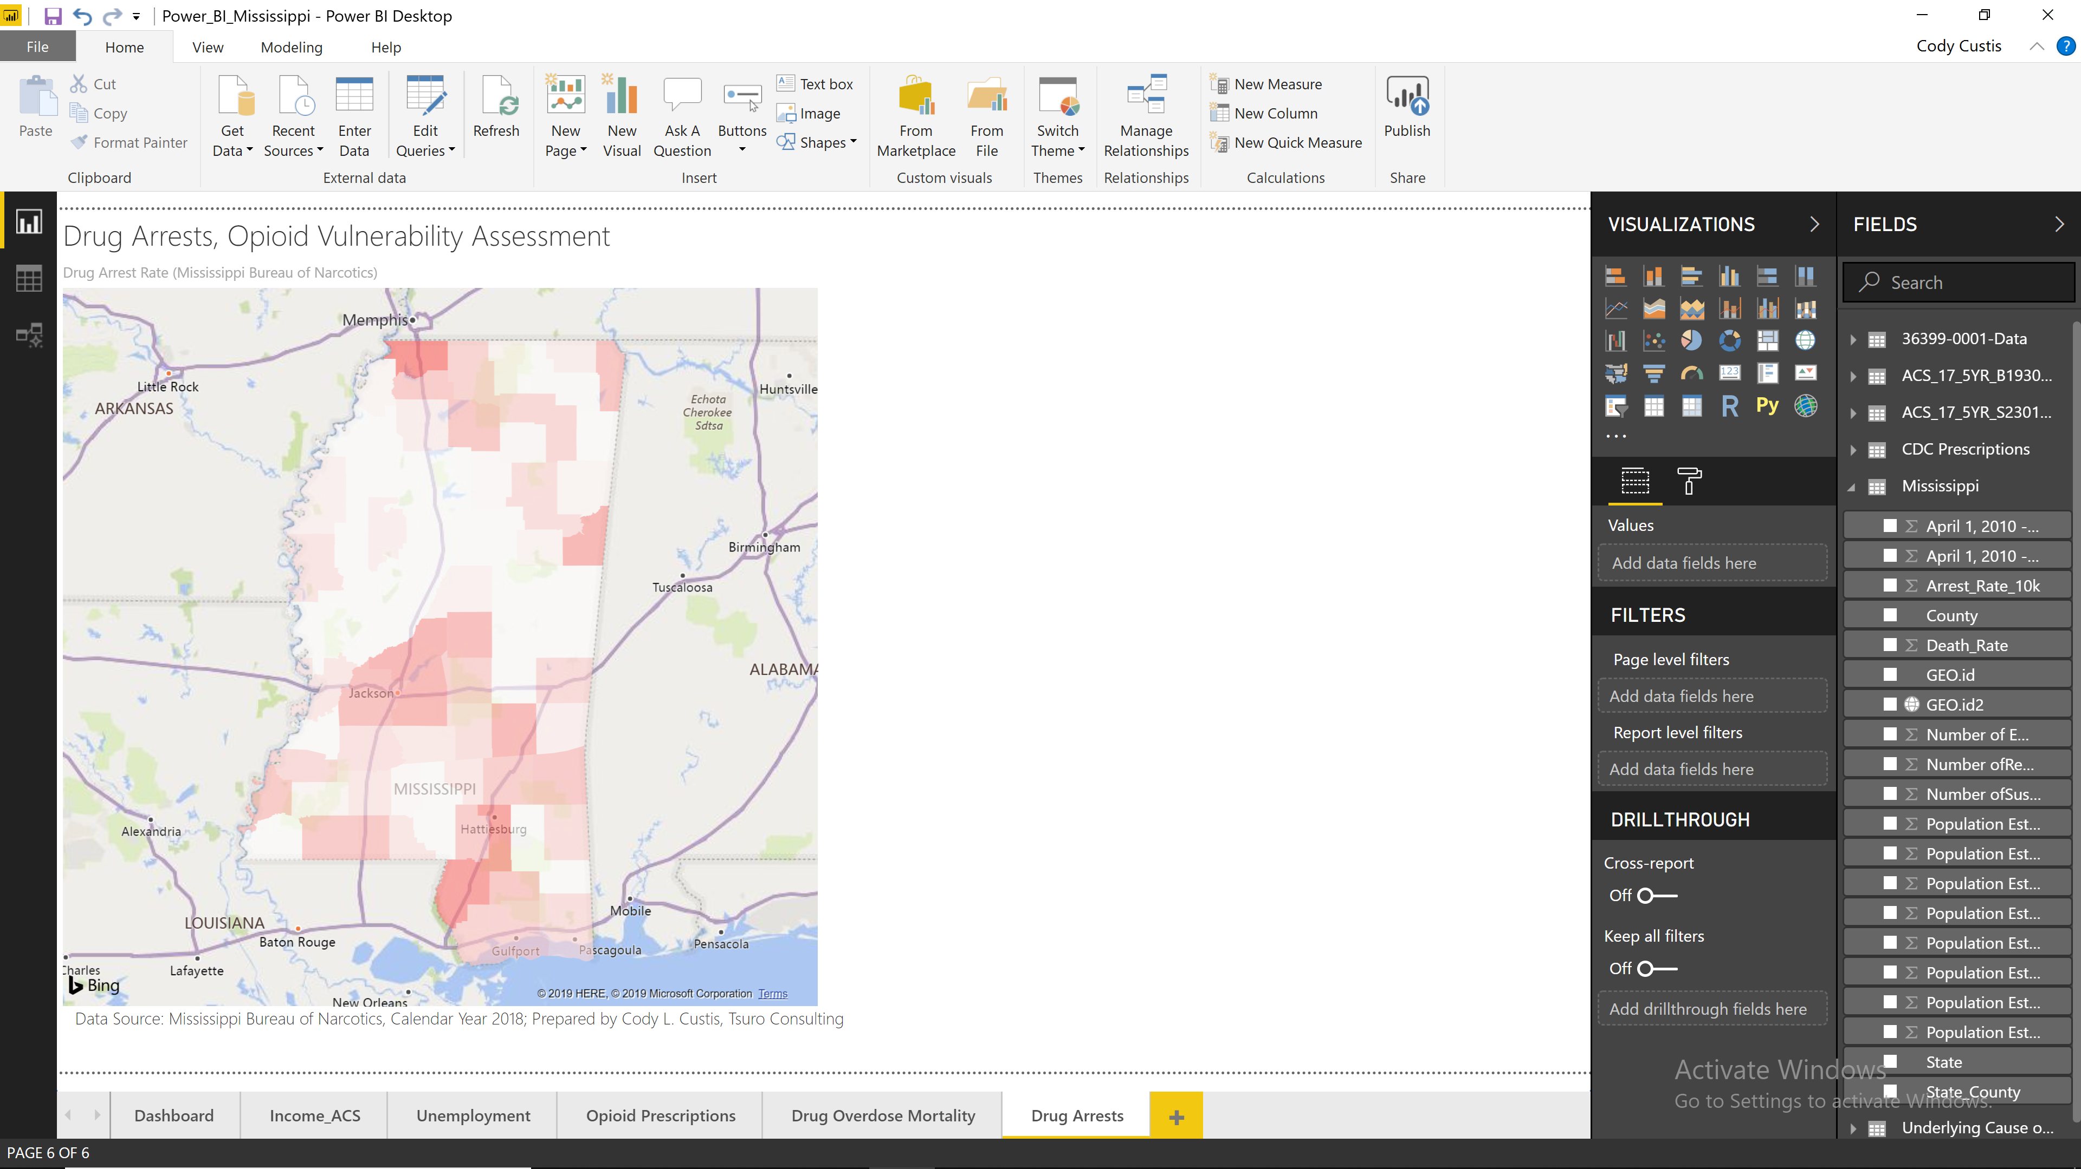

Hepatitis C
Topic: Outcomes – Hep C
Data Source: Mississippi – Patient Reporting Investigation Surveillance Manager (PRISM)
Maintained: Mississippi State Department of Health
Accessibility: TBD
Example URL: TBD
Years available: 2017,2018
Comment from Meg: “ it was explained to me the these are not Mississippi-specific data; rather, we used NHANES and other resources to estimate prevalence based on national data”
Data Wrangling Notes: Word table was cut and paste to Excel spreadsheet.
Other notes: 2018 rate is currently mapped, 2017-2018 map could be calculated from reports and rates. Although the reports are considered an underestimate, as long as that underestimate is not due to county level factors, it should be a consistent outcome variable. – Cody Custis
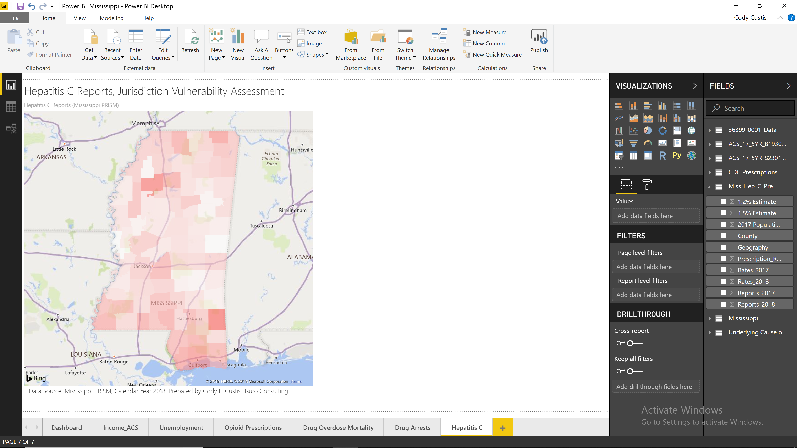

Opioid Prescriptions
Topic: Prescription
Data Source: Opioid and Benzodiazepine Prescriptions in Mississippi – 2018 Prescription Data Update – Figure 1
Maintained: Mississippi Board of Pharmacy, NSPARC
Accessibility: TBD
Example URL: https://pmp.mbp.ms.gov/statistics/
Years available: 2017,2018
Comment from Meg: NSPARC report posted at: https://pmp.mbp.ms.gov/statistics/; In public health review of this report, we noted that the MME for prescriptions is above similar national reports as well as a report produced by MSDH (https://msdh.ms.gov/msdhsite/_static/resources/7822.pdf). Additionally, we in public health are always very cautious when Issaquena county ranks either first or last - this is a farming community with a total population around 1,400 people.
Data Wrangling Notes: Manually typed from PDF map.
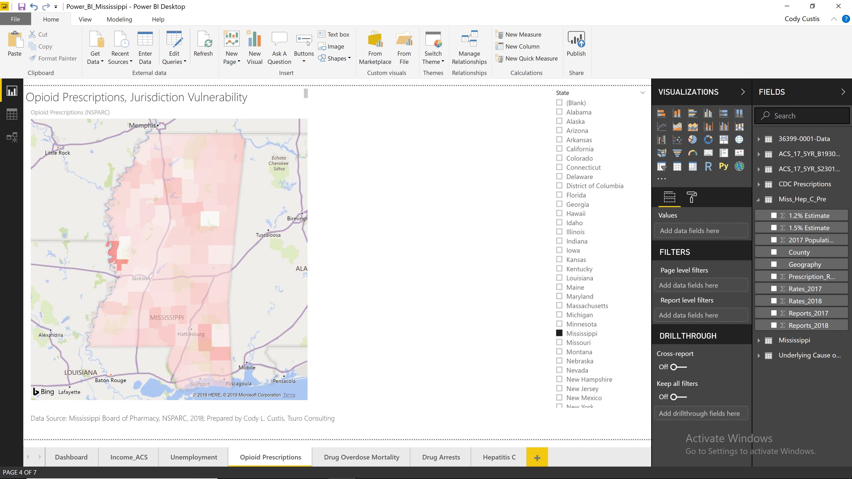

Technical Notes:
As of April 21, 2019, the following deployment options are available. The data modeled is American Community Survey Per Capita Income and available to the public:
Power BI – Static Maps (Private, Static)
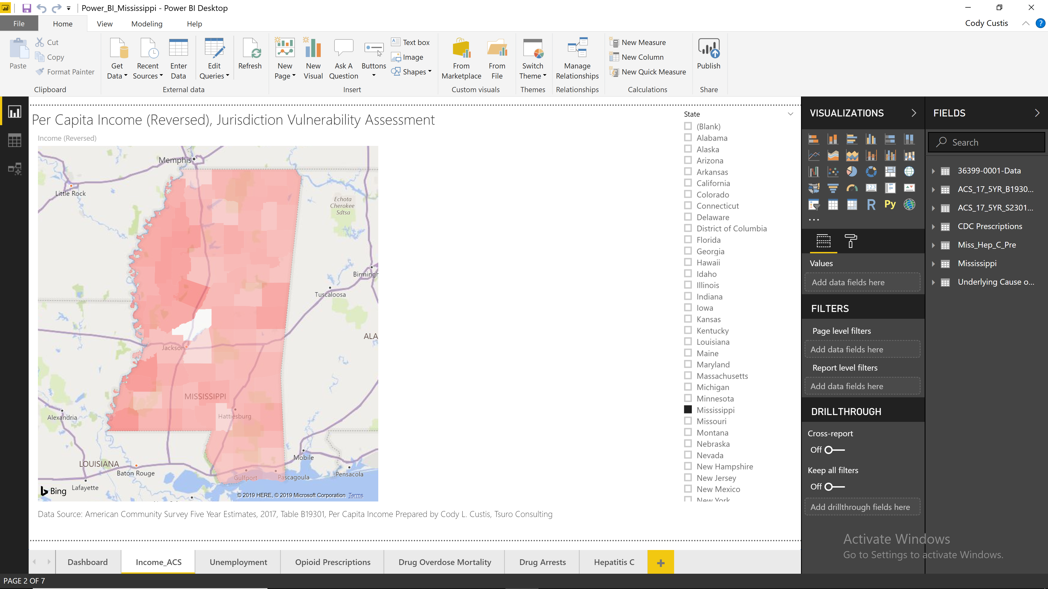
Power BI – Service (Public, Interactive)
https://app.powerbi.com/view?r=eyJrIjoiYmRkMDM2MDYtNjBjYi00OTUwLTliNjctOWZhNjYzODMwYWU0IiwidCI6IjcxZjNhYTMyLTg2NTYtNGU4Yi1iMTUxLTBkNWEwYjBkMjhiMCJ9
R – Static Images (Private, Static)
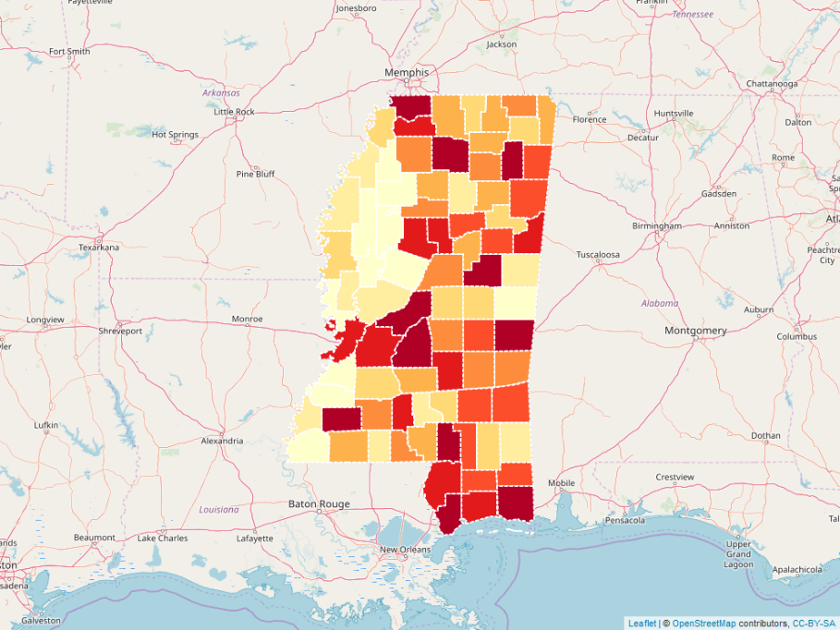
R – Interactive (Public, Interactive) http://rpubs.com/ccustis/MS_Income_Demo
