Mapping Software Solutions
Cody L. Custis, Jordan Larson; Tsuro Consulting

Common Requirements:

The mapping solutions that we considered are all capable of the following: displaying choropleth (aka hotspot) maps, adding point and polygon layers, the ability to post public maps. For this project, it is assumed that all maps will be released to the public. We consider costs and benefits and are familiar with each solution proposed; that does not mean that state and local health departments should not consider other solutions. Likewise, we are capable of providing technical support for the solutions proposed, however, we may be able to provide support for other solutions.
Disclaimer: the views and opinions expressed in this document are those of the authors, Cody Custis and Jordan Larson, both of Tsuro Consulting, and do not necessarily reflect the official policy or position of the Centers for Disease Control and Prevention, the Council of State and Territorial Epidemiologists, or any state, local, or tribal health agency.
1. R

Advantages: open source, free hosing available via Rshiny, extensible to do nearly anything, able to combine powerful statistical modeling with mapping capability

Disadvantages: requires programming skills, inconsistency in design from library to library,

Example: http://rpubs.com/ccustis/486856

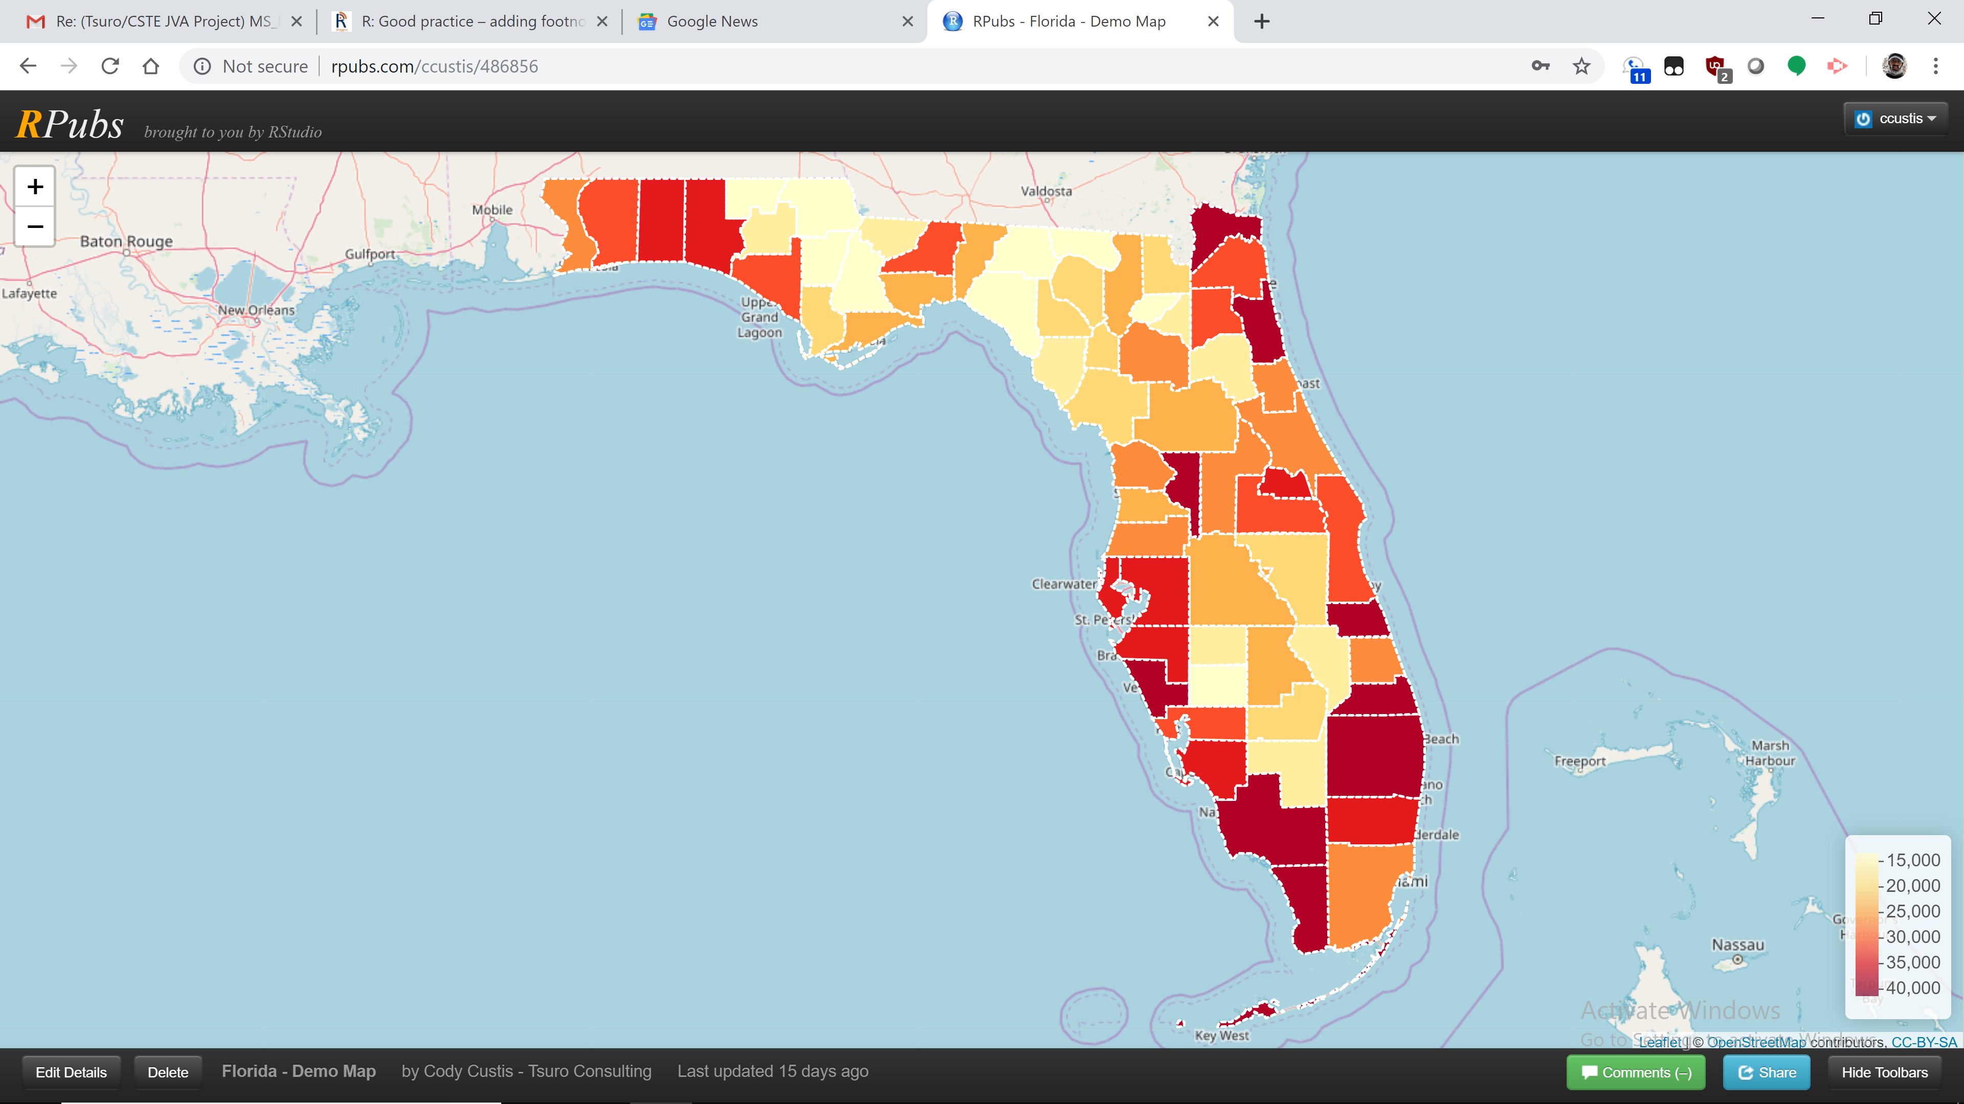
Summary: R is a open source programming language with extensive use in academic settings. As a programming language, it may require skills beyond the capability of some users. However, the advantage of being a programming language is that code can be reused from project to project. This means that, once a map is created, it can easily be altered as needed. Packages like Rshiny allow users, with a minimum of hosting or web development skill, to create applications available on the Internet.
Perhaps the strongest feature of R is that, with packages, nearly anything is possible. R offers near infinite customization, along with a, at time, overwhelming learning curve. R may be able to do nearly anything, however, individual users may find even basic changes extraordinarily difficult.
2. Microsoft Power BI

Advantages: free desktop version, free service for public users (requires registration), massive upgrade / update cycles, easy to deploy, integration with ArcGIS / R

Disadvantages: paid software as a service model pay discourage some users, minimal ability to customize, data manipulation requires two Microsoft specific programming languages (M and DAX)

Example: https://app.powerbi.com/view?r=eyJrIjoiMzAxMjgyZmMtZmVjYi00ZDU2LTgyOGMtYzFhOWExNzE1MDRiIiwidCI6IjcxZjNhYTMyLTg2NTYtNGU4Yi1iMTUxLTBkNWEwYjBkMjhiMCJ9

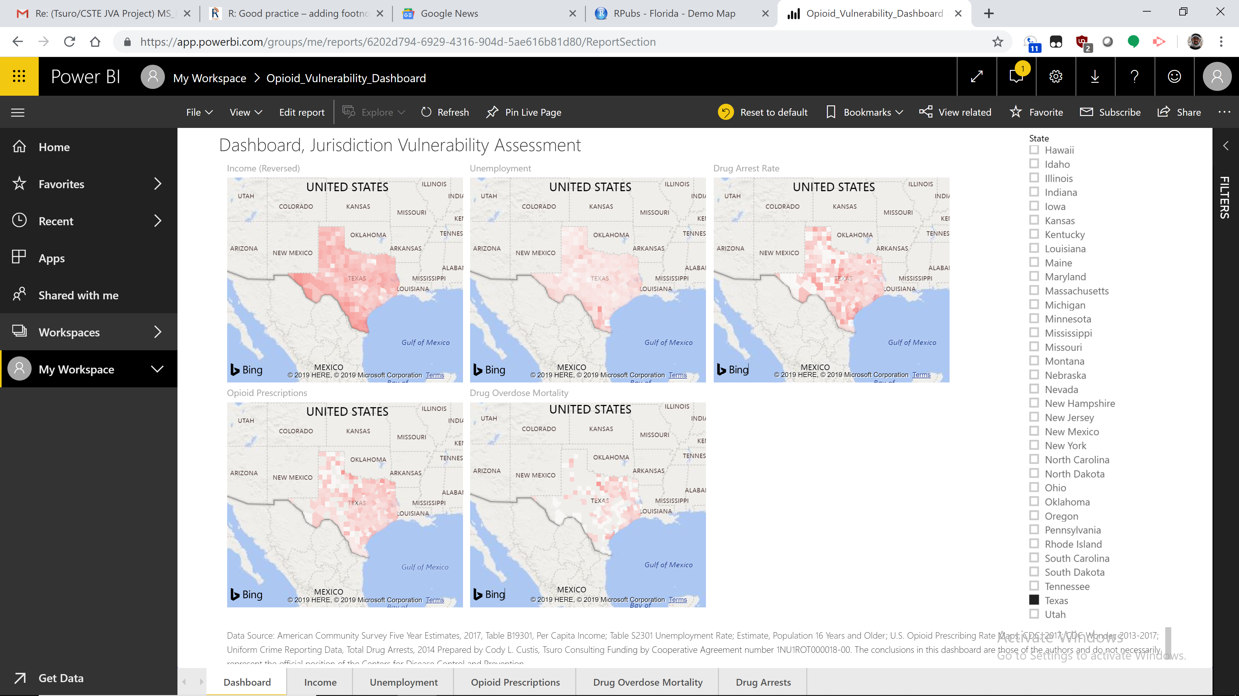

Summary: Power BI is a Microsoft visualization tool similar to Tableau, designed for the business intelligence market. Microsoft is committed to development and releases new features on a monthly basis. Power BI’s strengths include more modeling capability than competitors and integration with open source software such as R and Python. Power BI’s biggest weakness is that development is extremely fragmented. For example, Power BI has fragmented design and capabilities between desktop and service versions. Nonetheless, Power BI is a useful tool for bringing together datasets and has strong data wrangling / statistical analysis tools, especially with R integration.
As with Tableau, users will do well to focus on the mapping capabilities and needed features, while leaving other features for future exploration. For a user who just wants to open a file, make a basic heatmap, and publish, Power BI may be the easiest solution.
3. Indicator Based Information System (IBIS)

Advantages: available for certain health departments (NM, UT, MT, NJ, etc.); strong, public health based Community of Practice (CoP)

Disadvantages: more of a whole platform than software solution, utilitarian look and feel, maintenance and enhancements may be beyond the capabilities of some departments

Example: https://www-doh.state.nj.us/doh-shad/indicator/view/AgeSpecBirthRate.Co1517.html

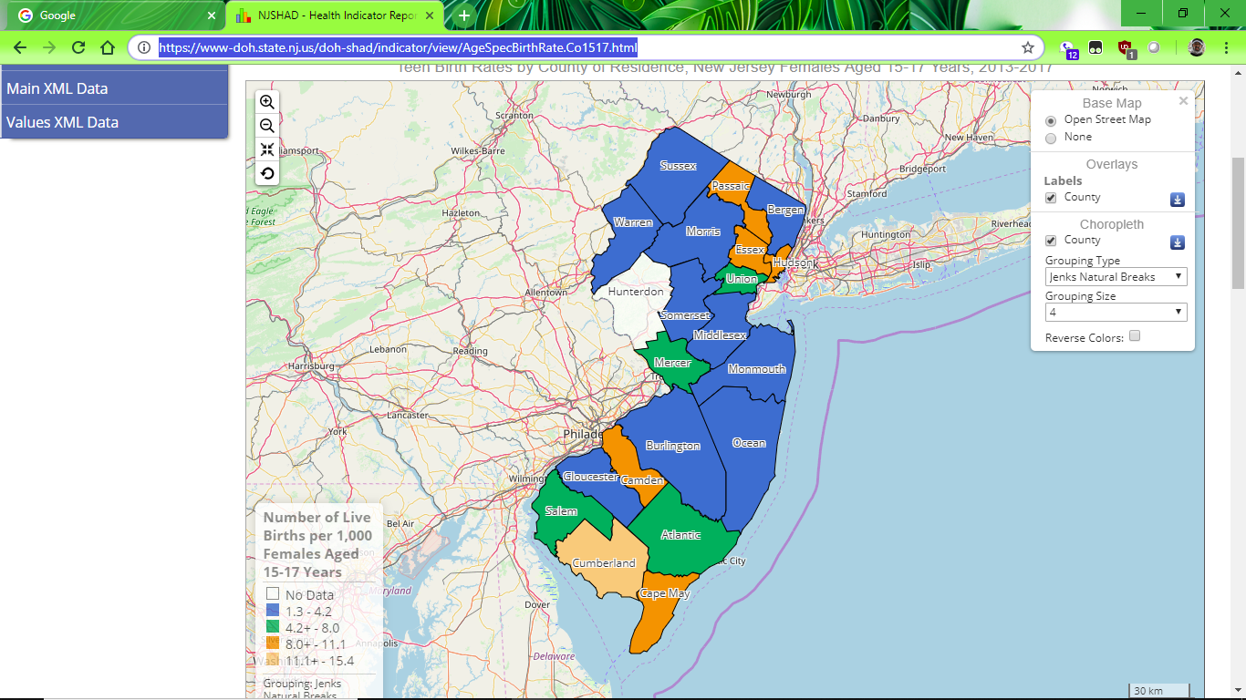
Summary: IBIS is a web-based platform designed to allow users to explore indicators, both graphically and through mapping. Montana used IBIS as part of the 2018 county health profiles and received overwhelmingly positive feedback from local partners. IBIS also offers topics pages and database query, although discussion of such is beyond the scope of this project. IBIS has a strong and open CoP, whereby states and jurisdictions work together for common development.
However, IBIS capabilities may be beyond that which are needed for this project. While IBIS is open source and free software; server hosting, software development, and software licensing requirements impose substantial costs. These costs mean that IBIS should be considered as part of a larger project for health departments, which can bring additional benefits. For jurisdictions which are in the process of adopting, or investigating, IBIS, a pilot project such as the Vulnerability Assessment may be a good

4. SAS

Mapping: SAS is capable of making basic maps using widely licensed packages. Advanced GIS work requires specific packages which require additional licensing.

Modeling: SAS has modeling capabilities through various procedures. SAS may have inconsistent capabilities from PROC to PROC. For example, Poisson regression is supported in PROC GENMOD, which has different syntax and features from PROC GLM.

Cost: SAS is usually available to state health departments as part of wider work. SAS licensing pricing varies drastically; individual licensing is roughly $12,000 to start with annual renewal of $4,000 per year.

Advantages: widely used industry and government workhorse, datasets often available in SAS formats

Disadvantages: very expensive if not already supported, not widely used for GIS work, not widely used for direct publishing to web

Example: https://support.sas.com/sassamples/graphgallery/PROC_GMAP.html

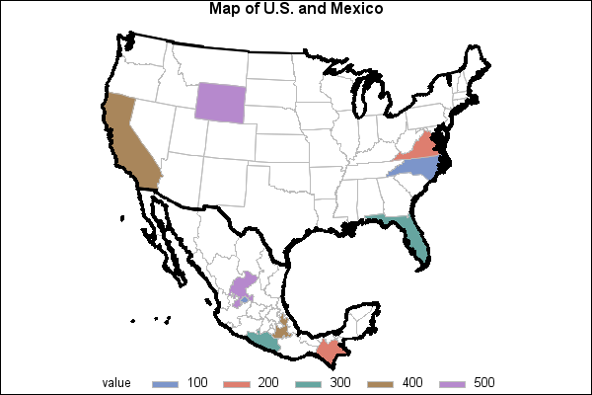
Summary: SAS is an industry workhorse with well standardized code, capable of data wrangling and modeling. However, SAS is less used for GIS work, which tends to be done in ArcGIS or R. Although PROC GMAP is capable of making basic choropleths, SAS does not offer easy ways to deploy these maps to partners. As such, SAS is not capable of being a single software solution for the opioid vulnerability assessment.
5. Tableau

Mapping: Tableau has extensive mapping capabilities and offers the most customization in terms of look and feel of proposed solutions.

Modeling: Tableau is capable of basic data wrangling and linear regression, but, as far as we know, is not capable of doing Poisson / negative binomial regression.

Cost: Tableau is available for public publishing for free, licensing costs for more advanced features run roughly $1000 per creator per year.

Advantages: beautiful, infographic quality maps

Disadvantages: somewhat odd dashboard capabilities, complicated licensing model, lacks advanced regression capabilities

Example: https://onlinehelp.tableau.com/current/pro/desktop/en-us/maps_howto_simple.htm

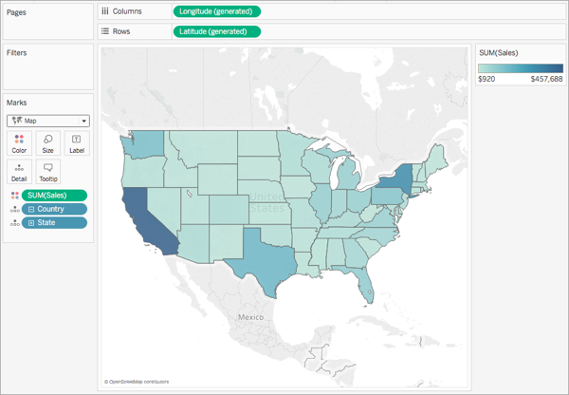
Summary: Tableau is widely used for data visualization. Similar to Power BI, it offers users the chance to publish directly to the public Internet. Tableau follows design principles of Edward Tufte, and is used for making professional quality infographics / dashboards. Tableau has limited data wrangling / data modeling capability, and would need to be paired with R or SAS to do data modeling. For departments who have solid skills in other languages, Tableau can be an amazing tool to deploy visualizations.
Changelog:
Version 1.0: Designed document, used public available websites for look and feel.
Plan
Version 2.0: Replace, as applicable, public websites with project specific examples.
April 29, 2019: Minor edits, replacement of specific maps.

https://codycustis.shinyapps.io/shiny/
https://trac.ibisph.org/trac/

