Appendix: Class Intervals

The two most common types of class intervals are the quantile method (usually four or five quantiles) and the Jenks Natural Breaks method. Formal discussion of the various class interval methods is beyond the scope of this document, the R documentation gives a quick summary of how such are implemented in R. For comparison, per capita income by county is plotted for all counties in the United States using quantile and Jenks methods.

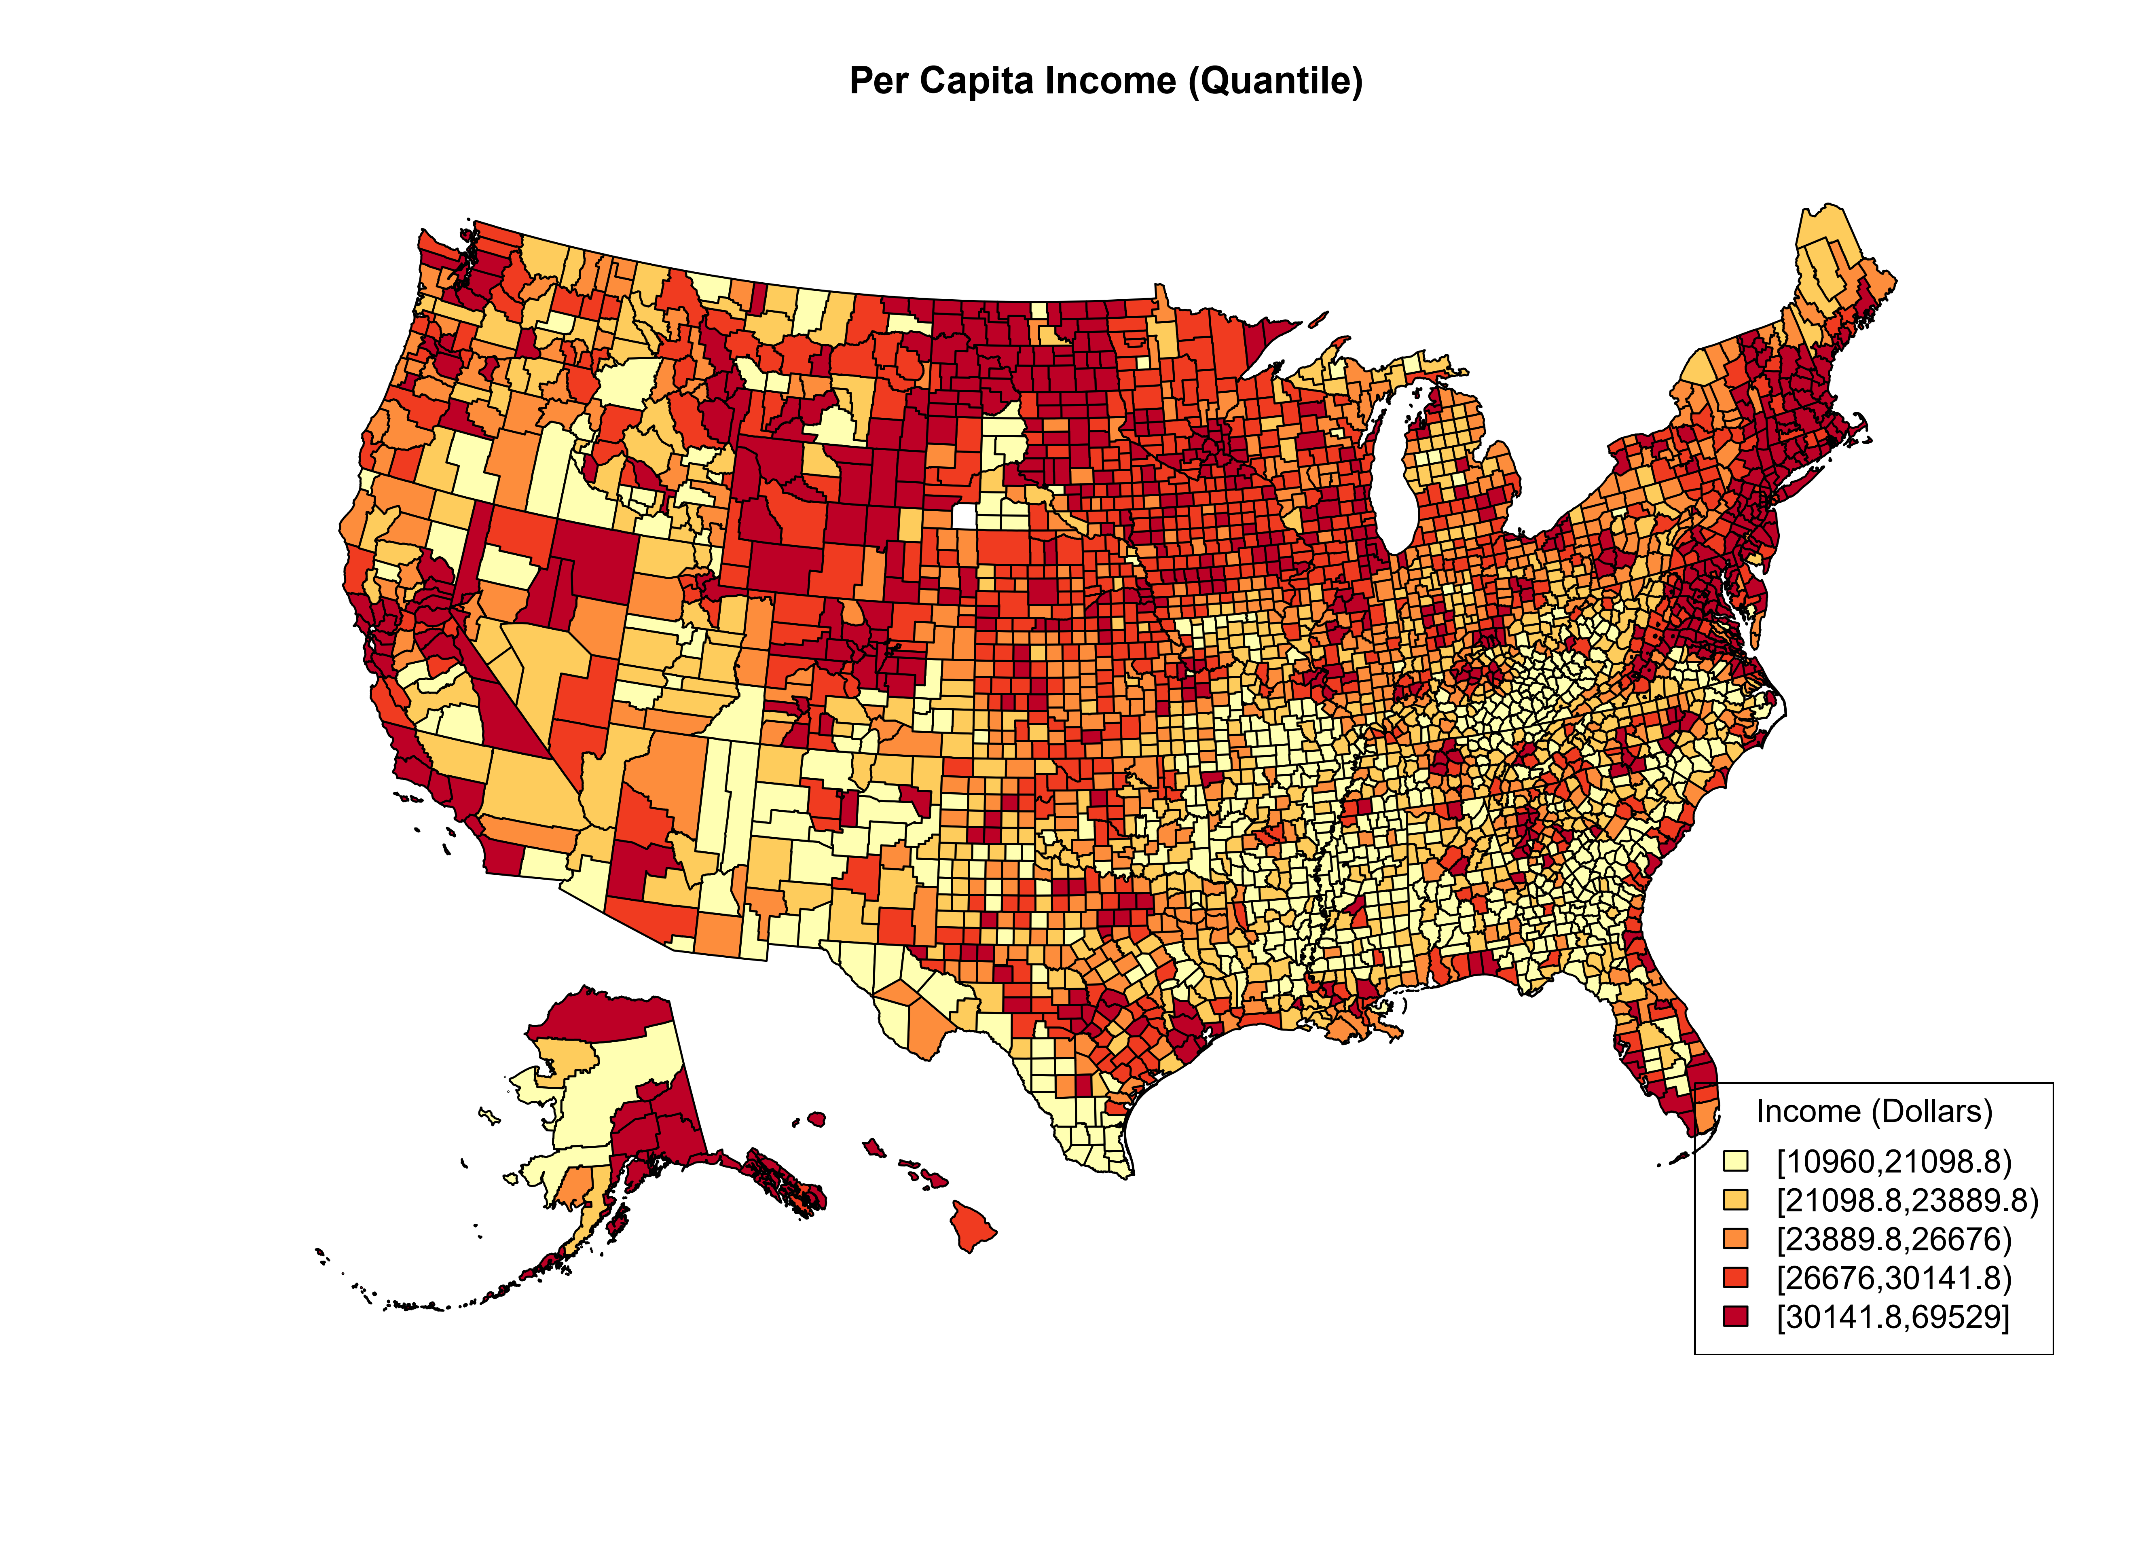
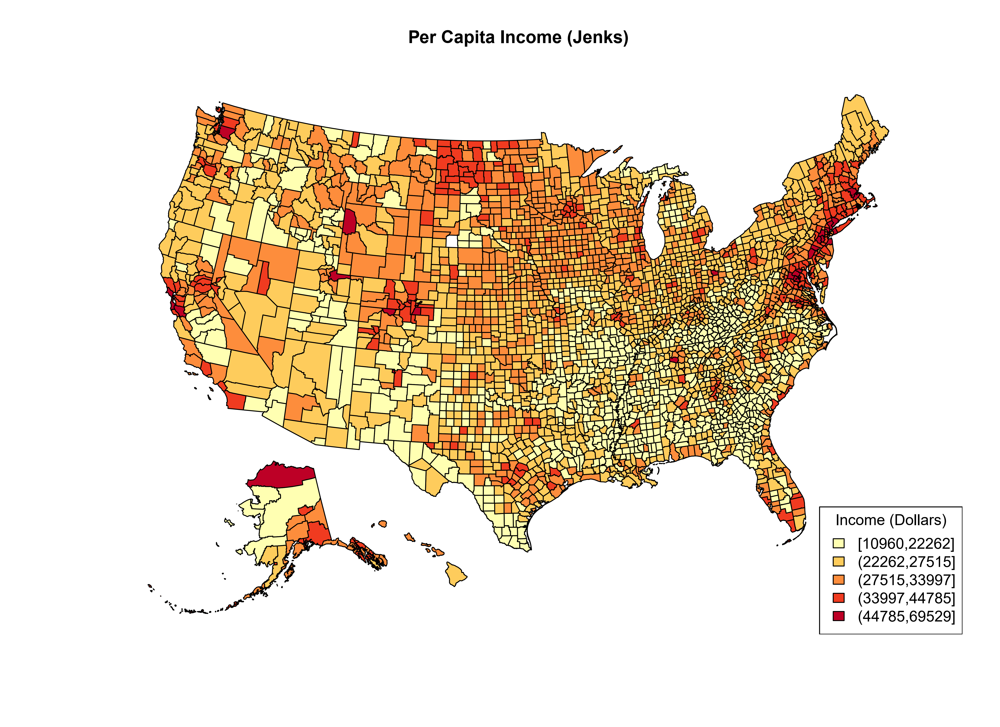
The main thing to notice about the quantile method is that the highest class is $30,141 through $69,529, whereas the Jenks method creates a class with the highest class of $44,785 through $69,529. The distribution of per capita income at the county level is right skewed, Jenks does a better job capturing such.
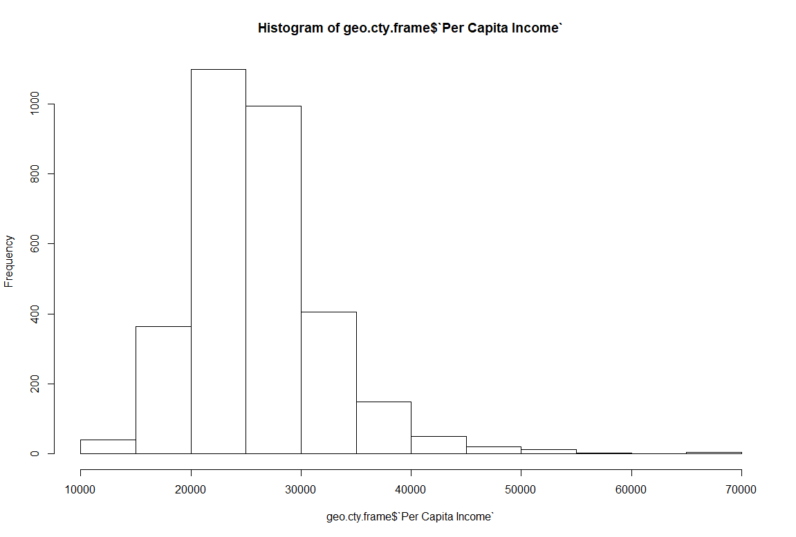
The downside of Jenks is that the category bins are difficult to explain, whereas quantiles are generally understood. Another disadvantage is that the Jenks method can be influenced by outliers.

https://www.rdocumentation.org/packages/classInt/versions/0.3-1/topics/classIntervals
https://rud.is/b/2014/11/16/moving-the-earth-well-alaska-hawaii-with-r/

