Appendix: Subcounty Analysis
Most of the analysis that we do as part of this project is at the county level. That’s because, for better or worse, most data sources are available at the county level (or county level equivalent). Because counties form compete partitions of states and territories, they’re really handy for statistical purposes. However, there are times where subcounty analysis is ideal. For example, consider the map of Texas unemployment below. Unemployment in Dallas County was 5.9%. However, Dallas County has a lot of people.
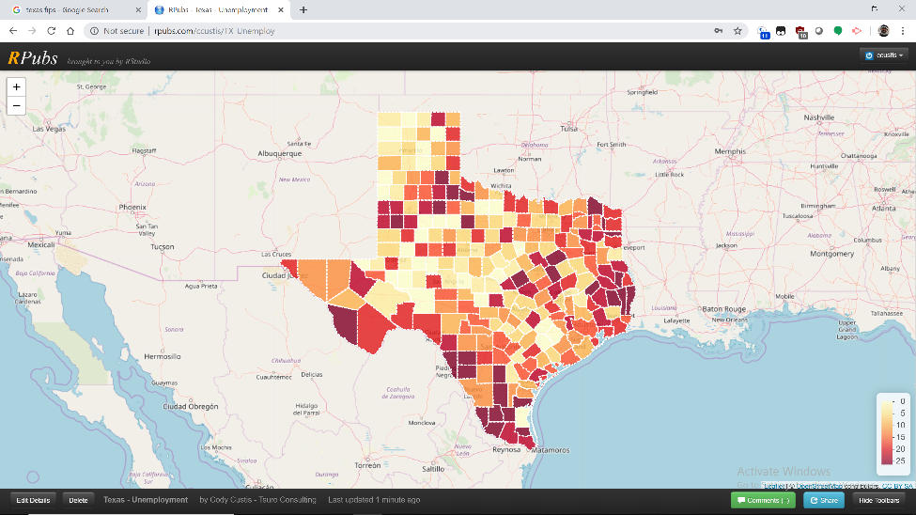
There are two main areas for subcounty analysis, zip code and census tract. Zip code data is advantageous because it’s usually recorded as part of standard addresses; census tract data has American Community Survey variables (at five year intervals) with populations (usually) between 2500 and 8000 people. HUD’s Office of Policy Development and Research has crosswalk files that convert zip codes, census tracts, and counties. Be careful, because the conversions are not bidirectional!
Census tract data often shows a much more complete picture. In this case, literally, of unemployment in Dallas County.
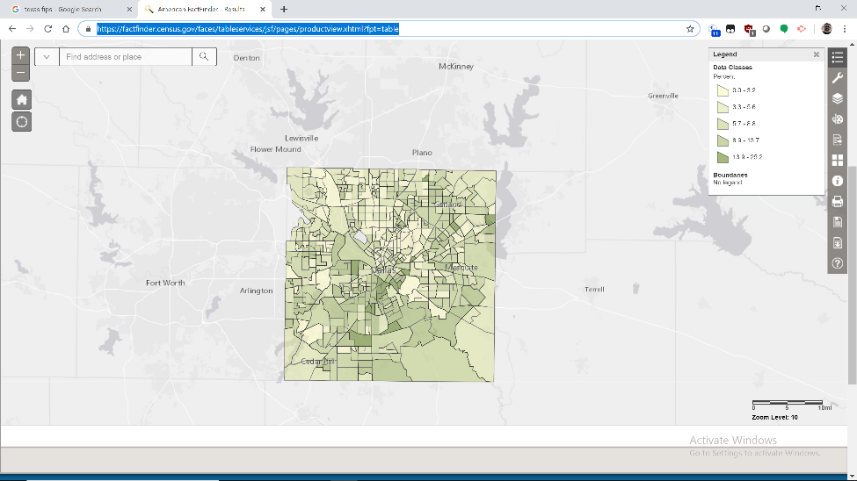
We see that some Census tracts, mostly south and west of the city center, have unemployment as high as 25%, while other tracts to the north and east of the city center have unemployment lower than 3.2%. There’s a much wider range.
Here’s the same variable by Zip Code Tabulation Area, which is a US Census Bureau modified version of zip code. Note that the map of Dallas is actually less detailed than the Census tract map.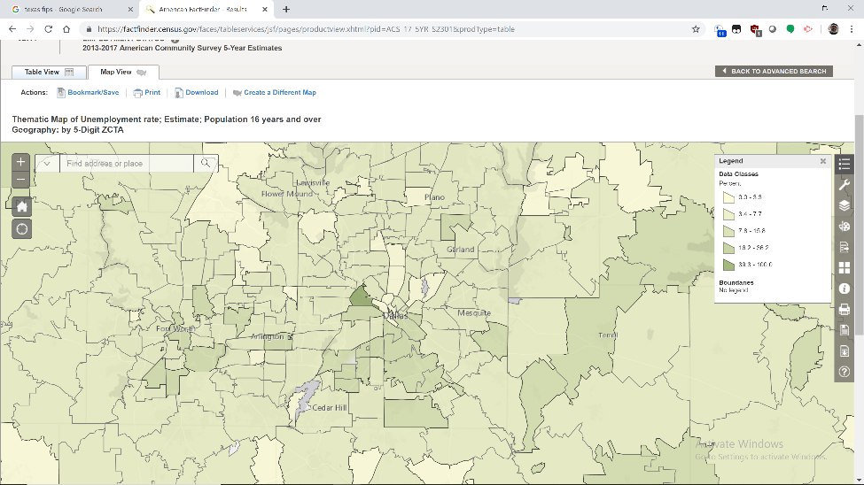

Using the Dallas County example, there are benefits to subcounty analysis, particularly when working with local partners. Nonetheless, getting subcounty data is often challenging. American Community Survey data (mostly demographic) is generally available at Census tract and ZCTA level; crime data is usually available at the county level due to the role of sheriffs in the American justice system; prescription data may be available at the county or zip code level depending on the source. Geocoding point data will be addressed in a later document.

https://libguides.lib.msu.edu/tracts
https://www.huduser.gov/portal/datasets/usps_crosswalk.html

