Tech Guidelines – Mississippi
Prepared by Cody L. Custis, Tsuro Consulting, for the Jurisdiction Vulnerability Assessment
Introduction:
This tech guidelines is specific to Mississippi. Per capita income from the American Community Survey is used as a demonstration variable. Because this variable is available online to the public, we consider any map that contains only American Community Survey data to be releasable to the public. Some maps can easily be altered in some ways, other maps will require more work, some alterations are not technically possible in certain formats.

Disclaimer: the views and opinions expressed in this document are those of the authors, Cody Custis and Jordan Larson, both of Tsuro Consulting, and do not necessarily reflect the official policy or position of the Centers for Disease Control and Prevention, the Council of State and Territorial Epidemiologists, or any state, local, or tribal health agency.

Power BI Desktop
URL: N/A
Power BI Desktop allows for easy mapping of indicators, with the weakness that mapping is very limited in both sharing and customization. In this case, the map can only be shared using screenshots or Windows snips.

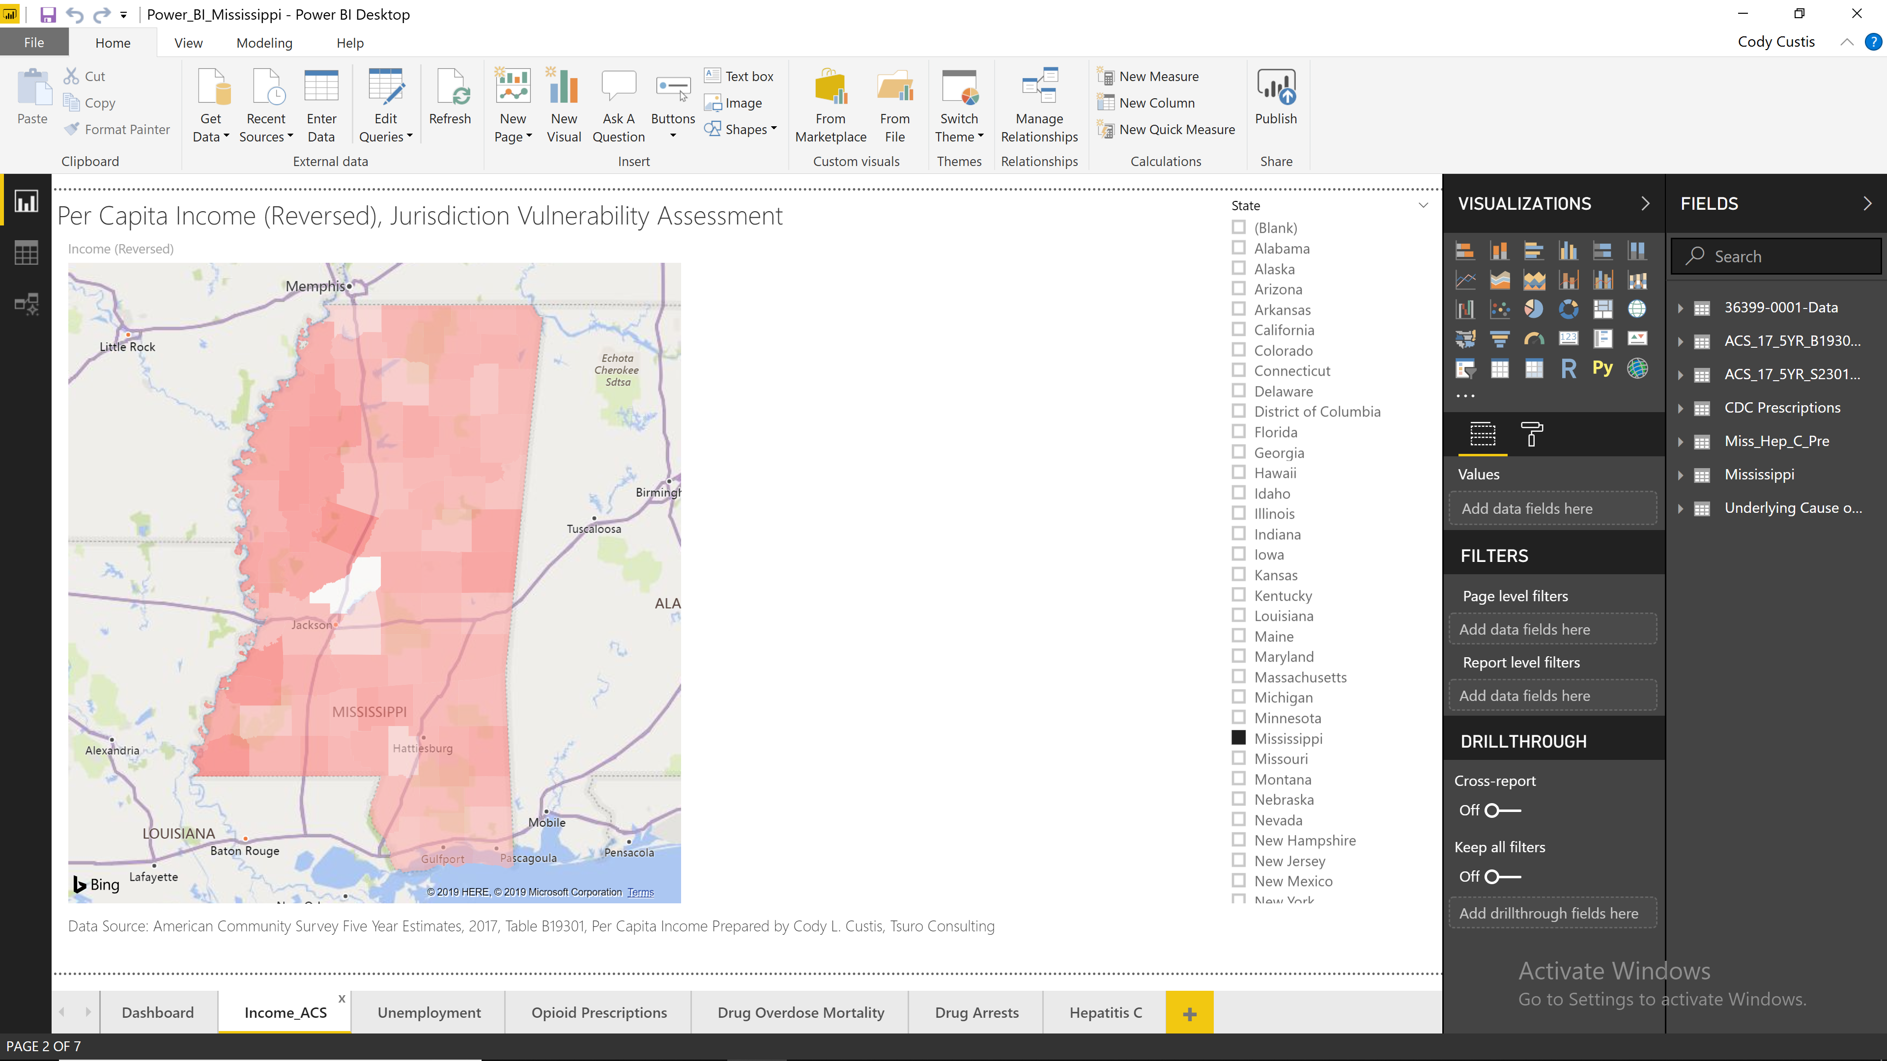

Power BI Service
URL: https://app.powerbi.com/view?r=eyJrIjoiYmRkMDM2MDYtNjBjYi00OTUwLTliNjctOWZhNjYzODMwYWU0IiwidCI6IjcxZjNhYTMyLTg2NTYtNGU4Yi1iMTUxLTBkNWEwYjBkMjhiMCJ9
Power BI Service allows interactive maps and dashboards, with the same limitations of the Power BI Desktop, but the added advantage that users can interact with the map. However, unless jurisdictions are willing to make substantial investments in IT, any maps published to the Power BI Service are public.
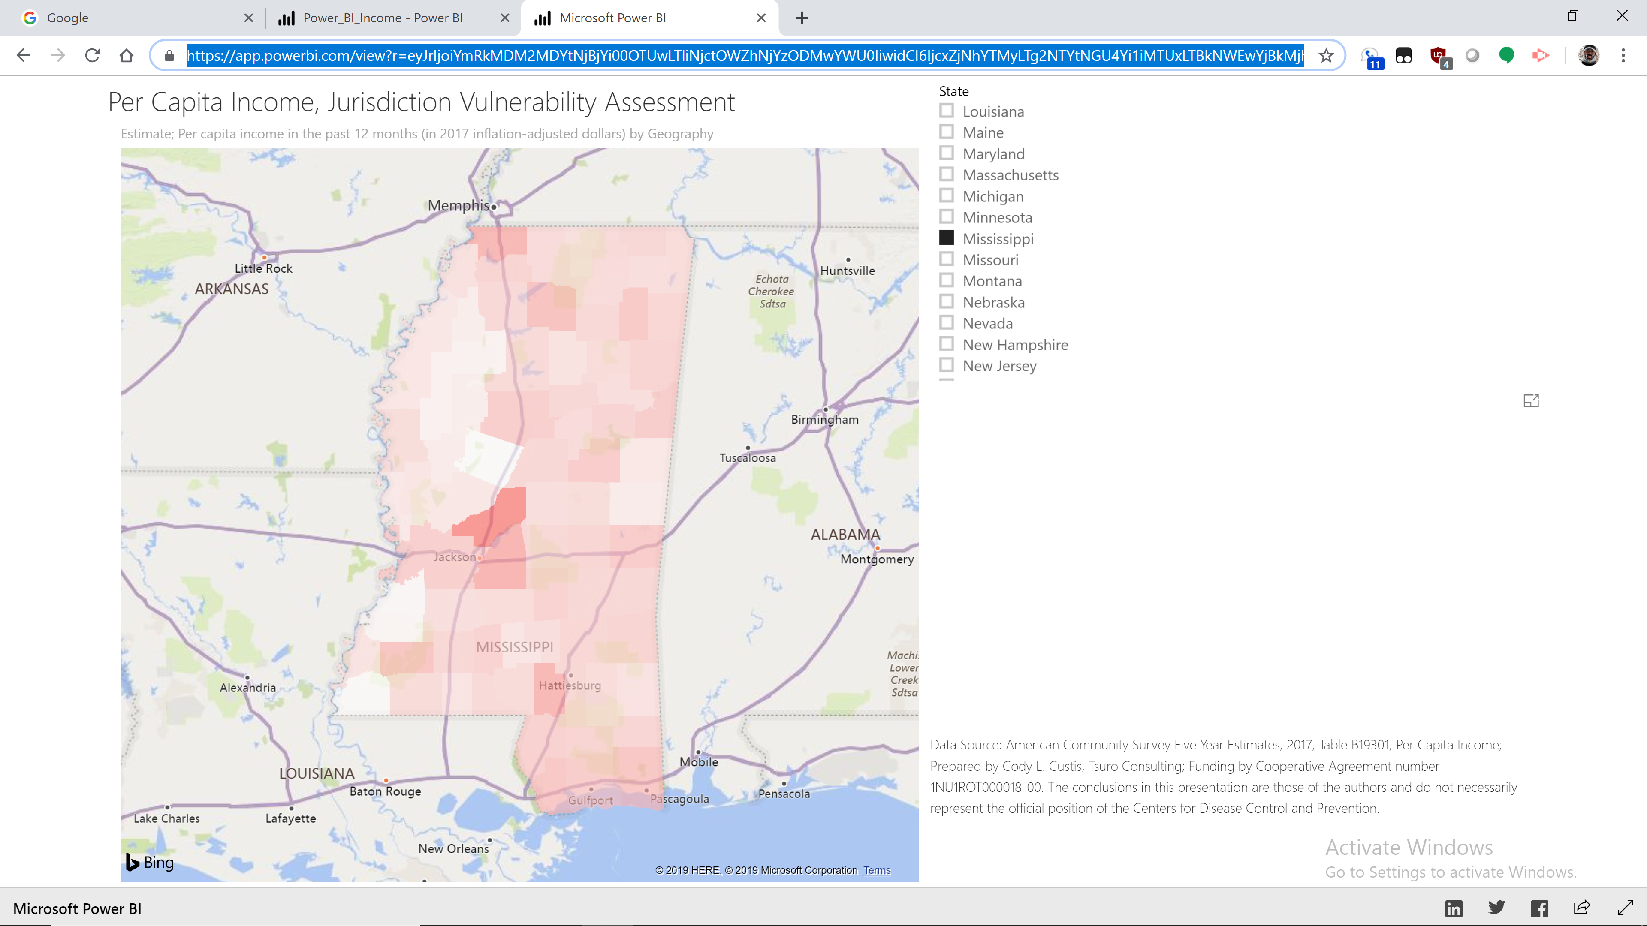

R Leaflet
URL: http://rpubs.com/ccustis/MS_Income_Demo
R Leaflet creates interactive maps using the Leaflet platform. As with Power BI, unless one is willing to make substantial investment in deployment, these maps are public. The advantage of these maps is that they use OpenStreetMap basemaps (which can be changed), allow for web based tooltips, and are viewable by anyone. The Leaflet object can be saved by states to apply as a data frame in their own webpages; such discussion would require working with a state’s Information Technology department.
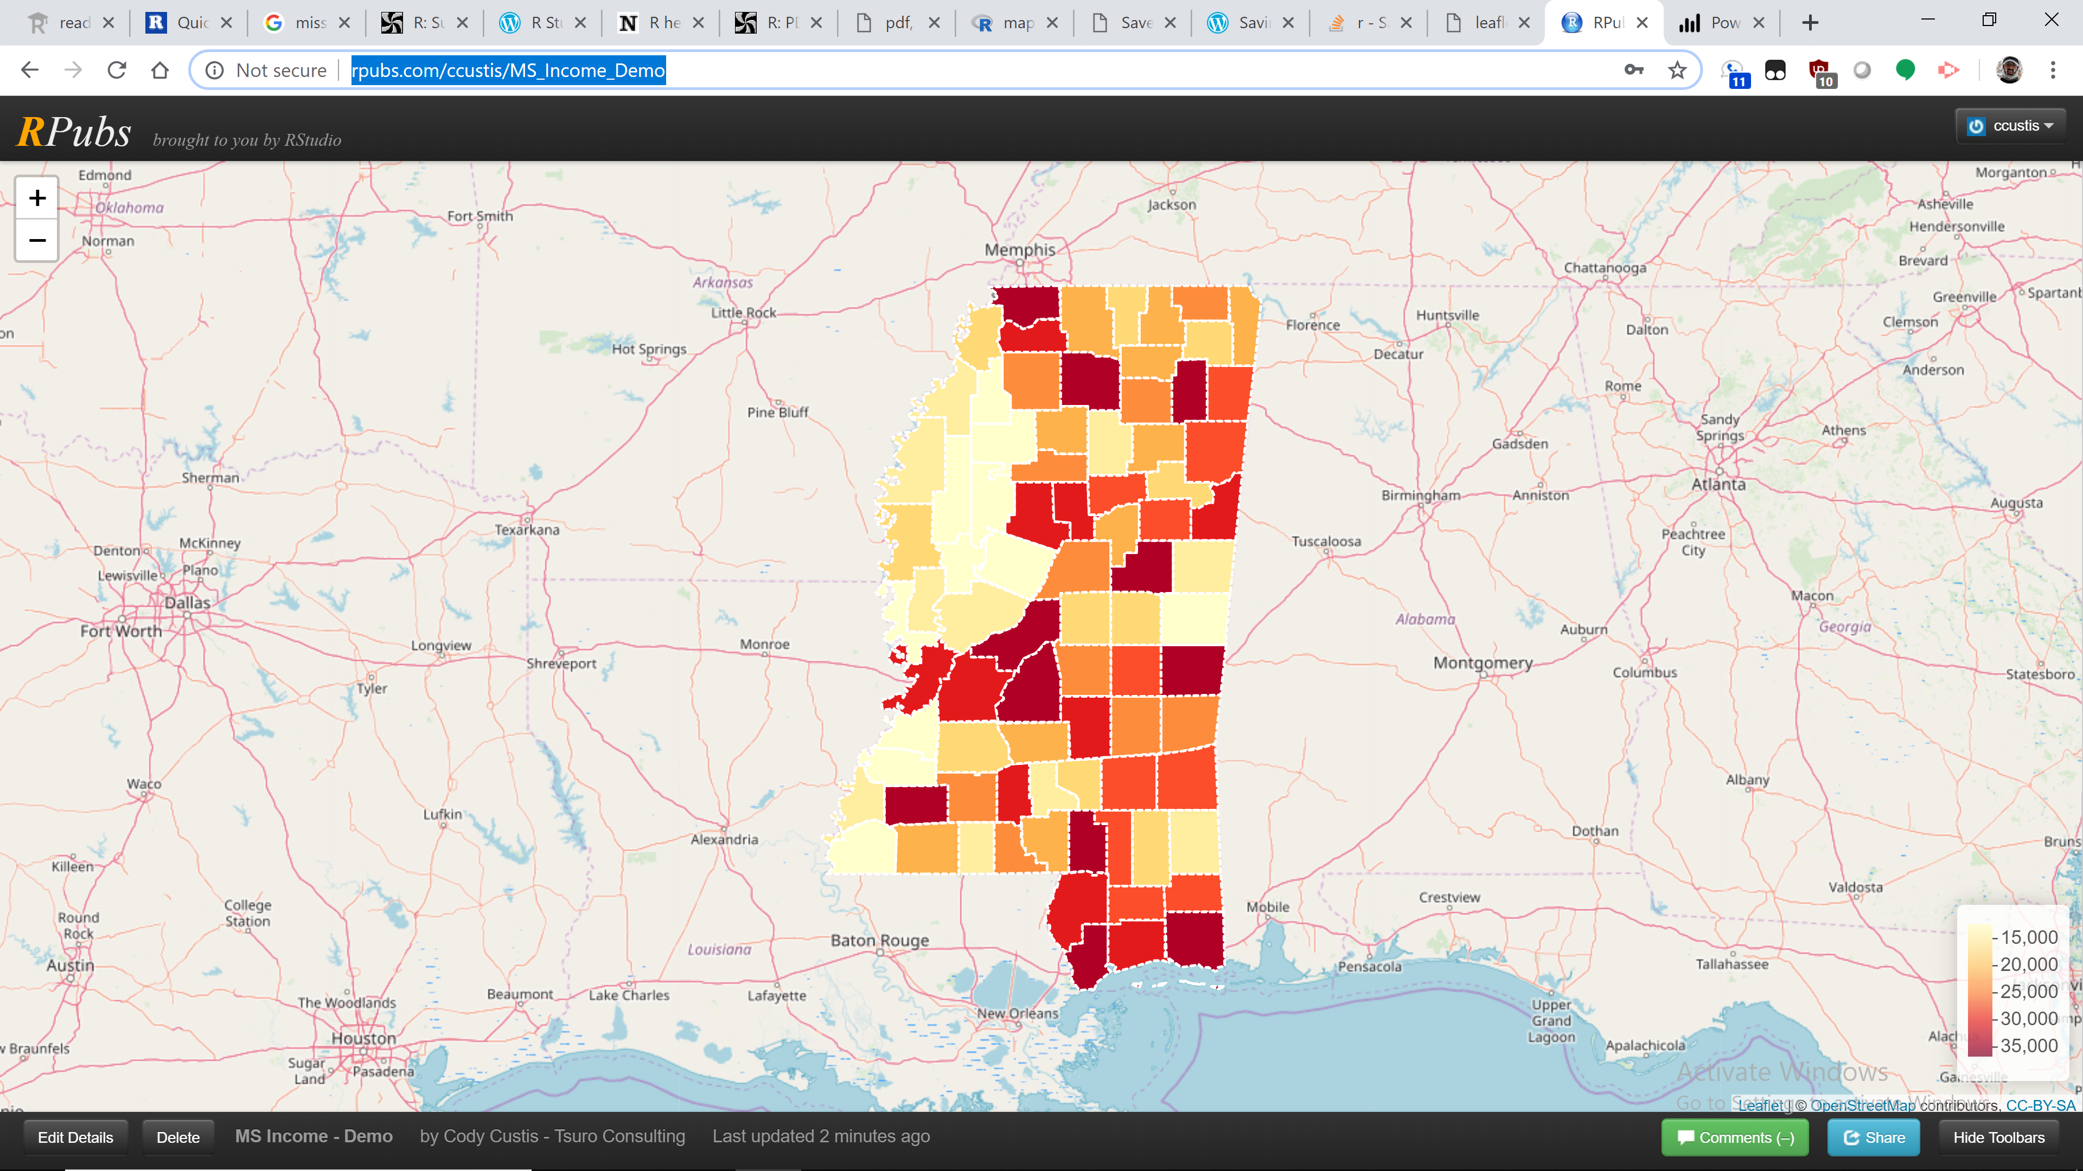

R GISTools
URL: N/A
GISTools creates high resolution PDF (or jpeg) maps. Currently, these maps do not support baselayers, that feature may be added later in the project. The PDF format is ideal for standalone maps (or standalone pages in documented); graphics formats like jpeg are ideal for embedding in documents along with narrative text. The formatting issue in the legend is due to R defaults; it will be fixed in the final version.
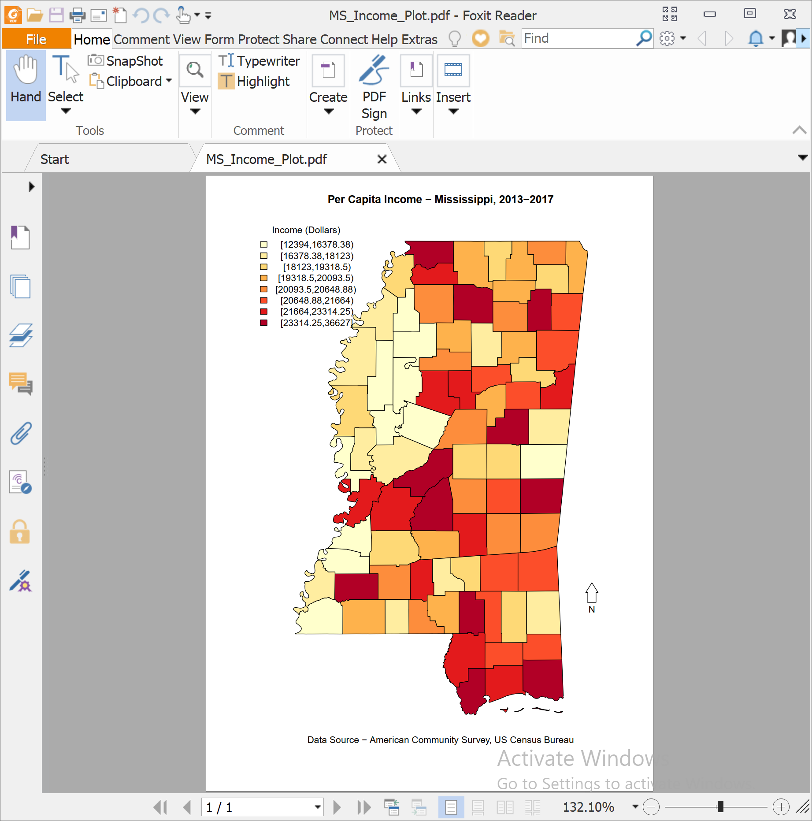

Power Maps (3D Maps)
URL: N/A
Similar to Power BI desktop, 3D maps can easily create basic playful maps inside of Microsoft Excel. 3D maps is designed for desktop ease and accessibility, but as a stand alone product plug-in it has some unique visualization and movie making abilities. Graphic and publishing options are limited, and so it may not provide enough capability for many projects.
