Data Dictionary – Mississippi
Prepared by Cody L. Custis, Tsuro Consulting, for the Jurisdiction Vulnerability Assessment
Introduction:
This data dictionary is specific to Mississippi for the jurisdiction vulnerability assessment. It contains data sources, comments on data wrangling, and preliminary maps for certain indicators.
Disclaimer: the views and opinions expressed in this document are those of the authors, Cody Custis and Jordan Larson, both of Tsuro Consulting, and do not necessarily reflect the official policy or position of the Centers for Disease Control and Prevention, the Council of State and Territorial Epidemiologists, or any state, local, or tribal health agency.
Current Indicators:
County level overdose deaths (Mississippi Bureau of Narcotics)
Hepatitis C (Mississippi STD / HIV Program)
Opioid prescription rate by county (NSPARC report)
Drug related arrests by county (Mississippi Bureau of Narcotics)
Per capita income (American Community Survey)
Per capita Income

Topic: Demographics
Data Source: American Community Survey
Maintained: US Census Bureau
Accessibility: Public
Example URL: https://www.census.gov/programs-surveys/acs
Years available: Five year estimates at county level, annualized, 2000-2017

Summary: the American Community Survey (ACS) has county level data on a number of subject areas, including education, employment, income, race and ethnicity. Depending on county size, this information may only be available as five-year estimates. Because ACS data is available to the public, collected on a regular basis, and available at the county level, it can form a basic core set of indicators that every state and jurisdiction health department can use to assess county level vulnerability. ACS data is available at the Census Tract level for larger counties that want to target sub-county areas.

Core: S1901 – Income in the Past 12 Months – 2017 ACS Five Year Estimates – Available from Tsuro (April 2019)

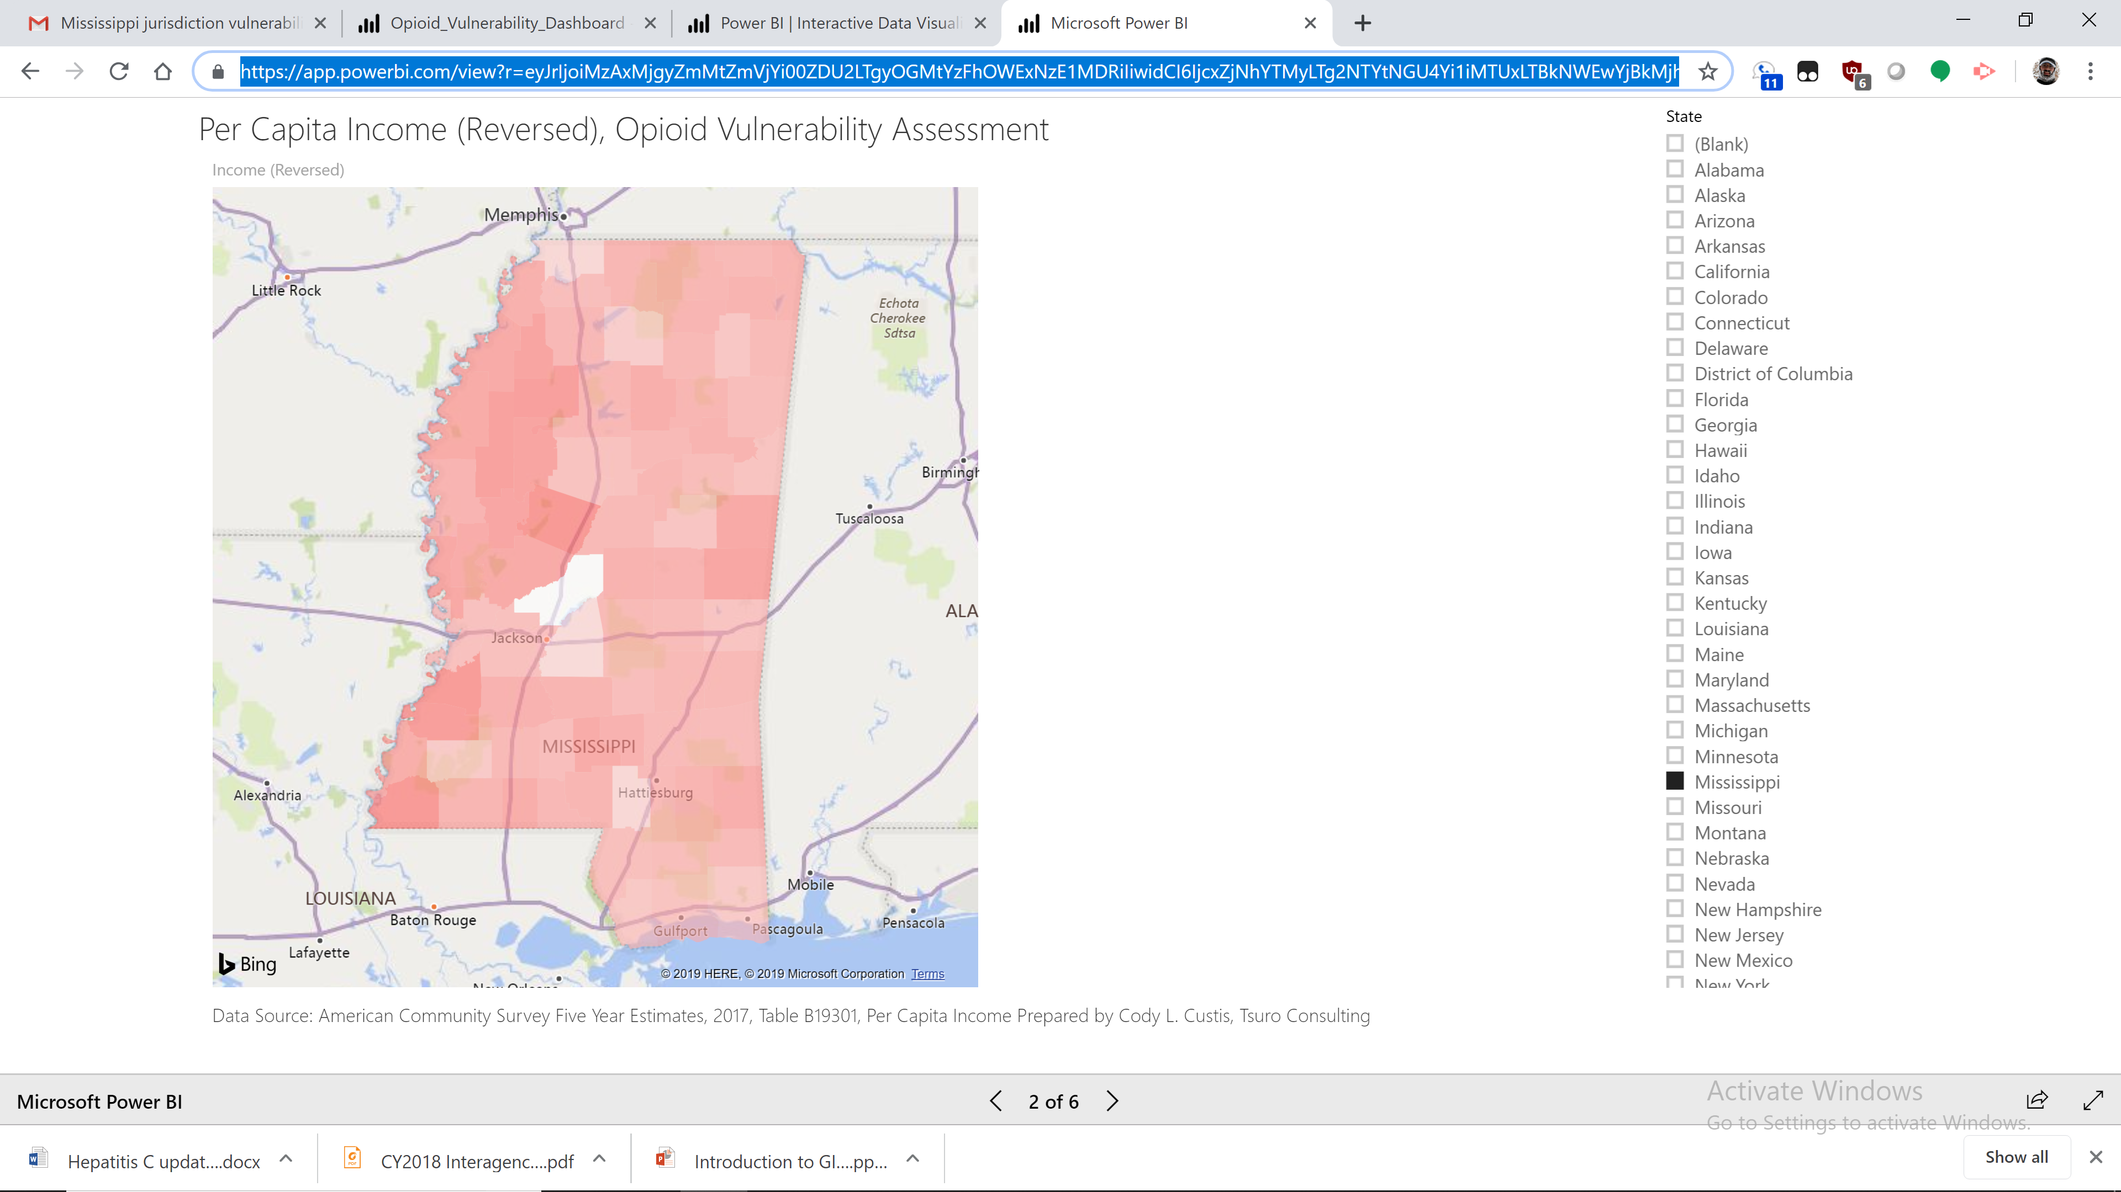
https://app.powerbi.com/view?r=eyJrIjoiMzAxMjgyZmMtZmVjYi00ZDU2LTgyOGMtYzFhOWExNzE1MDRiIiwidCI6IjcxZjNhYTMyLTg2NTYtNGU4Yi1iMTUxLTBkNWEwYjBkMjhiMCJ9

County Level Overdose Deaths
Topic: Mortality / Crime
Data Source: Mississippi – Bureau of Narcotics – Table 5 (Mortality and Arrests)
Maintained: Mississippi Opioid and Heroin Data Collaborative
Document Name: Mississippi Opioid and Heroin Data Collaborative – Provision Data Report – Calendar Year 2018
Years available: 2018
Comment from Meg: “This is provisional data from the Mississippi Bureau of Narcotics. We have no way to validate these data. We do know that for CY2017, MBN reported 255 suspected overdose deaths while Vital Records reported 346 drug overdose deaths.”
Data Wrangling Notes: PDF table was cut and paste using spreadsheet operations.
Notes: Suspected overdose deaths are reported to Mississippi Bureau of Narcotics (MBN). MBN deaths are not added to the count until toxicology reports are completed. As Meg notes, these numbers are different from those from vital statistics, which relies on the professional opinions of coroners / medical examiners vs a completed toxicology report.
Mississippi maps absolute values of deaths, instead of rates. We used population estimates to get crude rates.
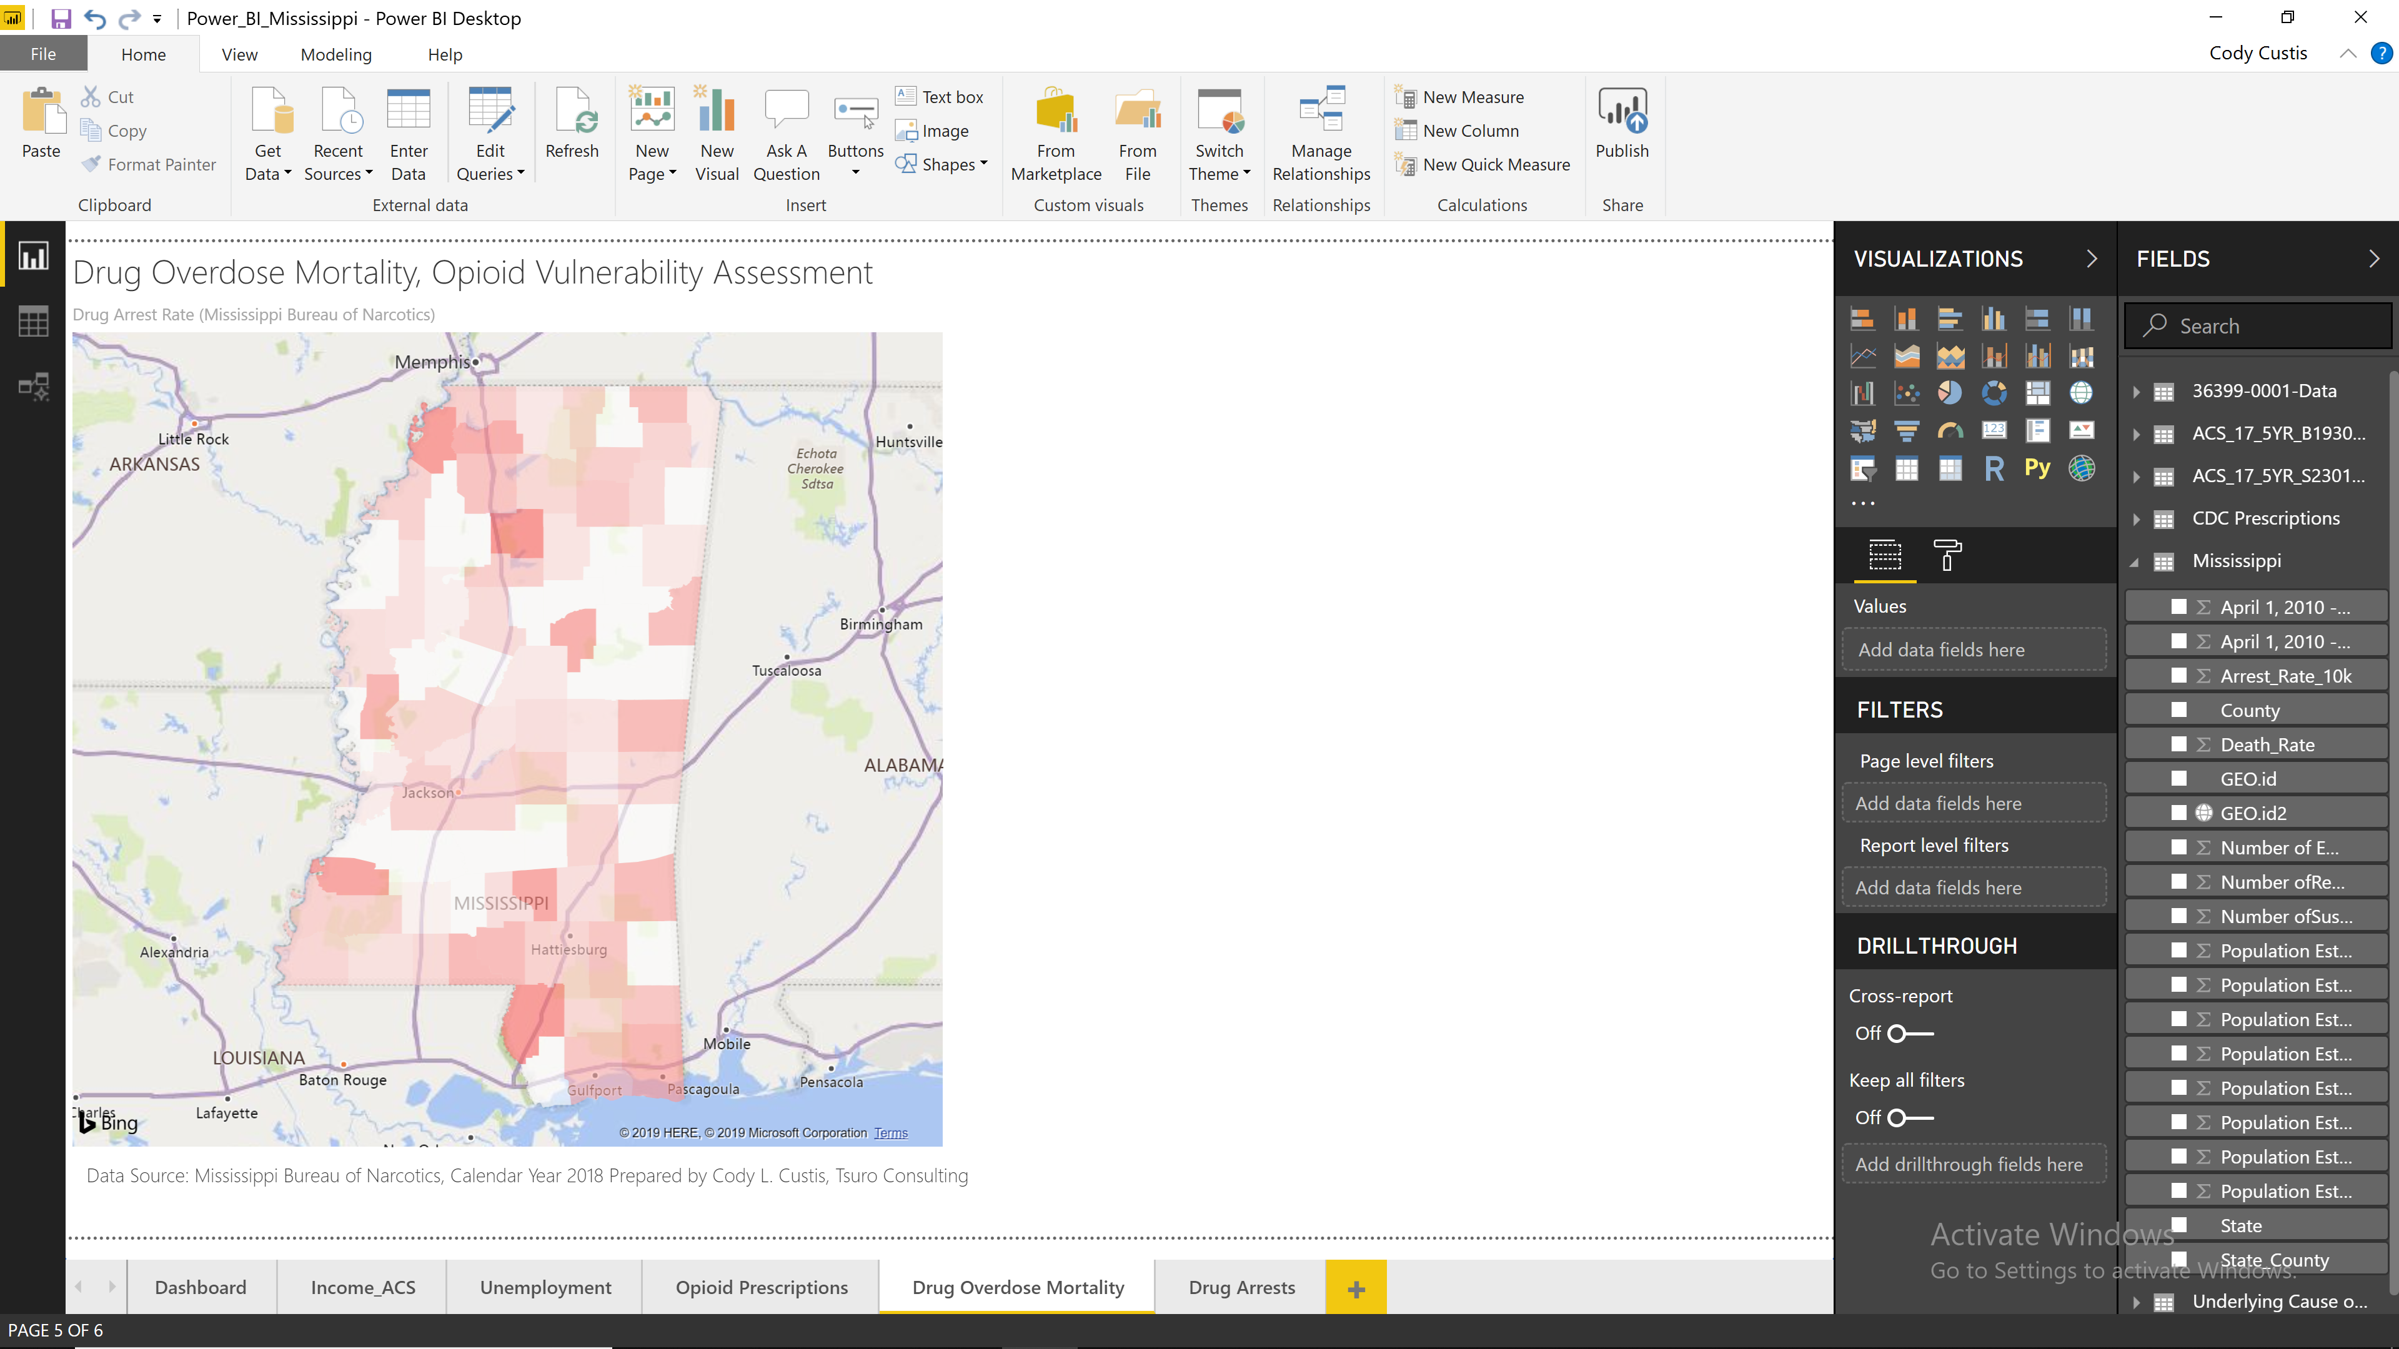

County Level Drug Arrests
Topic: Crime
Data Source: Mississippi – Bureau of Narcotics – Table 5 (Mortality and Arrests)
Maintained: Mississippi Opioid and Heroin Data Collaborative
Document Name: Mississippi Opioid and Heroin Data Collaborative – Provision Data Report – Calendar Year 2018
Years available: 2018
Comment from Meg: “This is provisional data from the Mississippi Bureau of Narcotics. We have no way to validate these data. We do know that for CY2017, MBN reported 255 suspected overdose deaths while Vital Records reported 346 drug overdose deaths.”
Data Wrangling Notes: PDF table was cut and paste using spreadsheet operations.
Notes: Many counties had zero arrests reported. Without knowing the exact situation in Mississippi, it matters if this is due to lack of crime or due to lack of reporting. If small counties lack the resources to participate in drug reporting systems, it may be reasonable to assume that arrests give a fairly complete picture of reporting in Mississippi, even if some counties are missing.

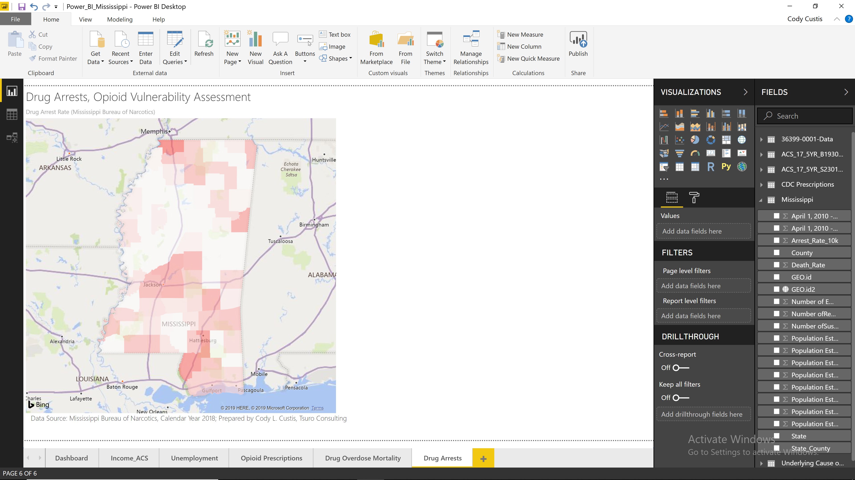

Hepatitis C
Topic: Outcomes – Hep C
Data Source: Mississippi – Patient Reporting Investigation Surveillance Manager (PRISM)
Maintained: Mississippi State Department of Health
Document Name: Hepatitis C updated SA_2019
Example URL: Table 2
Years available: 2017,2018
Comment from Meg: “ it was explained to me the these are not Mississippi-specific data; rather, we used NHANES and other resources to estimate prevalence based on national data”
Data Wrangling Notes: Word table was cut and paste to Excel spreadsheet.
Notes: The currently mapped data comes from the Mississippi Patient Reporting Investigation Surveillance Manager (PRISM), a “centralized data management system specifically designed for STD investigation and surveillance.” According to the document “the biggest barrier has been sporadic entry of lab results due to limited focused resources.” The table in the map below does come directly from Mississippi data.
In my (Cody Custis) professional view, as long as PRISM data is consistently reported, even if it is an underreported, it is a useful outcome for Hepatitis C modeling and surveillance. While it does not represent all individuals with Hepatitis C, it does represent clinical events that lead to reporting. Knowing if Hepatitis C clinical events are more associated with acute vs non-acute would make for more useful outbreak detection.
Mississippi also includes an National Health and Nutrition Examination Survey (NHANES) estimate of Hepatitis C, based on NHANES prevalence estimates (1.2% and 1.5%) and population. While these estimates may be useful for allocating resources or making providers aware, because every county has the same underlying rate (1.2% or 1.5%) they are not useful in determining which Mississippi counties have increased Hepatitis C for modeling or surveillance.
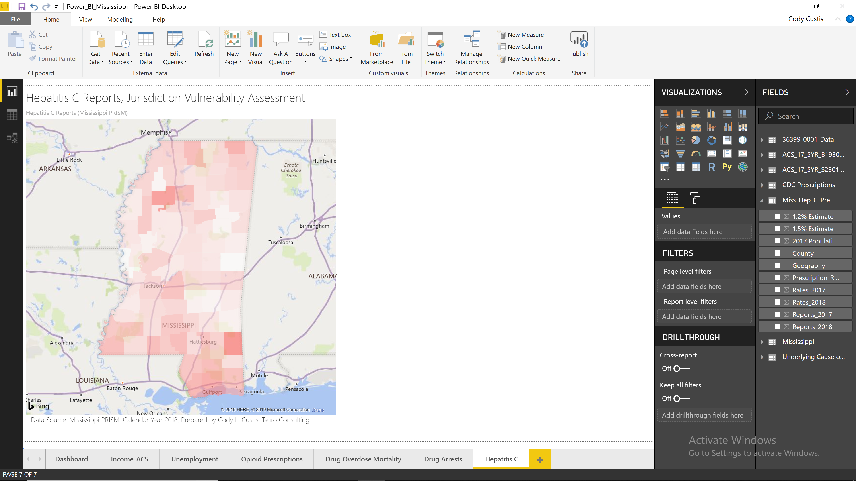
Table 2: Hepatitis C Reports in Mississippi by County (# Reports and Rate per 100,000), 2017-2018
 | 2017 |  | 2018
County | Reports | Rates | Reports | Rates
Adams County | 48 | 154.8 | 47 | 151.6
Alcorn County | 72 | 193.5 | 83 | 223.1
Amite County | 12 | 96.4 | 11 | 88.4
Attala County | 8 | 43.3 | 14 | 75.8
Benton County | 4 | 48.1 | 5 | 60.2
Bolivar County | 20 | 62.6 | 14 | 43.8
Calhoun County | 10 | 69.0 | 10 | 69.0
Carroll County | 8 | 78.9 | 5 | 49.3
Chickasaw County | 22 | 128.3 | 7 | 40.8
Choctaw County | 5 | 60.4 | 5 | 60.4
Claiborne County | 3 | 33.5 | 4 | 44.7
Clarke County | 8 | 50.5 | 7 | 44.2
Clay County | 9 | 45.8 | 3 | 15.3
Coahoma County | 17 | 73.4 | 26 | 112.3
Copiah County | 34 | 119.2 | 25 | 87.7
Covington County | 28 | 146.8 | 20 | 104.8

“Using Hepatitis C surveillance data captured in PRISM, it appears that in 2017, there were 3,936 reports of hepatitis C infected with a population of 2,984,100. Based on this estimate, the estimated prevalence is 0.13% of the total population. Due to the limitation of lab entry into surveillance database, other estimates were assessed.”

Opioid Prescriptions
Topic: Prescription
Data Source: Opioid and Benzodiazepine Prescriptions in Mississippi – 2018 Prescription Data Update – Figure 1
Maintained: Mississippi Board of Pharmacy, NSPARC
Document Name: Opioid and Benzodiazepine Prescriptions in Mississippi; 2018 Prescription Data Update; February 2019
Accessibility: TBD
Example URL: https://pmp.mbp.ms.gov/statistics/
Years available: 2017,2018
Comment from Meg: NSPARC report posted at: https://pmp.mbp.ms.gov/statistics/; In public health review of this report, we noted that the MME for prescriptions is above similar national reports as well as a report produced by MSDH (https://msdh.ms.gov/msdhsite/_static/resources/7822.pdf). Additionally, we in public health are always very cautious when Issaquena county ranks either first or last - this is a farming community with a total population around 1,400 people.
Data Wrangling Notes: Manually typed from PDF map.
Notes: Data are from the Mississippi Prescription Monitoring Program (PMP). Data is deduplicated to represent unique persons who receive opioid prescriptions. It appears that the estimate that 485 per 1000 (or 48.5%) of residents of Issaquana county is reasonable.
The report does not have MME prescription available at the county level. It is not currently known if MME standardized to a per capita measure providers a more accurate measure of prescriptions than per capita prescriptions. Also, it appears that the data is limited to Mississippi providers and Mississippi residents. As such, it would not capture providers who serve out of state clients, either due to cross-border treatment with states such as Louisiana or Alabama, or so-called “pill mill” providers who bring in patients from far away.
