FAQ May 2019
Cody L. Custis, Jordan Larson; Tsuro Consulting

Introduction:
This document summarizes a number of technical questions in short form. The ideas expressed are based on the opinions of the authors, and should be considered guidance, not rules.

Disclaimer: the views and opinions expressed in this document are those of the authors, Cody Custis and Jordan Larson, both of Tsuro Consulting, and do not necessarily reflect the official policy or position of the Centers for Disease Control and Prevention, the Council of State and Territorial Epidemiologists, or any state, local, or tribal health agency.

Table of Contents:
ICD-10-CM Transition
Missing Data
Multiyear Data
Class Intervals
Subcounty Analysis
Layering indicators on a single map
Hot spot distances with Outlier and Cluster Analysis
ICD-10-CM Transition
Inpatient admission, outpatient, and other billing data transitioned from ICD-9-CM to ICD-10-CM data on October 1, 2015, as part of the Affordable Care Act. The impact on this transition on indicators based on billing data depends on the specific topic area. Conditions such as myocardial infarction saw relatively little change with the code switch. On the other hand, drug poisoning is much different with the ICD-10-CM transition.
Ultimately, it can be difficult to disentangle changes in indicators due to ICD-10-CM definition versus changes in actual conditions. For example, a seen increase in non-heroin opioids may reflect updated definitions or a legitimate change in healthcare utilization; at the same time, a change in heroin opioids may reflect more specific coding or changes in drug availability. As such, analysts should be cautious in using billing data from before and after the transition, unless it is known that coding changes have a small impact (such as the myocardial infarction case).

Missing data

Data may be missing for a number of reasons. This document will discuss some of the reasons why data may be missing, some techniques for handling missing data, and implications thereof.

One reason that data may be missing is that there are legitimately zero events. For example, in the CDC Wonder dataset for drug overdose deaths, Loving County, TX does not appear. Loving County is one of the smallest counties in the country, with 134 people. There may be a small, but non-zero, number of events. In the same dataset, Grimes County, TX has ten deaths, and an unreliable, but non-zero rate. This can lead to the situation discussed by Andrew Gelman where counties have either extremely high or extremely low rates, due to having one event or zero events in counties with small populations. This may also be due to data release guidelines. For example, Utah has a comprehensive guide for data release which is similar to that used by New Mexico and Montana.
Data may be missing due to exogenous factors, for example, issues with reporting at specific facilities or with specific organizations. For example, hospital discharge data may be missing due to issues with reporting or ICD-10-CM transition issues at specific providers. These issues are unrelated to the specific values.
Finally, data may be missing due to reporting factors related to specific outcomes. For example, law enforcement may not want to release high or low arrest rates; neonatal abstinence syndrome may or may not be released due to awareness in specific geographic areas or facilities that serve specific populations.

The approach to take with missing data depends on what the data is to be used for. For mapping, if an indicator is only available at the state level, then it may be useful to map, but would not be useful for prioritizing outcomes among counties. Examples of indicators which may not be available for all counties include: death rates, hospitalization rates, prescription drug monitoring program data. On the other hand, for modeling, it may be better to include rates based on small values knowing those rates will even out in the regression process. To go back to the Texas counties example, including a zero value for Loving County and unreliable rates for other counties is fine, because it will group with other similar counties in the regression model. This would be preferable to using a statewide or imputed rate for modeling.

The following are some, but not a comprehensive, guide of ways to fill in missing or incomplete data.

- Use a statewide rate
- Use a rate for counties of a similar geography (Northwest, Eastern, etc).
- Use a rate for counties of a similar characteristic (NCHS Urban / Rural Classification, etc.)
- Aggregate counties based on geography (median of rates from surrounding counties)
- Aggregate counties based on characteristics (median of rates with NCHS Urban / Rural Classification)
- Multiple imputation methods
- Modeling techniques
- Bayesian smoothing

Jurisdictions are encouraged to weigh the usefulness of such techniques, along with the ease of use of explaining such to partners. Public health partners without extensive statistical training may find basic techniques easier to understand than complicated techniques.

Multiyear Data
One challenge is dealing with multiple years of data, which rarely has identical time frames. This happens due to updates during the data collection process (for example, population data from NCHS updating in June), program requirements for multiple years of data (CDC Wonder data downloaded as five year numbers / rates due to small numbers), or external challenges, such as the ICD-10-CM transition for hospital discharge data. No matter how well intentioned, time frames for multiple sources of data will inevitably drift.
As with any project, the important question is how this drift affects interpretation of results. For example, American Community Survey 5-Year Estimates from 2013-2017 will not be substantially different from 2014-2018 Estimates, indeed, for multi-year estimates it is ideal (though usually impractical) to revise once the entire time period has passed. Likewise, mortality from chronic diseases, even vulnerability related diseases such as HIV infection or Hepatitis C, should show small changes from year to year. On the other hand, arrest data may drastically change, particularly in boom and bust areas like oil patches. Likewise, overdose morbidity and mortality may show drastic changes, particularly with the introduction of fentanyl.
For datasets used for stand alone display such as mapping, this drift should not have a major impact on results. On the other hand, when modeling an outcome variable, such as Hepatitis C infection, HIV infection, or opioid overdose, these changes may be of drastic importance. Analysts should check to see if there are large changes in an explanatory variable at the same time as large changes in a response variable. For example, arrest data may (or may not) be particularly sensitive to changes in drug availability that lead to outbreaks, whereas income is not expected to drastically change from year to year.
Ultimately, it is up to the data analyst to decide what is the best tradeoff between timely, relevant, and obtainable data.

Class Intervals
The two most common types of class intervals are the quantile method (usually four or five quantiles) and the Jenks Natural Breaks method. Formal discussion of the various class interval methods is beyond the scope of this document, the R documentation gives a quick summary of how such are implemented in R. For comparison, per capita income by county is plotted for all counties in the United States using quantile and Jenks methods.

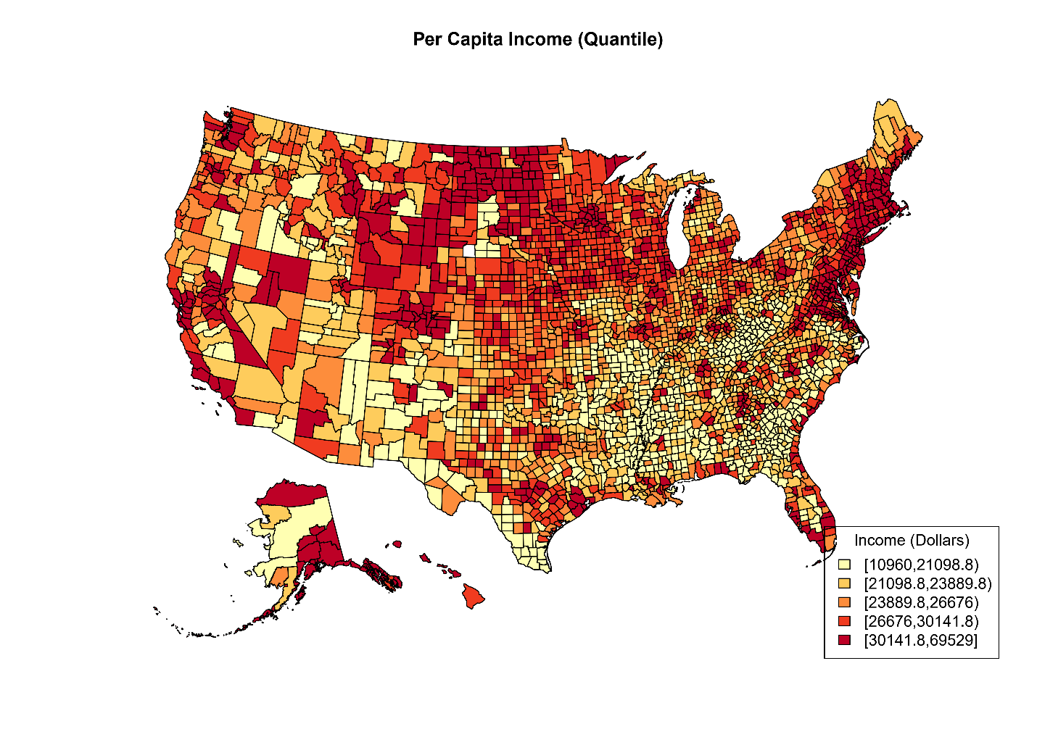
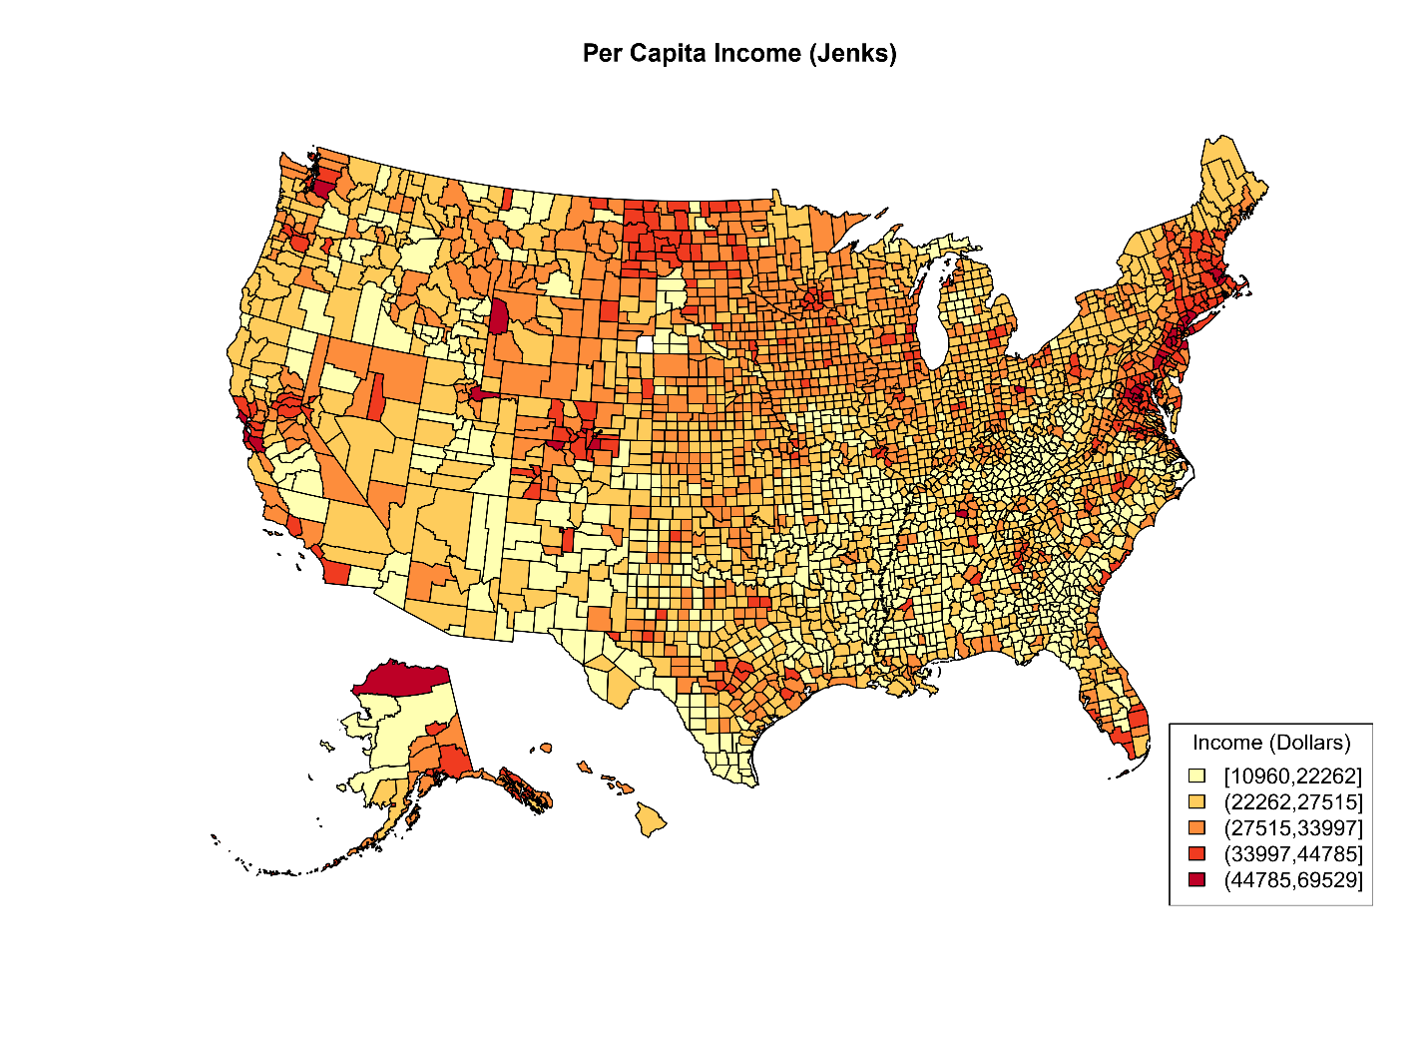
The main thing to notice about the quantile method is that the highest class is $30,141 through $69,529, whereas the Jenks method creates a class with the highest class of $44,785 through $69,529. The distribution of per capita income at the county level is right skewed, Jenks does a better job capturing such. On the other hand, for symmetric data, quantile methods will give similar results, but are easier to explain.
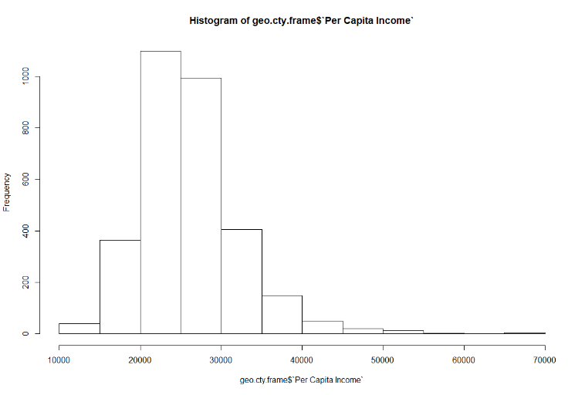
The downside of Jenks is that the category bins are difficult to explain, whereas quantiles are generally understood. Another disadvantage is that the Jenks method can be influenced by outliers. For a video discussion, see https://youtu.be/Amxec9Lx-3Y.

Subcounty Analysis
Most of the analysis that we do as part of this project is at the county level. That’s because, for better or worse, most data sources are available at the county level (or county level equivalent). Because counties form compete partitions of states and territories, they’re really handy for statistical purposes. However, there are times where subcounty analysis is ideal. For example, consider the map of Texas unemployment below. Unemployment in Dallas County was 5.9%. However, Dallas County has a lot of people.
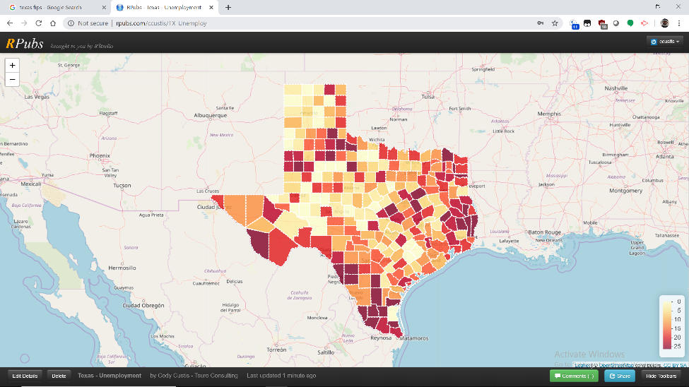
There are two main areas for subcounty analysis, zip code and census tract. Zip code data is advantageous because it’s usually recorded as part of standard addresses; census tract data has American Community Survey variables (at five year intervals) with populations (usually) between 2500 and 8000 people. HUD’s Office of Policy Development and Research has crosswalk files that convert zip codes, census tracts, and counties. Be careful, because the conversions are not bidirectional!
Census tract data often shows a much more complete picture. In this case, literally, of unemployment in Dallas County.
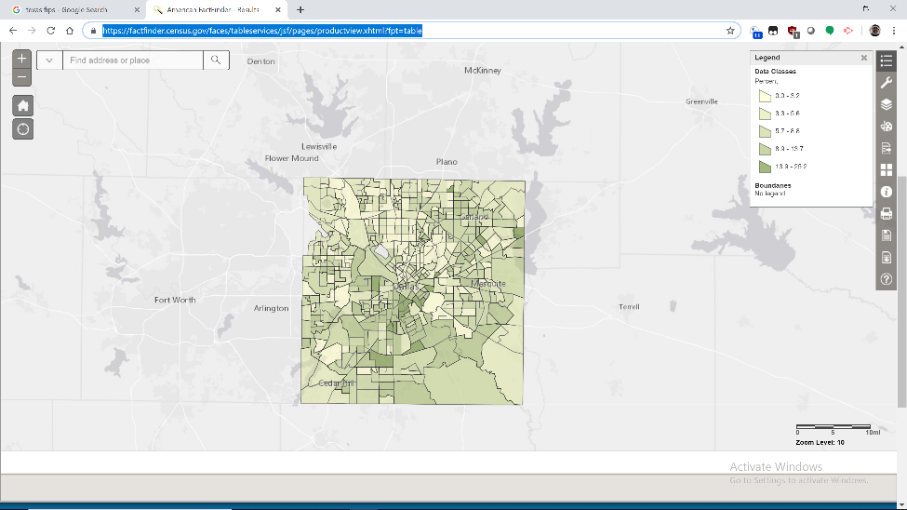
We see that some Census tracts, mostly south and west of the city center, have unemployment as high as 25%, while other tracts to the north and east of the city center have unemployment lower than 3.2%. There’s a much wider range.
Here’s the same variable by Zip Code Tabulation Area, which is a US Census Bureau modified version of zip code. Note that the map of Dallas is actually less detailed than the Census tract map.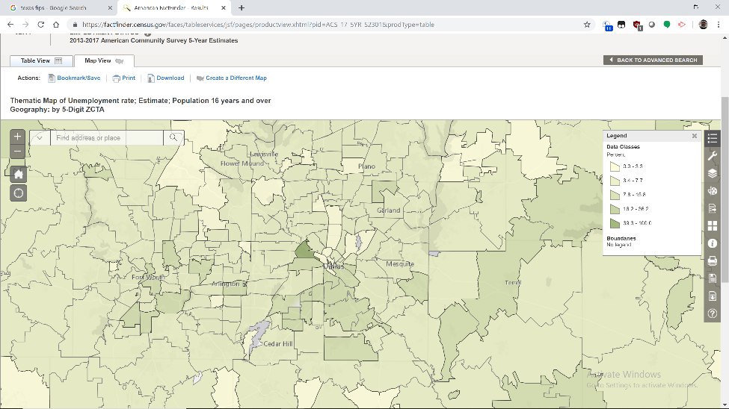

Using the Dallas County example, there are benefits to subcounty analysis, particularly when working with local partners. Nonetheless, getting subcounty data is often challenging. American Community Survey data (mostly demographic) is generally available at Census tract and ZCTA level; crime data is usually available at the county level due to the role of sheriffs in the American justice system; prescription data may be available at the county or zip code level depending on the source. Geocoding point data will be addressed in a later document.

What are the pros and cons of presenting multiple indicators in single map?
Good visualization and mapping boils down to presenting to the viewers mind the data and geography in a way such that it can be interpreted, impressed, and understood visually, directly in the observation. To make this easier on viewers, a map design should limit data and geography that remain unrelated to the information you are trying to draw an impression upon. If a map is created for the purpose of displaying county level statistics, and to juxtapose those statistics across administrative units, then unrelated geographic details should be spared.
Similarly, layering uncorrelated indicators on top of each other may diminish the visual impact of a map, as the viewer’s focus is spread to multiple overlapping details within a single map. And if the indicators remain unrelated, statistically or geospatially, this may serve only to confuse viewers.
At the same time, there are many strong reasons to layer data and geographic details that do correlate and where insights can be discovered from stacking them visually. In fact, this alignment of data and geography can be a powerful source of new understanding and problems solving ideas. Where details correlate there tends to be a balance of how much can be observed and studied within a single map, and this tends to be more of an art than science, and a discretionary process.

What is the suggested distance for using hot spot mapping using Outlier Analysis?
There is no single distance that works in every application, rather distances are best selected as they relate to the data and science being observed. For example, if details regarding an outbreak limit the potential impacts to 10 miles, then something within this range might be an appropriate assumption for hot spot distances. It also depends on what the observers of a model and map are trying to accomplish, and in this case it is often best to have a slider, or range of values to consider, in order to triage model results.

https://www.cms.gov/Medicare/Coding/ICD10/Downloads/ICD10Introduction20140819.pdf
https://www.hcup-us.ahrq.gov/datainnovations/ICD-10_DXCCS_Trends112817.pdf
https://www.cste.org/general/custom.asp?page=InjICD10DrugPoisInd
http://www.stat.columbia.edu/~gelman/research/published/allmaps.pdf
https://ibis.health.utah.gov/pdf/resource/DataSuppressionSummary.pdf
https://bismarcktribune.com/bakken/post-oil-boom-drug-prices-fall-in-oil-patch-as/article_92256837-b87d-5f38-8191-58fb1ae00453.html
https://kjzz.org/content/845391/arizona-opioid-overdoses-spike-state-looks-next-steps
https://www.rdocumentation.org/packages/classInt/versions/0.3-1/topics/classIntervals
https://rud.is/b/2014/11/16/moving-the-earth-well-alaska-hawaii-with-r/
https://libguides.lib.msu.edu/tracts
https://www.huduser.gov/portal/datasets/usps_crosswalk.html

