Mississippi Analysis Plan

Introduction:
This document summarizes the plan to analyze Mississippi data for Jurisdictional Vulnerability Assessment (JVA). It uses methods similar to (Van Handel, 2016), however, certain elements of the analysis are simplified, in the interest of creating a simpler model which is easier for less technical users.

Methods:

Outcome variables
The outcome variable for this analysis is Hepatitis C surveillance report data from Mississippi PRISM. Currently, rates from 2018 alone are mapped (Figure X). For modeling purposes, we plan on using the arithmetic mean of the 2017 and 2018 rates as an outcome variable, in order to provide more statistical reliability. Because population changes are relatively small, using the arithmetic mean of the rates should provide similar results to recalculating a true two year rate.
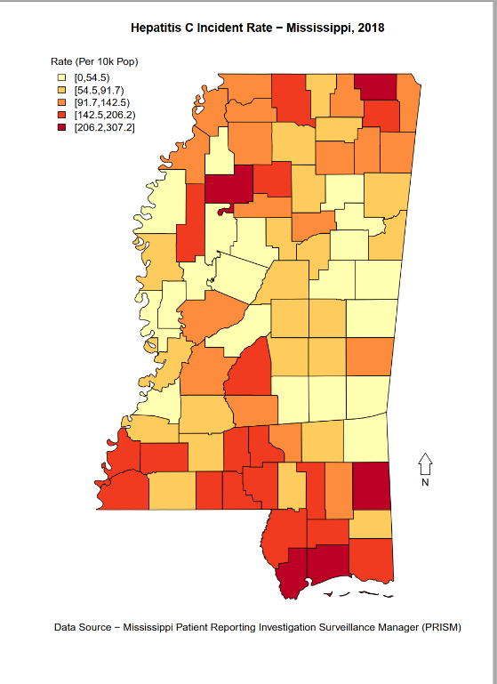
Figure 1. Hepatitis C Outcome Variable

Predictor Variables
The predictor variables for the Mississippi JVA model are: Per Capita Income (2013-2017, American Community Survey; Reversed ); County Level Overdose Death Rate (2018, Mississippi Bureau of Narcotics), County Level Drug Arrest Rate (2018, Mississippi Bureau of Narcotics), Opioid Prescriptions Per Capita (2018, NSPARC).

Imputation
For missing values, we impute based on the statewide median value. While this is less accurate than using a geographic weighted mean, this method is much easier to computationally implement.

Analysis
Our proposes analysis plan is to use the ranked values of each predictor variable, similar to the Social Vulnerability Index (CDC, 2018), and examine the Spearman rank correlation of the predictor variables with the outcome variable. In addition, we will calculate the mean of the predictor variable ranks. The calculation is done in the related spreadsheet, Mississippi_Data_Model; Spearman rank correlations will be calculated using R. Current analysis is set up so that higher score represent more vulnerability / negative outcome (lower is better modeling). For example, Kemper County has the lowest reported HCV rate (25.3 per 100,000), therefore, it has a score of 1 for the outcome variable; Tallahatchie County has the highest reported HCV rate (329.2 per 100,000), it has a score of 82 for the outcome variable.

Preliminary Results
For ease, results were mapped using Power Bi Desktop. Power BI Desktop allows for local analysis but not easy sharing of results. For both the outcome variable: Hepatitis C, and the predictor variables, there appears to be a cluster in the Gulf Coast section of Mississippi, near Hattiesburg. This can be formalized in later analysis using Spearman rank correlation.
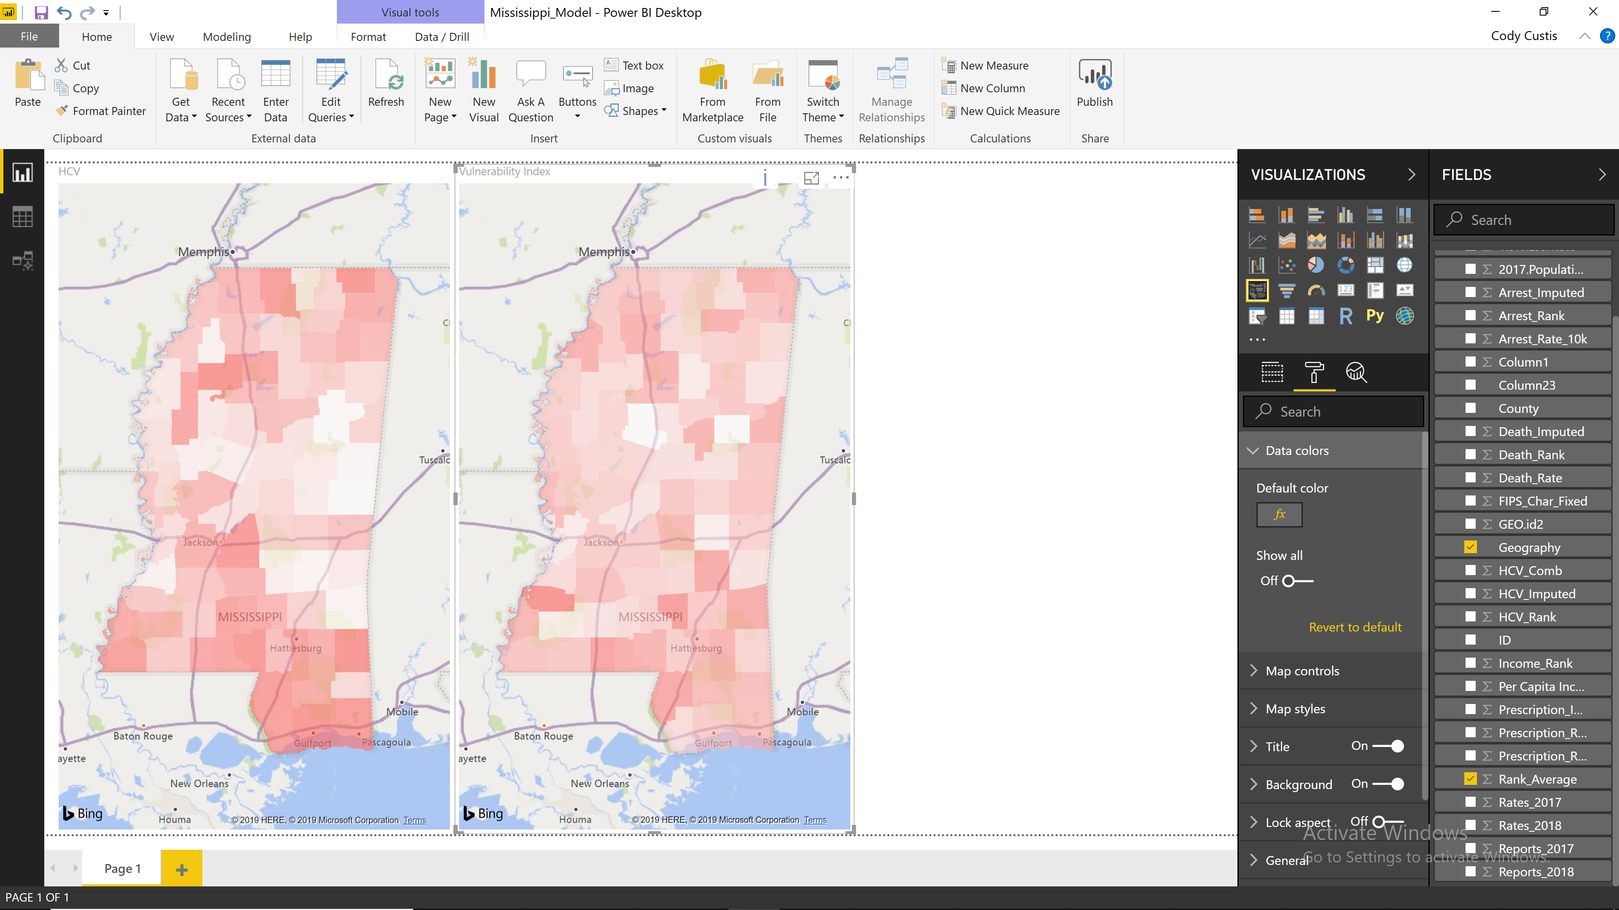
Figure 2 Social Vulnerability Index Results
Based on this analysis, potential action items for Mississippi include making sure that individuals in the Gulf Coast sufficient access to protective resources and treatment for HCV / HIV / opioid outbreak.
While Tallahatchie County has the highest HCV rate, it has a low JVA score (average rank 29.5 of 82 counties, below the median value). This suggested vulnerability due to factors not captured in the model, further investigation is needed to determine if those factors are ongoing (a variable excluded from the model), unique (something about the county that makes it different), or one-time (perhaps HCV users moving the county).
As far as general analysis, this model can be performed using basic spreadsheet calculations. Unlike Poisson regression, it cannot predict outcome rates or offer deeper analysis into specific variables. However, it has the advantage that jurisdictions can easily substitute their own variables to perform analysis and determine county vulnerability. Depending on needs, the spreadsheet can be expanded to include Spearman rank correlation calculations or conditional formatting for percentiles.

