Map Gallery – Kentucky
Prepared by Cody L. Custis, Jordan Larson, Tsuro Consulting, for the Jurisdiction Vulnerability Assessment
Introduction:
This map gallery is specific to the selected states. Per capita income from the American Community Survey is used as a demonstration variable. Because this variable is available online to the public, we consider any map that contains only American Community Survey data to be releasable to the public. Some maps can easily be altered in some ways, other maps will require more work, some alterations are not technically possible in certain formats.

Disclaimer: the views and opinions expressed in this document are those of the authors, Cody Custis and Jordan Larson, both of Tsuro Consulting, and do not necessarily reflect the official policy or position of the Centers for Disease Control and Prevention, the Council of State and Territorial Epidemiologists, or any state, local, or tribal health agency.

R GISTools
URL: N/A
GISTools creates high resolution PDF (or jpeg) maps. Currently, these maps do not support baselayers, that feature may be added later in the project. The PDF format is ideal for standalone maps (or standalone pages in documented); graphics formats like jpeg are ideal for embedding in documents along with narrative text. R GISTools is free to use and save files locally which can be distributed.
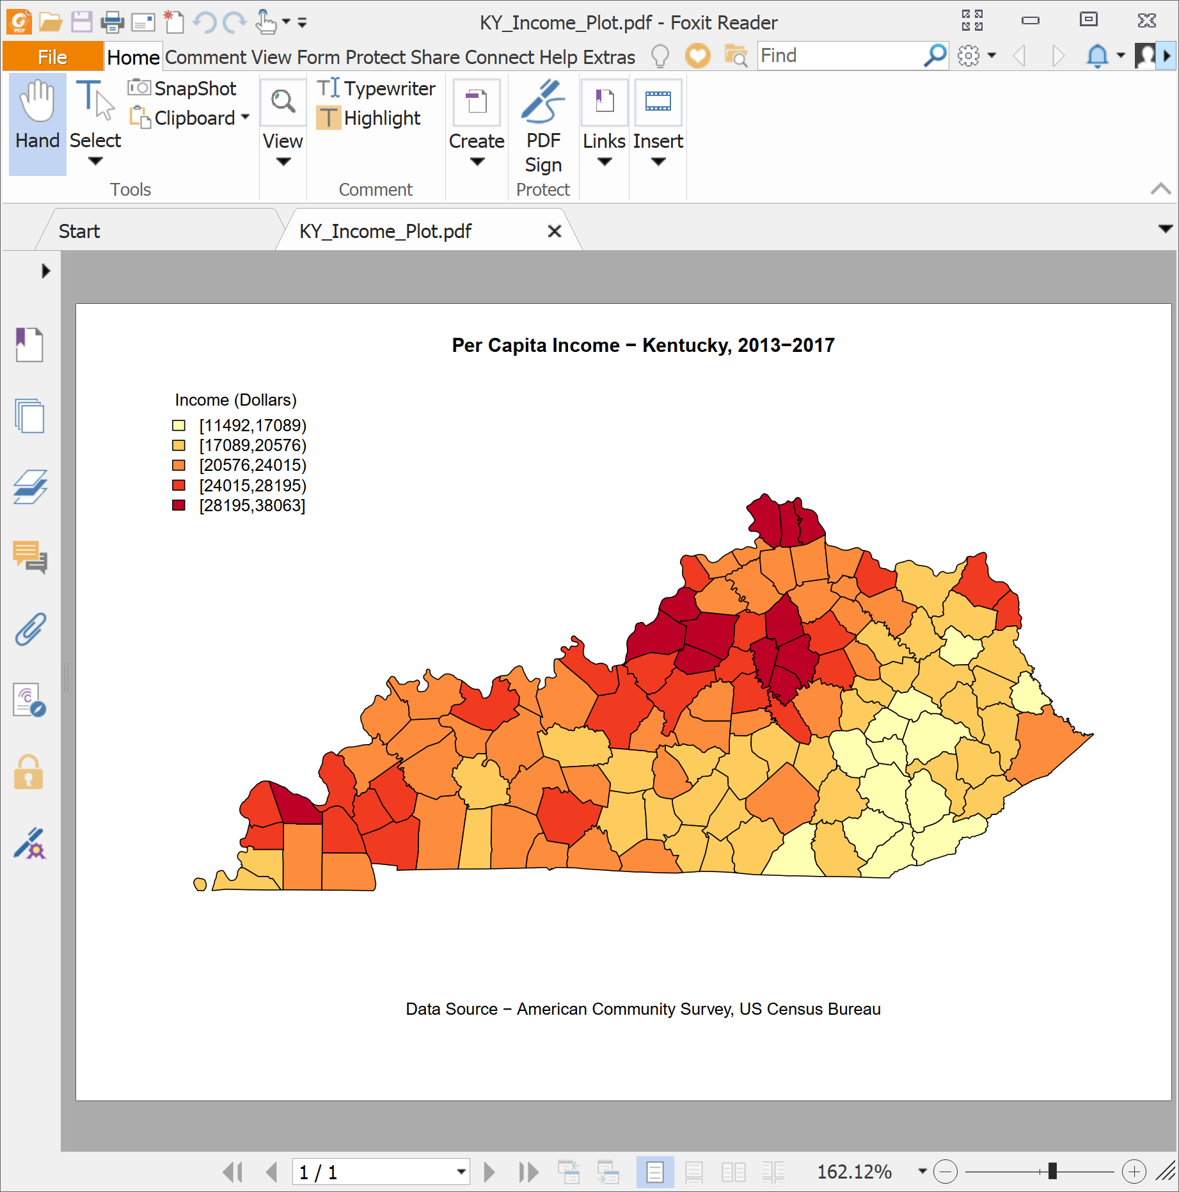

Power BI Desktop
URL: N/A
Power BI Desktop allows for easy mapping of indicators, with the weakness that mapping is very limited in both sharing and customization. In this case, the map can only be shared using screenshots or Windows snips. Power BI Desktop is free for individual analyst use, for development teams, a standard license is $10 per user per month.

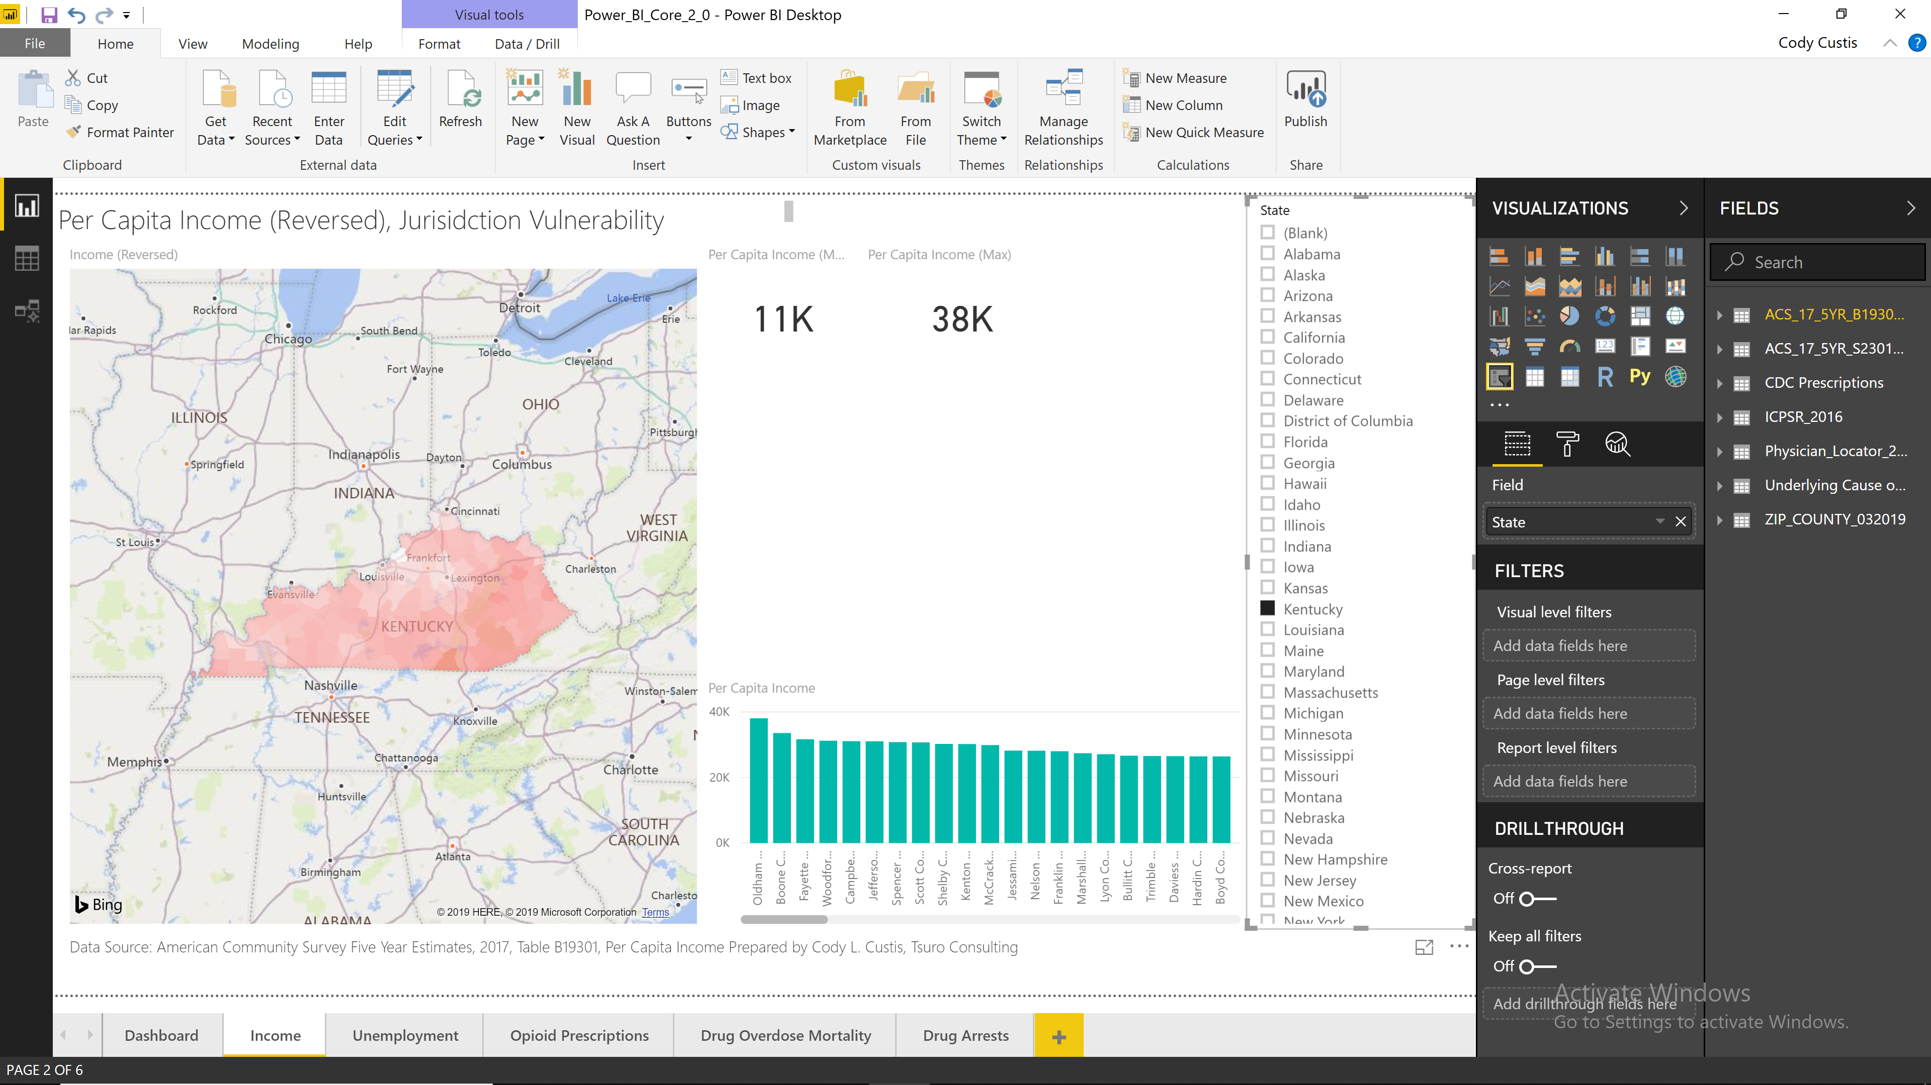

Power BI Service
URL: https://app.powerbi.com/view?r=eyJrIjoiYmRkMDM2MDYtNjBjYi00OTUwLTliNjctOWZhNjYzODMwYWU0IiwidCI6IjcxZjNhYTMyLTg2NTYtNGU4Yi1iMTUxLTBkNWEwYjBkMjhiMCJ9
Power BI Service allows free interactive maps and dashboards for public use, with the same limitations of the Power BI Desktop, but the added advantage that users can interact with the map. For private deployment, one either needs a per user license of $10 per user / viewer a month, or a Microsoft Azure account (estimated cost of more than $10,000 per year).

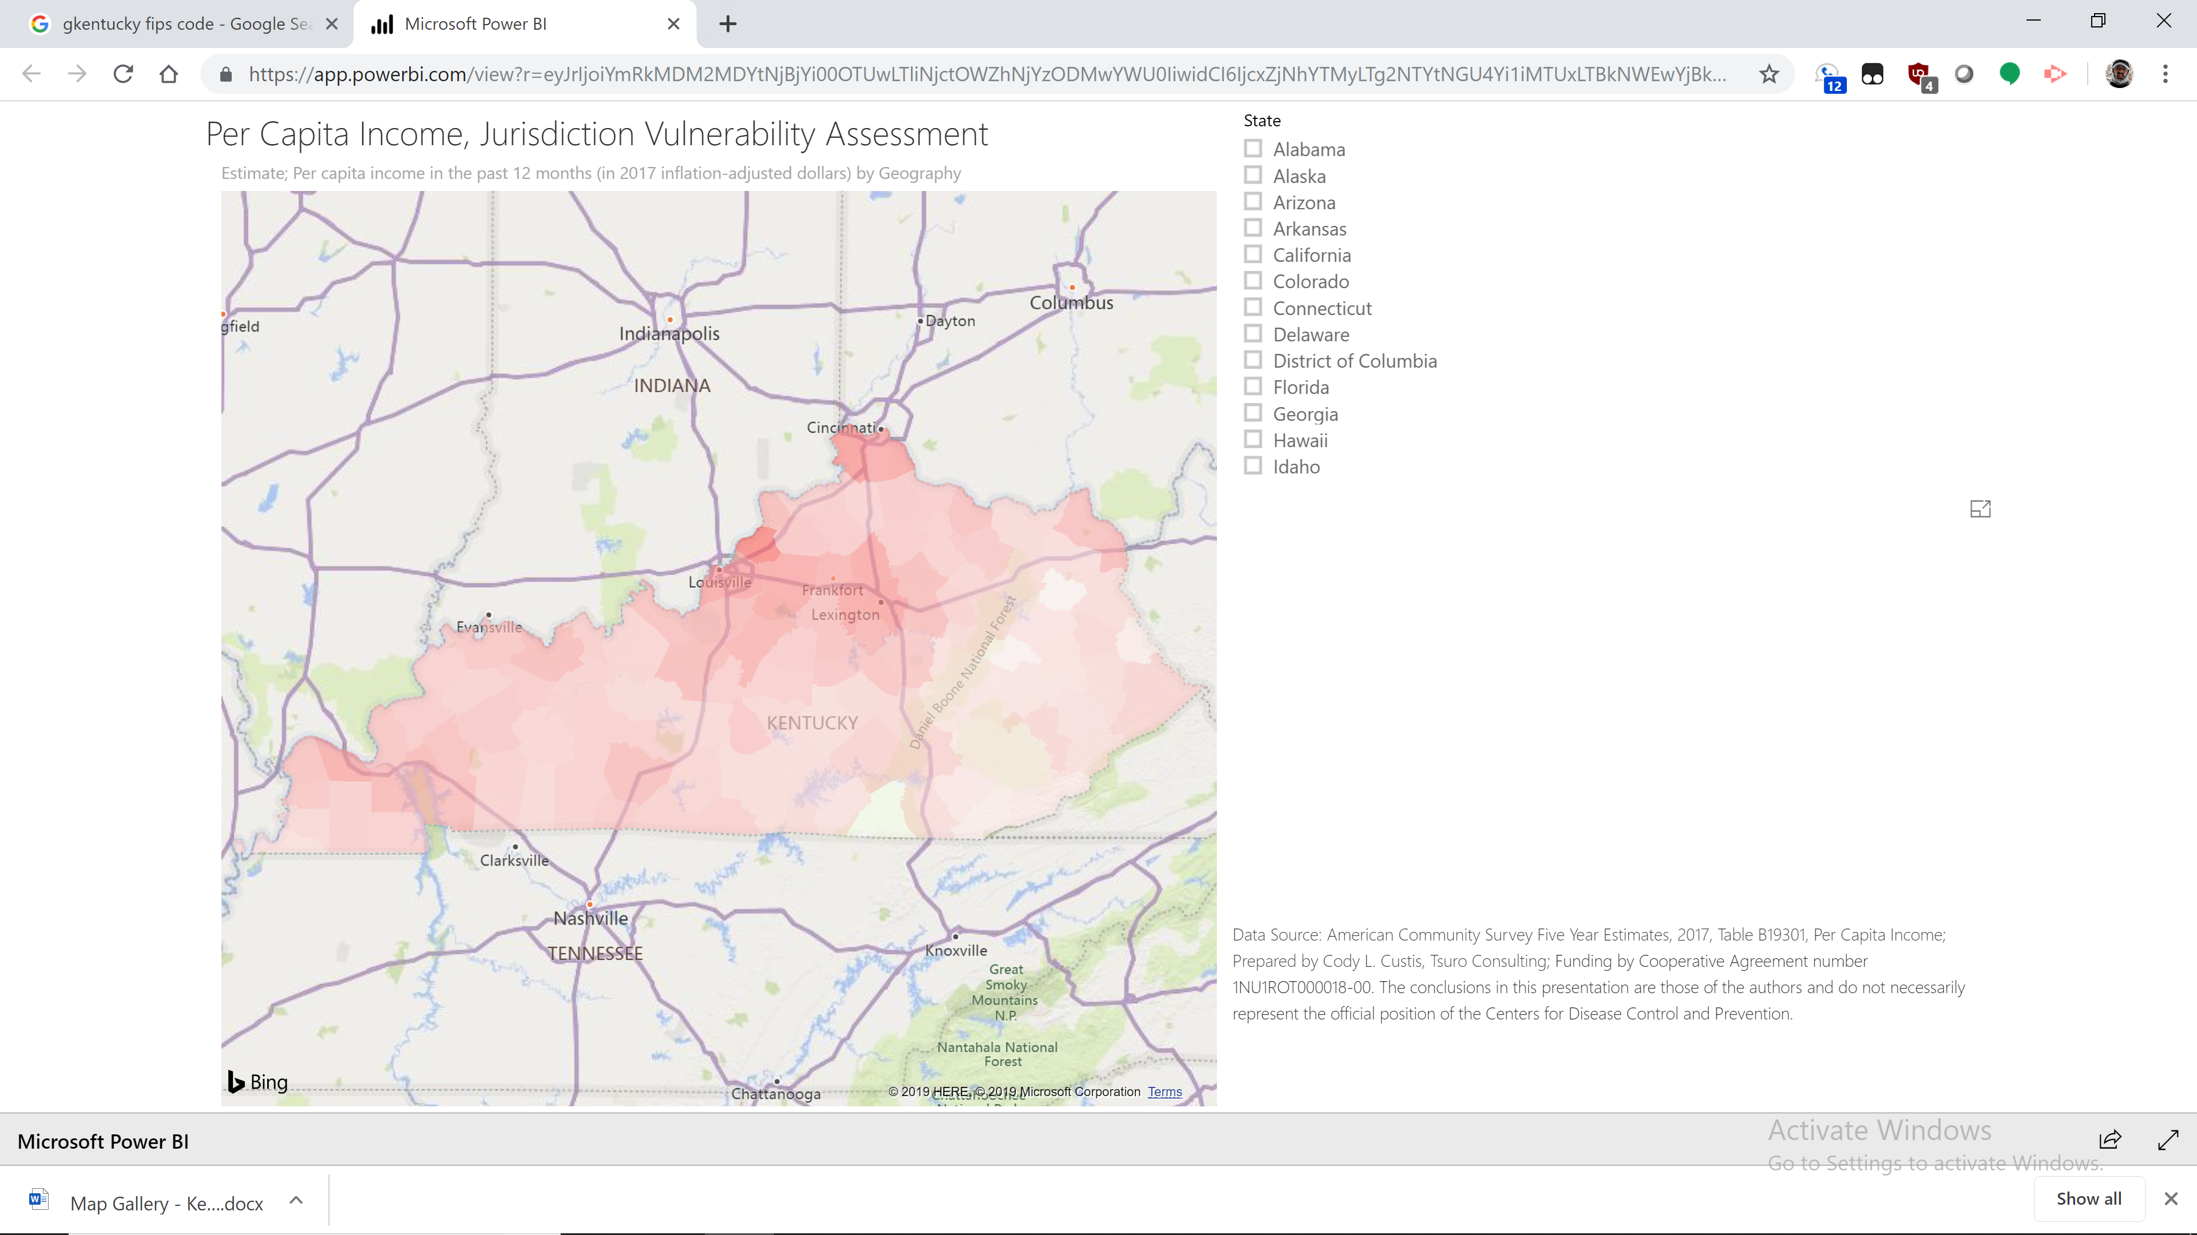

R Leaflet
URL: http://rpubs.com/ccustis/KY_Income
R Leaflet creates interactive maps using the Leaflet platform. These maps is that they use OpenStreetMap basemaps (which can be changed), allow for web based tooltips. The Leaflet object can be saved by states to apply as a data frame in their own webpages; such discussion would require working with a state’s Information Technology department. Alternatively, one can use the R Studio capability to deploy maps as publicly viewable on the Internet for free; or privately viewable at an estimated cost of $15,000 per year, assuming the department uses R Studio provided solutions.
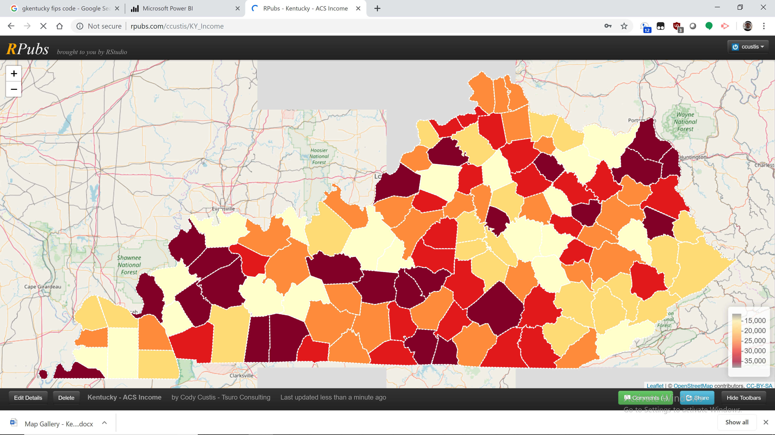

Power Maps (3D Maps)
URL: N/A
Similar to Power BI desktop, 3D maps can easily create basic playful maps inside of Microsoft Excel. 3D maps is designed for desktop ease and accessibility, but as a stand alone product plug-in it has some unique visualization and movie making abilities. Graphic and publishing options are limited, and so it may not provide enough capability for many projects. Power Maps is available as part of an Office 365 subscription, which many Information Technology services departments already provider, alternatively, a subscription costs roughly $10 per creator per month, with no costs for viewers.
