Mississippi Analysis Plan 2.0

Introduction:
This document summarizes the plan to analyze Mississippi data for Jurisdictional Vulnerability Assessment (JVA). The methods are based on the Social Vulnerability Index, variable section is based on subject matter expertise from Mississippi (Van Handel, 2016).

Methods:

Outcome variables
The outcome variable for this analysis is Hepatitis C surveillance report data from Mississippi PRISM. Currently, rates from 2018 alone are mapped (Figure X). For modeling purposes, we used the arithmetic mean of the 2017 and 2018 rates as an outcome variable, in order to provide more statistical reliability. Because population changes are relatively small, using the arithmetic mean of the rates should provide similar results to recalculating a true two year rate.
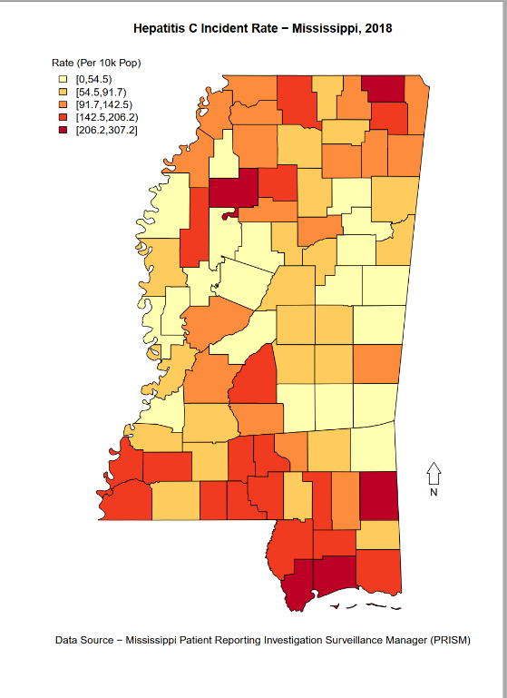
Figure 1. Hepatitis C Outcome Variable

Predictor Variables
The predictor variables for the Mississippi JVA model are: Per Capita Income (2013-2017, American Community Survey; Reversed ); County Level Overdose Death Rate (2018, Mississippi Bureau of Narcotics), County Level Drug Arrest Rate (2018, Mississippi Bureau of Narcotics), Opioid Prescriptions Per Capita (2018, NSPARC).

Imputation
For missing values, we impute based on the statewide median value. While this is less accurate than using a geographic weighted mean, this method is much easier to computationally implement.

Analysis
Our proposes analysis plan is to use the ranked values of each predictor variable, similar to the Social Vulnerability Index (CDC, 2018), and examine the Spearman rank correlation of the predictor variables with the outcome variable. In addition, we will calculate the mean of the predictor variable ranks. The calculation is done in the related spreadsheet, Mississippi_Data_Model; Spearman rank correlations will be calculated using R. Current analysis is set up so that higher score represent more vulnerability / negative outcome (lower is better modeling). For example, Kemper County has the lowest reported HCV rate (25.3 per 100,000), therefore, it has a score of 1 for the outcome variable; Tallahatchie County has the highest reported HCV rate (329.2 per 100,000), it has a score of 82 for the outcome variable. Because ranks are used, we did not take logarithm transformations of any variables.
We used three tools to perform Mississippi’s JVA: Power BI (mapping, selected univariate analysis), R (mapping, statistical analysis) and Excel (ranking). As such, figures may appear different depending on the tool used.

Results

Univariate Results

Selected univariate results are in Table 1.
Table 1: Selected Univariate Results
Indicator | Min | 1st Quartile | Median | Mean | 3rd Quartile | Max
Drug Related Arrest Rate | 0.00 | 0.00 | 17.0 | 32.6 | 57.4 | 152.4
Suspected Overdose Death Rate | 0.00 | 0.00 | 10.0 | 9.94 | 14.2 | 32.0
Per Capita Income | 12394 | 18123 | 20094 | 20128 | 21664 | 36627
Per Capita Patients with Opioid Precriptions | 153 | 228 | 248.5 | 252.9 | 268 | 488
Hepatitis C Incidence | 0 | 63.3 | 100.0 | 106.7 | 151.7 | 329.2

Vulnerability Index Results
For ease, results were mapped using Power Bi Desktop. Power BI Desktop allows for local analysis but not easy sharing of results. For both the outcome variable: Hepatitis C, and the predictor variables, there appears to be a cluster in the Gulf Coast section of Mississippi, near Hattiesburg. This can be formalized in later analysis using Spearman rank correlation.
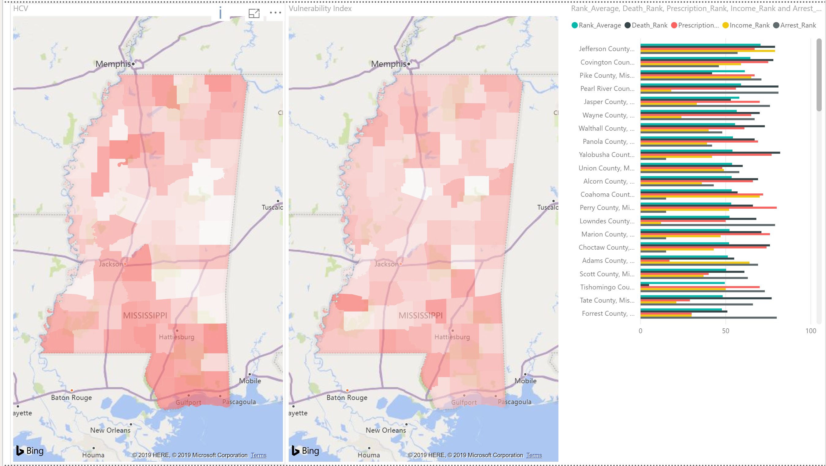
Figure 2 Jurisdiction Vulnerability Index Results
Based on this analysis, potential action items for Mississippi include making sure that individuals in the Gulf Coast sufficient access to protective resources and treatment for HCV / HIV / opioid outbreak.
While Tallahatchie County has the highest HCV rate, it has a low JVA score (average rank 29.5 of 82 counties, below the median value). This suggested vulnerability due to factors not captured in the model, further investigation is needed to determine if those factors are ongoing (a variable excluded from the model), unique (something about the county that makes it different), or one-time (perhaps HCV users moving the county).

Focus

We will focus on Pearl River County, located in the Gulf Coast Region. Across the four indicators, Pearl River has an average rank of 59 (out of a maximum possible of 88 counties): 81 for deaths (rate of , 56 for prescriptions, 18 for income, 81 for drug arrests. It has the 74th highest rate of HCV incidence, 179 per 100,000 population.
In comparison, the median rate of HCV incidence in Mississippi is 100 per 100,000 population. HCV incidence is Pearl River County is 1.8 times as high as the median. The two indicators where Pearl River County has the greatest ranked vulnerability are drug overdose deaths and drug arrests. By focusing on evidence based programs that lower these indicators, Pearl River County’s HCV incidence would be expected to move closer to the statewide median.

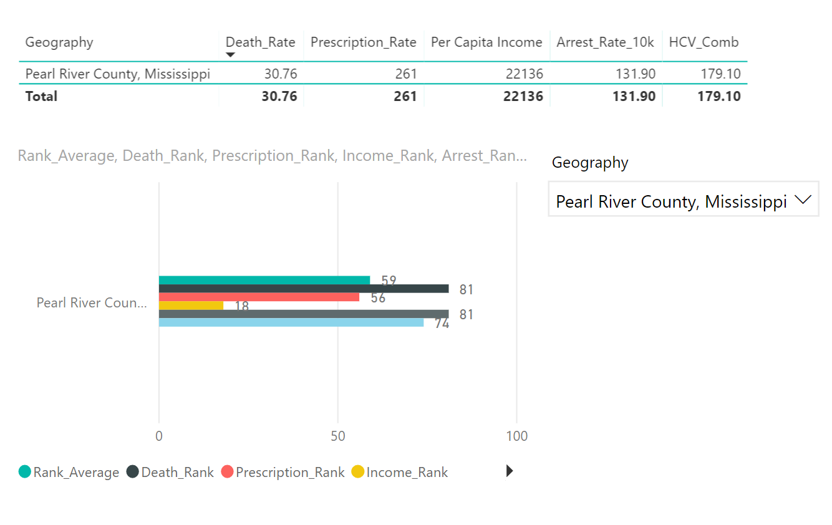
Conclusions
As far as general analysis, this model can be performed using basic spreadsheet calculations. Unlike Poisson regression, it cannot predict outcome rates or offer deeper analysis into specific variables. However, it has the advantage that jurisdictions can easily substitute their own variables to perform analysis and determine county vulnerability. Depending on needs, the spreadsheet can be expanded to include Spearman rank correlation calculations or conditional formatting for percentiles.

