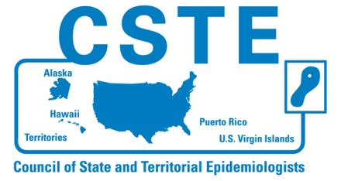
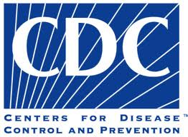
Old Tools for a New Epidemic:
Using Prescription Data to Prevent Drug Overdoses
Tuesday, July 31, 2012
1:00 – 2:30 p.m. EDT

The Centers for Disease Control and Prevention (CDC) and the Council of State and Territorial Epidemiologists (CSTE) will host a webinar on leveraging prescription drug data to better inform decision makers about the prescription drug overdose problem on Tuesday, July 31 from 1:00 to 2:30 pm (EDT). The webinar will provide an opportunity to discuss how epidemiologists and other researchers working at the state and local level can use traditional epidemiologic tools to assess the prescription drug abuse and overdose problems in their state. The webinar will discuss metrics and approaches that states can employ with prescription data available from state prescription drug monitoring programs or claims data. During the webinar, a representative from the CDC’s Injury Center will briefly describe the variety and validity of various measures of prescription use that could be employed by state or local health departments. Epidemiologists from two states will present their experiences with using state prescription drug monitoring program data.

Featured speakers include:

Len Paulozzi, MD, MPH
Dr. Paulozzi is a medical epidemiologist in the Division of Unintentional Injury Prevention of the National Center for Injury Prevention and Control (NCIPC). He works on drug overdoses, especially those due to prescription drugs. His presentation will focus on sources of information on prescription drugs at the state level and what is known about their value as risk factors for misuse, abuse, or overdose.

Christy Beeghly, MPH, and Matt Falb, MHS
Ms. Christy is the program manager, and Mr. Falb is an epidemiologist in the violence and injury program of the Ohio Department of Health. They will give an overview of Ohio’s linkage of the prescription drug monitoring program and death certificate data as well as programmatic efforts aided by the linkage.

Colleen McLaughlin, PhD, MPH
Dr. McLaughlin is an epidemiologist in the Patient Safety Center of the Division of Health Care Quality of the New York State Department of Health. She has recently been working with the New York Bureau of Narcotics Enforcement, which maintains the New York Prescription Drug Monitoring Program. She will describe New York’s use of its PDMP data for surveillance.
The webinar will be moderated by Denise Paone, EdD, Director of Research in the Bureau of Alcohol and Drug Use, Prevention, Care, and Treatment of the New York City DOHMH.

Feel free to share this announcement with your colleagues and please join us on Tuesday, July 31 from 1:00 pm to 2:30 pm EDT for this live meeting!

